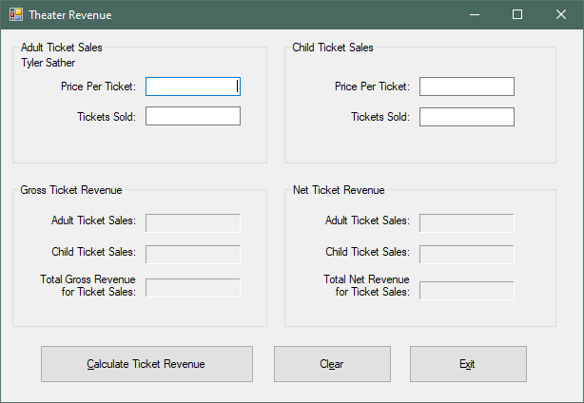

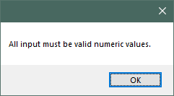

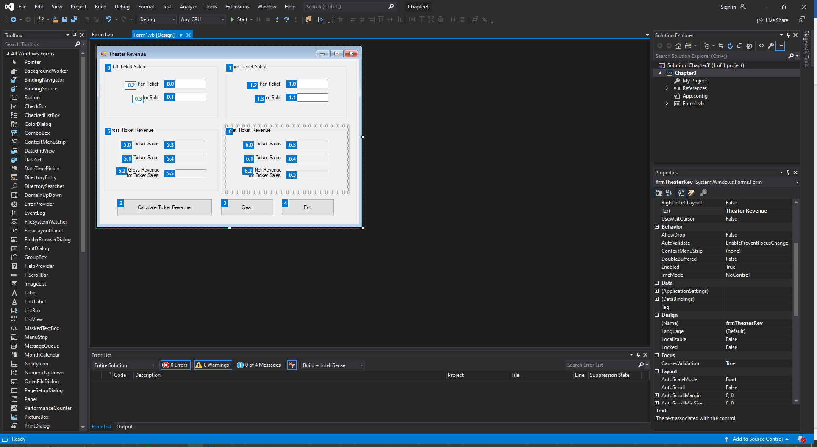

Public Class frmTheaterRev

Private Sub brnCalc_Click(sender As Object, e As EventArgs) Handles brnCalc.Click

'Declare variables for Calculations

Dim decATotalG As Decimal

Dim decCTotalG As Decimal

Dim decGrossTotal As Decimal

Dim decATotalN As Decimal

Dim decCTotalN As Decimal

Dim decNetTotal As Decimal

Const decTheaterPercentage = 0.2D

Try

'Calculate the Gross for adult ticket sales

decATotalG = CDec(txtPricePerTicketA.Text) *

CDec(txtTicketsSoldA.Text)

lblATicketSalesG.Text = decATotalG.ToString("c")

'Calculate the Gross for child ticket sales

decCTotalG = CDec(txtPricePerTicketC.Text) *

CDec(txtTicketsSoldC.Text)

lblCTicketSalesG.Text = decCTotalG.ToString("c")

'Calclulate the Gross Revenue

decGrossTotal = decATotalG + decCTotalG

lblGrossRev.Text = decGrossTotal.ToString("c")

'Calculate the Net for adult Ticket sales

decATotalN = decATotalG * decTheaterPercentage

lblATicketSalesN.Text = decATotalN.ToString("c")

'Calculate the net for the child ticket sales

decCTotalN = decCTotalG * decTheaterPercentage

lblCTicketSalesN.Text = decCTotalN.ToString("c")

'Calculate the net Revenue

decNetTotal = decGrossTotal * decTheaterPercentage

lblNetRev.Text = decNetTotal.ToString("c")

Catch

'Error Message

MessageBox.Show("All input must be valid numeric values.")

End Try

End Sub

Private Sub btnClear_Click(sender As Object, e As EventArgs) Handles btnClear.Click

'Clear the input fields

txtPricePerTicketA.Clear()

txtPricePerTicketC.Clear()

txtTicketsSoldA.Clear()

txtTicketsSoldC.Clear()

'Clear the output fields

lblATicketSalesG.Text = String.Empty

lblATicketSalesN.Text = String.Empty

lblCTicketSalesG.Text = String.Empty

lblCTicketSalesN.Text = String.Empty

lblGrossRev.Text = String.Empty

lblNetRev.Text = String.Empty

'Reset the focus to the first field

txtPricePerTicketA.Focus()

End Sub

Private Sub btnExit_Click(sender As Object, e As EventArgs) Handles btnExit.Click

'Close the form

Me.Close()

End Sub

End Class