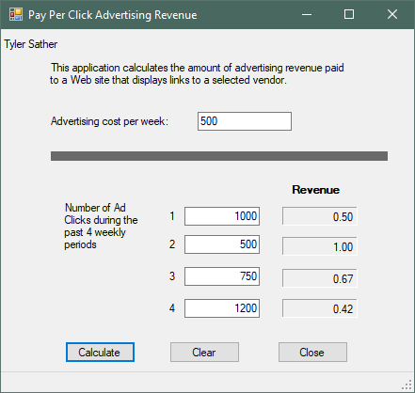

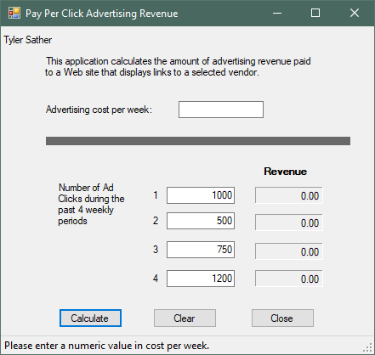

**I have it set up so the field erases the non numeric value in the txt box. There was a word in there before calculating.

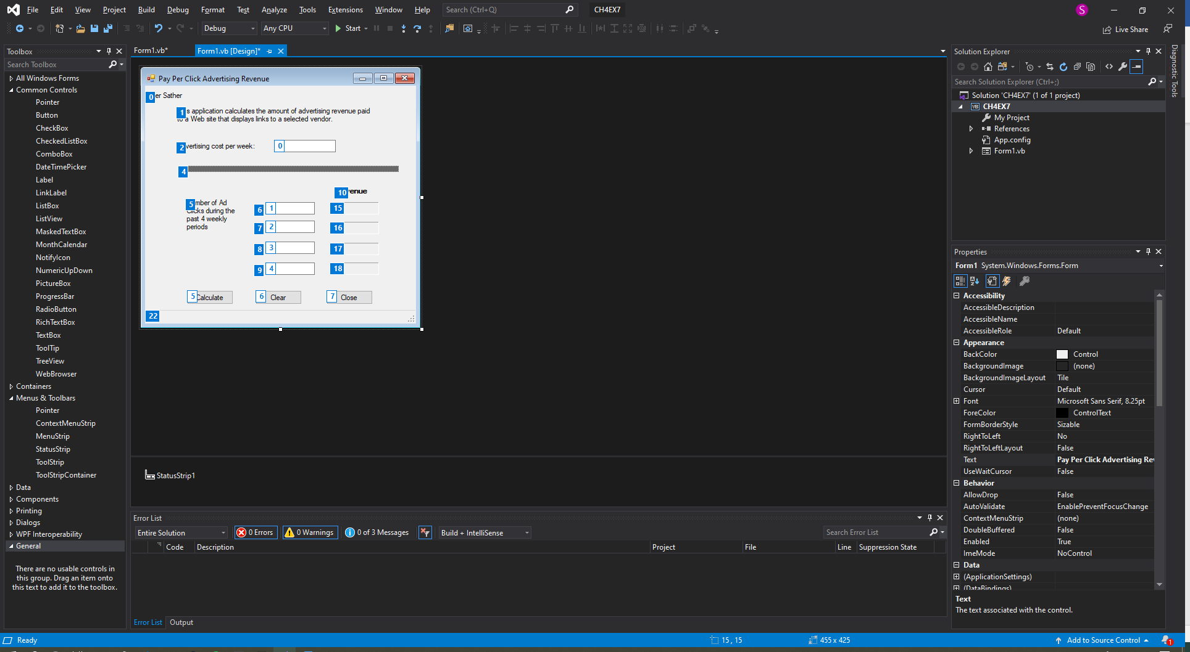

Main Program ******************************************************************

Public Class Form1

Private Sub btnCalc_Click(sender As Object, e As EventArgs) Handles btnCalc.Click

'Declare my variables for calculations

Dim intAdCost As Integer

Dim intClickOne As Integer

Dim intClickTwo As Integer

Dim intClickThree As Integer

Dim intClickFour As Integer

Dim dblRev As Double

'Clear status strip of any previous error message

'lblStatus.Text = String.Empty

'txtaddcost converted to integer and stored in varible.

If IsNumeric(txtAdCost.Text) Then

intAdCost = CInt(txtAdCost.Text)

Else

lblStatus.Text = "Please enter a numeric value in cost per week."

txtAdCost.Text = String.Empty

End If

'Calculate rev week one and test numeric

If IsNumeric(txtClickOne.Text) Then

intClickOne = CInt(txtClickOne.Text)

dblRev = intAdCost / intClickOne

lblRevOne.Text = dblRev.ToString("n")

Else

lblStatus.Text = "Please enter a numeric value in 1."

txtClickOne.Text = String.Empty

End If

'Calculate rev week two and test numeric

If IsNumeric(txtClickTwo.Text) Then

intClickTwo = CInt(txtClickTwo.Text)

dblRev = intAdCost / intClickTwo

lblRevTwo.Text = dblRev.ToString("n")

Else

lblStatus.Text = "Please enter a numeric value in 2."

txtClickTwo.Text = String.Empty

End If

'Calculate rev week Three and test numeric

If IsNumeric(txtClickThree.Text) Then

intClickThree = CInt(txtClickThree.Text)

dblRev = intAdCost / intClickThree

lblRevThree.Text = dblRev.ToString("n")

Else

lblStatus.Text = "Please enter a numeric value in 3."

txtClickThree.Text = String.Empty

End If

'Calculate rev week Four and test numeric

If IsNumeric(txtClickFour.Text) Then

intClickFour = CInt(txtClickFour.Text)

dblRev = intAdCost / intClickFour

lblRevFour.Text = dblRev.ToString("n")

Else

lblStatus.Text = "Please enter a numeric value in 4."

txtClickFour.Text = String.Empty

End If

End Sub

Private Sub btnClear_Click(sender As Object, e As EventArgs) Handles btnClear.Click

'Clears the input fields

txtAdCost.Clear()

txtClickOne.Clear()

txtClickTwo.Clear()

txtClickThree.Clear()

txtClickFour.Clear()

'Clears the output lables

lblRevOne.Text = String.Empty

lblRevTwo.Text = String.Empty

lblRevThree.Text = String.Empty

lblRevFour.Text = String.Empty

'Clears the Status lable

lblStatus.Text = String.Empty

End Sub

Private Sub btnClose_Click(sender As Object, e As EventArgs) Handles btnClose.Click

'Closes the form

Me.Close()

End Sub

End Class