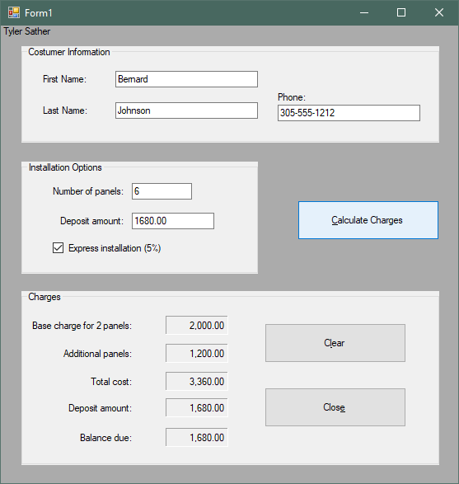

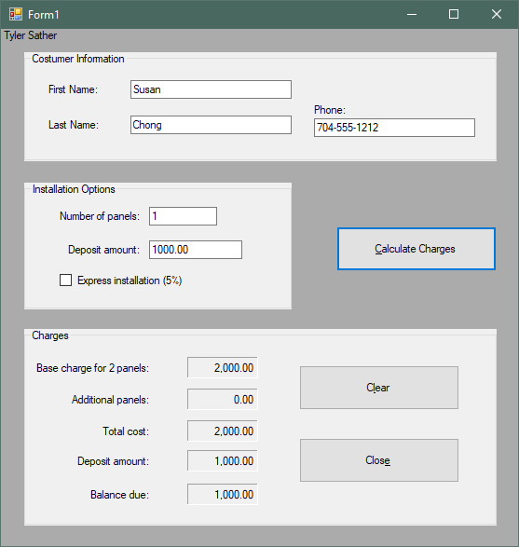

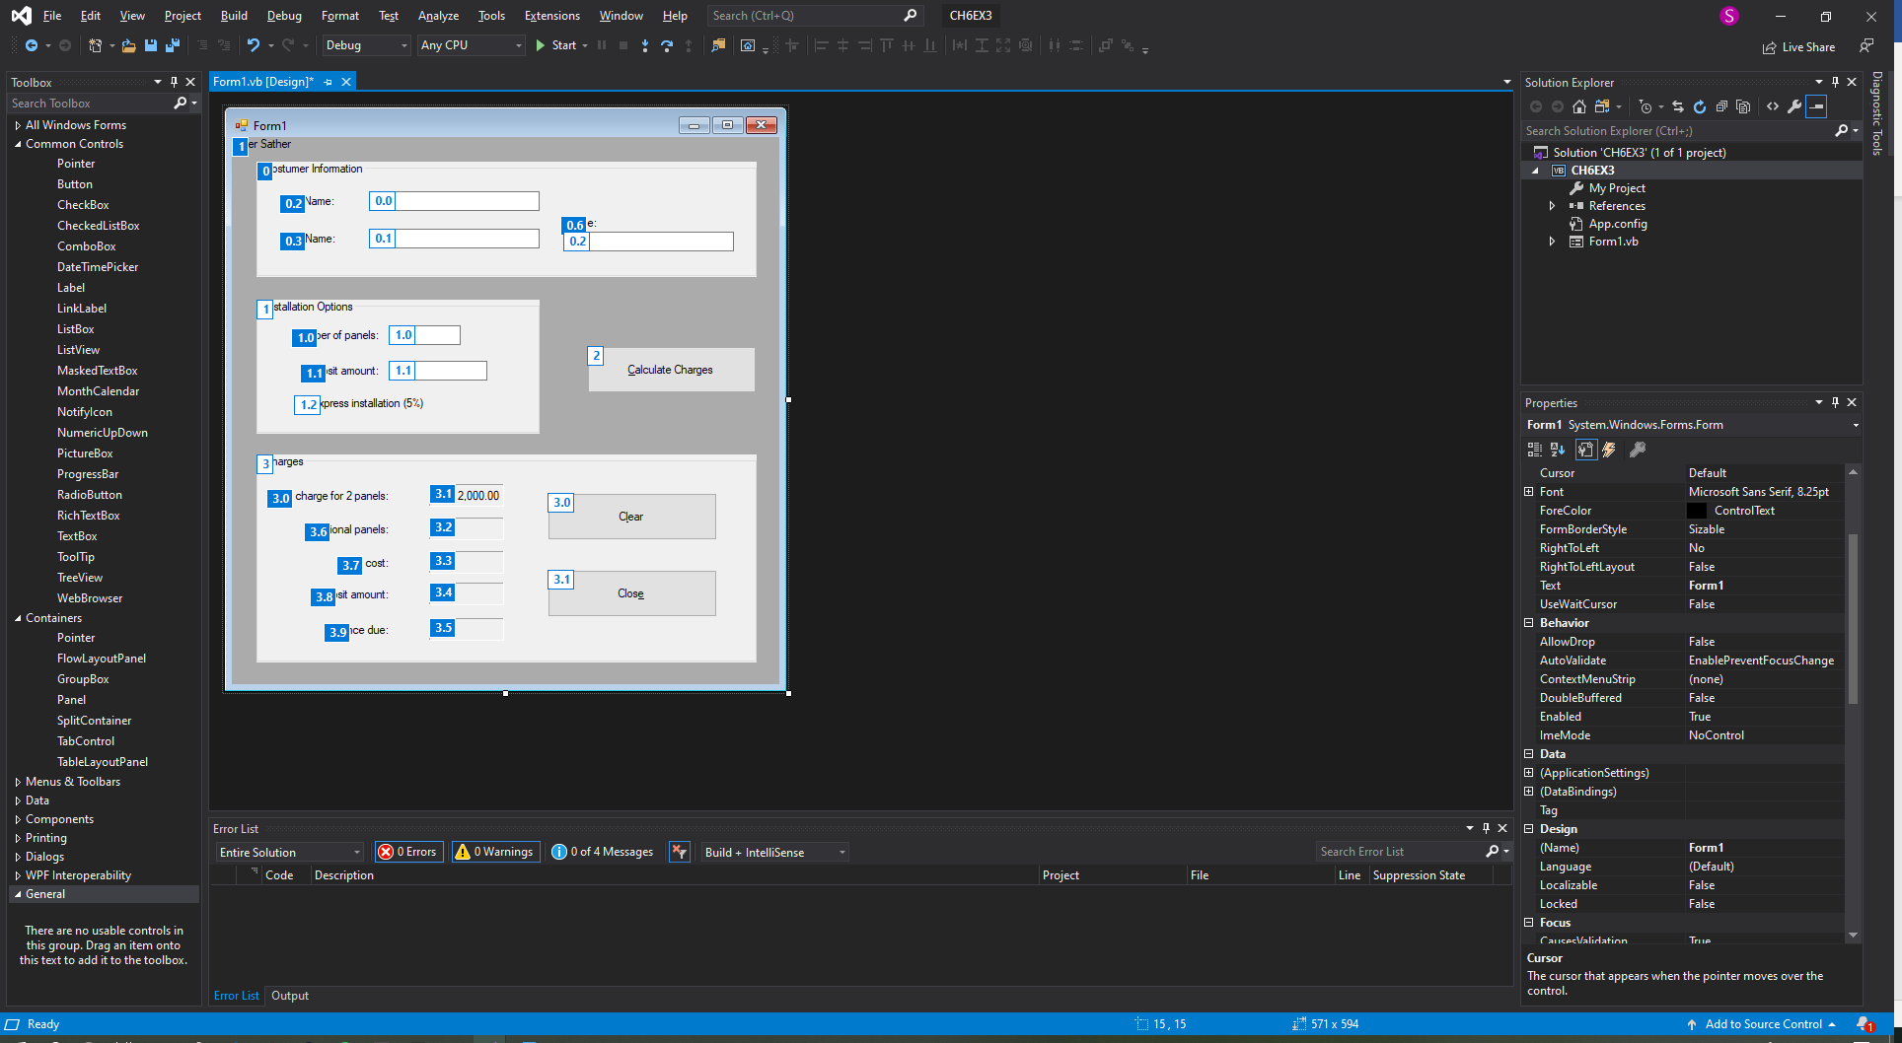

Public Class Form1

'Variables used in the functions

Private intPanels As Integer

Private decDownPay As Decimal

Private decAddPanels As Decimal

Private decTotalCost As Decimal

Private decBalance As Decimal

Private decAddPanelsCost As Decimal

'The below procedure will display the groupbox charges when the calculate button is pressed.

Sub DisplayCharges()

gbxCharges.Visible = True

End Sub

'The below procedure will hide the groupbox charges when the clear button is pressed.

Sub HideCharges()

gbxCharges.Visible = False

End Sub

'The below function will validate all input fields and display a error message if incorrect.

Private Function ValidateInput() As Boolean

If txtFirst.Text = String.Empty Then

MessageBox.Show("Please enter a first name")

Return False

End If

If txtLast.Text = String.Empty Then

MessageBox.Show("Please enter a last name")

Return False

End If

If txtPhone.Text = String.Empty Then

MessageBox.Show("Please enter a phone number")

Return False

End If

If Not Integer.TryParse(txtPanels.Text, intPanels) Then

MessageBox.Show("Number of panels must be numeric")

Return False

ElseIf intPanels < 1 Or intPanels > 1000 Then

MessageBox.Show("Number of panels must be between 1 - 1000")

Return False

End If

If Not Decimal.TryParse(txtDeposit.Text, decDownPay) Then

MessageBox.Show("Amount of deposit must be numeric")

Return False

ElseIf decDownPay <= 0 Then

MessageBox.Show("Amount of deposit must be more than 0")

Return False

End If

Return True

End Function

'The below function Calculates the additional panels over 2

Private Function AdditionalPanels(ByVal intPanels As Integer) As Decimal

If intPanels > 2 Then

decAddPanelsCost = (intPanels - 2) * 300

Else

decAddPanelsCost = 0

End If

Return decAddPanels

End Function

'The below function will calculate the total cost

Private Function TotalCost(ByVal intPanels As Integer,

ByVal decAddPanelsCost As Decimal) As Decimal

If intPanels <= 2 Then

If chkExpress.Checked = True Then

decTotalCost = CDec(2000 * 1.05)

Else

decTotalCost = 2000

End If

ElseIf chkExpress.Checked = True Then

decTotalCost = CDec((decAddPanelsCost + 2000) * 1.05)

Else

decTotalCost = decAddPanelsCost + 2000

End If

Return decTotalCost

End Function

'The Below Function will calculate the balance left

Private Function Balance(ByVal decTotalCost As Decimal,

ByVal decDeposit As Decimal) As Decimal

decBalance = decTotalCost - decDeposit

Return decBalance

End Function

Private Sub btnCalculate_Click(sender As Object, e As EventArgs) Handles btnCalculate.Click

Dim decDeposit As Decimal

'Calls all of the procedures and functions and displays outputs to the labels

If ValidateInput() Then

DisplayCharges()

AdditionalPanels(intPanels)

lblAddPanels.Text = decAddPanelsCost.ToString("n")

TotalCost(intPanels, decAddPanelsCost)

lbltotal.Text = decTotalCost.ToString("n")

decDeposit = CDec(txtDeposit.Text)

lblDepsosit.Text = decDeposit.ToString("n")

Balance(decTotalCost, decDeposit)

lblBalance.Text = decBalance.ToString("n")

End If

End Sub

Private Sub btnClear_Click(sender As Object, e As EventArgs) Handles btnClear.Click

'Clears Check box

chkExpress.Checked = False

'Clears Input text boxes

txtFirst.Clear()

txtLast.Clear()

txtPhone.Clear()

txtPanels.Clear()

txtDeposit.Clear()

'Clears labels

lblAddPanels.Text = String.Empty

lbltotal.Text = String.Empty

lblDepsosit.Text = String.Empty

lblBalance.Text = String.Empty

'Puts focus on first name

txtFirst.Focus()

'Hides Charges Group Box

HideCharges()

End Sub

Private Sub btnClose_Click(sender As Object, e As EventArgs) Handles btnClose.Click

Me.Close()

End Sub

End Class