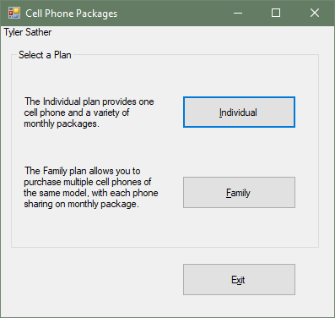

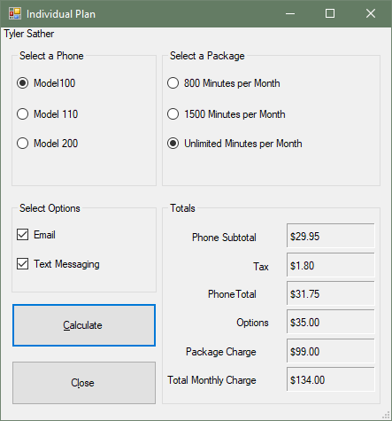

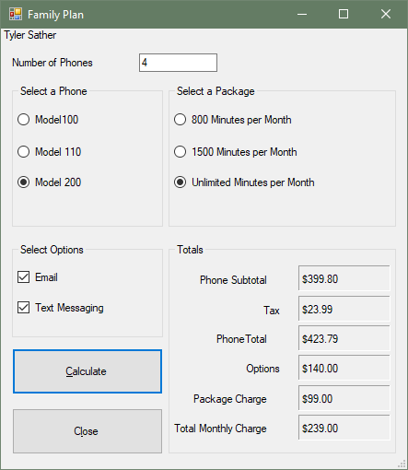

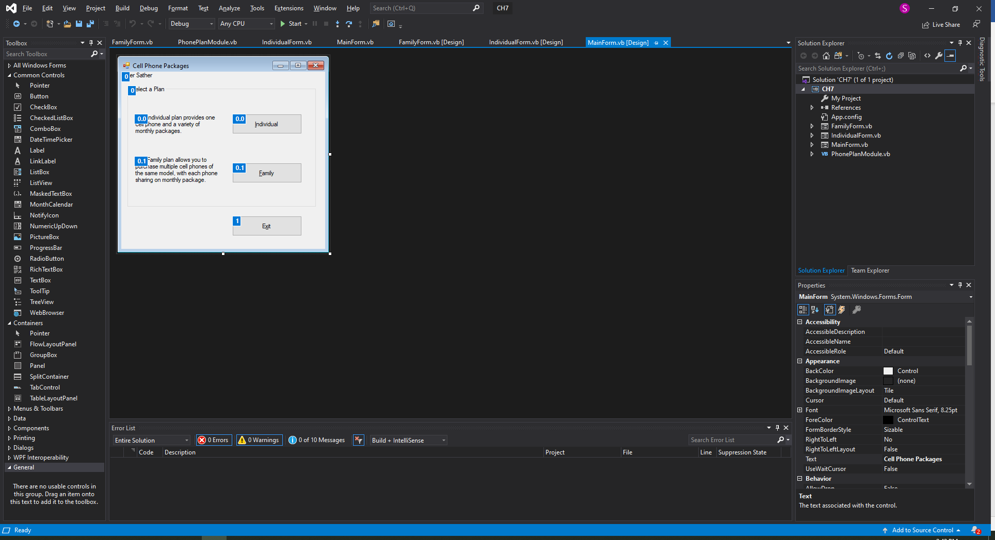

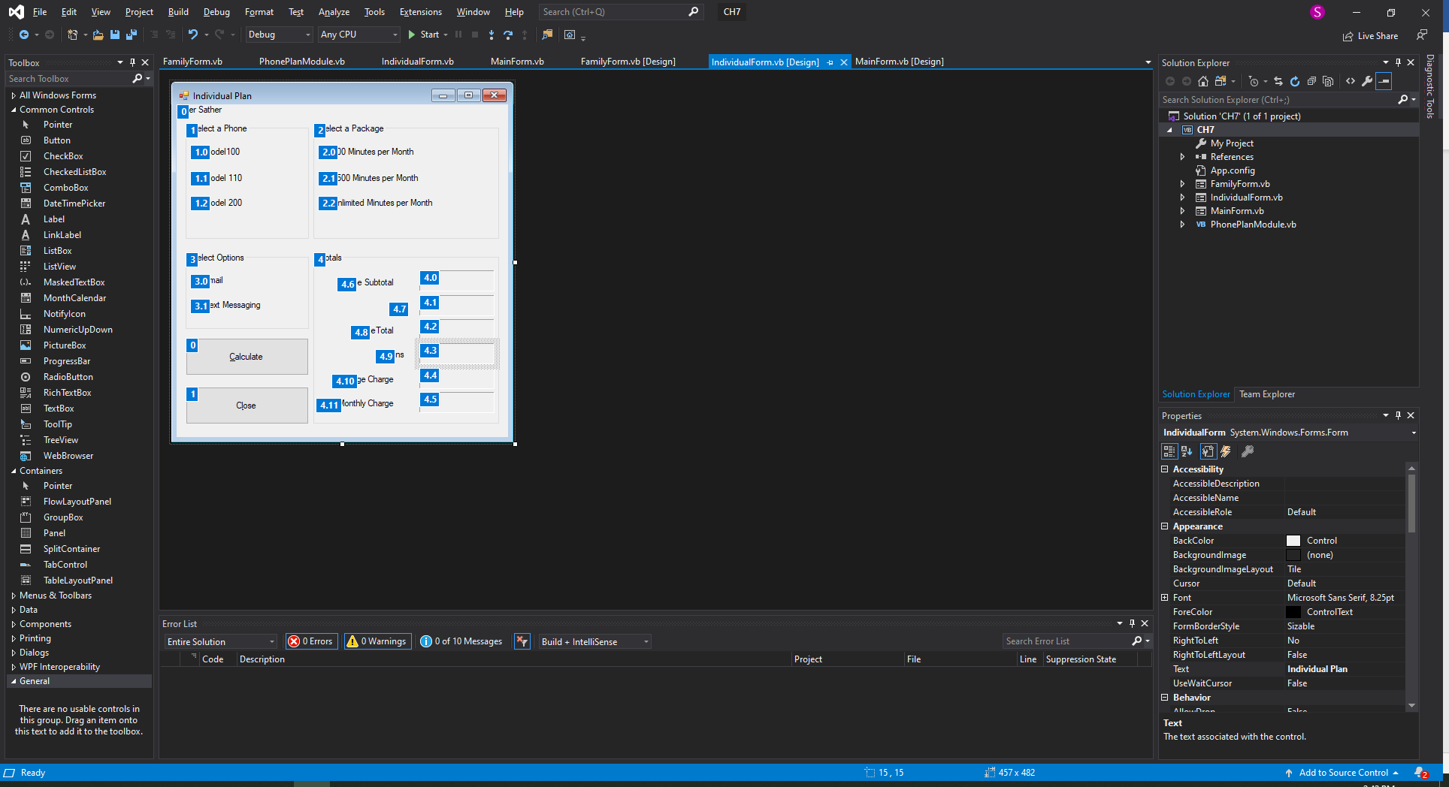

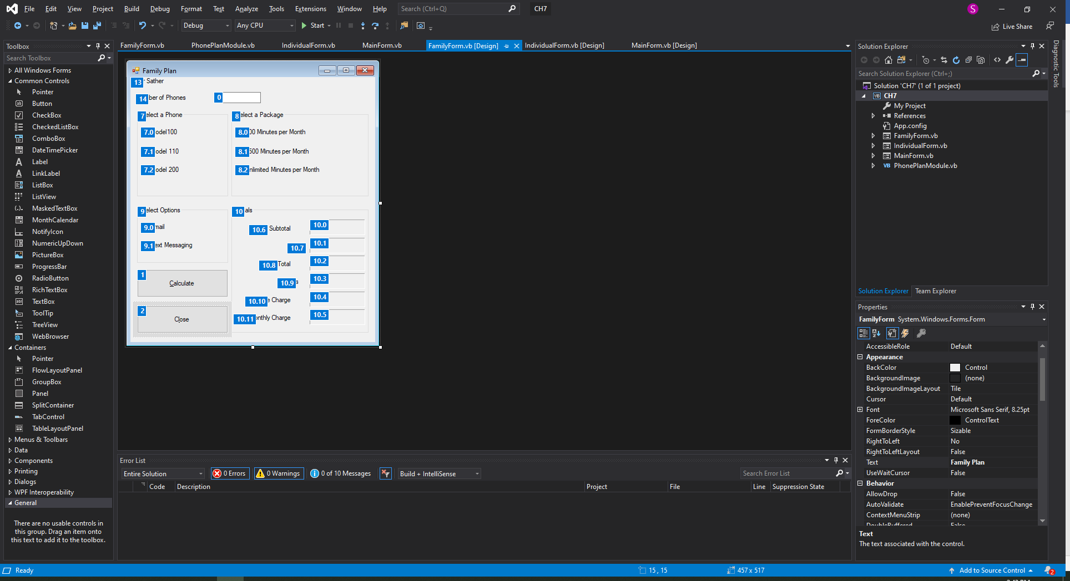

MAIN FORM ******************************************************

Public Class MainForm

Private Sub btnInd_Click(sender As Object, e As EventArgs) Handles btnInd.Click

'Creates an instance of the individual plan form

Dim frmIndividual As New IndividualForm

'Displays the form in Modal Style

frmIndividual.ShowDialog()

End Sub

Private Sub btnFam_Click(sender As Object, e As EventArgs) Handles btnFam.Click

'Creates an instance of the Family plan form

Dim frmFamily As New FamilyForm

'Displays the form in Modal Style

frmFamily.ShowDialog()

End Sub

Private Sub btnExit_Click(sender As Object, e As EventArgs) Handles btnExit.Click

'Closes the program

Me.Close()

End Sub

End Class

INDIVIDUAL FORM******************************************************

Public Class IndividualForm

'Variables set up to be used in my functions

Private decPhoneCost As Decimal

Private decTax As Decimal

Private decPhoneTotal As Decimal

Private decOptionsCost As Decimal

Private decPackage As Decimal

Private decMonthly As Decimal

Private Sub btnCalc_Click(sender As Object, e As EventArgs) Handles btnCalc.Click

'When the calculate button is pressed all functions will run

GetPhonePrice(g_decPH100, g_decPH110, g_decPH200)

GetPackagePrice(g_decPK800, g_decPK1500, g_decPKUnlimited)

GetOptionsPrice(g_decOptionEmail, g_decOptionTextM)

CalculateTax(decPhoneCost, g_decPhoneTax)

CalculateTotal(decPhoneCost, decTax)

CalculateMonthly(decPackage, decOptionsCost)

'After the functions are ran output will be passed out to the correct labels

lblSub.Text = decPhoneCost.ToString("c")

lblTax.Text = decTax.ToString("c")

lblTotal.Text = decPhoneTotal.ToString("c")

lblOptions.Text = decOptionsCost.ToString("c")

lblPackage.Text = decPackage.ToString("c")

lblMonthly.Text = decMonthly.ToString("c")

End Sub

Private Sub btnClose_Click(sender As Object, e As EventArgs) Handles btnClose.Click

'Closes the instance of this form

Me.Close()

End Sub

Function GetPhonePrice(ByVal g_decPH100 As Decimal,

ByVal g_decPH110 As Decimal,

ByVal g_decPH200 As Decimal) As Decimal

'this function will get the price of the phone

If rad100.Checked = True Then

decPhoneCost = g_decPH100

End If

If rad110.Checked = True Then

decPhoneCost = g_decPH110

End If

If rad200.Checked = True Then

decPhoneCost = g_decPH200

End If

Return decPhoneCost

End Function

Function GetPackagePrice(ByVal g_decPK800 As Decimal,

ByVal g_decPK1500 As Decimal,

ByVal g_decPKUnlimited As Decimal) As Decimal

'this function will get the price of the package

If rad800.Checked = True Then

decPackage = g_decPK800

End If

If rad1500.Checked = True Then

decPackage = g_decPK1500

End If

If radUnlimited.Checked = True Then

decPackage = g_decPKUnlimited

End If

Return decPackage

End Function

Function GetOptionsPrice(ByVal g_decOptionEmail As Decimal,

ByVal g_decOptionTextM As Decimal) As Decimal

'This function will get the price of the selected options

If chkEmail.Checked = True Then

decOptionsCost += g_decOptionEmail

End If

If chkTextMessage.Checked = True Then

decOptionsCost += g_decOptionTextM

End If

Return decOptionsCost

End Function

Function CalculateTax(ByVal decPhoneCost As Decimal,

ByVal g_decTax As Decimal) As Decimal

'this function will calculate the tax off the phone cost

decTax = decPhoneCost * g_decTax

Return decTax

End Function

Function CalculateTotal(ByVal decPhoneCost As Decimal,

ByVal decTax As Decimal) As Decimal

'This function will add the phone cost and tax together for a total cost

decPhoneTotal = decPhoneCost + decTax

Return decPhoneTotal

End Function

Function CalculateMonthly(ByVal decPackage As Decimal,

ByVal decOptionCost As Decimal) As Decimal

'This function will add the options cost and package cost to get a monthly charge

decMonthly = decPackage + decOptionCost

Return decMonthly

End Function

End Class

FAMILYFORM***************************************************************************

Public Class FamilyForm

'Set up the variables to be used in the functions

Private intNumPhones As Integer

Private decPhoneCost As Decimal

Private decTax As Decimal

Private decPhoneTotal As Decimal

Private decOptionsCost As Decimal

Private decPackage As Decimal

Private decMonthly As Decimal

Private Sub btnCalc_Click(sender As Object, e As EventArgs) Handles btnCalc.Click

'This will test the input entered to see if it is an int and above 1 phone, if true it will run all of the functions

'if false it will display an error message

Dim intNumPhones As Integer = 0

If Integer.TryParse(txtNumPhones.Text, intNumPhones) And intNumPhones > 1 Then

GetPhonePrice(g_decPH100, g_decPH110, g_decPH200)

'Phone multiplier cost of phone times the amout of phones ordered

decPhoneCost = decPhoneCost * intNumPhones

GetPackagePrice(g_decPK800, g_decPK1500, g_decPKUnlimited)

GetOptionsPrice(g_decOptionEmail, g_decOptionTextM)

'Phone multiplier cost of options time the amount of phones ordered

decOptionsCost = decOptionsCost * intNumPhones

CalculateTax(decPhoneCost, g_decPhoneTax)

CalculateTotal(decPhoneCost, decTax)

CalculateMonthly(decPackage, decOptionsCost)

lblSub.Text = decPhoneCost.ToString("c")

lblTax.Text = decTax.ToString("c")

lblTotal.Text = decPhoneTotal.ToString("c")

lblOptions.Text = decOptionsCost.ToString("c")

lblPackage.Text = decPackage.ToString("c")

lblMonthly.Text = decMonthly.ToString("c")

Else

MessageBox.Show("Please enter a valid number of phones!")

End If

End Sub

Private Sub btnClose_Click(sender As Object, e As EventArgs) Handles btnClose.Click

'This will close the form instance

Me.Close()

End Sub

Function GetPhonePrice(ByVal g_decPH100 As Decimal,

ByVal g_decPH110 As Decimal,

ByVal g_decPH200 As Decimal) As Decimal

'This functoin will get the cost of the phones

If rad100.Checked = True Then

decPhoneCost = g_decPH100

End If

If rad110.Checked = True Then

decPhoneCost = g_decPH110

End If

If rad200.Checked = True Then

decPhoneCost = g_decPH200

End If

Return decPhoneCost

End Function

Function GetPackagePrice(ByVal g_decPK800 As Decimal,

ByVal g_decPK1500 As Decimal,

ByVal g_decPKUnlimited As Decimal) As Decimal

'This function will get the cost of the packages

If rad800.Checked = True Then

decPackage = g_decPK800

End If

If rad1500.Checked = True Then

decPackage = g_decPK1500

End If

If radUnlimited.Checked = True Then

decPackage = g_decPKUnlimited

End If

Return decPackage

End Function

Function GetOptionsPrice(ByVal g_decOptionEmail As Decimal,

ByVal g_decOptionTextM As Decimal) As Decimal

'This function will get the total of the options wanted

If chkEmail.Checked = True Then

decOptionsCost += g_decOptionEmail

End If

If chkTextMessage.Checked = True Then

decOptionsCost += g_decOptionTextM

End If

Return decOptionsCost

End Function

Function CalculateTax(ByVal decPhoneCost As Decimal,

ByVal g_decTax As Decimal) As Decimal

'This function will get the cost of the taxes

decTax = decPhoneCost * g_decTax

Return decTax

End Function

Function CalculateTotal(ByVal decPhoneCost As Decimal,

ByVal decTax As Decimal) As Decimal

'This function will get the total of the phones and taxes

decPhoneTotal = decPhoneCost + decTax

Return decPhoneTotal

End Function

Function CalculateMonthly(ByVal decPackage As Decimal,

ByVal decOptionCost As Decimal) As Decimal

'This function will add the options and the package for a monthly charge

decMonthly = decPackage + decOptionCost

Return decMonthly

End Function

End Class

PHONEPLANMODULE***********************************************************

Module PhonePlanModule

'Global Constant Variables to be used in this program

Public Const g_decPK800 As Decimal = 45D

Public Const g_decPK1500 As Decimal = 65D

Public Const g_decPKUnlimited As Decimal = 99D

Public Const g_decPH100 As Decimal = 29.95D

Public Const g_decPH110 As Decimal = 49.95D

Public Const g_decPH200 As Decimal = 99.95D

Public Const g_decPhoneTax As Decimal = 0.06D

Public Const g_decOptionEmail As Decimal = 25D

Public Const g_decOptionTextM As Decimal = 10D

End Module