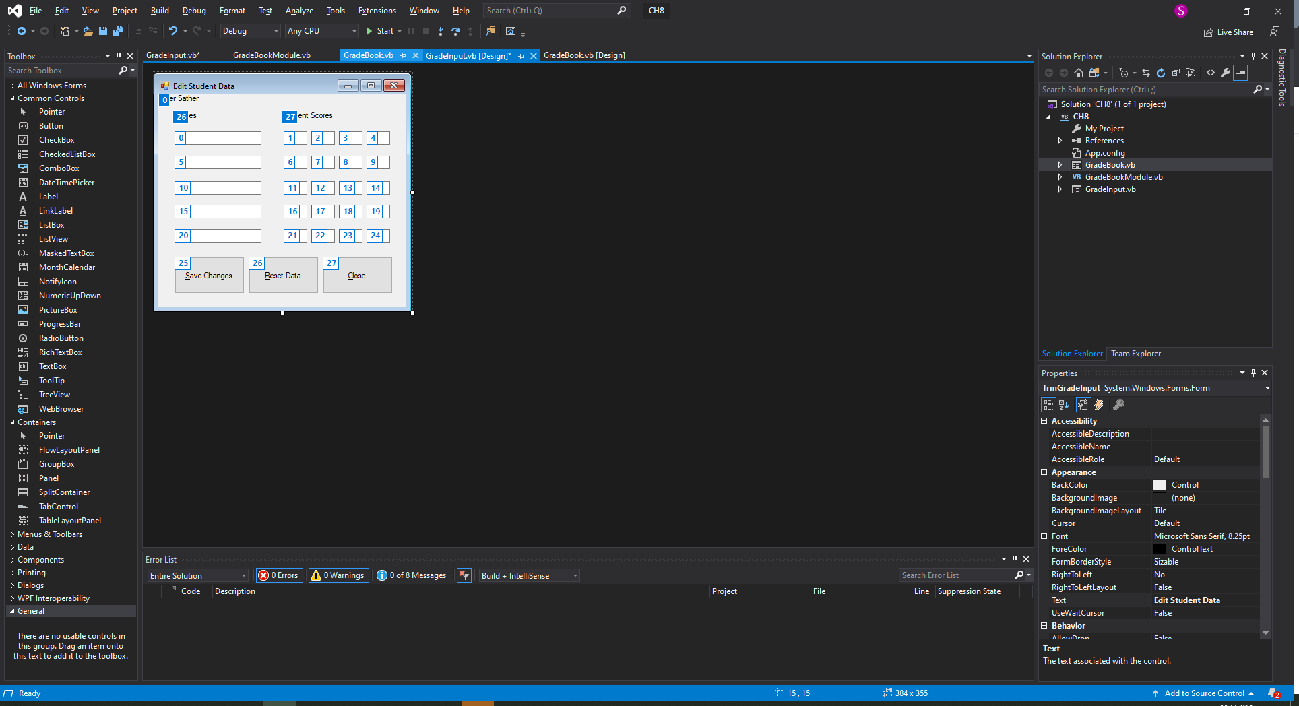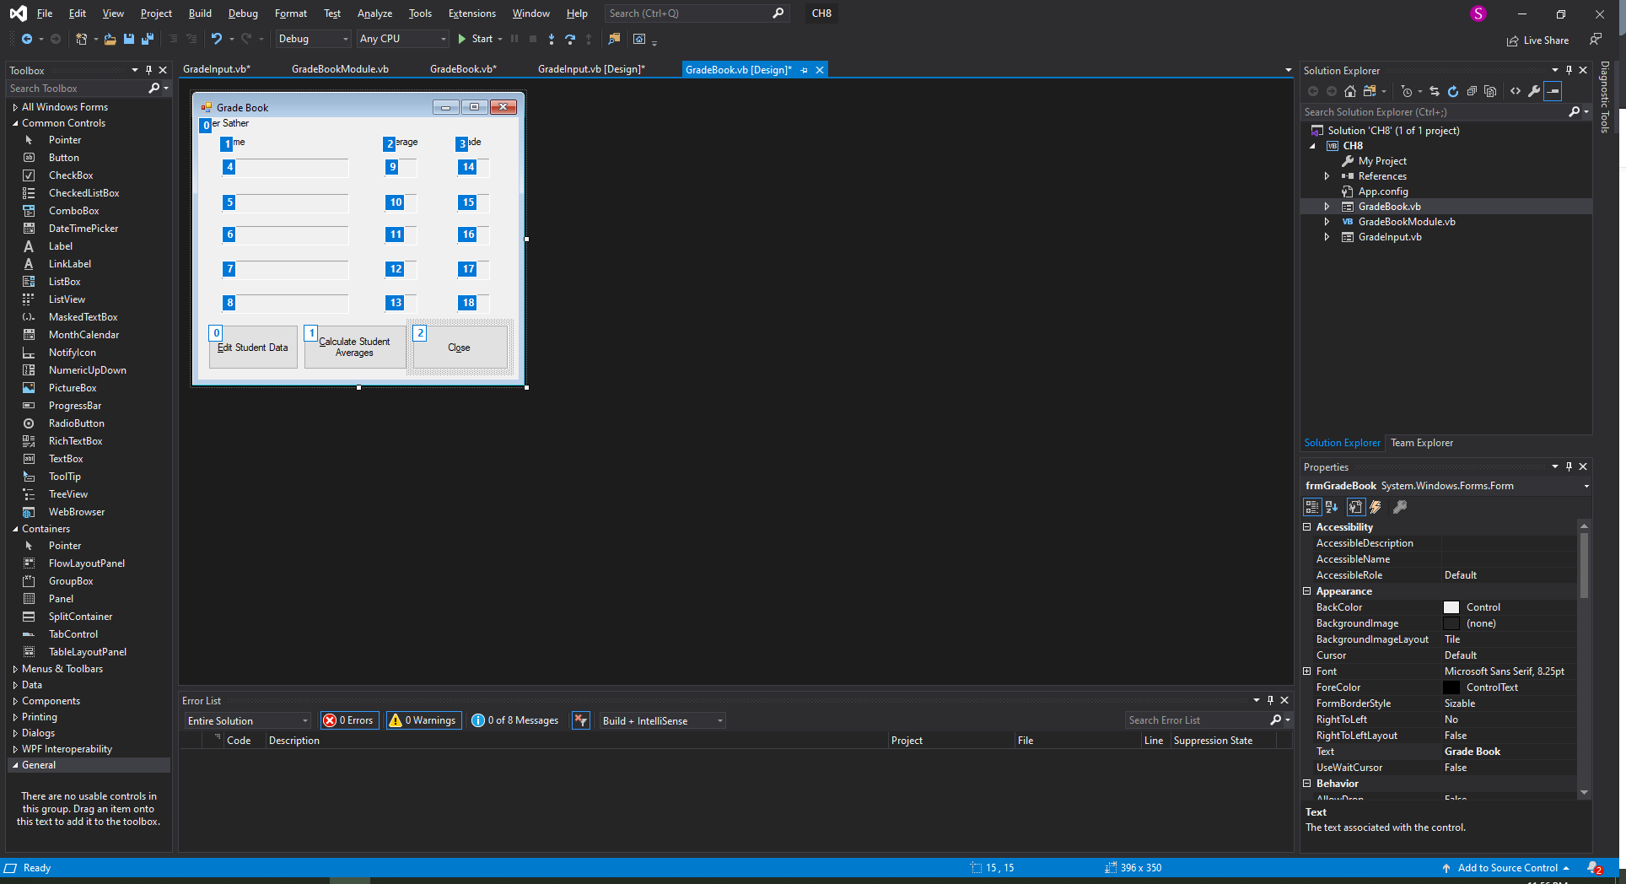

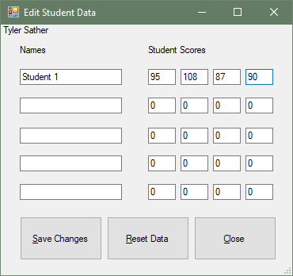

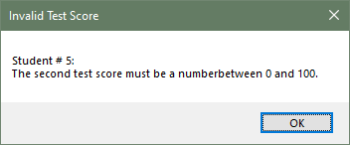

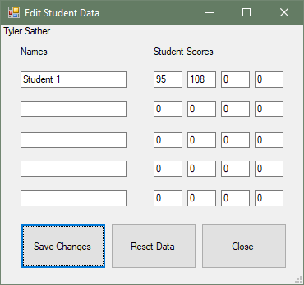

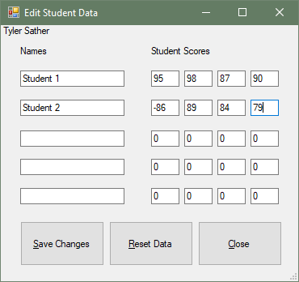

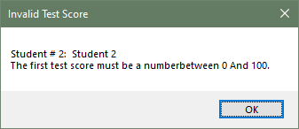

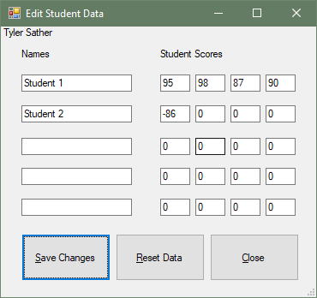

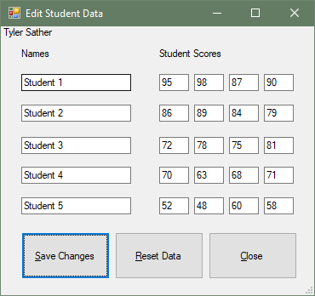

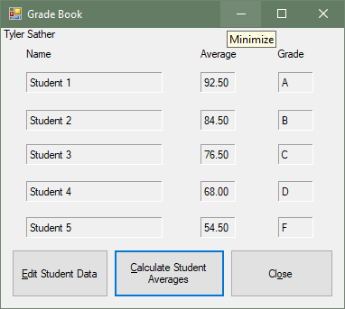

GRADEBOOk.VB**********************************

Public Class frmGradeBook

Private Sub btnEdit_Click(sender As Object, e As EventArgs) Handles btnEdit.Click

'Displays the edit grade form

DisplayInputForm()

End Sub

Sub DisplayInputForm()

'Funcion will dispay an istance of the stundent grade input form

Dim frmInput As New frmGradeInput

frmInput.ShowDialog()

End Sub

Private Sub btnClose_Click(sender As Object, e As EventArgs) Handles btnClose.Click

'Closes out the program

Me.Close()

End Sub

Private Sub btnCalc_Click(sender As Object, e As EventArgs) Handles btnCalc.Click

DisplayStudentNames()

DisplayTestAverages()

DisplayLetterGrades()

End Sub

Sub DisplayStudentNames()

lblStudent1.Text = g_strStudents(0).ToString()

lblStudent2.Text = g_strStudents(1).ToString()

lblStudent3.Text = g_strStudents(2).ToString()

lblStudent4.Text = g_strStudents(3).ToString()

lblStudent5.Text = g_strStudents(4).ToString()

End Sub

Sub DisplayTestAverages()

lblAverage1.Text = (Average(g_sngScores1)).ToString(“N2”)

lblAverage2.Text = (Average(g_sngScores2)).ToString(“N2”)

lblAverage3.Text = (Average(g_sngScores3)).ToString(“N2”)

lblAverage4.Text = (Average(g_sngScores4)).ToString(“N2”)

lblAverage5.Text = (Average(g_sngScores5)).ToString(“N2”)

End Sub

Sub DisplayLetterGrades()

Dim sngStudentAverages() As Single = {Average(g_sngScores1), Average(g_sngScores2), Average(g_sngScores3), Average(g_sngScores4), Average(g_sngScores5)}

Dim intCount As Integer = 0

For intCount = 0 To (sngStudentAverages.Length - 1)

Select Case sngStudentAverages(intCount)

Case Is >= 90

g_strGrades(intCount) = "A"

Case 80 To 89

g_strGrades(intCount) = "B"

Case 70 To 79

g_strGrades(intCount) = "C"

Case 60 To 69

g_strGrades(intCount) = "D"

Case Else

g_strGrades(intCount) = "F"

End Select

Next

lblGrade1.Text = g_strGrades(0).ToString()

lblGrade2.Text = g_strGrades(1).ToString()

lblGrade3.Text = g_strGrades(2).ToString()

lblGrade4.Text = g_strGrades(3).ToString()

lblGrade5.Text = g_strGrades(4).ToString()

End Sub

Function Total(ByVal sngValues() As Single) As Single

Dim sngTotal As Single = 0

Dim intCount As Integer

For intCount = 0 To g_intMAX_TESTSCORES

sngTotal += sngValues(intCount)

Next

Return sngTotal

End Function

Function Average(ByVal sngValues() As Single) As Single

Dim sngTotal As Single = Total(sngValues)

Dim intNumValues As Integer = sngValues.Length

Return sngTotal / intNumValues

End Function

End Class

GRADEINPUT.VB*****************************************

Public Class frmGradeInput

Private Sub GradeInput_Activated(ByVal sender As System.Object, ByVal e As System.EventArgs) Handles MyBase.Activated

'When the form is activated this will display what is current saved in the arrays

DisplayStudentNames()

DisplayTestScores()

End Sub

Private Sub btnSave_Click(sender As Object, e As EventArgs) Handles btnSave.Click

'Clicking the button will run all the functions to store what is in the text boxes

StoreStudentNames()

StoreScores1()

StoreScores2()

StoreScores3()

StoreScores4()

StoreScores5()

End Sub

Private Sub btnClose_Click(sender As Object, e As EventArgs) Handles btnClose.Click

'Closes this instance of the form

Me.Close()

End Sub

Private Sub ResetStudentData()

Dim intStudentIndex As Integer

Dim intScoreIndex As Integer

'Empties the student name array

For intStudentIndex = 0 To (g_strStudents.Length - 1)

g_strStudents(intStudentIndex) = String.Empty

Next

'Sets all of the scores to zero in the test score arrays

For intScoreIndex = 0 To g_intMAX_TESTSCORES

g_sngScores1(intScoreIndex) = 0

g_sngScores2(intScoreIndex) = 0

g_sngScores3(intScoreIndex) = 0

g_sngScores4(intScoreIndex) = 0

g_sngScores5(intScoreIndex) = 0

Next

End Sub

Sub StoreStudentNames()

'Saves the txt boxes into the the proper array index posistions

g_strStudents(0) = txtStudent1.Text

g_strStudents(1) = txtStudent2.Text

g_strStudents(2) = txtStudent3.Text

g_strStudents(3) = txtStudent4.Text

g_strStudents(4) = txtStudent5.Text

End Sub

Sub StoreScores1()

'validates all the test scores to be numeric and between 0 and 100 then enters them into the array

If Single.TryParse(txtS1S1.Text, g_sngScores1(0)) And

g_sngScores1(0) >= 0 And g_sngScores1(0) <= 100 Then

If Single.TryParse(txtS1S2.Text, g_sngScores1(1)) And

g_sngScores1(1) >= 0 And g_sngScores1(1) <= 100 Then

If Single.TryParse(txtS1S3.Text, g_sngScores1(2)) And

g_sngScores1(2) >= 0 And g_sngScores1(2) <= 100 Then

If Single.TryParse(txtS1S4.Text, g_sngScores1(3)) And

g_sngScores1(3) >= 0 And g_sngScores1(3) <= 100 Then

Else

MessageBox.Show("Student # 1: " & txtStudent1.Text & ControlChars.CrLf &

"The fourth test score must be a numberbetween 0 and 100.",

"Invalid Test Score")

End If

Else

MessageBox.Show("Student # 1: " & txtStudent1.Text & ControlChars.CrLf &

"The third test score must be a numberbetween 0 and 100.",

"Invalid Test Score")

End If

Else

MessageBox.Show("Student # 1: " & txtStudent1.Text & ControlChars.CrLf &

"The second test score must be a numberbetween 0 and 100.",

"Invalid Test Score")

End If

Else

MessageBox.Show("Student # 1: " & txtStudent1.Text & ControlChars.CrLf &

"The first test score must be a numberbetween 0 and 100.",

"Invalid Test Score")

End If

End Sub

Sub StoreScores2()

'validates all the test scores to be numeric and between 0 and 100 then enters them into the array

If Single.TryParse(txtS2S1.Text, g_sngScores2(0)) And

g_sngScores2(0) >= 0 And g_sngScores2(0) <= 100 Then

If Single.TryParse(txtS2S2.Text, g_sngScores2(1)) And

g_sngScores2(1) >= 0 And g_sngScores2(1) <= 100 Then

If Single.TryParse(txtS2S3.Text, g_sngScores2(2)) And

g_sngScores2(2) >= 0 And g_sngScores2(2) <= 100 Then

If Single.TryParse(txtS2S4.Text, g_sngScores2(3)) And

g_sngScores2(3) >= 0 And g_sngScores2(3) <= 100 Then

Else

MessageBox.Show("Student # 2: " & txtStudent2.Text & ControlChars.CrLf &

"The fourth test score must be a numberbetween 0 And 100.",

"Invalid Test Score")

End If

Else

MessageBox.Show("Student # 2: " & txtStudent2.Text & ControlChars.CrLf &

"The third test score must be a numberbetween 0 And 100.",

"Invalid Test Score")

End If

Else

MessageBox.Show("Student # 2: " & txtStudent2.Text & ControlChars.CrLf &

"The second test score must be a numberbetween 0 And 100.",

"Invalid Test Score")

End If

Else

MessageBox.Show("Student # 2: " & txtStudent2.Text & ControlChars.CrLf &

"The first test score must be a numberbetween 0 And 100.",

"Invalid Test Score")

End If

End Sub

Sub StoreScores3()

'validates all the test scores to be numeric and between 0 and 100 then enters them into the array

If Single.TryParse(txtS3S1.Text, g_sngScores3(0)) And

g_sngScores3(0) >= 0 And g_sngScores3(0) <= 100 Then

If Single.TryParse(txtS3S2.Text, g_sngScores3(1)) And

g_sngScores3(1) >= 0 And g_sngScores3(1) <= 100 Then

If Single.TryParse(txtS3S3.Text, g_sngScores3(2)) And

g_sngScores3(2) >= 0 And g_sngScores3(2) <= 100 Then

If Single.TryParse(txtS3S4.Text, g_sngScores3(3)) And

g_sngScores3(3) >= 0 And g_sngScores3(3) <= 100 Then

Else

MessageBox.Show("Student # 3: " & txtStudent3.Text & ControlChars.CrLf &

"The fourth test score must be a numberbetween 0 and 100.",

"Invalid Test Score")

End If

Else

MessageBox.Show("Student # 3: " & txtStudent3.Text & ControlChars.CrLf &

"The third test score must be a numberbetween 0 and 100.",

"Invalid Test Score")

End If

Else

MessageBox.Show("Student # 3: " & txtStudent3.Text & ControlChars.CrLf &

"The second test score must be a numberbetween 0 and 100.",

"Invalid Test Score")

End If

Else

MessageBox.Show("Student # 3: " & txtStudent3.Text & ControlChars.CrLf &

"The first test score must be a numberbetween 0 and 100.",

"Invalid Test Score")

End If

End Sub

Sub StoreScores4()

'validates all the test scores to be numeric and between 0 and 100 then enters them into the array

If Single.TryParse(txtS4S1.Text, g_sngScores4(0)) And

g_sngScores4(0) >= 0 And g_sngScores4(0) <= 100 Then

If Single.TryParse(txtS4S2.Text, g_sngScores4(1)) And

g_sngScores4(1) >= 0 And g_sngScores4(1) <= 100 Then

If Single.TryParse(txtS4S3.Text, g_sngScores4(2)) And

g_sngScores4(2) >= 0 And g_sngScores4(2) <= 100 Then

If Single.TryParse(txtS4S4.Text, g_sngScores4(3)) And

g_sngScores4(3) >= 0 And g_sngScores4(3) <= 100 Then

Else

MessageBox.Show("Student # 4: " & txtStudent4.Text & ControlChars.CrLf &

"The fourth test score must be a numberbetween 0 and 100.",

"Invalid Test Score")

End If

Else

MessageBox.Show("Student # 4: " & txtStudent4.Text & ControlChars.CrLf &

"The third test score must be a numberbetween 0 and 100.",

"Invalid Test Score")

End If

Else

MessageBox.Show("Student # 4: " & txtStudent4.Text & ControlChars.CrLf &

"The second test score must be a numberbetween 0 and 100.",

"Invalid Test Score")

End If

Else

MessageBox.Show("Student # 4: " & txtStudent4.Text & ControlChars.CrLf &

"The first test score must be a numberbetween 0 and 100.",

"Invalid Test Score")

End If

End Sub

Sub StoreScores5()

'validates all the test scores to be numeric and between 0 and 100 then enters them into the array

If Single.TryParse(txtS5S1.Text, g_sngScores5(0)) And

g_sngScores5(0) >= 0 And g_sngScores5(0) <= 100 Then

If Single.TryParse(txtS5S2.Text, g_sngScores5(1)) And

g_sngScores5(1) >= 0 And g_sngScores5(1) <= 100 Then

If Single.TryParse(txtS5S3.Text, g_sngScores5(2)) And

g_sngScores5(2) >= 0 And g_sngScores5(2) <= 100 Then

If Single.TryParse(txtS5S4.Text, g_sngScores5(3)) And

g_sngScores5(3) >= 0 And g_sngScores5(3) <= 100 Then

Else

MessageBox.Show("Student # 5: " & txtStudent5.Text & ControlChars.CrLf &

"The fourth test score must be a numberbetween 0 and 100.",

"Invalid Test Score")

End If

Else

MessageBox.Show("Student # 5: " & txtStudent5.Text & ControlChars.CrLf &

"The third test score must be a numberbetween 0 and 100.",

"Invalid Test Score")

End If

Else

MessageBox.Show("Student # 5: " & txtStudent5.Text & ControlChars.CrLf &

"The second test score must be a numberbetween 0 and 100.",

"Invalid Test Score")

End If

Else

MessageBox.Show("Student # 5: " & txtStudent5.Text & ControlChars.CrLf &

"The first test score must be a numberbetween 0 and 100.",

"Invalid Test Score")

End If

End Sub

Sub DisplayStudentNames()

'Function to display current student names in the array into the text boxes

txtStudent1.Text = g_strStudents(0).ToString()

txtStudent2.Text = g_strStudents(1).ToString()

txtStudent3.Text = g_strStudents(2).ToString()

txtStudent4.Text = g_strStudents(3).ToString()

txtStudent5.Text = g_strStudents(4).ToString()

End Sub

Sub DisplayTestScores()

'Function to display current scores in the array into the text boxes

txtS1S1.Text = g_sngScores1(0).ToString()

txtS1S2.Text = g_sngScores1(1).ToString()

txtS1S3.Text = g_sngScores1(2).ToString()

txtS1S4.Text = g_sngScores1(3).ToString()

txtS2S1.Text = g_sngScores2(0).ToString()

txtS2S2.Text = g_sngScores2(1).ToString()

txtS2S3.Text = g_sngScores2(2).ToString()

txtS2S4.Text = g_sngScores2(3).ToString()

txtS3S1.Text = g_sngScores3(0).ToString()

txtS3S2.Text = g_sngScores3(1).ToString()

txtS3S3.Text = g_sngScores3(2).ToString()

txtS3S4.Text = g_sngScores3(3).ToString()

txtS4S1.Text = g_sngScores4(0).ToString()

txtS4S2.Text = g_sngScores4(1).ToString()

txtS4S3.Text = g_sngScores4(2).ToString()

txtS4S4.Text = g_sngScores4(3).ToString()

txtS5S1.Text = g_sngScores5(0).ToString()

txtS5S2.Text = g_sngScores5(1).ToString()

txtS5S3.Text = g_sngScores5(2).ToString()

txtS5S4.Text = g_sngScores5(3).ToString()

End Sub

Private Sub btnReset_Click(sender As Object, e As EventArgs) Handles btnReset.Click

Dim intResult As Integer =

MessageBox.Show("Warning: All Previous data will be lost.", "Reset Data",

MessageBoxButtons.OKCancel, MessageBoxIcon.Warning)

'if Ok is pressed all arrays and text boxes are cleared

If intResult = DialogResult.OK Then

'Resets the Arrays

ResetStudentData()

'Clears the Text boxes

txtStudent1.Clear()

txtStudent2.Clear()

txtStudent3.Clear()

txtStudent4.Clear()

txtStudent5.Clear()

txtS1S1.Clear()

txtS1S2.Clear()

txtS1S3.Clear()

txtS1S4.Clear()

txtS2S1.Clear()

txtS2S2.Clear()

txtS2S3.Clear()

txtS2S4.Clear()

txtS3S1.Clear()

txtS3S2.Clear()

txtS3S3.Clear()

txtS3S4.Clear()

txtS4S1.Clear()

txtS4S2.Clear()

txtS4S3.Clear()

txtS4S4.Clear()

txtS5S1.Clear()

txtS5S2.Clear()

txtS5S3.Clear()

txtS5S4.Clear()

'Gives focus to the first text box

txtStudent1.Focus()

End If

End Sub

End Class

MODULE************************************

Module GradeBookModule

Public Const g_intMAX_STUDENTS As Integer = 4

Public Const g_intMAX_TESTSCORES As Integer = 3

Public g_strStudents() As String = {"", "", "", "", ""}

Public g_strGrades() As String = {"", "", "", "", ""}

Public g_sngScores1() As Single = {0, 0, 0, 0}

Public g_sngScores2() As Single = {0, 0, 0, 0}

Public g_sngScores3() As Single = {0, 0, 0, 0}

Public g_sngScores4() As Single = {0, 0, 0, 0}

Public g_sngScores5() As Single = {0, 0, 0, 0}

End Module