Tyler Sather

Chapter2 Challenge 2

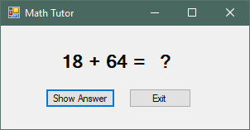

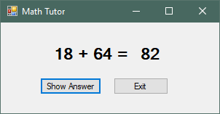

*******************************Form1.VB

Public Class Form1

'Tyler Sather

'Chapter 2 Challenge 2

'This program displays a simple equation, the buttons will show the answer and close the program.

Private Sub btnShowAnswer_Click(sender As Object, e As EventArgs) Handles btnShowAnswer.Click

lblAnswer.Text = "82" 'This changes the label to show the answer to the equation

End Sub

Private Sub btnClose_Click(sender As Object, e As EventArgs) Handles btnClose.Click

Me.Close() 'This closes the program

End Sub

End Class