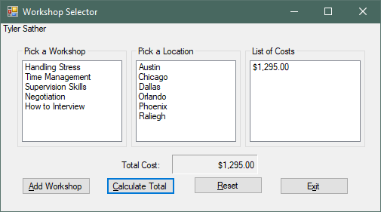

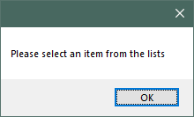

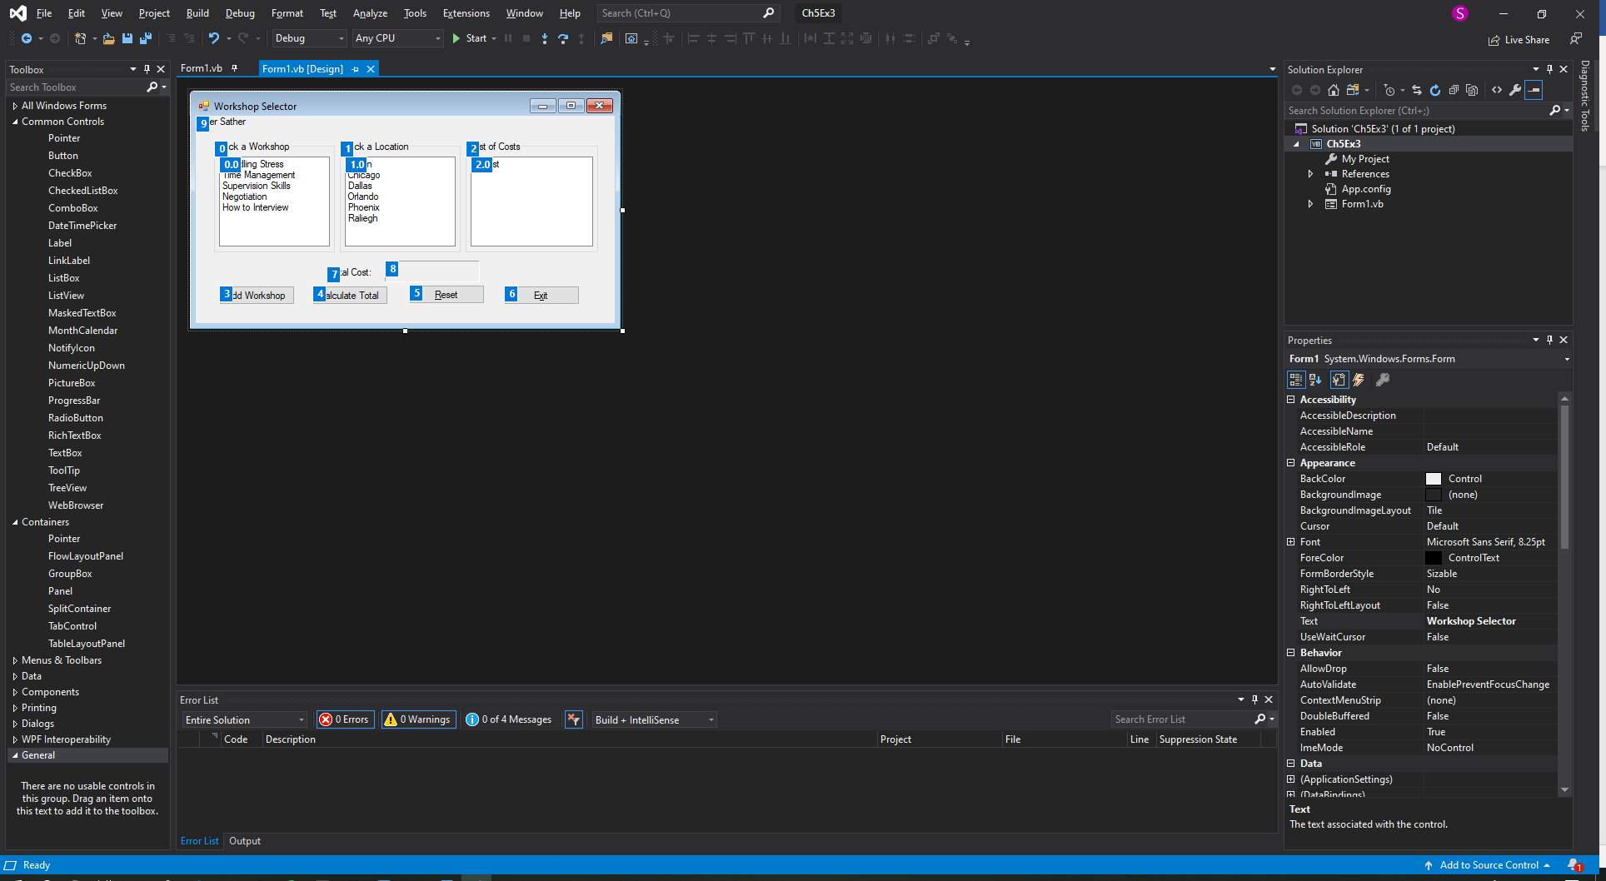

****************Main Program

Public Class Form1

Private Sub btnAdd_Click(sender As Object, e As EventArgs) Handles btnAdd.Click

'Set my variables for the add workshop button

Dim intDays As Integer

Dim intReg As Integer

Dim intLodge As Integer

Dim intWorkTotal As Integer

Dim strTemp As String

'Selecting From the Work shop list will assign values to the variables. Program will send a message if no item is chosen.

If lstWork.SelectedIndex = -1 Or lstLocation.SelectedIndex = -1 Then

MessageBox.Show("Please select an item from the lists")

ElseIf lstWork.SelectedIndex = 0 Then

intDays = 3

intReg = 595

ElseIf lstWork.SelectedIndex = 1 Then

intDays = 3

intReg = 695

ElseIf lstWork.SelectedIndex = 2 Then

intDays = 3

intReg = 995

ElseIf lstWork.SelectedIndex = 3 Then

intDays = 5

intReg = 1295

ElseIf lstWork.SelectedIndex = 4 Then

intDays = 1

intReg = 395

ElseIf lstLocation.SelectedIndex = 0 Then

intLodge = 95

ElseIf lstLocation.SelectedIndex = 1 Then

intLodge = 125

ElseIf lstLocation.SelectedIndex = 2 Then

intLodge = 110

ElseIf lstLocation.SelectedIndex = 3 Then

intLodge = 100

ElseIf lstLocation.SelectedIndex = 4 Then

intLodge = 92

ElseIf lstLocation.SelectedIndex = 5 Then

intLodge = 90

End If

'Takes the values from the above lists and calulates the total costs and display it in the 3rd list

intWorkTotal = (intDays * intLodge) + intReg

'If statement stops the program from adding S0.00 to the list.

If intWorkTotal > 0 Then

strTemp = intWorkTotal.ToString("c")

lstCost.Items.Add(strTemp)

End If

'After Calculating it will deselect the list items

lstWork.SelectedIndex = -1

lstLocation.SelectedIndex = -1

End Sub

Private Sub btnCalc_Click(sender As Object, e As EventArgs) Handles btnCalc.Click

'Setting the variables for the total cost button

Dim intCount As Integer = 0

Dim intIndex As Integer

Dim intCost As Integer

Dim intTotal As Integer = 0

Dim intIndexTrue As Integer

'gets a count of the list to be used as a stopping point for my loop

intIndex = lstCost.Items.Count

intIndexTrue = intIndex - 1

'takes a list item converts it to an integer and keeps a running sum. The accumulator will add 1 everytime it loops until the list is complete.

Do While intCount <= intIndexTrue

intCost = CInt(lstCost.Items(intCount))

intTotal += intCost

intCount += +1

Loop

'Displays the total in the label

lblTotal.Text = intTotal.ToString("c")

End Sub

Private Sub btnReset_Click(sender As Object, e As EventArgs) Handles btnReset.Click

'Resets the work and location list so nothing is selected

lstWork.SelectedIndex = -1

lstLocation.SelectedIndex = -1

'Clears out the cost list

lstCost.Items.Clear()

'Clears Total Cost label

lblTotal.Text = String.Empty

End Sub

Private Sub btnExit_Click(sender As Object, e As EventArgs) Handles btnExit.Click

'Closes the form

Me.Close()

End Sub

End Class