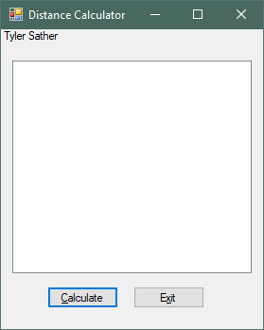

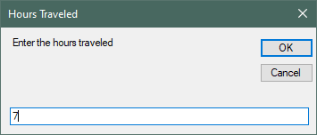

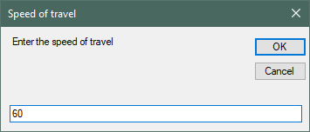

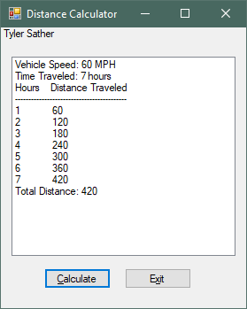

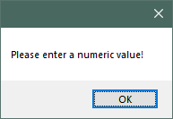

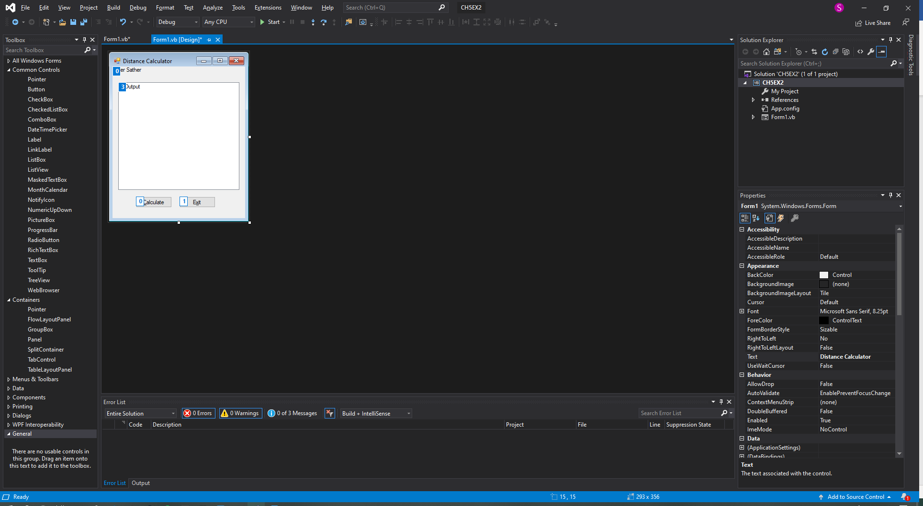

************Main Program

Public Class Form1

Private Sub btnCalc_Click(sender As Object, e As EventArgs) Handles btnCalc.Click

'Setting the variables for the program

Dim strUserSpeed As String

Dim strUserHours As String

Dim intSpeed As Integer

Dim intHours As Integer

Dim intCount As Integer = 0

Dim intDist As Integer

Dim strTemp As String

Dim blnHours As Boolean

Dim blnSpeed As Boolean

'Clears out previous output when program runs

lstOutput.Items.Clear()

'These open inputboxes to get data from the user and is tested for nueric value loops until a numeric value

Do Until blnHours = True

strUserHours = InputBox("Enter the hours traveled", "Hours Traveled")

If IsNumeric(strUserHours) Then

intHours = CInt(strUserHours)

blnHours = True

Else

MessageBox.Show("Please enter a numeric value!")

End If

Loop

Do Until blnSpeed = True

strUserSpeed = InputBox("Enter the speed of travel", "Speed of travel")

If IsNumeric(strUserSpeed) Then

intSpeed = CInt(strUserSpeed)

blnSpeed = True

Else

MessageBox.Show("Please enter a numeric value!")

End If

Loop

'enters the first few lines onto the list using input entered from the user

strTemp = "Vehicle Speed: " & intSpeed.ToString() & " MPH"

lstOutput.Items.Add(strTemp)

strTemp = "Time Traveled: " & intHours.ToString() & " hours"

lstOutput.Items.Add(strTemp)

lstOutput.Items.Add("Hours Distance Traveled")

lstOutput.Items.Add("------------------------------------------")

'The loop that will calulate distance traveled at every hour.

For intCount = 1 To intHours

intDist = intCount * intSpeed

strTemp = intCount & " " & intDist

lstOutput.Items.Add(strTemp)

Next

'Final item added to the list with the calculated total distance traveled

intDist = intSpeed * intHours

strTemp = "Total Distance: " & intDist

lstOutput.Items.Add(strTemp)

End Sub

Private Sub btnExit_Click(sender As Object, e As EventArgs) Handles btnExit.Click

'closes the form

Me.Close()

End Sub

End Class