St10084621

POE PART 2 – Changelog (OPSC7311)

Course: BCAD year 3 (group 1)

Due date: 7 June 2023

**Table of Contents**

POE Part 2 – Changelog (User interface design) 2

# POE Part 2 – Changelog (User interface design)

Main screen:

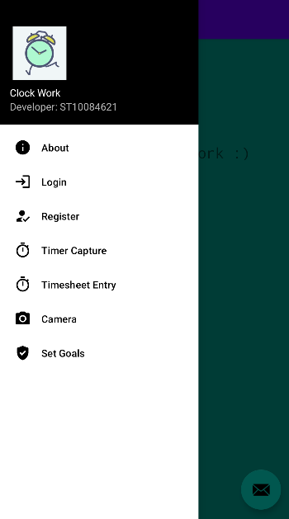

Description:

When the app launches, this is the first page that appears, it is a navigation drawer that contains the details of the app at the top left and the functions of the app below it.

About screen:

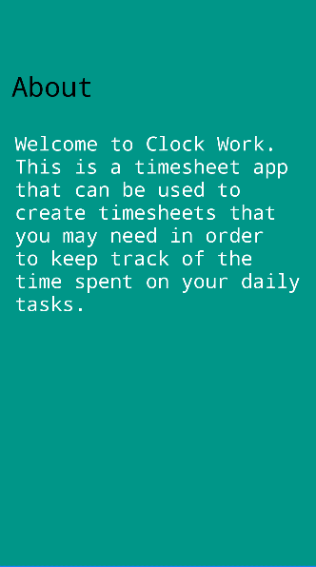

Description:

This page contains information of what the application consists of.

Login screen:

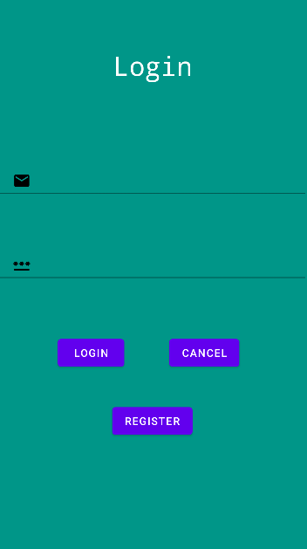

Description:

A user can enter their email address and password, and click on the Login button, to log into the app. A user can click on the Register button to navigate to the Register screen or click the Cancel button to reset their login process.

Register screen:

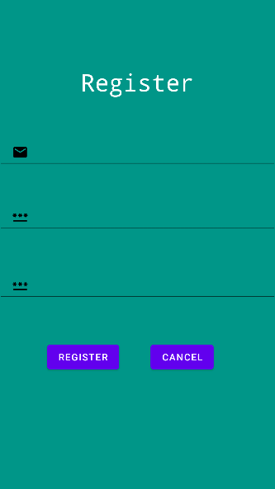

Description:

A user can enter their email address, password, password again (confirm password) and click on the Register button to register an account. A user can click the Reset button to reset their registration process.

Timer Capture screen:

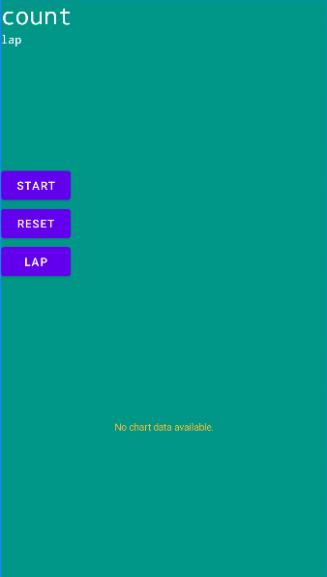

Description:

A user can click the Start button to start the timer, Reset button to reset the timer or Lap button to depict their progress on a chart.

Timesheet Entry screen:

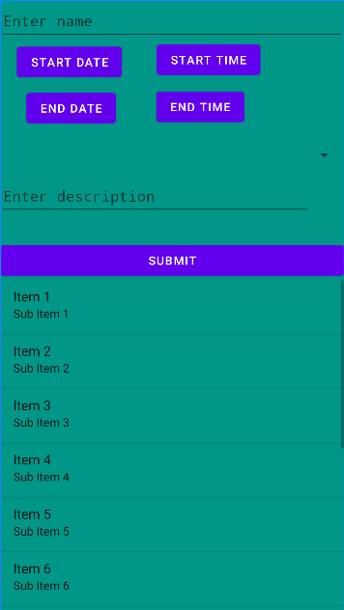

Description:

A user can enter the name of their Timesheet entry, a start/finish date, start/end time, select a category from the drop down, enter a description and click the Submit button to store their Timesheet entry and view it at the bottom of the screen.

Camera screen:  
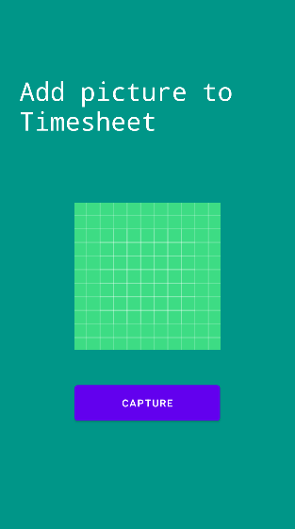

Description:

A user can click the Capture button, their device’s camera will open and they may take a picture to add it to their timesheet.

Set Goals page:  
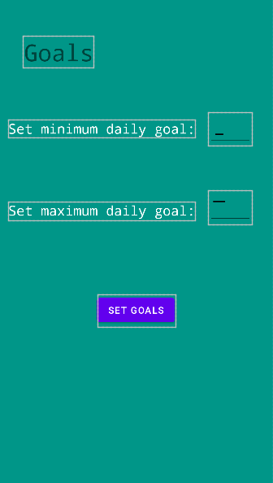

Description:

A user can enter a minimum and maximum daily goal for hours worked and click the Set goals button to set their goals.