**1)What kind of macroeconomic factors could influence the international business (based on the case materials)? Which of them are the most influential?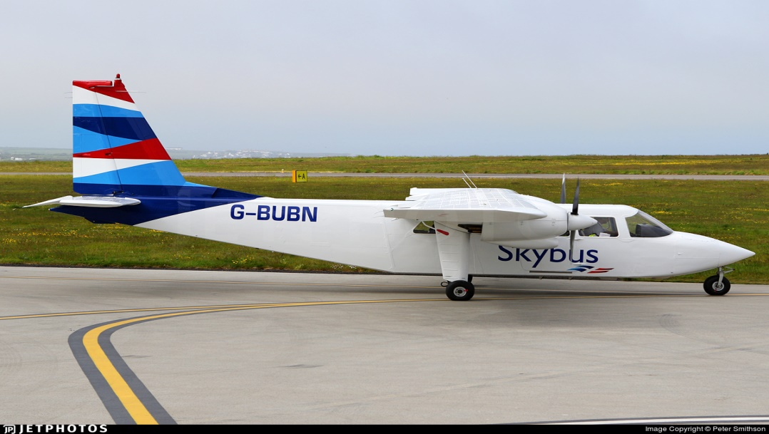 Macroeconomic factors:**

• level of competition;

• price of oil;

• high fixed costs;

• low profit margins;

• high level of capital concentration and centralization of market participants;

• high level demands for personnel training and retraining process;

• high level demands for securing safety in activity;

• uninterrupted implementation of capital investments;

• great influence of SRW and their implementation in market functioning.

Macroeconomic regulators can't avoid vivid tendency in world aviation. It is as follows:

**1.** Active appearance of low budget carriers carrying on aggressive commercial policy and forcing out network airlines from intra-regional and inter-regional lines

**2.** Number of big companies decreased because of merger of some companies or bankruptcy.

One of the most influential factor is high level of competition. New companies exist in many countries today and they create different bonuses and they in many cases more interesting for customers so others(old) companies have to pay attention on it and every month develop their company to attract people for example to change their price because the oil’s price is changing now as the situation in economy not stable. To create new comfortable opportunities for people and give people chance to choose what they really want.  
**2. Which risk-factors should be taken in account by the companies starting international business?**

1）**Market Fluctuations** Semiconductor market fluctuations, which are caused by factors such as economic cycles in each region and shifts in demand of end customers, affect the Company. Although the Group carefully monitors changes in market conditions, it is difficult to completely avoid the impact of market fluctuations due to economic cycles in countries around the world and changes in the demand for end products. Market downturns, therefore, could lead to decline in product demand and increase in production and inventory amounts, as well as lower sales prices. Consequently, market downturns could reduce the Company’s sales, as well as lower fab utilization rates, which may in turn result in worsened gross margins, ultimately leading to deterioration in profits.

2）**Natural Disasters** Natural disasters such as earthquakes, typhoons, and floods, as well as accidents, acts of terror, infection and other factors beyond the control of the Company could adversely affect the Company’s business operation.

3）**Financing**While the Company has been procuring business funds by methods such as borrowing from financial institutions and other sources, in the future it may become necessary to procure additional financing to implement business and investment plans, expand manufacturing capabilities, acquire technologies and services, and repay debts.

4）**Competition** The semiconductor industry is extremely competitive, and the Company is exposed to fierce competition from competitors around the world in areas such as product performance, structure, pricing and quality.

5）**Business Activities Worldwide** The Company conducts business worldwide, which can be adversely affected by factors such as barriers to long-term relationships with potential customers and local enterprises; restrictions on investment and imports/exports; tariffs; fair trade regulations; political, social, and economic risks; outbreaks of illness or disease; exchange rate fluctuations; rising wage levels; and transportation delays.

6）**Implementation of Management Strategies** The Company is implementing a variety of business strategies and structural measures, including the development of “The Mid- Term Growth Strategy” and reforming the organizational structure of the Group, to strengthen the foundations of its profitability.

7）**Fast Technological Evolutions and Other Issues** The semiconductor market in which the Company does business is characterized by rapid technological changes and rapid evolution of technological standards.

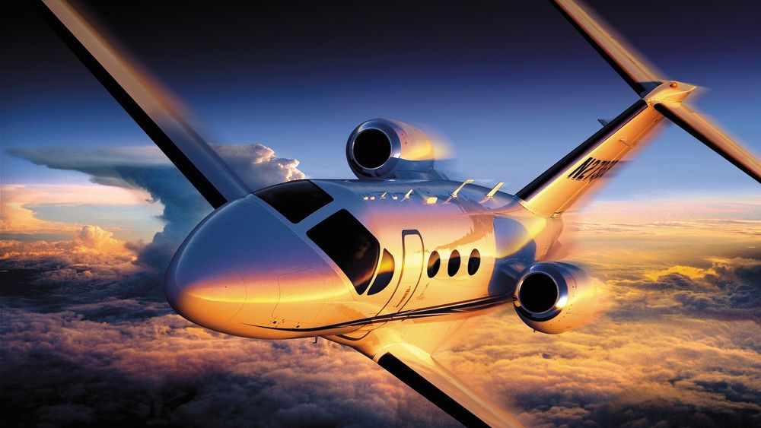

*As for the risks for airlines:*  
1) **Volatility in the geopolitical and economic environment** Most airlines have a global footprint and are, thus, vulnerable to external factors, such as political tension and economic conjunctures.

2**) Managing the supply chain** Aviation companies around the world are pointing to managing the supply chain as the second biggest threat in the aviation industry in 2019 and the years to come – and for good reason. A record number of new aircraft deliveries are set to keep the supply chain extremely busy during the next 8-10 years.

3) **Competition in domestic and international markets** Airbus and Boeing are the only players in the wide-body market, and they dominate the narrow-body-segment as well.

4) **Managing and retaining talent in the aviation industry** Due to the influx of new technologies and processes and the relentless focus on cost reduction, companies in the aviation industry will require, perhaps more than any other industries, a talented, engaged and increasingly specialized workforce in the future.

5) **Ability to perform in key contracts** The major OEMs in the industry are typically involved in multimillion-dollar contracts and have huge backlogs with tight deadlines. Failure to deliver on major programs can lead to significant negative implications affecting the financial performance as well as brand value.

6**) Compliance with a wide range of regulations and restrictions** The commercial aerospace industry has to comply with a long list of requirements for aircraft design, maintenance, pilot training activities and safety regulations.

7) **Incapacity to innovate** The demand from passengers is evolving constantly, pushing the aviation industry to adopt new work processes and technologies. Due to the conservative nature of the industry, it’s proving to be a hard race to win. The aviation companies that fall too far behind in great run of innovation will likely face a series of challenges in 2019 and beyond.

8**) Failure to realize the benefits of M&As and partnerships** Collaboration and partnerships in the supply chain is a [hot topic in the aviation industry these days.](https://blog.satair.com/mro-europe-2018) According to the study from Ernst & Young, M&As (mergers and acquisitions) and partnerships can complement a company’s existing products, technologies, services and customer base. At the same time, failing to collaborate with other businesses could pose a real threat to some companies in the aviation industry.

9**) Exposure to cybersecurity events** The ninth biggest challenge in the aviation industry in 2019 is failure to have appropriate cybersecurity measures in place. As more airlines, OEMs and MROs pursue big data analytics and predictive maintenance, the risk of cyber breaches increases. And the problem with inappropriate cybersecurity can be very costly for the aviation industry.

10) **Foreign currency and commodity price fluctuations** Fluctuations in currency exchange rates is the tenth and final types of risks that in the aviation industry in 2019. Given that a large amount of aviation companies operate globally, a large portion of their revenue streams are earned in a variety of currencies, making them vulnerable to fluctuations in currency exchange rates.

**3. Provide an example of macroeconomic factors' influence the international business based on your broad background knowledge or using the Internet**

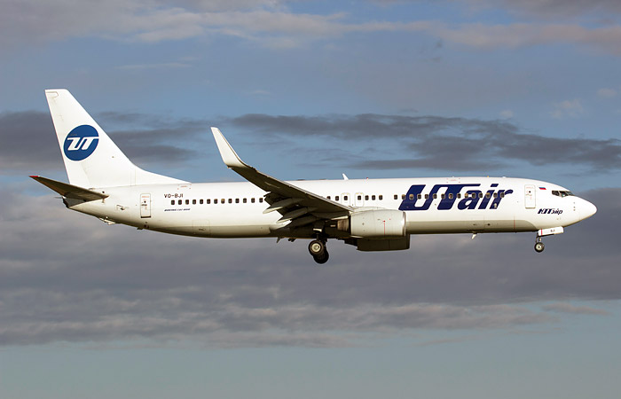To finish the topic of macroeconomic factors that are associated with airlines around the world, let’s take as an example the third airline in terms of traffic in Russia - the UTair group, which was in critical condition in 2014.

Reasons: ruble devaluation, falling purchasing power, financial losses due to the need to fly around Ukraine on popular tourist routes. The government is discussing two “plans” for rescuing the company: providing the Ugra carrier with state guarantees and transferring UTair to Aeroflot, which is fraught with a reduction in the number of regional routes.

So, the presidential aide, Andrei Belousov, told reporters that “UTair has a rather difficult situation, and the government is now working on how to resolve this situation.” At the same time, Sberbank announced that it is raising interest rates on UTair credit lines, which also indicates problems with debt repayment.

According to RAS, UTair's net profit for the 1st quarter of 2014 decreased by more than 50 times - to almost 5.47 million rubles. The degree of debt coverage by current income / profit / went into negative values, amounting to minus 78.24 versus 15.99 in the second quarter of 2013. According to the quarterly report, by June 30, 2014, UTair almost completely chose the credit lines opened for it by Sberbank in 2013 and this spring for a total of 22 billion rubles. In addition, a $ 130 million credit line with a repayment term in the summer of 2016 was selected.

At the end of July, the company announced the launch of the Impulse cost optimization program, which should save the carrier 5 billion rubles by the end of the year. As part of the savings, the route network, company employees and the air fleet are subject to reduction. The main airports based in the company are Tyumen (Roshchino), Surgut, Moscow (Vnukovo) and Ufa. The controlling shareholder of UTair is NPF Surgutneftegas, which owns more than 70% of the company. The passenger flow of 9.6 million people is formed due to an extensive network of transportation within the country and even within individual regions.

“The market situation is certainly not simple,” admits UTair CEO Andrei Martirosov. “We all, airlines operating in Russia, are naturally fighting, no one is going to stop anything, we are in interaction with each other and with banks and the authorities to continue to work. We hope that the market will survive these difficult times. " While flights take place normally, tickets are sold, food has been canceled on medium-range routes, the company employee said.

Experts suggest not thinking about supporting one company, but about how to raise the industry as a whole: to create conditions so that airlines do not depend on payments on loans for foreign aircraft, and regions do not suffer from a monopoly on domestic flights of one carrier.