Planning of Service Level Milestone 1
Launch Date: 3 May 2026, 12 AM PT.
Vehicle/Site: SpaceX Falcon 9 | Vandenberg Space Force Base, California
Mission: CAS500-2
Mission Objective
The primary goal of this campaign is to demonstrate KSAT SSA capabilities by achieving three core technical milestones as outlined in ESA contract 4000151130.
- Frequency Identification: Detect center frequency for at least 1 payload (S-band or X-band).
- Rapid Orbit Determination (OD): Perform 1-way Doppler OD offline with first 3 hours of collected data.
- Precision Accuracy: Achieve a position error of < 1 km (verified via ESA or on-board GPS).

Work Package Summary
WP2000: Orbit Determination
Success Metrics: Latency: Solution available within 3 hours of pass.
Accuracy: Position error < 1 km.
Deliverables: Orbit ephemeris (TLE), covariance, residuals, and processing logs.

WP3000: Center Frequency Identification
Process: Utilize fixed pointing and Digital IF bandwidth monitoring (narrowband and wideband).
Success Metrics: Positive identification of at least one payload downlink.
Deliverables: Frequency estimate and IQ spectral plots.

Operational Timeline
Pre-Launch: Finalize payload authorizations, expected frequency ranges, and station readiness.
LEOP Day (Priority Window): 3-hour data window for IF/IQ and Doppler data capture.
Refinement (T+1 week): Delivery of refined OD and comprehensive final report.

WP2000 - Results
An experiment was conducted to verify the performance of the DART passive-RF based OD program for four Ororatech satellites released during the CAS500-2 mission on may 3rd 2026. Initial analysis proved difficult due to the presence of high non-gaussian noise in the doppler readings, later identified as being caused by Burst-Radios on the four spacecraft.

This reports outlines how the noise was characterised and corrected for in the software, showing that single-pass accuracies of <1 km relative to GPS can be achieved and identified with post-pass gating.

Noise Characterisation for Burst-Radio Passive RF

Previous DART implementations assumed that the residual distribution followed a white-noise sequence- essentially a Gaussian distribution. As such, with an assumed sensor noise of around 10 Hz, this can be used to gate the RMSE values for the residuals. A fit is deemed correct if the RMSE is below 10 Hz. Burst radio configurations do not allow for such simple gating.

Typical noise for burst radios may look like this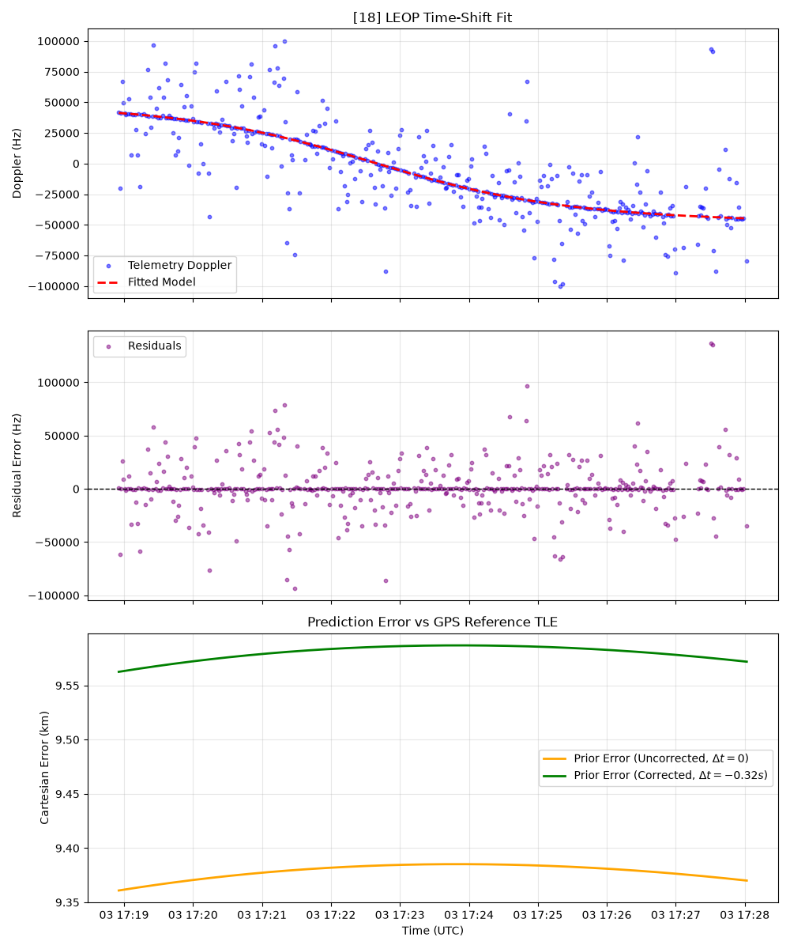
Initial experiments assumed the noise distribution was explained by a Gaussian and overlapping Laplacian, as this is how previous outliers were handled. With this assumption a Huber-based loss function is mathematically sufficient to perform optimal LS regression. This did not achieve expected results, and was the primary reason as to why analysis was infeasible during the first day. By using a Huber-based loss function to fit each pass, and storing the residuals. Then gaussian-mixture-models (GMM) can be used to fit a dual set of overlapping gaussians to the data. For this purpose a dataset of hundreds of later passes from the four satellites were utilized. The result being a 2 dimensional distribution of fits, as can be seen in the figure below.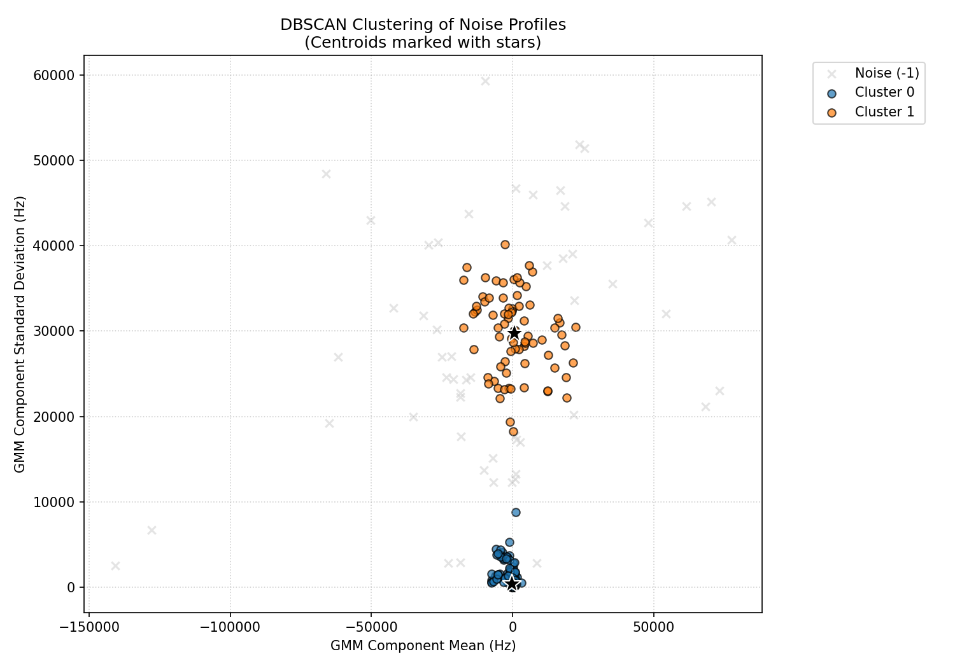
The DBSCAN clustering algorithm was then employed to estimate the underlying distribution. It can be seen that two clear clusters emerge from this dataset, showing that burst-radio doppler does not follow the Gaussian+Laplacian distribution, but rather a GMM distribution:

The larger residual archive contained 817 retained components from 527 contacts. DBSCAN put 685 components in a narrow group. This group had an average offset of -180.55 Hz and an average standard deviation of 351.24 Hz. This corresponds to expected performance on normal passes
DBSCAN put 78 components in a broad group. This group had an average offset of +654.08 Hz and an average standard deviation of 29,770.65 Hz, corresponding to the “outlier distribution” caused by short contacts with KSAT Lite backend hardware. DBSCAN left 54 components ungrouped.

To handle such distributions, a loss function which allows for heavy tails in the dataset is necessary. By using GPS-referenced TLEs which were later provided by Ororatech, a rough performance metric could be established for meta-parameter tuning.

Meta-optimizing was done as such:
Objective: find optimizer parameters such that the produced TLE best matches the GPS-referenced TLE.
Using this approach, we could iteratively tune the optimizer parameters to correct for the specific GMM noise distribution. The specific tuning was performed using the optuna python module, and the optimizer was chosen as Scipy’s LeastSquare.

The results can be found as:

Reproducibility settings:
• Fitted variables and Doppler filters: time offset and frequency bias; accepted, valid one-way Doppler samples only (invalid samples and samples without Doppler are excluded).
• Robust objective: soft-L1 loss; Doppler residual scale 500 Hz; robust scale 700 Hz.
• Bounds and starts: time offset ±120 s; frequency bias ±100 kHz; seven offset starting points at −90, −60, −30, 0, +30, +60, and +90 s.
• Numerical settings: parameter scales 30 s and 5,000 Hz; central-difference Jacobian steps 1e-3 s and 1 Hz; ftol, xtol, and gtol each 1e-10.
• Fit health checks: successful solve, full Jacobian rank (2/2), finite scaled-Jacobian condition number ≤1e12, and no parameter at a bound.
• Final gates (inclusive): ≥250 accepted Doppler measurements, offset variance ≤15 s², and healthy fit.

A pass is valid only when it has at least 250 accepted Doppler measurements, offset variance no greater than 15 s², and a healthy fit (measurements ≥250 and variance ≤15 s², inclusively).

Results

Forest-16
Prior TLE:
1 90916U 00000AAA 26123.38989170 .00000000 00000-0 15851-2 0 9996
2 90916 97.7445 21.6711 0001088 184.3194 124.1089 14.91831094 03
Time | Station | Duration | Samples | Variance | Prior (km) | Posterior (km)
2026-05-03 10:20:36 UTC | AWARUA | 29:20 | 297 | 2.098 | 4.923‡ | 0.541‡
2026-05-03 15:31:25 UTC | PUNTA_ARENAS | 29:26 | 340 | 2.540 | 9.310 | 19.154
2026-05-04 00:23:14 UTC | SVALSAT | 17:43 | 475 | 0.556 | 18.412 | 1.232
2026-05-04 02:35:53 UTC | PUNTA_ARENAS | 17:50 | 401 | 0.882 | 21.147 | 3.008
‡ FOREST-16 AWARUA accuracy uses the median 3-D position error from the first five GPS fixes after the recorded contact; all other rows use GPS fixes within the recorded contact.

Forest-17
Prior TLE:
1 90917U 00000AAA 26123.38823777 .00000000 00000-0 15851-2 0 9997
2 90917 97.7396 21.6764 0005261 314.5846 344.9937 14.90540572 06
Time | Station | Duration | Samples | Variance | Prior (km) | Posterior (km)
2026-05-03 20:03:32 UTC | HARTEBEESTHOEK | 17:24 | 349 | 4.453 | 6.384 | 24.862
2026-05-03 21:51:59 UTC | TROLL | 17:45 | 370 | 1.246 | 7.167 | 3.838
2026-05-04 01:02:54 UTC | PUNTA_ARENAS | 15:47 | 344 | 11.569 | 8.305 | 4.468

Forest-18
Prior TLE:
1 90918U 00000AAA 26123.38910698 .00000000 00000-0 15851-2 0 9997
2 90918 97.7376 21.6797 0001897 93.2348 211.0047 14.92051430 08
Time | Station | Duration | Samples | Variance | Prior (km) | Posterior (km)
2026-05-03 17:07:14 UTC | PUNTA_ARENAS | 28:08 | 471 | 8.299 | 9.917 | 10.767
2026-05-03 20:15:20 UTC | TROLL | 17:49 | 341 | 0.517 | 15.370 | 1.351
2026-05-03 21:12:35 UTC | SVALSAT | 12:03 | 336 | 5.297 | 14.452 | 4.779
2026-05-03 22:47:18 UTC | SVALSAT | 17:40 | 339 | 1.240 | 16.722 | 0.288
2026-05-03 23:28:25 UTC | TROLL | 16:21 | 322 | 14.807 | 19.570 | 1.372

Forest-19
Prior TLE:
1 90919U 00000AAA 26123.38960698 .00000000 00000-0 15851-2 0 9993
2 90919 97.7424 21.6734 0001942 141.5194 165.3859 14.92112300 07
Time | Station | Duration | Samples | Variance | Prior (km) | Posterior (km)
2026-05-03 18:40:28 UTC | TROLL | 17:14 | 358 | 2.354 | 2.382 | 5.196
2026-05-03 23:44:06 UTC | AWARUA | 17:49 | 521 | 0.769 | 2.746 | 0.494
2026-05-04 05:09:13 UTC | SVALSAT | 17:37 | 357 | 0.823 | 3.097 | 1.841

Conclusion

As can be achieved, using the tuned optimizer and heuristic gating mechanisms, accuracies of ~3 km median error and <1 km can be achieved reliably for Burst Radio configurations. This technique should be extendable to other burst radio satellites, and should not affect previous results.
All of these results were performed using single-pass performance, the main difficulty of combining passes is knowing how to gate data reliably, as such this was not performed here but can potentially be used to increase performance and reliability further.
however it should be noted that even with these filters some results show that DART can estimate a result “worse” than the prior, however the worst-case performance is still within about 25 km, which during a closest approach assuming a 600 km orbit, and using a small-angle approximation would be an offset of around 2.5 degrees, meaning it is still well within detectability.
In essence, this shows that DART can now handle Burst-Radio configurations and improve tracking performance using heuristic checks.

