FOREST-16/17/18/19 May 2026 Passive RF Orbit Evaluation
Performance, method, and limitations
May 2026
Table of Contents

1 Executive result
This report evaluates passive radio-frequency orbit determination during May 2026 launch operations. It covers 61 contacts from 2026-05-03 09:40:38.191475 UTC to 2026-05-04 05:26:49.694147 UTC.
Fifteen contacts had at least 301 accepted Doppler measurements. The estimator fitted these contacts. Eleven fitted contacts had at least five GPS position records during the same contact. These 11 contacts form the primary result set.
This is a retrospective full-contact evaluation. The estimator used all accepted measurements after each contact ended. The results do not show real-time performance. This evaluation does not qualify the system for flight.
For the primary contacts, the initial median errors were 2.437 km best, 9.310 km middle, and 21.391 km worst. The robust fit gave 0.494 km best, 3.857 km middle, and 24.856 km worst. It improved 7 of 11 primary contacts.
All 15 fits passed the acceptance checks. Fourteen fitted contacts had GPS data. The fit improved 10 of these contacts and made 4 worse.
The best observed contact had a median error of 0.494 km. This is a best-case result from the recorded data. It is not a guaranteed accuracy.
The results show the potential performance for future launch operations. This potential depends on sufficient Doppler coverage, enough Doppler change, and stable receiver data.

2 Terms and definitions
- Launch and early orbit operations (LEOP): The work done immediately after launch to find and control a spacecraft.
- Passive radio-frequency orbit determination (passive RF OD): An orbit estimate that uses received radio frequency changes. It does not transmit a ranging signal.
- Contact: A recorded period when one ground station observed one spacecraft.
- Accepted Doppler measurement: A valid frequency-offset value that passed the data-quality filters.
- Global Positioning System (GPS) reference: A GPS position record used to measure error after the Doppler fit. The estimator does not use it during the fit.
- Residual: The measured Doppler value minus the Doppler value predicted by the model.
- Initial orbit estimate: The spacecraft orbit information available before the Doppler fit.
- Primary contact: A fitted contact with at least five GPS records during that contact.
- Limited-GPS contact: A fitted contact with one to four GPS records. It is not part of the primary result set.
- GPS-free contact: A fitted contact with no GPS record during that contact. It has no same-contact position-error result.
- Median error: The middle position-error value after the values are put in order.
- Standard deviation: A value that shows how widely a set of values spreads around its average.
- Hertz (Hz): The unit of frequency. One hertz is one cycle each second.
- Coordinated Universal Time (UTC): The common time standard used for all contact times in this report.
- Gauss-Newton method: An iterative fit method that reduces the sum of squared residuals.
- Gaussian mixture model (GMM): A statistical method that represents residuals as one or more bell-shaped groups. Each group is a component.
- Density-based spatial clustering of applications with noise (DBSCAN): A method that groups nearby items and leaves isolated items ungrouped.
- Robust loss: A fit rule that gives less influence to very large residuals.
- Soft-L1 loss: The robust loss used for the final fit. It limits the influence of large residuals without deleting them.
- Retrospective full-contact evaluation: An evaluation that uses a complete recorded contact after that contact ended.

3 Contact timelines
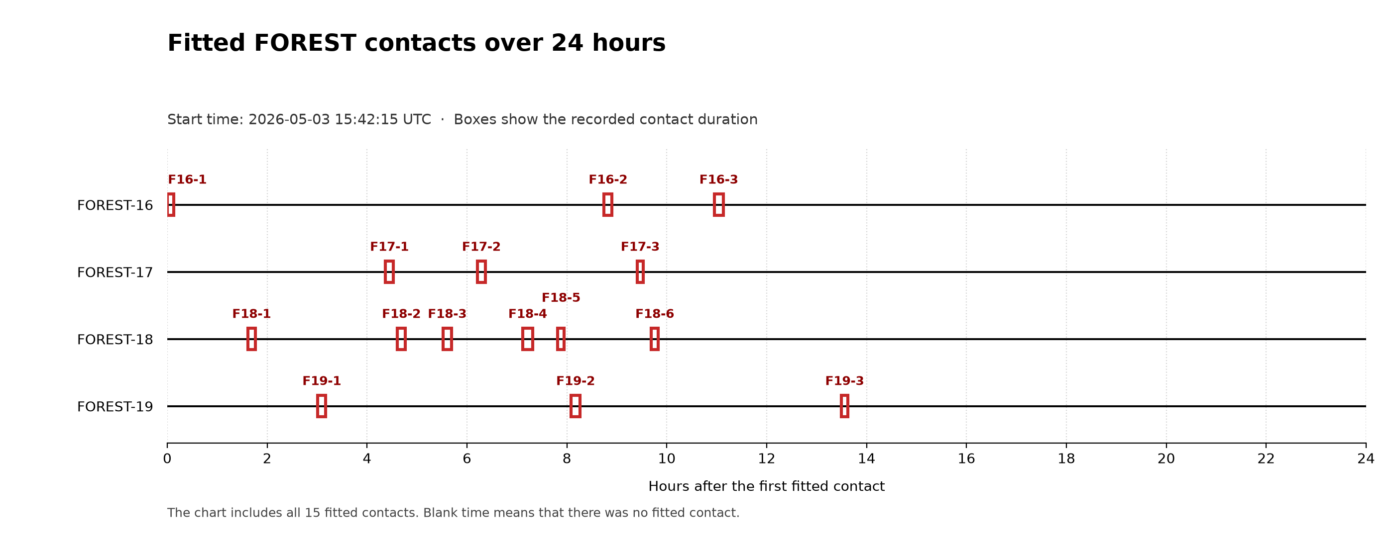
Figure 1. The 15 contacts used for fitting. The horizontal axis shows elapsed time.
The first timeline shows the 15 fitted contacts. The next timeline shows all 61 contacts.
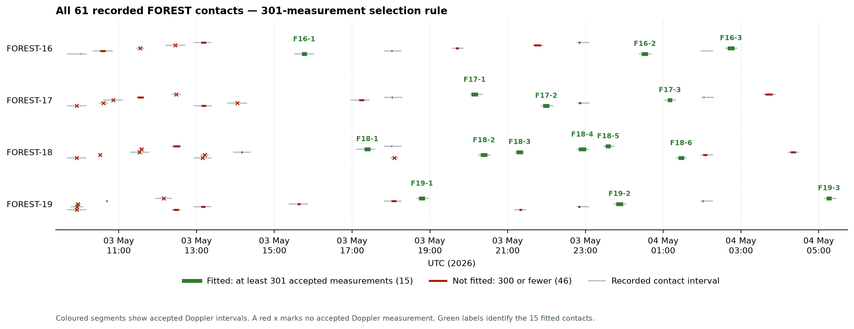
Figure 2. All 61 contacts on a UTC time axis. Green segments passed the 301-measurement rule. Red segments did not.
The result table contains the 15 fitted contacts.

4 Data and contact selection
The evaluation used recorded carrier-frequency offsets and GPS positions for all four spacecraft.
An accepted Doppler measurement met all of these conditions:
- The frequency offset was present and not zero.
- The absolute frequency offset was at least 0.1 Hz.
- The recorded antenna elevation was more than 1 degree and less than 89 degrees.
A contact required at least 301 accepted Doppler measurements before fitting. A fitted contact required at least five GPS records to enter the primary result set.
The team selected the 301-measurement rule after it reviewed the early contacts. Those contacts had too few measurements or too much radio interference. The rule is specific to this evaluation. It is not a universal limit for passive RF OD.
The evaluation started with 176,474 telemetry measurements. Of these, 67,882 had a frequency offset. The filters retained 9,568 accepted Doppler measurements. The data include 61 recorded contacts, 15 fitted contacts, and 11 primary contacts.
FOREST-16 had 13 recorded, 3 fitted, and 2 primary contacts. FOREST-17 had 15, 3, and 3. FOREST-18 had 18, 6, and 4. FOREST-19 had 15, 3, and 2.
The estimator did not fit 46 contacts. Eighteen had no accepted Doppler measurement. The other 28 had between 1 and 300 accepted Doppler measurements.

5 Burst-radio errors and estimator change

5.1 Cause of the earlier fit problems
The earlier Gauss-Newton method used a standard squared-error cost. This method works well when most residuals are small and follow one bell-shaped group.
The FOREST burst radios sometimes produced errors of tens of kilohertz. The squared-error cost gave these large errors too much influence. A short burst could outweigh hundreds of representative measurements.
The estimator changed both time and frequency. During a short contact, one correction can partly imitate the other. Large radio errors, small Doppler changes, and a poor starting value could therefore move the fit to a wrong solution.

5.2 Residual analysis
The residual study examined each contact separately. It removed duplicate times and contacts with fewer than 100 residuals. It then used a GMM with one to five groups. A statistical rule balanced the fit quality against the number of groups.
The study removed a group if it represented less than 25 percent of its contact. It then used DBSCAN to group the retained GMM components by their average and standard deviation.
The larger residual archive contained 817 retained components from 527 contacts. DBSCAN put 685 components in a narrow group. This group had an average offset of -180.55 Hz and an average standard deviation of 351.24 Hz.
DBSCAN put 78 components in a broad group. This group had an average offset of +654.08 Hz and an average standard deviation of 29,770.65 Hz. DBSCAN left 54 components ungrouped.
The residual archive is larger than the 61-contact performance set. It describes the radio environment, not the reported orbit accuracy. The group values are not universal hardware limits.
The analysis found a narrow error group and a separate burst-error group. A single bell-shaped error model did not describe both groups.
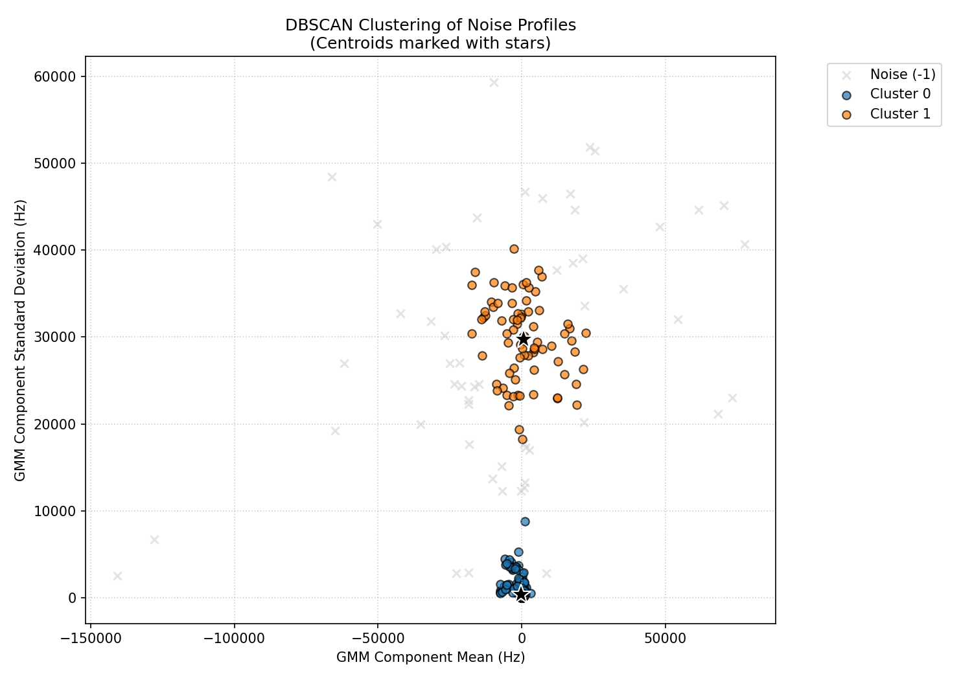
Figure 3. DBSCAN groups the retained GMM components by average and standard deviation. Stars show group centres. Grey crosses are ungrouped components.

5.3 Estimator selection
Development tests compared standard loss and robust loss. Separate stress tests added known time errors and measurement noise.
These tests supported four changes. The final estimator uses soft-L1 loss, correction limits, several starting values, and a minimum data rule. The development tests used recorded data and were retrospective. Only the fixed final settings produced the accuracy results in this report.

6 Initial orbit estimates
Each fitted contact started from one spacecraft-specific initial orbit estimate. The estimator did not change this initial estimate. It calculated a time correction and a frequency correction for each contact.
- FOREST-16: Initial estimate time 2026-05-03 09:21:26 UTC; used for 3 fitted contacts.
- FOREST-17: Initial estimate time 2026-05-03 09:19:03 UTC; used for 3 fitted contacts.
- FOREST-18: Initial estimate time 2026-05-03 09:20:18 UTC; used for 6 fitted contacts.
- FOREST-19: Initial estimate time 2026-05-03 09:21:02 UTC; used for 3 fitted contacts.

7 Analyzed contacts and results
Elapsed time starts at the first fitted contact for each spacecraft. Each spacecraft has its own T+00:00:00. The median error compares the corrected three-dimensional position with GPS during the same contact. GPS-free means that the contact has no same-contact GPS error result.
Spacecraft | Contact ID | Time after first contact | Median error
FOREST-16 | e5d79f0b-730b-4832-becf-f716d7322784 | T+00:00:00 | 19.154 km
FOREST-16 | 33061519-fa11-49e4-becd-6c770efd6e11 | T+08:44:35 | 1.014 km
FOREST-16 | 556b1cfa-0a8e-4d19-8f95-b123fd47cd60 | T+10:57:04 | 3.013 km
FOREST-17 | 2610bd5f-3a3f-4756-be38-d31392d4324c | T+00:00:00 | 24.856 km
FOREST-17 | 36c92afa-8853-4630-a788-ad2e63912d51 | T+01:50:31 | 3.857 km
FOREST-17 | d623db96-56fd-4783-9f1e-bf3933f4dbd8 | T+05:02:41 | 4.500 km
FOREST-18 | 49e74a6c-b21d-46c0-87bb-e4195b4a0dab | T+00:00:00 | 10.826 km
FOREST-18 | 48de3125-1fd3-40df-be87-5fc55aa2485f | T+02:59:30 | 1.377 km
FOREST-18 | 2735b79f-1ae2-4be6-9b13-774d026efd72 | T+03:54:21 | 4.769 km
FOREST-18 | 7654ef67-7aba-4f18-bf0a-65eacc1b6a22 | T+05:30:24 | 0.307 km
FOREST-18 | 105f1f16-870e-4658-9a38-41c74ea5939c | T+06:12:19 | 1.390 km
FOREST-18 | 8db51bff-de04-4287-b3c8-4f949e7a8df1 | T+08:04:24 | 1.585 km
FOREST-19 | d2af3474-5932-431d-ae42-c7ce901c93ba | T+00:00:00 | 5.249 km
FOREST-19 | df2618ab-46b7-49bb-a148-ea9f89466869 | T+05:04:08 | 0.494 km
FOREST-19 | e629dfe8-8210-4af9-a61d-f02b5377a4fd | T+10:28:44 | GPS-free
Four fitted contacts are not primary contacts. Three are limited-GPS contacts. One is a GPS-free contact.
The 0.307 km FOREST-18 result uses only three GPS records. It is a limited-GPS result. It does not replace the 0.494 km best primary result.

8 Doppler model and final estimator
The model predicts Doppler from the relative motion of the spacecraft and the ground station. It also includes a constant frequency correction for each contact.
The estimator changes two values. The time correction moves the spacecraft along its initial orbit. The frequency correction accounts for a constant radio-frequency offset.
The final fit uses soft-L1 loss with a 700 Hz transition value. Small residuals retain their normal influence. Large residuals receive less influence.
The time correction is limited to -120 through +120 seconds. The frequency correction is limited to -100,000 through +100,000 Hz. The fit starts from several time values and keeps the best soft-L1 result.
A fit is accepted only if it completes, finds both corrections, and does not stop at a limit. All 15 fits met these conditions.
This method does not estimate a complete orbit state. It cannot correct all types of orbit error.

9 Position-error calculation
The evaluation compares the estimated three-dimensional position with the GPS position at the same time. The distance between these positions is the position error in kilometres.
The initial error uses no time correction. The corrected error uses the fitted time correction. The contact result is the median of its GPS position errors.
The report gives each contact equal weight. A long contact or a contact with more GPS records cannot dominate the summary.

10 Later GPS comparison
For this comparison, the fitted time correction remains constant after the contact ends. The evaluation then compares the orbit estimate with later GPS positions.
Each time interval requires at least five GPS records. Each value is the median of the contact median errors.
From 0 to 1 hour, the initial and corrected errors were 9.676 km and 2.617 km. The correction improved 11 of 15 contacts. From 1 to 3 hours, the values were 12.740 km and 3.509 km, with 11 of 15 improved. From 3 to 6 hours, they were 16.735 km and 5.860 km, with 11 of 15 improved. From 6 to 12 hours, they were 22.378 km and 10.519 km, with 12 of 15 improved. From 12 to 24 hours, they were 31.735 km and 19.798 km, with 11 of 15 improved.

11 Controls and limitations
The evaluation used these controls:
- The contact accounting includes all 61 recorded contacts.
- The report includes contacts that became worse after the fit.
- GPS data does not enter a production fit. It measures error after the fit.
- The same data-quality rules apply to all contacts.
- The primary result set uses the same five-record GPS rule for all contacts.
- GPS position and orbit position are compared at the same measurement time.
- The summary gives each contact equal weight.
The study is retrospective. The team reviewed the contacts before it completed this evaluation. The estimator settings were also developed with recorded data.
A future confirmation must use fixed rules on new contacts. This report shows potential performance under the recorded conditions. It does not guarantee operational accuracy.

12 Verification summary
The review counted all 61 contacts and applied the same selection rules to each contact. It confirmed 15 fitted contacts and 11 primary contacts.
The review also checked the contact times, measurement counts, GPS counts, initial estimates, and fit results. The result tables include all 15 fitted contacts.

