Service Level Milestone 1 – updated results
Launch Date: 3 May 2026, 12 AM PT.
Vehicle/Site: SpaceX Falcon 9 | Vandenberg Space Force Base, California
Mission: CAS500-2
Mission Objective
The primary goal of this campaign is to demonstrate KSAT SSA capabilities by achieving three core technical milestones as outlined in ESA contract 4000151130.
- Frequency Identification: Detect center frequency for at least 1 payload (S-band or X-band).
- Rapid Orbit Determination (OD): Perform 1-way Doppler OD offline with first 3 hours of collected data.
- Precision Accuracy: Achieve a position error of < 1 km (verified via ESA or on-board GPS).

Work Package Summary
WP2000: Orbit Determination
Success Metrics: Latency: Solution available within 3 hours of pass.
Accuracy: Position error < 1 km.
Deliverables: Orbit ephemeris (TLE), covariance, residuals, and processing logs.

WP3000: Center Frequency Identification
Process: Utilize fixed pointing and Digital IF bandwidth monitoring (narrowband and wideband).
Success Metrics: Positive identification of at least one payload downlink.
Deliverables: Frequency estimate and IQ spectral plots.

Operational Timeline
Pre-Launch: Finalize payload authorizations, expected frequency ranges, and station readiness.
LEOP Day (Priority Window): 3-hour data window for IF/IQ and Doppler data capture.
Refinement (T+1 week): Delivery of refined OD and comprehensive final report.

WP2000 - Results
This report details an experiment to verify the performance of the DART passive-RF orbit determination (OD) program. The experiment analyzed four Ororatech satellites released during the CAS500-2 mission on May 3, 2026. Initial analysis proved difficult because the Doppler readings contained high non-Gaussian noise. Burst-radios on the four spacecraft were determined to have caused this noise.
This section explains the noise characterization and the software corrections. The results demonstrate that the system achieves single-pass accuracies of < 1 km relative to GPS. Post-pass gating identifies these correct fits.

Noise Characterisation for Burst-Radio Passive RF
For orbit determination based on normalized telemetry metrics, the DART tool was developed internally at KSAT. Previous DART versions assumed that the residual distribution followed a white-noise sequence (a Gaussian distribution). With an assumed sensor noise of approximately 10 Hz, the software used this distribution to gate the root mean square error (RMSE) values for the residuals. The software identifies a fit as correct if the RMSE is < 10 Hz. Burst-radio configurations make this simple gating procedure impossible.
Initial experiments assumed a noise distribution containing a Gaussian and an overlapping Laplacian. Past procedures used this assumption to handle outliers. With this assumption, a Huber-based loss function is mathematically sufficient to perform optimal least-squares (LS) regression. This method did not achieve the expected results, which prevented data analysis during the first day.
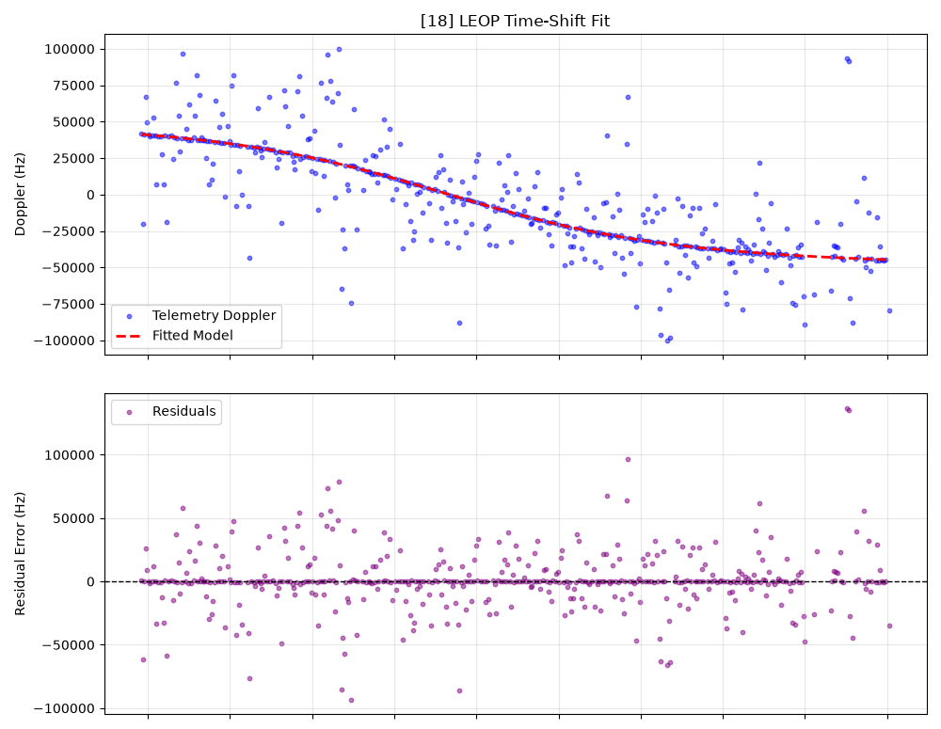
To solve this, the procedure changed to the following steps:
- Limit degrees of freedom to only along-track (Mean-Anomaly) corrections.
- Apply a Huber-based loss function to fit each pass.
- Store the residuals.
- Use Gaussian-Mixture-Models (GMM) to fit a dual set of overlapping Gaussians to the data.
This procedure used a dataset of hundreds of subsequent passes from the four satellites. The output is a two-dimensional distribution of fits (refer to the typical noise figure).

Data Clustering and Distribution

The system then used the DBSCAN clustering algorithm to estimate the underlying distribution. The data shows two clear clusters. This result proves that burst-radio Doppler follows a GMM distribution, not a Gaussian and Laplacian distribution.
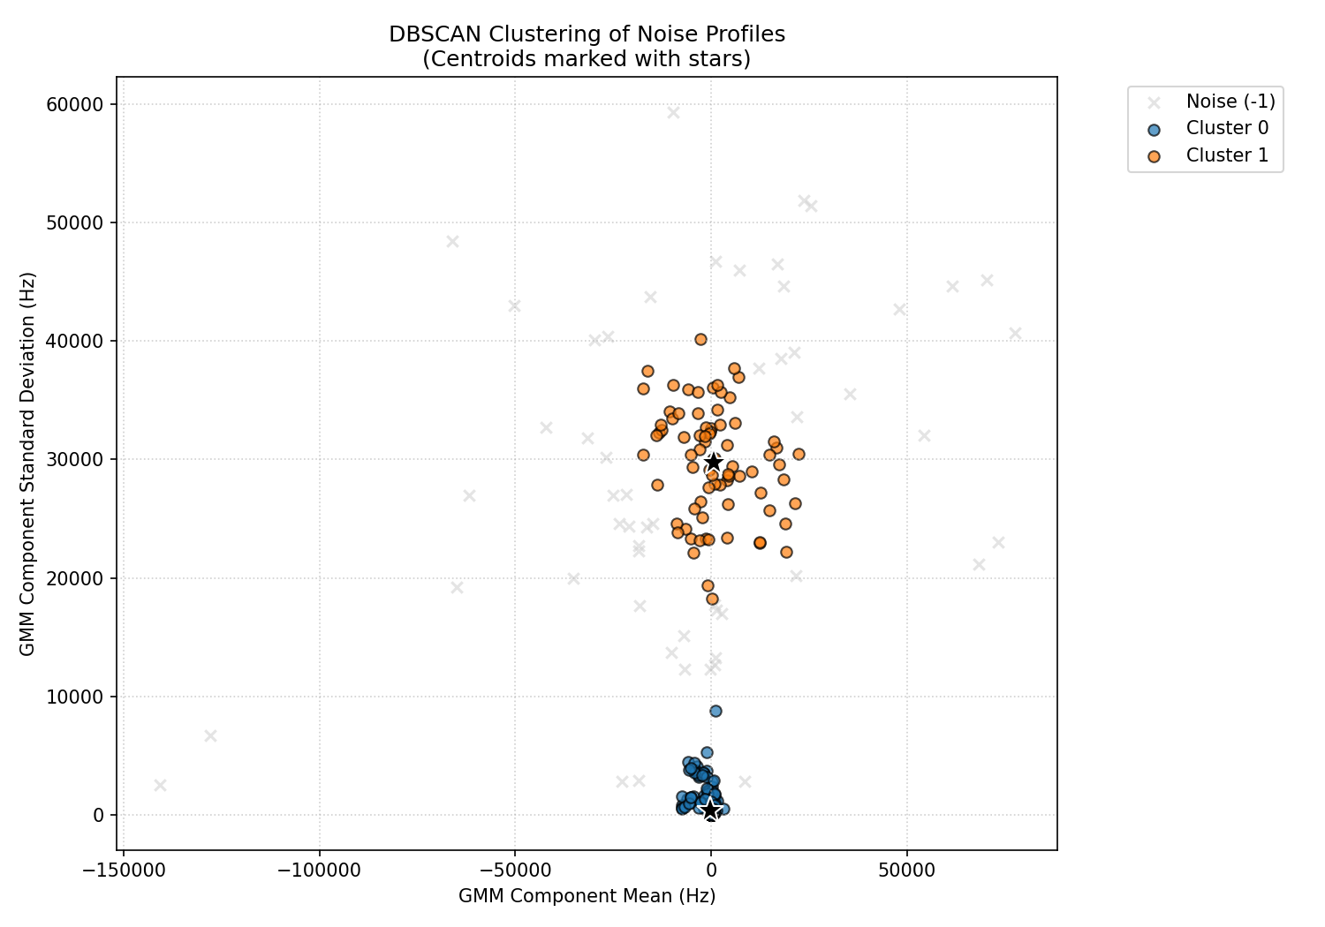
The larger residual archive contained 817 retained components from 527 contacts. The DBSCAN algorithm divided these components into three categories:
- Narrow Group (685 components): Average offset of -180.55 Hz and an average standard deviation of 351.24 Hz. This group represents the expected performance on normal passes.
- Broad Group (78 components): Average offset of +654.08 Hz and an average standard deviation of 29,770.65 Hz. This group represents the outlier distribution caused by short contacts with the KSAT Lite backend hardware.
- Ungrouped: 54 components did not fit into a cluster.

Meta-Parameter Tuning

GMM distributions require a loss function that permits heavy tails in the dataset. Ororatech provided GPS-referenced Two-Line Elements (TLEs). The study used these TLEs to establish a baseline performance metric for meta-parameter tuning.
The objective of the meta-optimization is to find optimizer parameters that make the generated TLE match the GPS-referenced TLE. This method iteratively tunes the optimizer parameters to correct for the specific GMM noise distribution. The tuning procedure used the Optuna Python module, and the SciPy LeastSquares function served as the optimizer.

Reproducibility Settings and Final Gates

The final system parameters required to reproduce the optimized results are detailed below. A pass is only valid if it passes all criteria in the Final Gates category.

Parameter Category | Settings
Fitted Variables & Filters | Time offset and frequency bias. All passes used a center frequency of 2.216GHz during the optimization process to estimate the doppler- slightly off from the true center frequencies.
Robust Objective | Soft-L1 loss. Doppler residual scale: 500 Hz. Robust scale: 700 Hz.
Bounds & Starts | Time offset: ±120 s. Frequency bias: ±100 kHz. Staring points were randomly initialized within the bounding box.
Numerical Settings | Parameter scales: 30 s and 5,000 Hz. Central-difference Jacobian steps: 1e-3 s and 1 Hz. Tolerances (ftol, xtol, gtol): 1e-10.
Fit Health Checks | Successful solve, full Jacobian rank (2/2), finite scaled-Jacobian condition number ≤ 1e12, and no parameter at a bound.
Final Gates | ≥ 250 accepted Doppler measurements, offset variance ≤ 15 s², and a healthy fit.

Results
A timeline of all passes during the first 24 hours after launch can be seen below, with passes that passed through all gating mechanisms shown in green.
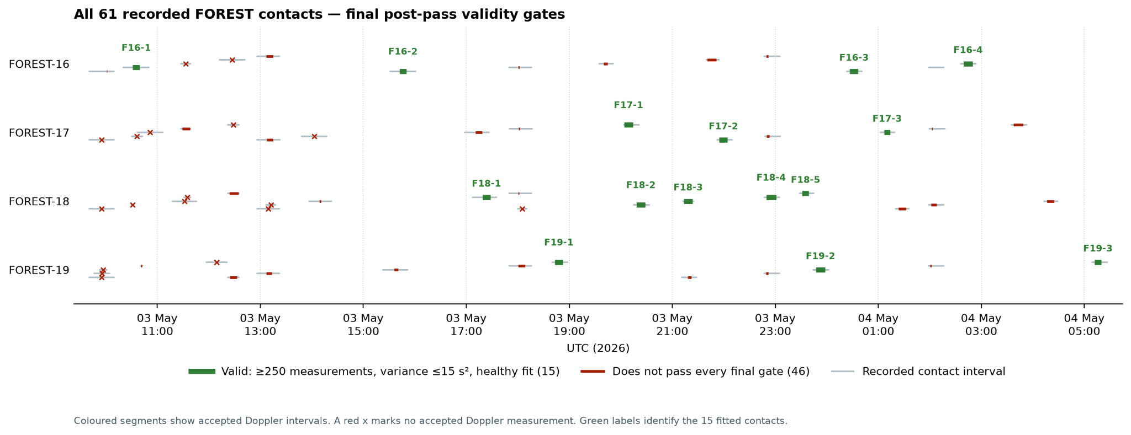
Below one can see all successful fits, with the prior TLE available at time of payload separation.

Forest-16

1 90916U 00000AAA 26123.38989170 .00000000 00000-0 15851-2 0 9996
2 90916 97.7445 21.6711 0001088 184.3194 124.1089 14.91831094 03

Time | Station | Duration | Samples | Variance | Prior (km) | Posterior (km)
2026-05-03 10:20:36 UTC | AWARUA | 29:20 | 297 | 2.098 | 4.923 | 0.541
2026-05-03 15:31:25 UTC | PUNTA_ARENAS | 29:26 | 340 | 2.540 | 9.310 | 19.154
2026-05-04 00:23:14 UTC | SVALSAT | 17:43 | 475 | 0.556 | 18.412 | 1.232
2026-05-04 02:35:53 UTC | PUNTA_ARENAS | 17:50 | 401 | 0.882 | 21.147 | 3.008
.

Forest-17

1 90917U 00000AAA 26123.38823777 .00000000 00000-0 15851-2 0 9997
2 90917 97.7396 21.6764 0005261 314.5846 344.9937 14.90540572 06

Time | Station | Duration | Samples | Variance | Prior (km) | Posterior (km)
2026-05-03 20:03:32 UTC | HARTEBEESTHOEK | 17:24 | 349 | 4.453 | 6.384 | 24.862
2026-05-03 21:51:59 UTC | TROLL | 17:45 | 370 | 1.246 | 7.167 | 3.838
2026-05-04 01:02:54 UTC | PUNTA_ARENAS | 15:47 | 344 | 11.569 | 8.305 | 4.468

Forest-18

1 90918U 00000AAA 26123.38910698 .00000000 00000-0 15851-2 0 9997
2 90918 97.7376 21.6797 0001897 93.2348 211.0047 14.92051430 08

Time | Station | Duration | Samples | Variance | Prior (km) | Posterior (km)
2026-05-03 17:07:14 UTC | PUNTA_ARENAS | 28:08 | 471 | 8.299 | 9.917 | 10.767
2026-05-03 20:15:20 UTC | TROLL | 17:49 | 341 | 0.517 | 15.370 | 1.351
2026-05-03 21:12:35 UTC | SVALSAT | 12:03 | 336 | 5.297 | 14.452 | 4.779
2026-05-03 22:47:18 UTC | SVALSAT | 17:40 | 339 | 1.240 | 16.722 | 0.288
2026-05-03 23:28:25 UTC | TROLL | 16:21 | 322 | 14.807 | 19.570 | 1.372

Forest-19

1 90919U 00000AAA 26123.38960698 .00000000 00000-0 15851-2 0 9993
2 90919 97.7424 21.6734 0001942 141.5194 165.3859 14.92112300 07

Time | Station | Duration | Samples | Variance | Prior (km) | Posterior (km)
2026-05-03 18:40:28 UTC | TROLL | 17:14 | 358 | 2.354 | 2.382 | 5.196
2026-05-03 23:44:06 UTC | AWARUA | 17:49 | 521 | 0.769 | 2.746 | 0.494
2026-05-04 05:09:13 UTC | SVALSAT | 17:37 | 357 | 0.823 | 3.097 | 1.841

The specific pass at 2026-05-03 23:44:06 UTC for Forest-19 can be seen below: Corrections are limited to along-track position for Burst-Radios, but still manages to achieve a <1km RMSE around 1 hour of epoch.
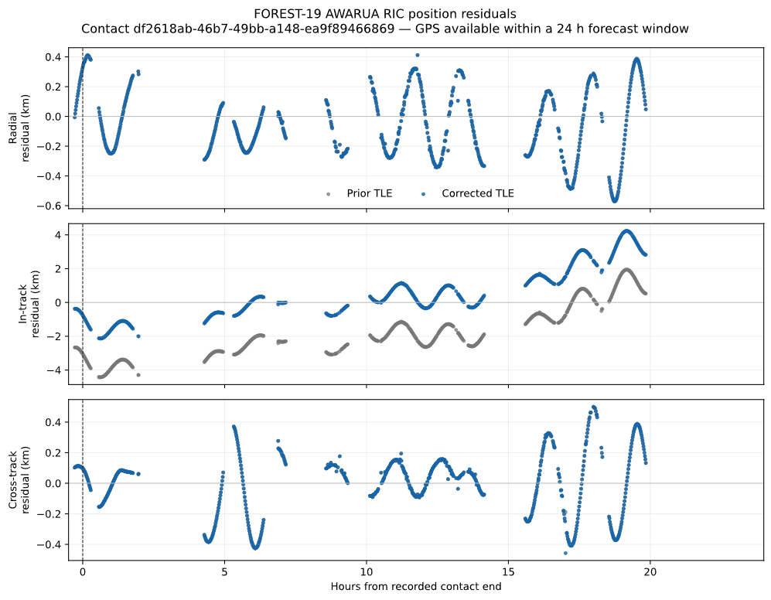
Results for other passes can be found in the attached JSON.

Conclusion
system Performance
- The system achieves a median error of approximately 3 km.
- For Burst-Radio configurations with valid data, the single-pass accuracy is < 1 km.
- The first valid pass for the Forest-16 satellite achieved an accuracy of 500 m. This result occurred within 3 hours after payload separation.
- This performance uses the tuned optimizer and the heuristic gating mechanisms.
- This technique applies to other burst-radio satellites and does not change previous results.
Limitations and Future Work
- This study evaluated only single-pass performance.
- The combination of multiple passes is difficult. It requires a reliable data gating procedure for data of low quality.
- Future procedures can combine passes to increase the performance and reliability of the system.
Edge Cases
- Note: Some results show that the DART estimates are less accurate than the prior data. This condition occurs even with the new filters.
- Under these conditions, the maximum error is approximately 25 km.
- For a 600 km orbit at the closest approach, the small-angle approximation shows an angular offset of approximately 2.5 degrees.
- At this offset, the spacecraft stays within the limits of detectability.
Summary The DART software can correctly process Burst-Radio configurations. It increases tracking performance through the use of heuristic checks.
WP3000 assessment
The WP3000 is also deemed to have met the requirements to fulfill this first milestone. From the status report that was previously shared, three out of the four satellites’ center frequencies were detected and confirmed by using the KSAT lite standard equipment while the antenna was statically positioned at the PCA (Point of Closest Approach, i.e highest elevation) of the first satellite’s trajectory in the release schedule. Thus, further improvements are currently being brought to the acquisition pipeline to make this method more robust and performant for the upcoming milestones in order to meet future requirements.
