Service Level Milestone 1 – updated results
Launch Date: 3 May 2026, 12 AM PT.
Vehicle/Site: SpaceX Falcon 9 | Vandenberg Space Force Base, California
Mission: CAS500-2
Mission Objective
The primary goal of this campaign is to demonstrate KSAT SSA capabilities by achieving three core technical milestones as outlined in ESA contract 4000151130.
- Frequency Identification: Detect center frequency for at least 1 payload (S-band or X-band).
- Rapid Orbit Determination (OD): Perform 1-way Doppler OD offline with first 3 hours of collected data.
- Precision Accuracy: Achieve a position error of < 1 km (verified via ESA or on-board GPS).

Work Package Summary
WP2000: Orbit Determination
Success Metrics: Latency: Solution available within 3 hours of pass.
Accuracy: Position error < 1 km.
Deliverables: Orbit ephemeris (TLE), covariance, residuals, and processing logs.

WP3000: Center Frequency Identification
Process: Utilize fixed pointing and Digital IF bandwidth monitoring (narrowband and wideband).
Success Metrics: Positive identification of at least one payload downlink.
Deliverables: Frequency estimate and IQ spectral plots.

Operational Timeline
Pre-Launch: Finalize payload authorizations, expected frequency ranges, and station readiness.
LEOP Day (Priority Window): 3-hour data window for IF/IQ and Doppler data capture.
Refinement (T+1 week): Delivery of refined OD and comprehensive final report.

WP2000 – Orbit determination: methods and results
DART is KSAT’s internally developed passive-RF orbit-determination toolkit. This analysis evaluates recovery and refinement of spacecraft orbits from one-way carrier Doppler during the CAS500-2 campaign. Burst-radio telemetry contains substantial non-Gaussian contamination, motivating robust estimation, per-pass frequency-bias parameters and checks on the information available to constrain an orbit.

Purpose and scenarios
This study evaluates orbit estimation from passive reception of spacecraft carrier signals during the CAS500-2 campaign. It covers four low-Earth-orbit spacecraft, FOREST-16–19, during 3–4 May 2026, using one-way Doppler observations and two initial-orbit scenarios.
The pre-launch scenario represents initial orbit determination (IOD) assisted by an approximate orbit. Its large initial errors resemble the recovery problem posed by a stale TLE, potentially weeks old in an operational setting. The experimental TLEs were submitted two days before separation; the analogy concerns prior quality. The post-separation update scenario starts from a substantially better orbit and evaluates refinement during early operations. At the cumulative fit checkpoints, median initial position errors were approximately 549 km and 9 km, respectively.

Observation model
The observable is the carrier-frequency shift caused by spacecraft motion relative to a ground receiver. For observation $i$ in pass $p\left(i\right)$,
$${\hat{d}}_{i} = −\frac{f_{c}}{c}\frac{{\left(r_{i} − r_{g,i}\right)}^{T}\left(v_{i} − v_{g,i}\right)}{\left\|r_{i} − r_{g,i}\right\|} + b_{p(i)}\text{ (1)}$$
Here $r_{i}, v_{i}$ and $r_{g,i}, v_{g,i}$ are spacecraft and receiver position and velocity in a common Earth-centred inertial frame at the observation time. Receiver motion includes Earth rotation. The common nominal carrier used for modelling is $f_{c} = 2216.3$ MHz, $c$ is the speed of light, and Doppler ${\hat{d}}_{i}$ and pass bias $b_{p}$ are in hertz. Each pass has an estimated constant bias to absorb approximately constant frequency offsets. The changing Doppler curve constrains orbital motion, while the bias accommodates its offset.

Estimation methods
Timing correction estimates one adjustment to the TLE epoch, shared across the selected passes. Observation and receiver times remain fixed. This changes the spacecraft's progression along its SGP4-predicted orbit and is useful when the dominant error is orbital timing.
SGP4 mean-element correction estimates changes in mean longitude $L$ and mean motion $n$. Mean longitude specifies orbital phase; mean motion controls its evolution. SGP4 propagates the corrected TLE using its standard perturbation model. This two-parameter correction, denoted L+n, retains the prior's orbit shape and plane. Before fitting, the TLE is represented at an epoch near the observations while preserving its predicted trajectory.
Cartesian full-state estimation adjusts all three position and three velocity components at a reference epoch. Numerical propagation uses Earth gravity through degree and order four, Sun and Moon attraction, tides, and relativistic corrections. Atmospheric drag is omitted because this configuration has no supplied spacecraft drag properties. The additional state freedom allows correction of orbit shape and plane, but requires more observational information to constrain the solution.
All methods jointly estimate their orbit parameters and one bias per pass using bounded robust least squares, implemented with SciPy’s least-squares solver. With $ε_{i}\left(θ\right) = {\hat{d}}_{i}\left(θ\right) − d_{i}$, the soft-L1 objective can be written, up to a constant multiplier, as
minθ ∈ ℬ i1 + εiθs2 − 1, s = 700 Hz (2)
The vector $θ$ contains the estimated parameters, and $ℬ$ specifies their allowed bounds. Large residuals receive less influence, helping tolerate contaminated Doppler observations. The initial orbit supplies the starting point; the objective contains measurement residuals only.
Timing is fitted to individual passes and cumulatively. L+n uses either the latest three eligible passes or all completed eligible passes; full-state fitting is cumulative. Each fit starts from the scenario's fixed initial orbit. Repeated updates therefore measure the benefit of newly available observations. Orbit fits use carrier-lock and signal-quality screening; timing uses elevation and sample count screening, producing a smaller contact set.

Evaluation
Each solution is forecast over the hour immediately following its latest input pass. Position accuracy is measured against a trajectory fitted independently to GPS observations:
$$E_{r} = \sqrt{\frac{1}{K}\sum_{k = 1}^{K}{{\left\|r_{fit}\left(t_{k}\right) − r_{GPS}\left(t_{k}\right)\right\|}^{2}}}\text{ (3)}$$
This position-vector RMSE is reported in kilometres. Initial and fitted orbits are evaluated at identical timestamps, strictly after the fitting observations. The forecast starts at pass completion, assuming immediate solution availability.
The reference trajectory estimates Cartesian state and effective drag from GPS positions. Withholding ten minutes of each hour gives validation errors of 35–83 m for FOREST-16–18. FOREST-19 has a 167 m validation error, exceeding the 100 m acceptance threshold, and remains a candidate reference. This distinction matters most when interpreting the smallest orbit errors.
Of 254 fits, 242 have complete reference coverage for the forecast hour. Twelve early forecasts lack that coverage and are excluded from accuracy statistics. Timing and L+n fits also undergo a quality screen requiring sufficient samples, convergence, inactive parameter bounds, and full-rank, adequately conditioned measurement sensitivities. Full-state fits are reported without this screen.

Results and interpretation
The table reports median next-hour position RMSE. “All scored” includes fits rejected by the quality screen; the accepted subset is labelled separately.
Table 1. Median position-vector RMSE over the hour following the latest fitted pass.
Initial orbit | Cumulative method and population | Fits | Median RMSE
Pre-launch | Full state, all scored | 32 | 11.7 km
Pre-launch | Full state, at least six passes | 15 | 8.5 km
Pre-launch | L+n, all scored | 32 | 22.7 km
Post-separation update | L+n, all scored | 32 | 3.5 km
Post-separation update | L+n, quality-accepted | 25 | 2.7 km
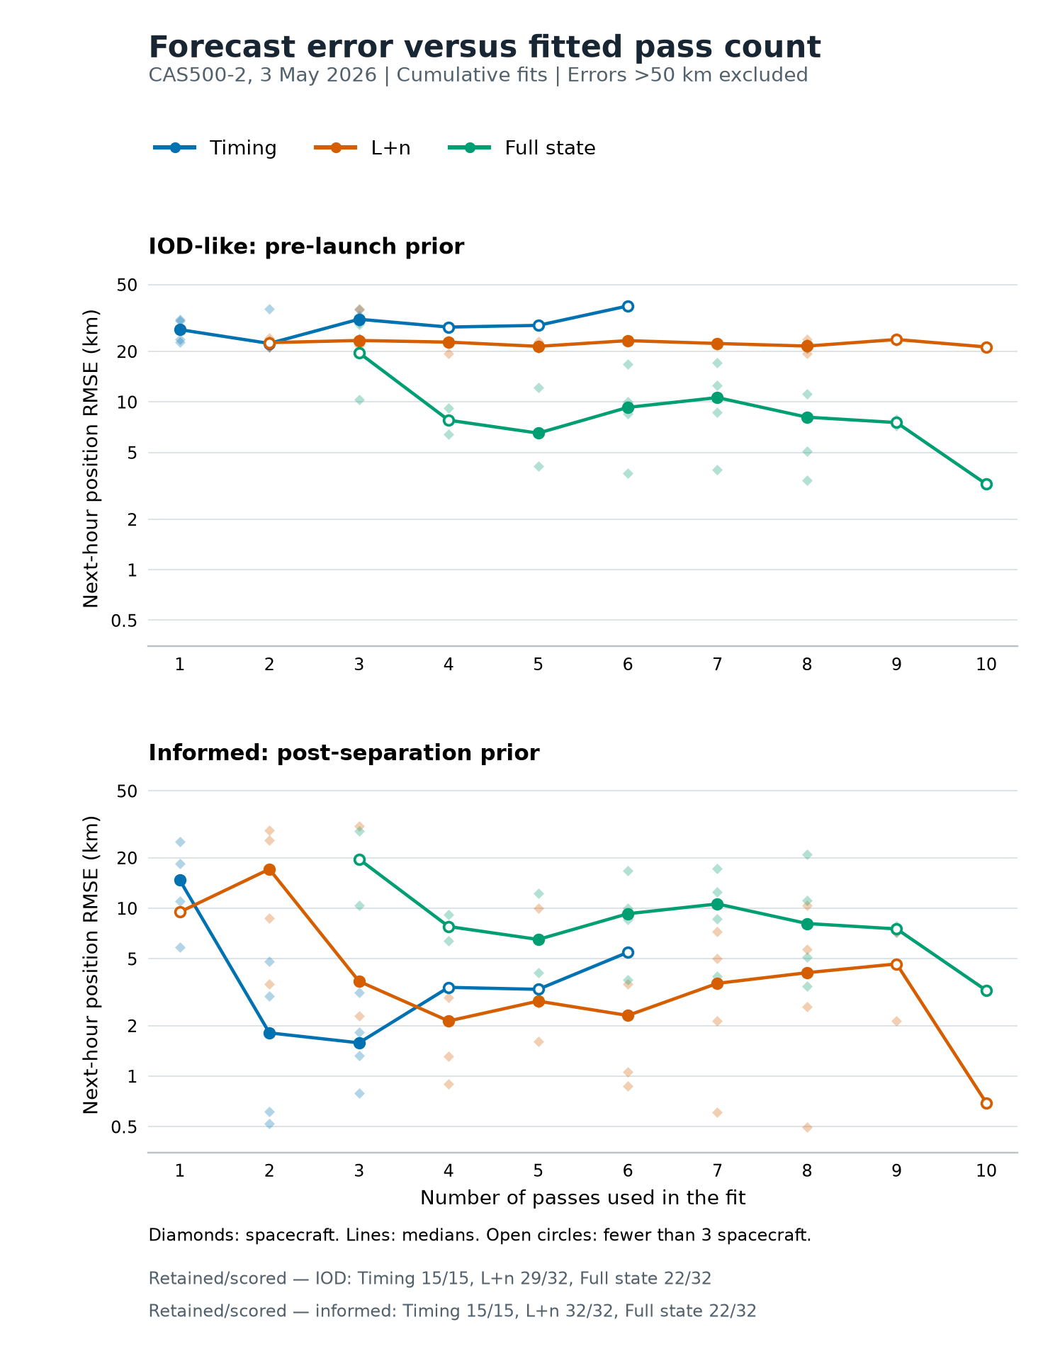
Figure 1. Cumulative next-hour position accuracy versus fitted pass count. Errors above 50 km are excluded from this figure; open median markers indicate fewer than three contributing spacecraft.
The figure shows cumulative fits, with errors above 50 km removed before calculating each median. The table retains its original populations. Single-pass timing and rolling L+n use fixed counts of one and three passes, respectively.
IOD-like recovery reaches an approximately 10 km accuracy scale with full-state estimation in these cases. Early fits can have errors of thousands of kilometres: short Doppler arcs can leave combinations of position, velocity, and frequency bias weakly constrained. By six–eight passes, full-state median error settles around 8–11 km, with all four spacecraft below the cutoff. Earlier filtered medians represent fewer spacecraft. L+n levels off near 21–23 km after three–four passes: its two orbit parameters preserve the prior's shape and plane. It improves every scored pre-launch prior.
A useful prior enables approximately 3 km refinement. Cumulative L+n improves the updated prior in 26 of 32 scored fits. Its main improvement occurs by three–four passes, followed by median errors around 2–4 km through eight passes. Retaining prior geometry reduces the number of unknowns that Doppler must determine. The accepted-fit 90th percentile is 8.8 km, showing the spread around the 2.7 km median.
Cumulative timing reaches median errors of 1.6–1.8 km after two–three passes with informed priors, compared with roughly 22–31 km for the IOD-like case. Later timing points represent FOREST-18 alone. Likewise, only two spacecraft reach nine orbit-model passes and one reaches ten; those final points describe the remaining spacecraft rather than a plateau across all four.
Repeated updates achieve sub-kilometre accuracy in favourable cases. FOREST-16 reaches 0.50 km with eight cumulative passes; FOREST-18 reaches 0.90 km with four. Both spacecraft have accepted GPS references. Accuracy varies with pass geometry and data quality; overlapping forecasts and shared observations make successive fits correlated.
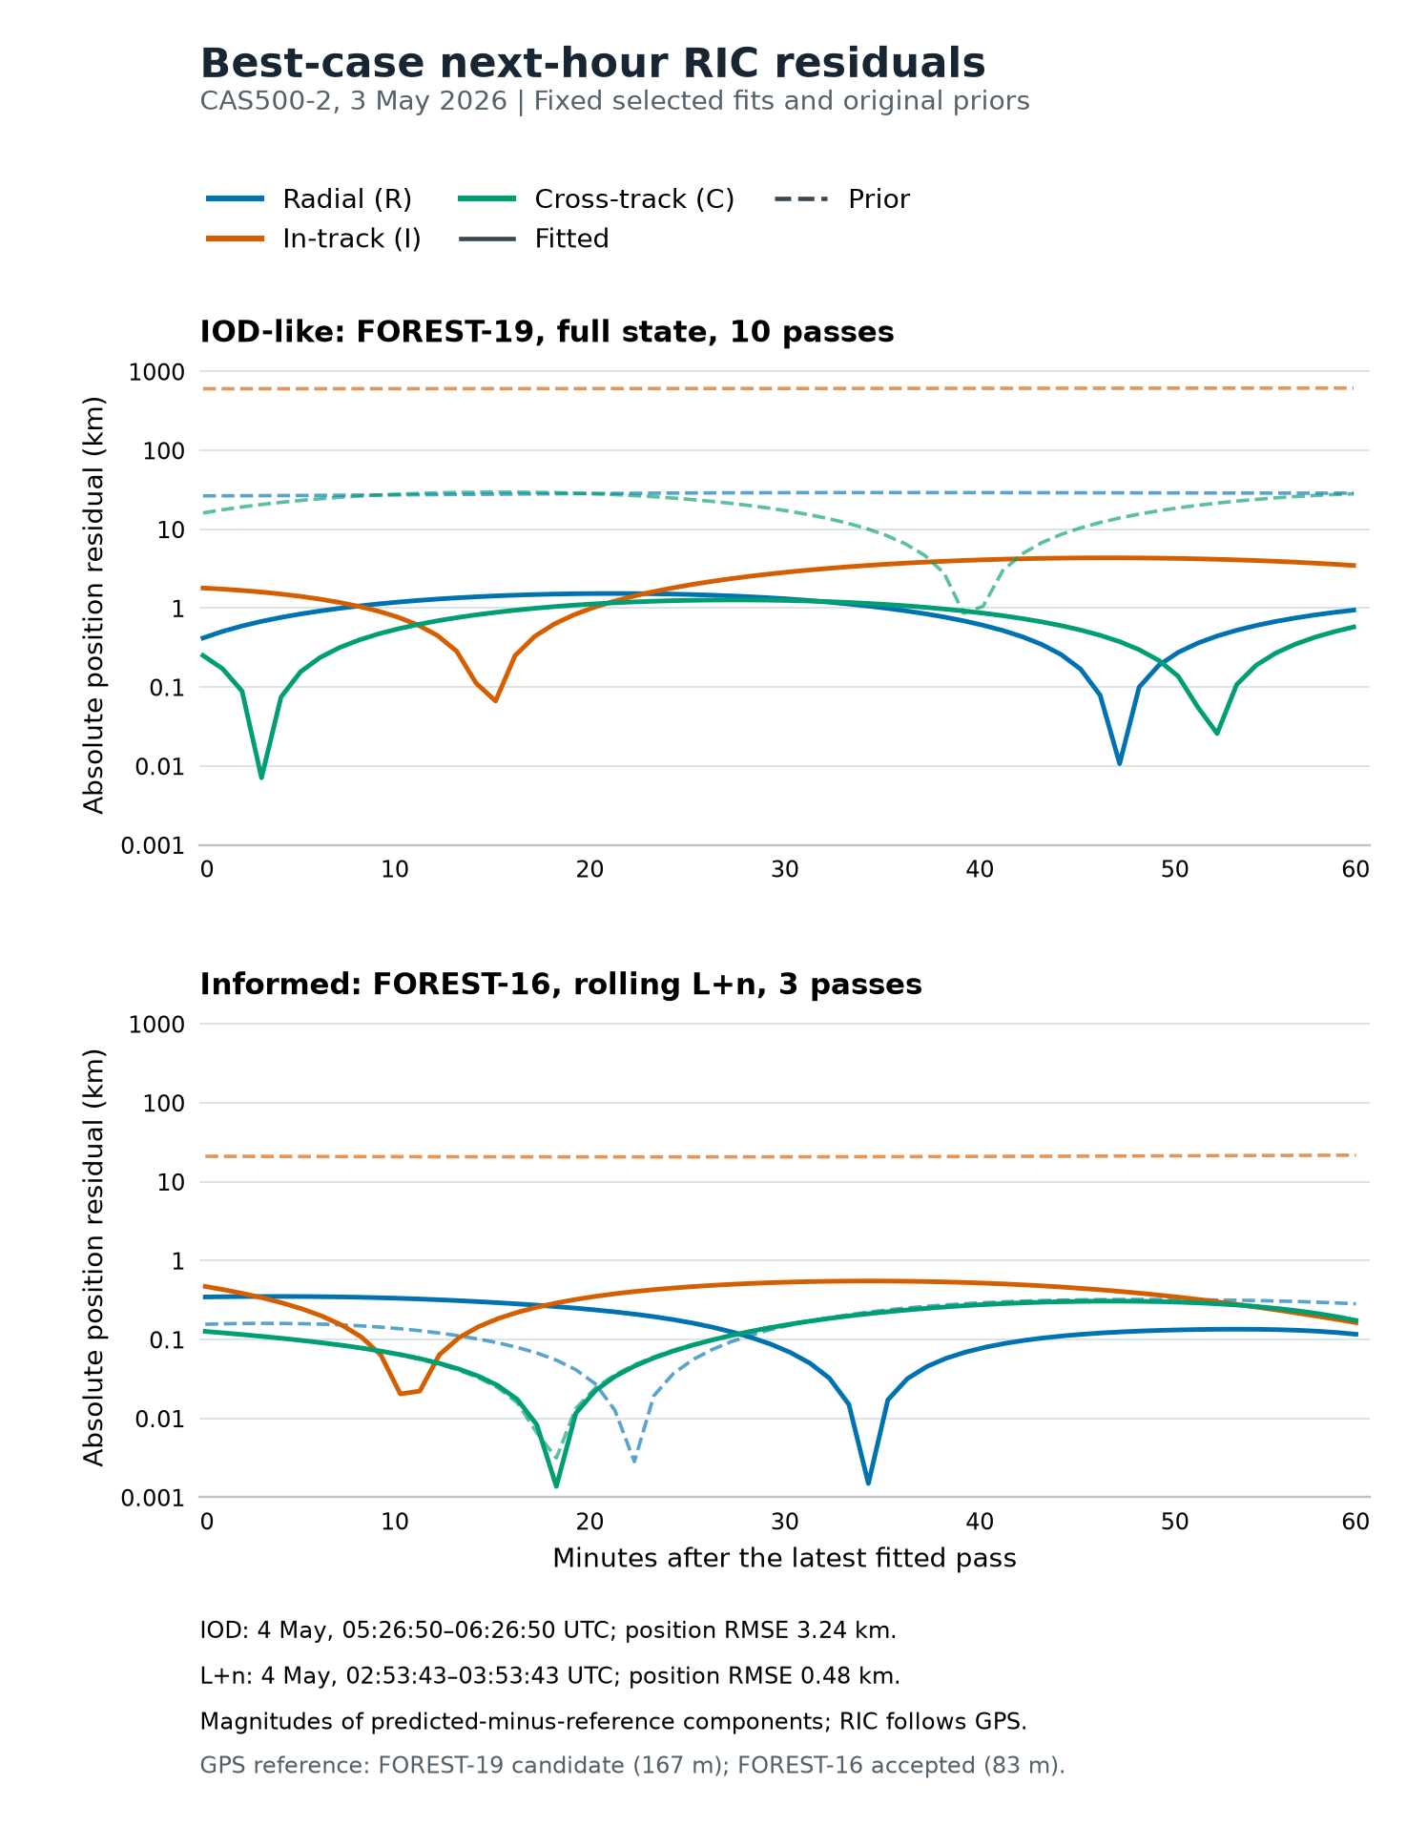
Figure 2. Next-hour RIC position residuals for the best IOD-like full-state and informed-prior L+n fits. The log scale shows absolute component errors; dashed curves are the original priors.
The best-case examples are selected by lowest next-hour position RMSE: the pre-launch full-state fit reaches 3.24 km for FOREST-19 with ten passes; the informed-prior L+n fit reaches 0.48 km for FOREST-16 using the latest three passes. The latter is selected across both rolling and cumulative fits. FOREST-19 retains its candidate-reference designation because its GPS validation error exceeds the acceptance threshold.
Residuals are projected onto the GPS reference orbit's radial, in-track and cross-track (RIC) axes. The figure shows absolute component errors on a log scale; sharp dips occur near component zero crossings. Dashed curves show the original prior and solid curves the fitted orbit. Full-state fitting reduces errors in all three directions. L+n mainly corrects in-track error, reducing its RMS from 20.9 km to 0.39 km, while radial and cross-track RMS remain around 0.2 km.
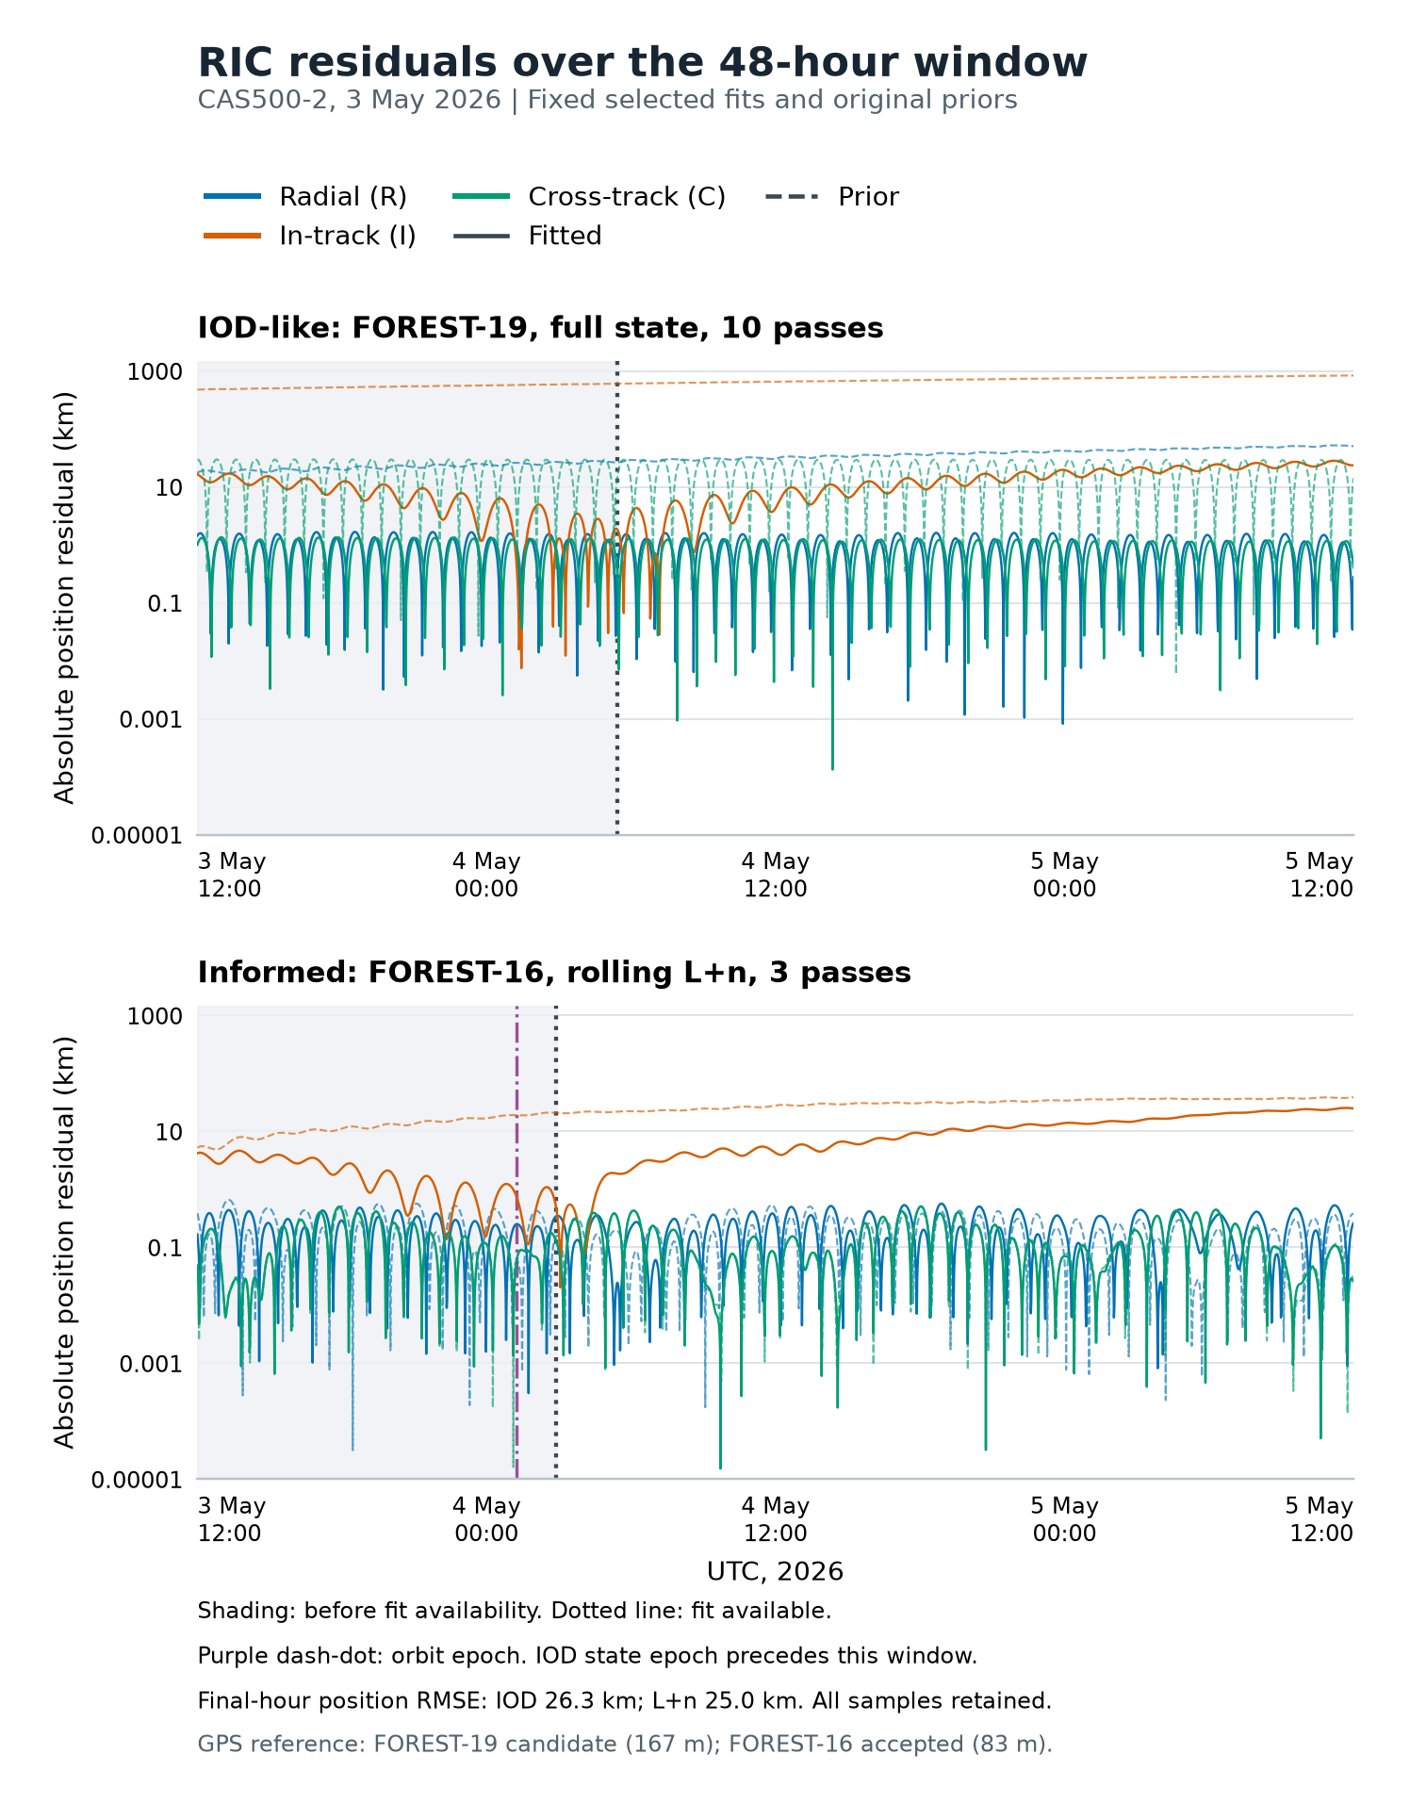
Figure 3. The same fixed solutions across the full 48-hour GPS reference window. Shading marks reconstruction before fit availability; the later interval is prediction without further updates.
Extending the same fixed solutions across 3 May, 12:00 UTC to 5 May, 12:00 UTC reveals substantial error growth. In the final hour, the IOD-like fit reaches 26.3 km position RMSE and L+n reaches 25.0 km, approximately 30–33 hours after fit availability. The growth is mainly in-track, consistent with accumulating orbital-phase error beyond the fitted observations. Radial and cross-track errors remain predominantly periodic.
The shaded interval precedes fit availability and shows retrospective reconstruction; the remaining interval shows prediction with fixed parameters. Orbit epochs are identified separately. These are the same cases selected for their next-hour accuracy, carried through the complete reference window without further updates. The contrast shows why the sub-kilometre result is tied to its forecast horizon.

WP2000 outcome and operational interpretation
For this spacecraft group, the campaign demonstrates IOD-like recovery at an approximately 10 km next-hour accuracy scale, refinement at an approximately 3 km scale from an informed prior, and sub-kilometre accuracy in favourable cases. The longer forecast shows why those results must be reported together with the prior, observation span and prediction horizon. Further observations and renewed fits provide a way to limit the phase-error growth seen when a solution is propagated without updates.
The replay assumes immediate solution availability after the last fitted pass. Assessment of the three-hour delivery objective therefore requires measured acquisition, processing and delivery timestamps. The GPS reference starts at 12:00 UTC on 3 May, so early post-separation accuracy is unscored where the reference does not cover the required forecast hour. The results above establish the measured accuracy of the available cases while keeping the timing assessment tied to its required evidence.

Method reference
Vallado, Crawford, Hujsak and Kelso (2006), Revisiting Spacetrack Report #3, AIAA 2006-6753. The numerical results in this section derive from the frozen 254-fit CAS500-2 comparison and its GPS-reference trajectories. Full-state propagation and SGP4 correction are evaluated as distinct orbit-estimation methods.
WP3000 assessment
The WP3000 is also deemed to have met the requirements to fulfill this first milestone. From the status report that was previously shared, three out of the four satellites’ center frequencies were detected and confirmed by using the KSAT lite standard equipment while the antenna was statically positioned at the PCA (Point of Closest Approach, i.e highest elevation) of the first satellite’s trajectory in the release schedule. Thus, further improvements are currently being brought to the acquisition pipeline to make this method more robust and performant for the upcoming milestones in order to meet future requirements.
