Orbit Determination (OD) using Doppler frequency shift data contained in L band RF signals

Introduction

In the light of the question about which options exist to exploit passive RF (PRF) signals receivable at KSAT’s ground antennas an immediate idea is to use Doppler shifts as they are experienced with every ground station antenna contact, for example, when receiving satellite telemetry (TM). These signals are usually communication signals, not designed for use in ground based tracking and navigation systems.

This part of the study focuses on OD.

This may have influence on the quality of time stamping and frequency stability, especially for 1-way downlink RF signals.

Prerequisite to a PRF scenario is that the object (RSO) is actively radiating RF signals. Then, the reception can be passive for either 1-way or 3-way signal legs. PRF scenarios are further characterized by the unknown or lacking components when receiving the signal. Among others there are the RSO’s transmission system properties like onboard frequency and timing normals being in use.

A possible approach that can be considered to carefully approach the conditions in PRF scenarios is to start with a scenario that is under full operational control and going to learn step-by-step how to fill gaps that arise from one or the other lacking knowledge about physical components in the receive path of the signal.
In other words, and in particular for the OD case, the method to step-wise cutting off knowledge in a controlled manner from a complete signal reception scenario and to find the corresponding workaround back to a satisfying reconstruction of the quality in the complete scenario.

The complete RF scenario therefore builds a reference case for the passive RF one that runs under non-cooperative conditions – unlike the operational counterpart of an active RF scenario.

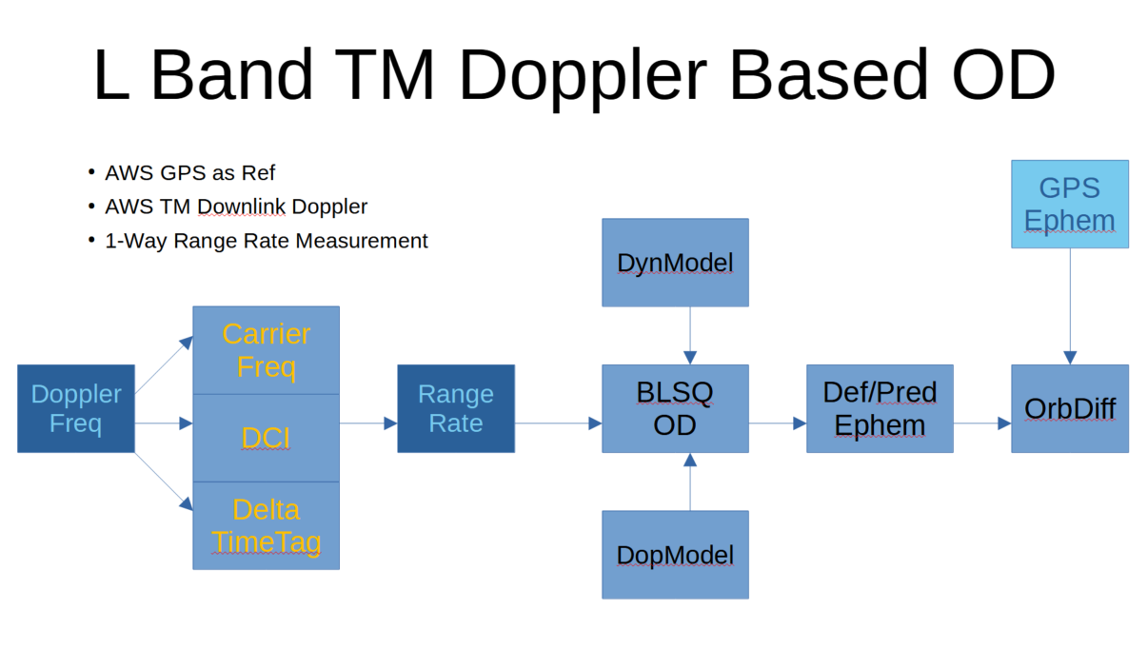Figure 1: Experimental scheme as complete reference for the PRF reception case; a PRF scenario lacks one or more pre-conditions, for example, frequency or initial state vector; the basic idea is to experimentally reduce the complete reference scenario by the various factors and find a solution to bridge the missing part/information

Among other missions, KSAT, at its own mission control center in Tromsø Satellite Operations Center, is operating the Arctic Weather Satellite proto-flight model (AWESAT-1) for ESA. To dump mission data down from the satellite, L band TM is collected over all daily passes at Svalbard’s SG109 antenna which is in use for the AWESAT-1 mission. Its nominal carrier frequency is specified by the satellite manufacturer as nominally being 1707 MHz.
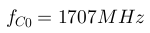
The Doppler effect adds up the carrier frequency offset that is obtained by simply assuming and subtracting a constant carrier frequency from the measured frequency at time of signal reception at the antenna feed.
To follow the above idea of building a complete (and full functional) reference scenario, it could be taken advantage of a flying satellite operated under TSOC responsibility.

At the example of AWESAT-1, Doppler frequency shift (or carrier frequency offset) data could be extracted from telemetry (TM) down-linked during passes over KSAT’s Svalbard station.

Through the TSOC Flight Dynamics (FD) team operationally used GPS data from AWESAT-1 are available, which provide a good reference for comparing OD that is based on extracted Doppler measurements (or carrier frequency offsets) with OD that is based on GPS point positioning data.

The available flight dynamics (sub-)system software GMAT is a suited processor of 1-way range rate data derived from the 1-way Doppler shift frequencies.

The operational carrier frequency offset data is stored in data bases accessible through KOGNI, the KSAT Operational Ground station Network Interface.
In particular, the information of interest in the framework of this part of the study is given through recordings of the parameter “avg_lr1_receiver1_actualCarrierFrequencyOffset”. It is stored chronologically as a measurement time series where time tags are given as Unix time stamps in the UTC time scale.

Conversion of the original measurement data is required to turn the data into the type and format that is used in GMAT to perform the OD. The data type imported to GMAT is 1-way Range Rate (RR) and the time tags are needed in the TAI scale (converted from original data given with UTC epochs).

The RR measurement type requires the specification of a Doppler count interval (DCI) since GMAT models the line-of-sight velocity as being a range difference that occurs during this count time interval.

For this (ideal) ‘measurement re-formulation’ the equation
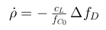

is applied, with

= 299792458 m/s.

The GMAT internal RR model requires a Doppler count interval (DCI) to be specified (communicated to the OD process through GMAT’s input tracking measurement data file (GMD). Here the relation
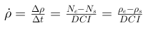

states the equivalent of a range rate as the measured Doppler frequency (counted Doppler). The numerator carries the difference of the counts at the end and the start of the DCI, respectively.

Here, the two RR equations above re set equal and so the range rate observation is directly deduced from the carrier frequency offset (Doppler shift).
Currently lacking detailed information about how the Doppler frequency gets extracted electronically in the ground station and since the Doppler measurements are provided every second, it is deemed a valid assumption to use a DCI of 1 second. Indeed, experimentally this proved to give the best results in terms of orbit differences with the referenced ‘GPS ephemeris’.

AWESAT-1 mission operations provides operational tracking data (GPS) and L band TM signal Doppler offset measurements being downlinked to Svalbard station SG109.

The used antenna at the SG109 Svalbard site was specified with the following coordinates (WGS-84 ellipsoid, angles in decimal degrees and altitude in km):

S109.Latitude = 78.228874;
S109.Longitude = 15.376932;
S109.Altitude = 0.463;

KOGNI provided Doppler offset measurements were re-formulated a range rate converted into GMD files (GMAT measurement data files)

The OD test scenario is set for spanning a single data arc of 1 day on 08 July 2025. It starts at 08:00 UTC and ranges until 09 July 2025 08:00 UTC. For this day – called the ‘test day’ in this report - GPS based OD is performed on 24 hours of evenly distributed data and forms the reference solution, while the Doppler based OD runs over the first 8 passes of that test day interval to form the test solution.

Comparing the two orbit solutions based on GPS and Doppler, here called GPS-OD and Doppler-OD, respectively. For OD the batch-least-squares (BLSQ) method has been utilized. For this to execute tracking Data will be collected and used for orbit parameters estimation post-hoc. The, in any case, past estimation epoch (and associated state vector) can be chosen, for example, at the beginning of the end of the data batch.

The graph shows a 4 days prediction from 8.7./9h to 12.7./9h that is generated upon the determined orbit for the test day. The definitive ephemeris is included in the comparison as the first day within the plot’s time axis interval.

In the first line, the overall result is as follows:

- The solution was experimentally ‘optimized’ in that an artificial time tag offset was found and applied (+0.707 seconds, while -350ms – mision-specific – were reported to be known as being offset). If not applied, the solution of the following graph changes into the graph shown below for the 8-passes Doppler solution in the chapter describing the outcome from the processing of fewer passes. It should be noted that this effect is a symptomatic one and the factual root cause of it is not yet known.
- it reveals mutually offset position solutions (the velocity components are ignored for the time being) between about 500m and 1km (oscillating with orbital cycle and alternating amplitudes).
- it is stable in the mutual predictive deviations over multiple days of propagation by lining up with the GPS solution except an offset for which one cause apparently is the eccentricity error remaining with the Doppler-OD.

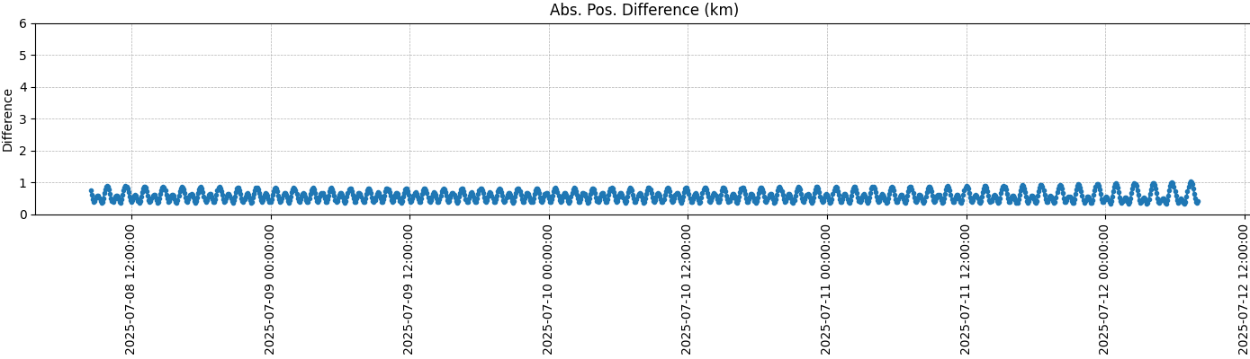Figure 2: Doppler-OD versus GPS-OD; comparison of definitive and predictive ephemerides
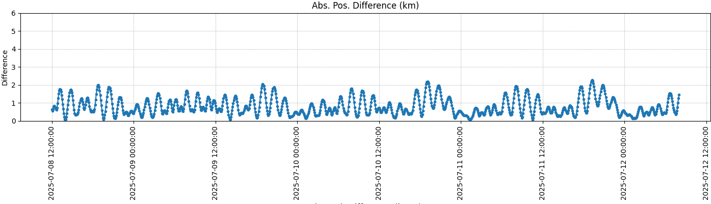Figure 3: Doppler-OD estim TLE versus GPS ephemeris

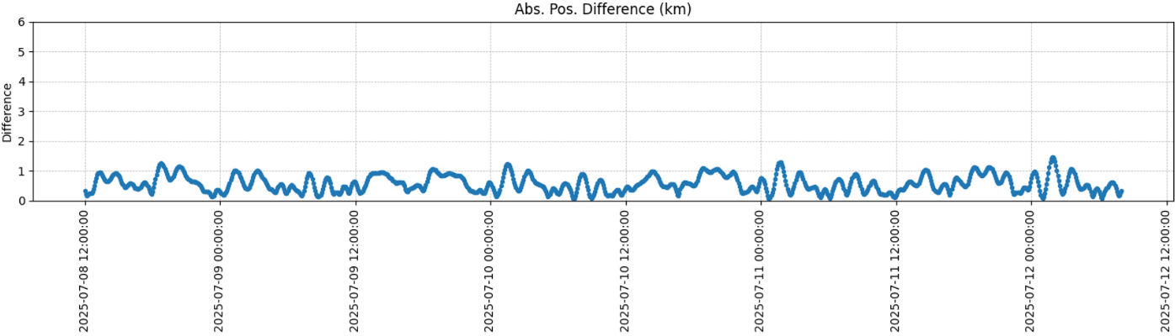Figure 4: GPS-OD estim TLE versus GPS ephemeris
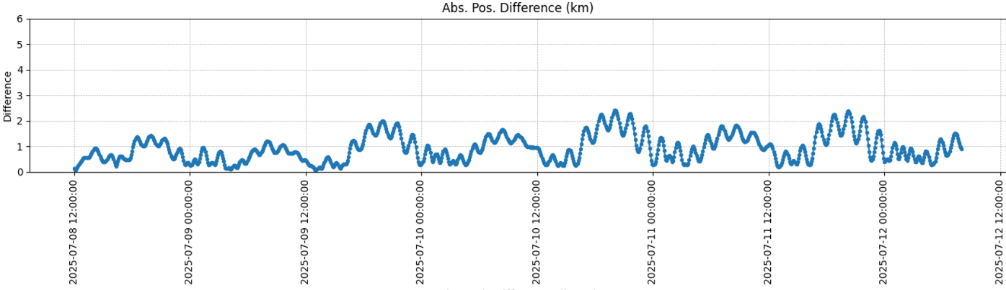
Figure 5: Celestrak TLE propagated ephemeris versus GPS-OD ephemeris

This result is the best achieved and was generated after the OD preparation phase was complete and settled after various trials needed to tune the OD processes setup and performance.

The preparation phase is just briefly summarized and included to properly setting up the satellite dynamics model and the measurement models to process GPS or Doppler data. Initial state vector estimation is common to both solutions (test and reference).

In addition, we are estimating a drag coefficient only for the GPS-OD, and pass-biases (assumed constant RR offsets as part of the measurements) only the Doppler measurement passes over the ground station.

Running the Doppler-OD leads to residuals (observed minus computed observations) as captured by the following image, and converged after 4 iterations:
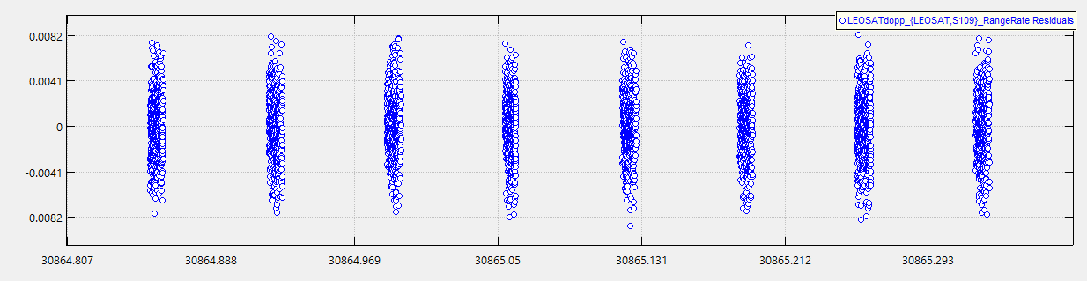

For this test solution (Doppler-OD scenario under test), here

Mean Standard Units
Data Type Total Accepted Percent Residual Deviation
--------------------------------------------------------------------- --------------------------- -----
RangeRate 4735 4683 98.90% 0.000008 0.002839 km/s

we see the quality of fit in terms of residuals. While mean value is close to zero standard deviation is on 3 m/s level for the line-of-sight tracking observation. This latter is a rather large noise figure. Using this point cloud as plot markers doesn’t reveal if any systematic feature can be discerned from the residuals, which would mean to see remaining modeling or measurement errors that could not be resolved by the BLSQ fit. If the pattern would be actually of the white noise type it would indicate that mainly measurement errors are the major cause the of the errors in the data fit.

The OD output file reports the following estimates for this Doppler-OD:

Estimation Epoch : 08 Jul 2025 08:00:03.000 UTC

State Component Units Current State Apriori State Standard Dev.

ECEF coordinates of estimated LEOSAT orbit
(curr. state) and Doppler measurement parameters:

LEOSAT.ECEF.X km -4849.69053402 -4849.50600000 1.20167631e-01
LEOSAT.ECEF.Y km -4173.14719993 -4173.16200000 1.36743298e-01
LEOSAT.ECEF.Z km -2801.25990126 -2800.71680000 1.64066735e-01
LEOSAT.ECEF.VX km/s -3.29328476 -3.29338840 1.68585508e-04
LEOSAT.ECEF.VY km/s -0.75840642 -0.75852606 1.24389672e-04
LEOSAT.ECEF.VZ km/s 6.84565633 6.84636960 2.12866122e-05
S109.LEOSAT_RealRangeRateErrors.PassBiases.1 km/s 0.99107792 1.00000000 1.13699260e-04
S109.LEOSAT_RealRangeRateErrors.PassBiases.2 km/s 0.93819980 1.00000000 1.01614856e-04
S109.LEOSAT_RealRangeRateErrors.PassBiases.3 km/s 0.82507857 1.00000000 9.45499441e-05
S109.LEOSAT_RealRangeRateErrors.PassBiases.4 km/s 0.72107247 1.00000000 1.00470841e-04
S109.LEOSAT_RealRangeRateErrors.PassBiases.5 km/s 1.11631255 1.00000000 9.00739102e-05
S109.LEOSAT_RealRangeRateErrors.PassBiases.6 km/s 1.11408551 1.00000000 9.29237552e-05
S109.LEOSAT_RealRangeRateErrors.PassBiases.7 km/s 1.03919775 1.00000000 8.76815365e-05
S109.LEOSAT_RealRangeRateErrors.PassBiases.8 km/s 0.97980826 1.00000000 1.09299344e-04

Orbit solution in EME2000 coordinates:

SMA km 6979.91881497 6980.54298930 6.73304641e-04
ECC 0.00099433 0.00087831 2.71648140e-06
INC deg 97.57311697 97.57294672 2.21291738e-04
RAAN deg 263.52984265 263.53168683 1.16573370e-03
AOP deg 106.30238744 101.11912134 5.37042429e-01
MA deg 229.92824128 235.11058783 5.35834247e-01

The propagation in the first image was based on this estimated state vector.

For the reference orbit, the GPS-OD produces the following position vector residuals, having reached converged loss function after 5 iterations:

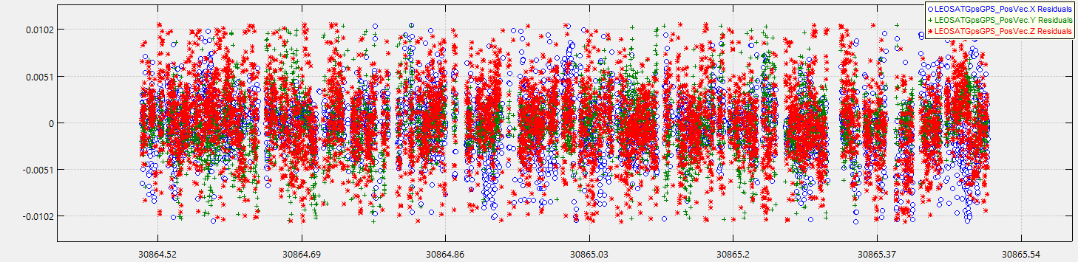

The (GPS point positioning) residuals statistics are as follows:

Mean Standard Units
Data Type Total Accepted Percent Residual Deviation
--------------------------------------------------------------------- -------------------------- -----
GPS_PosVec 6428 6179 96.13% -0.000100 0.004526 km

The residual observation errors (observed by GPS versus computed orbit position vectors) are of low decimeter level in its mean and about 4 to 5 m in its standard deviation.

Further Orbit Comparisons

For a more detailed results assessment regarding test versus reference the following FD analysis products have been generated:
- ORBDIFF(DOPOD vs GPSOD): a comparison of the two orbit ephemerides in RTN coordinates (again, only position difference for the time being)
- ORBDIFF(TLECEL vs GPSOD): a comparison with an SGP4 propagated TLE from Celestrak that was used to initialize the Doppler-OD
- ORBDIFF(ESTTLE vs GPSOD): a comparison with an SGP4 propagated TLE estimated from a 4 days predictive ephemeris that was propagated based on the GPS-OD
- ORBDIFF(ESTTLE vs TLECEL): a comparison of the two TLE propagations

A note to the TLE estimation step (d): the TLE estimator was borrowed from AWESAT-1 flight dynamics operations. Here is a connection point with future continuation: the estimation can be compared to one using the dSGP4 tool used in the associated summer camp project 2025!

a) RTN orbit difference Doppler-OD (test) minus GPS-OD (reference)

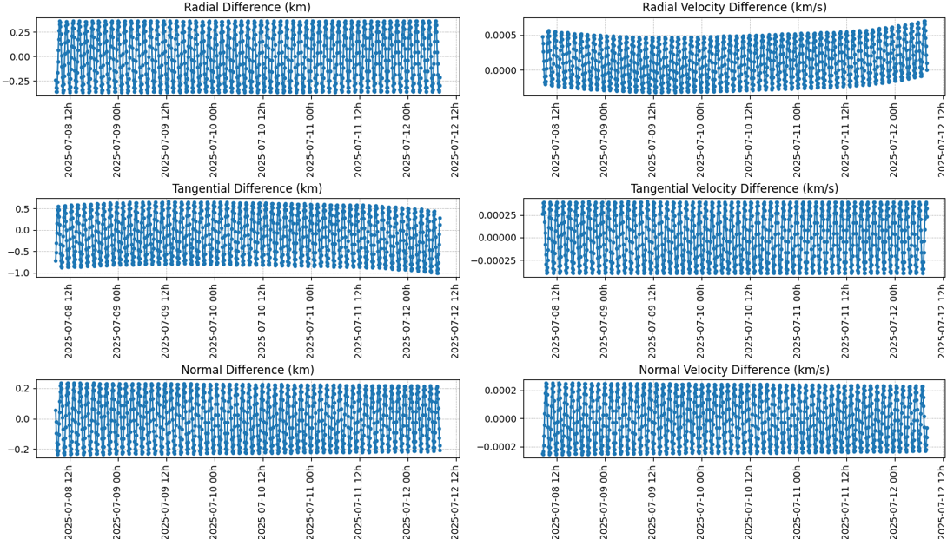

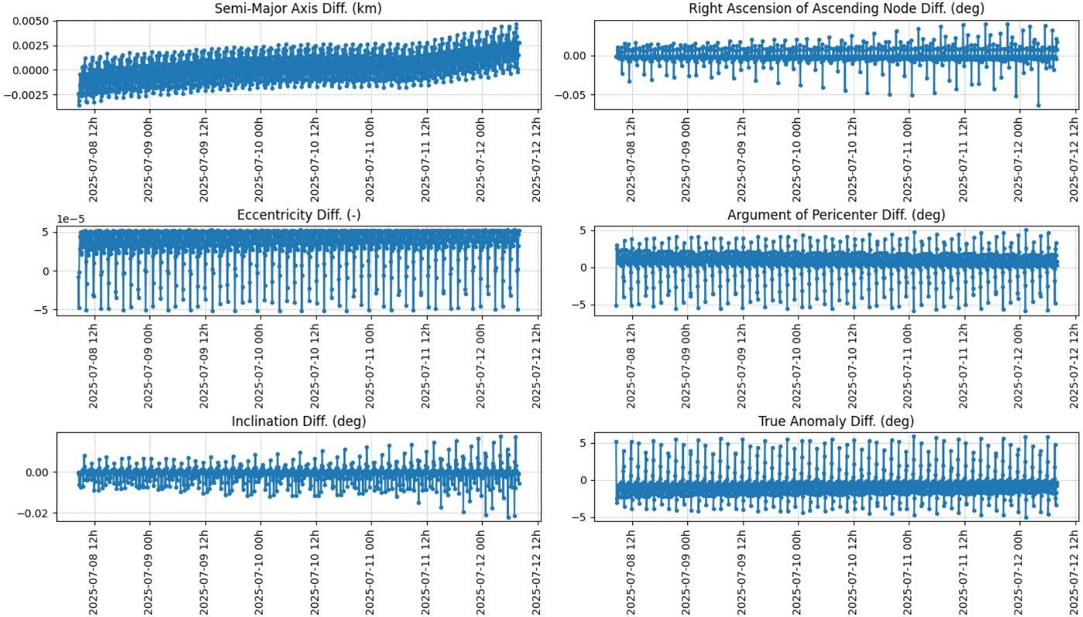

The SMA estimated in the Doppler-OD shows a small upward trend over 4 days. On the 4th day of prediction the SMA difference gradient starts to increase.

In the eccentricity difference a positive offset against the GPS-OD can be observed.

The difference of the inclinations is small and with zero mean.

b) Celestrak TLE propagated ephemeris versus GPS-OD ephemeris (ref.)

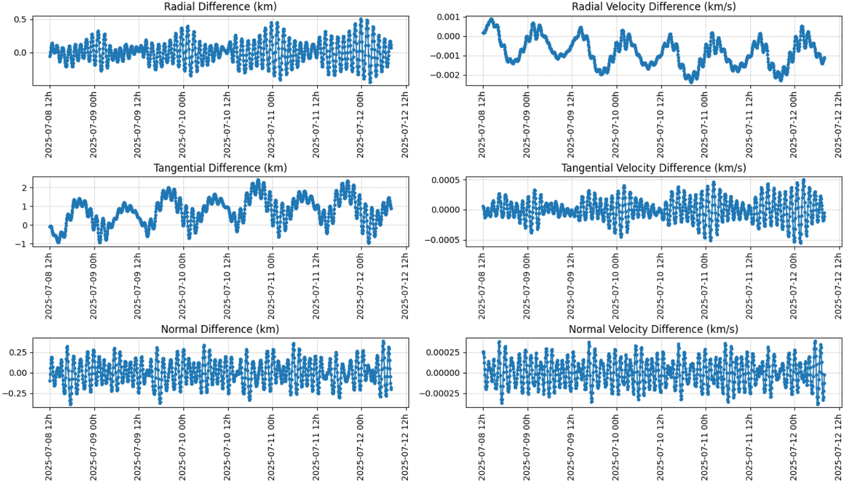

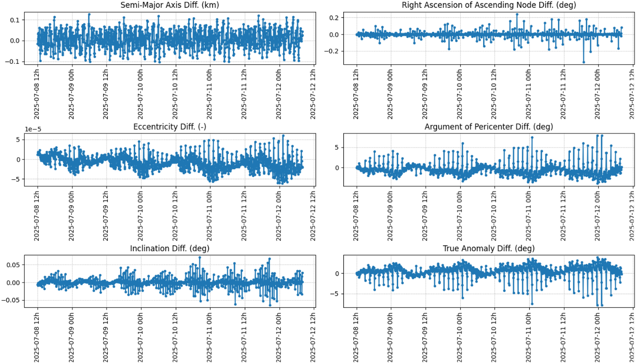
The typical error level of TLE based predictions are revelaed by these graphs.

c) Doppler-OD estimated TLE propagated ephemeris versus GPS-OD (ref.) ephemeris

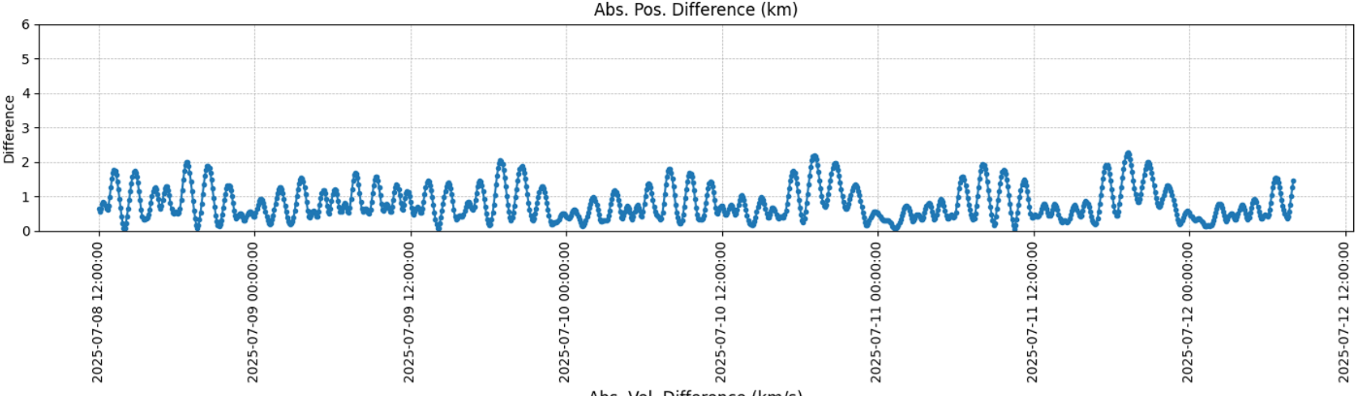
Abs. position diff.: Error bounding improved (more stable mid-term propagation) as compared to (b), but biased by an absolute average position error approaching 1 km level.

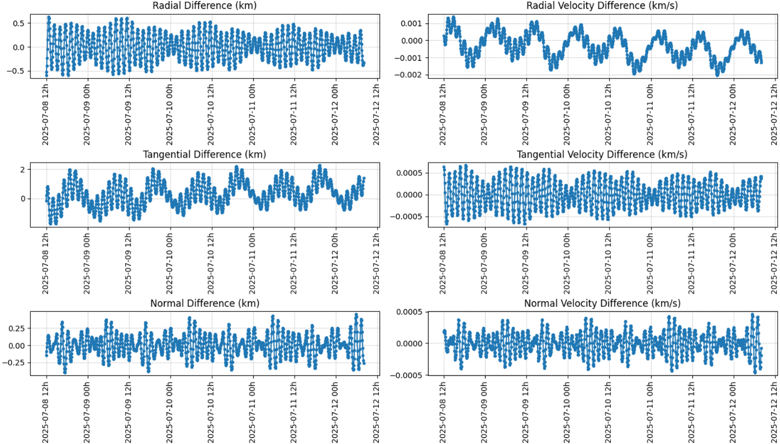

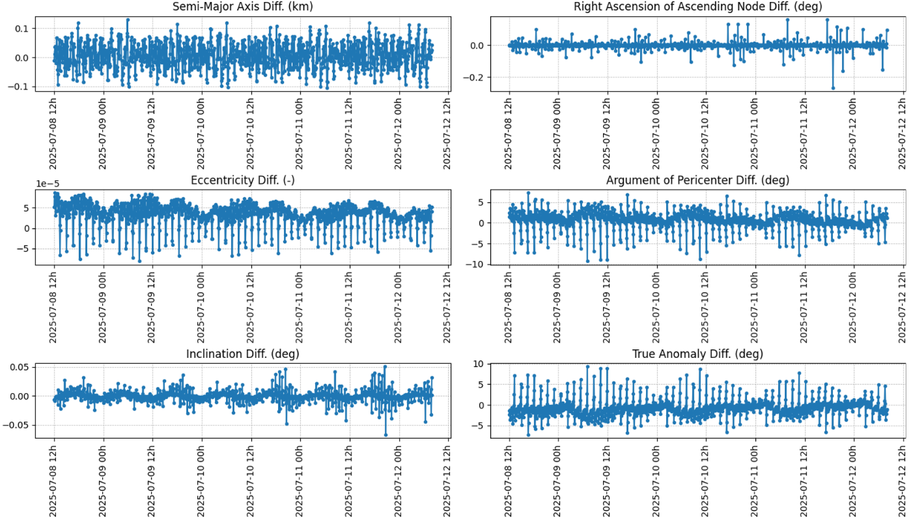

d) Estimated TLE/SGP4 ephemeris versus propagated Celestrak TLE ephemeris

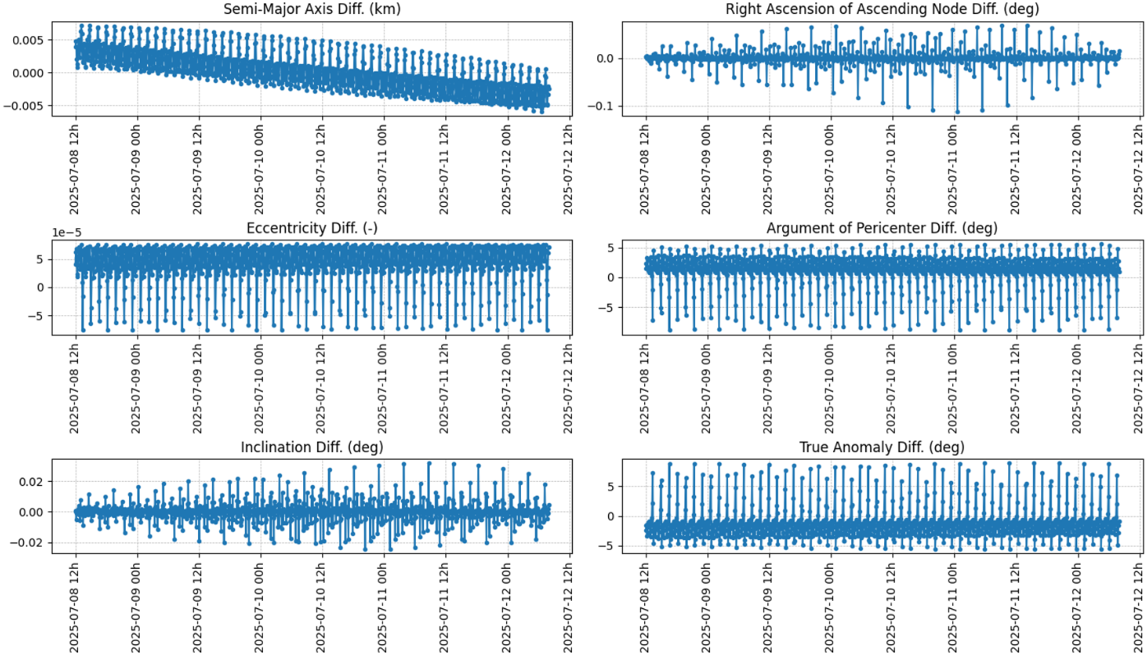

Obvious is a small mean eccentricity error, which is also existent when comparing the Doppler-OD estimated TLE with the GPS-OD ephemeris in case (d), or the Doppler-OD with the GPS-OD in (a).

Observations and Workarounds

Time Tagging

The first attempts to fit the orbit model ended up with an absolute position error at the level of about 5 km. This led to consider checking out the possibility of a timing bias in the measurement epochs. A manual action to search for a potential time tag error search was performed which was oriented at the semi-major axis, i.e. it aimed at minimizing the SMA difference with respect to the GPS-OD ephemeris. See graph below.

With a time offset of 0.707 seconds, added up to the logged observation UTC epoch, the minimum solution for the SMA difference apparently was about 36 cm.

Later it was reported that actually a time offset is applied to the actual measurement time tag. The delta time that was added is 350 ms and would have to be subtracted from the logged observation epoch.

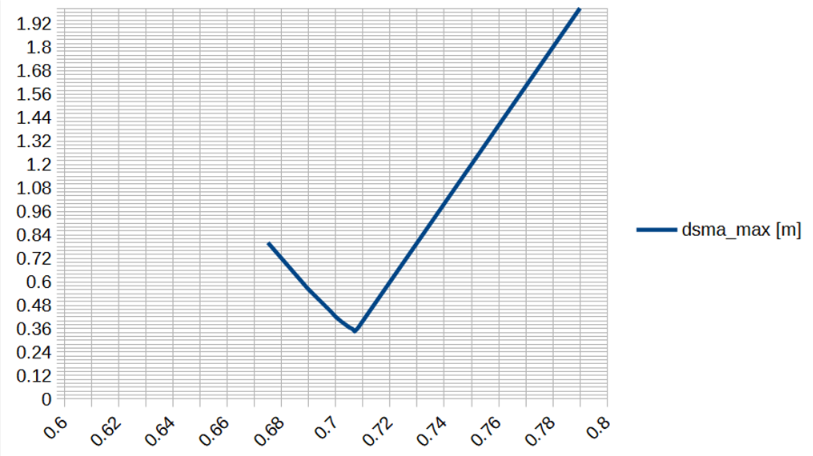
x-axis: experimentally applied time tag offset (added)
y-axis: resulting SMA error when compared to reference from GPS-OD

To be noted: The attempt to add 0.707 seconds still leads to the best Doppler-OD solution as compared to the reference ephemeris. By contrast, only subtracting 0.350 s worsens the consistency instead.

Pass-Biases

The Doppler-OD process only works when applying pass-bias estimation. A single bias to be estimated does not suffice.

This leads to questioning the satellite onboard frequency stability by observing exponentially changing pass-biases. See images below. It needs to be noted that pass-bias estimation is not covering drift (bias rate). The level of estimated biases found is 1 km/s in range rate. This translates into a constant frequency bias of

1 km/s * 1707000000 Hz / 299792.458 km/s = 5693.939 Hz

according to the formula that converts Doppler velocity into Doppler frequency shift, or vice versa.

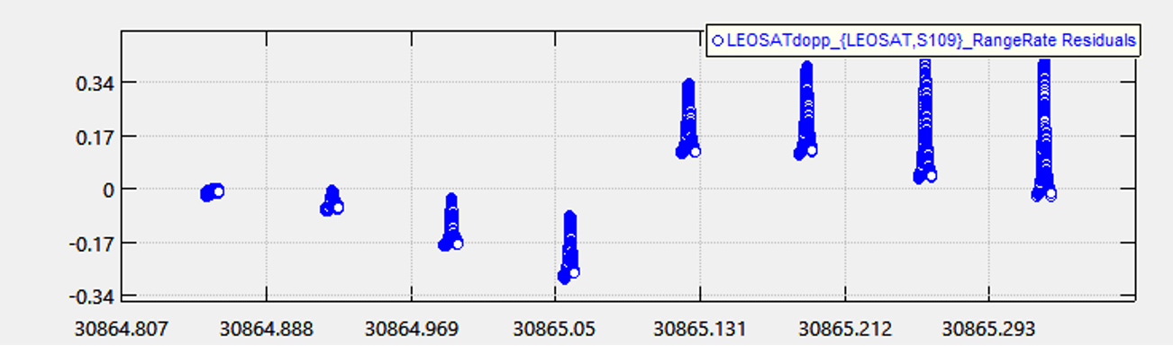
A priori PB set (1 km/s):

A priori PB = 0 km/s:
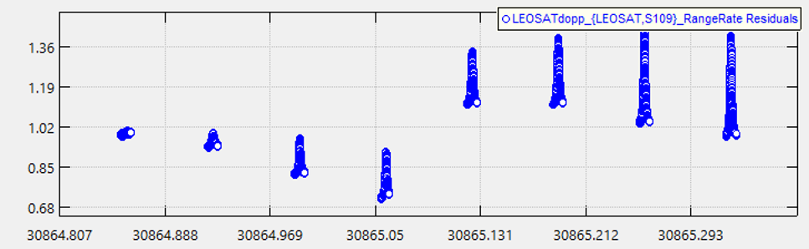

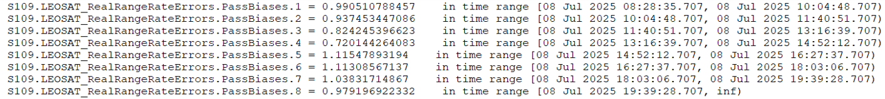
In this listing of the estimated PBs the times on the right-hand-side indicate the start of a pass until the start of the next pass. The variations of the pass bias estimations correspond with the above picture that shows the very first (0-th) iteration before any update is applied by the BLSQ process, i.e. the residuals based on the a priori settings (0 or 1 km/s).

Testing shorter arc (1 > N_passes <= 8) orbit determinations (no time tag correction)

Absolut position comparing 8-passes-estimation with estimated GPS reference. The accuracy is degraded as compared with testing an empirical correction on the Doppler measurement time tags of +0.707 seconds:

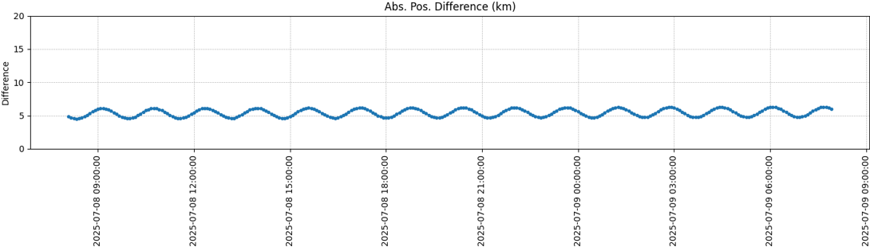

Absolut position comparing 7-passes-estimation with estimated GPS reference:
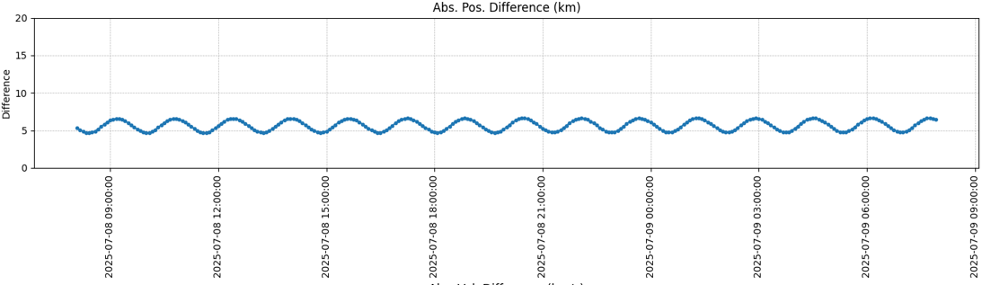

Absolut position comparing 6-passes-estimation with estimated GPS reference:
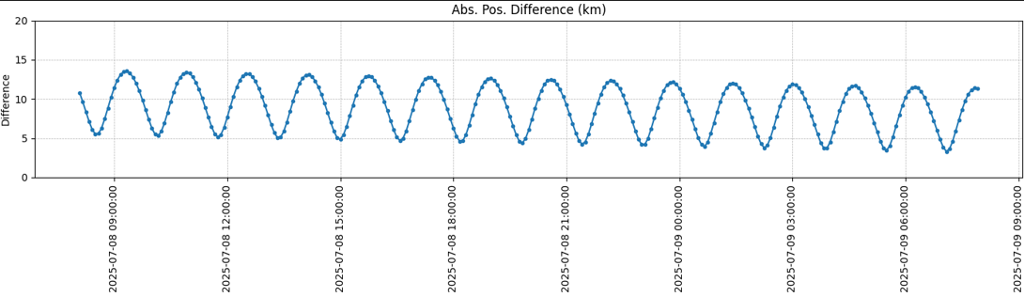

Absolut position comparing 5-passes-estimation with estimated GPS reference:
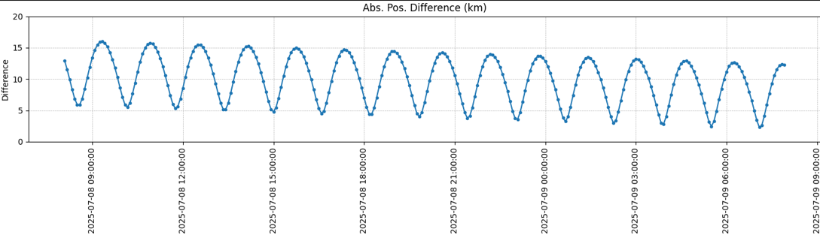
Absolut position comparing 4-passes-estimation with estimated GPS reference:
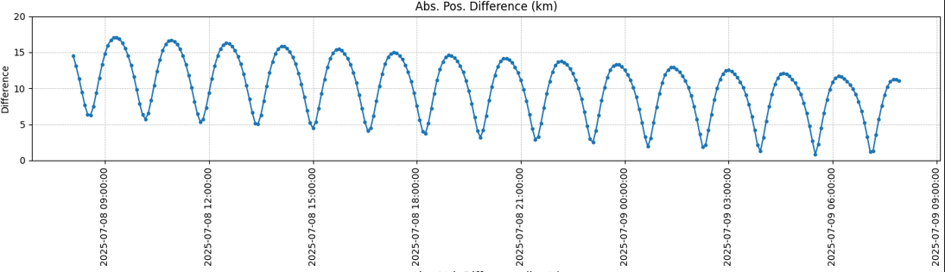

Solution accuracies for the cases of 3 or 2 passes of data go beyond 20 km position errors. For achieving a coverged solution it is required to accumulate at least 2 passes of data. Employing a single pass only leads to divergence when using the batch least-squares based OD method.

The lower limit for highest possible orbit reconstruction accuracy is found with 7 passess as a minimum.

Summary

A test scenario has been defined and called ‘Doppler-OD’, executed at the example of Arctic Weather Satellite (AWESAT-1). It is meant to be a complete reference case (about to be established, see Outlook chapter), since all information/data required to run an OD process is available.

AWESAT-1 TM data signals were used as input for a full-numerical, high-fidelity dynamics based batch least-squares estimator, realized through the NSAS-funded and operationally validated and used GMAT software. This data originates from carrier frequency offset extractions from L band downlink signals, collected in KOGNI. These extractions denote Doppler frequency shift data when considering the transmission frequency to be exactly known.

For the transmission frequency deviating from the nominal specified, the only estimate that can be made in the frame of the OD/BLSQ process is to define pass biases that get estimated alongside the initial state vector. This estimates compensate for irregular frequency variations or other effects perturbing the theoretical measurement. However, they principally cannot not cope with frequency rates/drifts (time varying frequencies) throughout the time span of employed pass data, if such effects are present from the generation of the signal.

Orbit determination proves possible using extracted Doppler data, modelled as range rate. An experimentally found time offset was found that apparently lowers position accuracy to sub-kilometer level in the prediction over

Outlook

Analyzing orbit determination capability as one option to exploit PRF signals arriving at ground stations lead to the task to first establish a general test in the full cooperative sense. The test incorporated signal and orbit knowledge that is not expected to be available in the scenarios of interest in the frame of SSA/SDA. The full-cooperative test case instead allowed, by using real mission data as reference, to establish a reference scenarion for non-cooperative cases, a reference scenarios that can now be derived from successively cutting down techincal information (reducing knowledge of the received PRF signal) to investigate cases where only parts of information for tracking and orbit determination might be available. However, before running into such scenarios of interest, the tests done here at first revealed further need to investigate and understand timing and other modelling characteristics before drawing a complete conclusion of useability and limitations of Doppler data for the underlying type of OD scenarios. The proposed next step therefore is to investigate further (and different) mission data as soon as there is the readily provided opportunity as referred to data availabilities. The goal for such extensions would be to answer open questions regarding timing and modelling. Looking at the remaining apparent errors form the comparison of Doppler-OD based with GPS-OD based orbit solutions (ephemerides), there may already indications what kind of errors could be expected if correctnes of frequency and time tagging is doubted. In order to finally precisely knowing that the designed reference Doppler-OD solution of a full-cooperative (or operational and therefore intended full-info tracking scenario) is a sufficiently good one, the open questions still need to be answered. Can Doppler-OD in this sense – to serve a feasible and best case reference – be verified, this would pave the way to further ask for the incomplete knowledge scenarios that lack in having information about various parts in the (kind of nominal) reference processing chain that aims at orbit determination from PRF Doppler frequency signals.

