Passive-Doppler performance: May LEOP, NOSA study and ICSSA report

1. Purpose and evidence
Passive reception of spacecraft carriers provides orbit information using existing ground-station equipment. The NOSA study and ICSSA report examine observations from established operations with useful trajectory priors. The May LEOP campaign examines recovery and refinement using approximate pre-launch and improved post-separation orbits. Together these cases establish practical performance targets for WP2000 and demonstrate the method required for Milestone 1.
Both the NOSA study and ICSSA report [1] corrected measurement timing using GPS-referenced information. The May LEOP analysis evaluates single-pass and multi-pass estimation, burst-radio noise, prior quality and force-model sensitivity. The datasets, comparison windows and numerical results are described below.

2. Estimation from passive Doppler
The observable is the carrier-frequency shift caused by relative spacecraft–station motion. In a common inertial frame, the predicted shift is:
$${\hat{d}}_{i} = −\frac{f_{c}}{c}\frac{{\left(r_{i} − r_{g,i}\right)}^{T}\left(v_{i} − v_{g,i}\right)}{\left\|r_{i} − r_{g,i}\right\|} + b_{p(i)}\text{ (1)}$$
Here f_c is nominal carrier frequency, c is light speed, r and v describe spacecraft position and velocity, and subscript g denotes the receiving station. The scalar b is a constant frequency bias estimated separately for each pass. Receding motion gives negative Doppler under this convention. The bias accommodates approximately constant transmitter or receiver frequency offsets; variations within a pass can remain as model error.
The May LEOP forecast comparison uses three estimation methods. Timing correction adjusts the spacecraft’s progression along its SGP4 orbit while keeping observation timestamps fixed. SGP4 L+n correction estimates mean longitude and mean motion, preserving the prior’s shape and plane. Cartesian full-state estimation adjusts all three position and velocity components. Orbital timing correction and the measurement-time calibration used in the NOSA study and ICSSA report address different sources of timing error.
All three methods estimate pass biases alongside the orbit parameters using bounded robust least squares. Signal-quality screening and a soft-L1 loss reduce the influence of contaminated burst-radio observations. Timing and L+n acceptance additionally checks convergence, parameter bounds and measurement sensitivity. Full-state results retain diagnostics without applying that acceptance screen.

3. Accuracy, acquisition time and prediction horizon
The proposed targets are engineering performance levels chosen from the demonstrated results with practical margin. Let t₀ be completion of the first pass satisfying the orbit-fit observation gates, and t_d actual product delivery. Acquisition time is t_d − t₀, including further passes and processing. Record completion of the latest fitted pass, t_last, delivery latency and separation-to-delivery time separately.
For each delivered product, evaluate three-dimensional position-vector RMSE against an independent reference:
$$E_{r} = \sqrt{\frac{1}{K}\sum_{k = 1}^{K}{{\left\|r_{fit}\left(t_{k}\right) − r_{GPS}\left(t_{k}\right)\right\|}^{2}}}\text{ (2)}$$
Use K = 60 UTC whole-minute epochs in (t_d, t_d + 1 hour], identical epochs for prediction and reference, GCRF coordinates and kilometres. Hold the delivered orbit, timing correction and propagation settings fixed. Require reference coverage of the complete interval and every scoring epoch; otherwise label the result unscorable. Reference observations are evaluation data, not additional measurements for fitting that delivered product. Report maximum sampled position error separately, since RMSE does not bound every instantaneous error.
For example, if the first usable pass ends at 08:00 and delivery occurs at 18:00, acquisition takes ten hours. The accuracy score uses 18:01–19:00. A twelve-hour acquisition allowance therefore does not imply twelve hours of prediction accuracy.
The May LEOP replay sets t_d = t_last. Its 242 scored forecasts each contain 60 one-minute samples; twelve forecasts lack complete reference coverage. Operational delays require rescoring after actual delivery. Longer-term performance uses separate one-hour windows ending 6, 12 and 24 hours after delivery, keeping the original product fixed. Record prior epoch, product age and forecast interval with each result.
Those windows span delivery plus 5–6, 11–12 and 23–24 hours, excluding each start and including its endpoint. Apply the same sampling and reference requirements, and evaluate replacement products separately. Reference identity and quality establish the uncertainty of the comparison trajectory.

4. NOSA study and ICSSA report: timing-calibrated performance
The NOSA study used Arctic Weather Satellite telemetry from AWESAT-1, received at Svalbard’s SG109 antenna with a nominal 1707 MHz carrier. Carrier-frequency offsets were converted to one-way range rate for GMAT batch least-squares estimation. The experiment covered 8 July 2025, 08:00 UTC to 9 July, 08:00 UTC. GPS-based orbit determination used the full day as reference; Doppler estimation used the first eight passes. A CelesTrak TLE initialized the Doppler solution.
The estimator fitted Cartesian state and one constant range-rate bias per pass. The GPS-reference fit also estimated drag. The eight-pass Doppler solution accepted 4,683 of 4,735 observations, with approximately 2.84 m/s range-rate residual standard deviation.
The best reported orbit comparison showed approximately 0.5–1 km position differences, with orbital-period oscillations, across a four-day plotted interval beginning on 8 July at 09:00 UTC. This demonstrates close agreement between the Doppler and GPS-derived trajectories. The interval combines reconstruction and prediction; beyond the GPS fitting interval, it compares propagated solutions. These trajectory differences retain that definition, separately from the new first-hour delivery KPI.
Timing calibration was decisive. Initial solutions differed by about 5 km; an empirical +0.707-second measurement-time adjustment, identified against the GPS-derived orbit, enabled the approximately 0.5–1 km result. A reported 350-millisecond offset did not fully explain the optimum, but the experiment directly demonstrated the performance impact of timing errors. Per-pass frequency biases were also necessary. The poorer uncorrected shorter-arc results emphasize the need to calibrate timing before judging achievable Doppler accuracy.
The ICSSA report analysed 26 observation passes collected over 48 hours in November 2025. GPS-referenced preprocessing corrected system timing errors. Per-pass timing and frequency offsets were characterized, with timing drift of order 100 milliseconds identified as the primary operational residual-error source. The orbit-estimation results describe performance with this calibration applied [1].
For L+n estimation, ICSSA reports mean one-hour forecast RMSE of 0.84 ± 0.52 km with two passes and 0.69 ± 0.33 km with five passes. The ± terms are reported standard deviations. Its corresponding 24-hour results were 4.41 ± 3.35 km and 2.58 ± 0.72 km, reinforcing the distinction between short-term accuracy and longer prediction. These are the paper’s forecast metrics, not measured product-delivery times.
The NOSA study and ICSSA report both identify system timing error as the principal practical residual-error source and demonstrate substantially better accuracy after correction. GPS supports timing calibration and evaluation; Doppler supplies the orbit-estimation observations. Calibration must remain valid across passes and hardware configurations.

5. May LEOP: burst-radio processing, recovery and refinement
Four OroraTech spacecraft, numbered 16–19, were observed during the May LEOP campaign on 3–4 May 2026. Two fixed prior categories were evaluated: approximate pre-launch trajectories, with median initial next-hour position errors near 549 km at cumulative checkpoints, and post-separation updates, with corresponding errors near 9 km. Their nearly identical orbital epochs allow comparison of prior quality without attributing the difference to TLE age.
A broader noise characterization of the same spacecraft used two-component Gaussian-mixture models fitted to pass residuals. Across 527 contacts, 817 retained mixture components were clustered into narrow and broad groups. The narrow group contained 685 components, with group-average means of −180.55 Hz and standard deviations of 351.24 Hz. The broad group contained 78 components, averaging +654.08 Hz and 29,770.65 Hz respectively; 54 components remained ungrouped. These are averages of fitted component parameters. The broad group was associated with short contacts in the receiver configuration. The separation supports robust estimation and pass-quality screening.
Single-pass time-offset characterization fitted a time shift within ±120 seconds and frequency bias within ±100 kHz. A soft-L1 loss with a 700 Hz transition accommodated the broad residual population. Screening required at least 250 accepted measurements, offset variance no greater than 15 s², convergence, full Jacobian rank and inactive parameter bounds. Selected passes achieved sub-kilometre position RMSE over an hour around the fitted epoch. These local reconstruction results demonstrate useful single-pass correction; the acquisition targets below use the separate hour following solution availability.
In the forecast comparison, each fit started independently from its category’s source prior. GPS positions were reserved for evaluation; GPS provenance of the supplied priors is unknown. Reference validation errors were 35–83 m for spacecraft 16–18. Spacecraft 19 reached 167 m, exceeding the 100 m acceptance threshold, and retains a candidate reference. All 254 fits converged and 242 had complete forecast reference coverage.
Orbit-fitting gates retained 8, 9, 8 and 10 passes for spacecraft 16–19; timing gates retained 3, 3, 6 and 3. Timing used single and cumulative passes, L+n used cumulative or rolling three-pass windows, and full-state fitting was cumulative.
Prior and method | Population | Median next-hour RMSE
Pre-launch, cumulative full state | 32 scored fits | 11.7 km
Pre-launch, cumulative full state | 15 scored fits using at least six passes | 8.5 km
Updated prior, cumulative L+n | 32 scored fits | 3.5 km
Updated prior, cumulative L+n | 25 quality-accepted fits | 2.7 km
Full-state estimation provides approximately 10 km recovery from the poor prior once sufficient observations accumulate. Earlier solutions can remain thousands of kilometres wrong because short Doppler arcs weakly constrain combinations of orbit state and frequency bias. L+n retains useful geometry and is effective for refinement: it improved the informed prior in 26 of 32 scored fits. The accepted subset’s 90th-percentile error was 8.8 km, showing why its 2.7 km median is not a general accuracy bound.
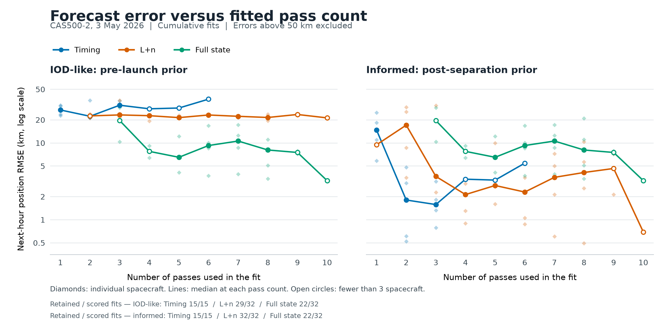
Figure 1. May LEOP cumulative next-hour error versus pass count. The figure excludes errors above 50 km; target assessments and tabulated populations retain them. Open circles indicate fewer than three contributing spacecraft.
The proposed targets include margin above the demonstrated campaign results. They describe feasible engineering performance for the stated prior and observation conditions:
Suggested target | Evidence and assessment
Informed prior: ≤5 km first-hour RMSE; delivery within 12 hours of the first usable pass. | All four spacecraft demonstrated first accepted errors of 1.31–3.52 km after 3.0–8.7 hours, using 2–5 passes.
Timing correction: ≤4 km first-hour RMSE after three eligible passes with suitable prior geometry. | All four spacecraft demonstrated 0.79–3.15 km, with a 1.6 km median. Typical performance was better than 2 km.
IOD-like recovery: ≤10 km first-hour RMSE; delivery within 20 hours of the first usable pass. | All four spacecraft reached the threshold within 16.3 hours, leaving more than three hours of time margin.
A correctly associated Space-Track TLE with an original epoch less than 24 hours old at first use is an example of an informed prior with useful geometry. IOD-like recovery assumes an approximate trajectory. The timing target uses cumulative correction after three passes; its 4 km level provides margin above the largest observed error without changing the per-product RMSE metric. The 20-hour IOD allowance provides margin above the latest threshold acquisition at 16.23 hours.
Acquisition and continued accuracy remain separate: 17 of 25 accepted informed-prior updates were within 5 km, while 22 of 22 with at least four eligible passes were within 12 km. This supports a wider allowance if a future service also specifies continued-update accuracy. The present targets are demonstrated campaign capabilities; additional spacecraft, measured delivery latency and automatic full-state acceptance will establish operational reliability.

6. Force model and forecast-error growth
The Cartesian force model includes degree/order-four Earth gravity, Sun and Moon attraction, tides and relativistic corrections. A 546-fit comparison evaluated no drag, three prescribed drag coefficients, jointly estimated drag, and SGP4 with fixed or estimated B*. Each variant used all-pass fits and leave-one-pass-out validation on the same observations and two prior categories.
Prescribed C_D A/m values of 0.01, 0.02 and 0.04 m²/kg changed next-hour position RMSE by less than 0.25 km relative to no drag across all four spacecraft and both priors. Joint estimates over 0–0.2 m²/kg approached the bounds without consistent predictive improvement. Mean held-out Doppler shape accuracy also showed no improvement with prescribed drag.
Each validation fit excluded one complete pass. Shape RMSE removed that held-out pass’s mean residual for scoring only, isolating variation in the Doppler curve from its constant frequency offset.
Atmospheric density used NRLMSISE-00 with F10.7 = F10.7A = 150 and Ap = 4; the fitted coefficient therefore absorbs density-model error as well as spacecraft properties. The approximately one-day arcs support the no-drag model for the stated LEOP accuracy and forecast horizon. Longer arcs may improve separation of drag, initial-state error and pass biases. The results justify the short-arc force-model choice without assigning a universal drag-observability threshold.
The selected best next-hour examples achieved 3.24 km for spacecraft 19 full-state recovery and 0.48 km for spacecraft 16 rolling L+n refinement. Propagating those same fixed products without further updates gave final-hour errors of 26.3 and 25.0 km, approximately 30–33 hours after availability. Growth was predominantly in-track, consistent with accumulating orbital-phase error.
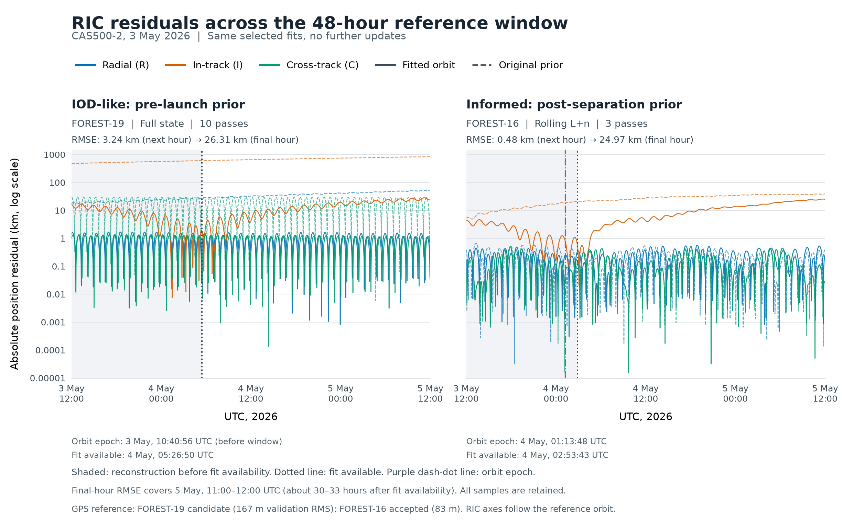
Figure 2. May LEOP selected products across the 48-hour GPS-reference interval. Shading indicates reconstruction before availability; later times are prediction. Final-hour scores cover 5 May, 11:00–12:00 UTC. Spacecraft 19 uses the candidate reference.

7. Milestone interpretation
The NOSA study, ICSSA report and May LEOP campaign demonstrate the passive-Doppler capability required for WP2000. Timing calibration and useful priors enable approximately kilometre and sub-kilometre performance. The May LEOP results support 5 km refinement, 4 km three-pass timing correction with typical accuracy near 2 km, and 10 km IOD recovery within 20 hours across all four spacecraft in replay. Maintaining timing calibration and verifying delivery and acceptance procedures will carry that estimation performance into operations.

References
[1] Johansen, Tauge, Hollosi and Schulte, Orbit Determination from Passive RF Measurements: Low-Cost Implementation, Differentiable Propagation, and ML-Driven Accuracy Improvements, IAA-ICSSA-26-04-07. One-hour and 24-hour forecast statistics: Table 5.

