Programmed robot trajectory
Planned motion and interpretation of simulation results
Starting at rest at (x, y) = (0, 0) and zero yaw, the robot is commanded to drive forward, turn left in place, then drive forward again.

Planned sequence
Time (s, rounded) | Command
0–4.00 | Remain stationary
4.00–7.33 | Drive 0.5 m forward at 0.15 m/s
7.33–7.83 | Pause
7.83–10.97 | Turn 90° counterclockwise at 0.5 rad/s
10.97–11.47 | Pause
11.47–14.81 | Drive another 0.5 m forward at 0.15 m/s
14.81–15.81 | Stop and allow the wheel response to settle
Ideal tracking produces an L-shaped path ending at (0.5, 0.5) m, with 1 m signed accumulated distance and 90° yaw. Motion durations follow commanded distance/speed and angle/yaw rate.

Simulated motion
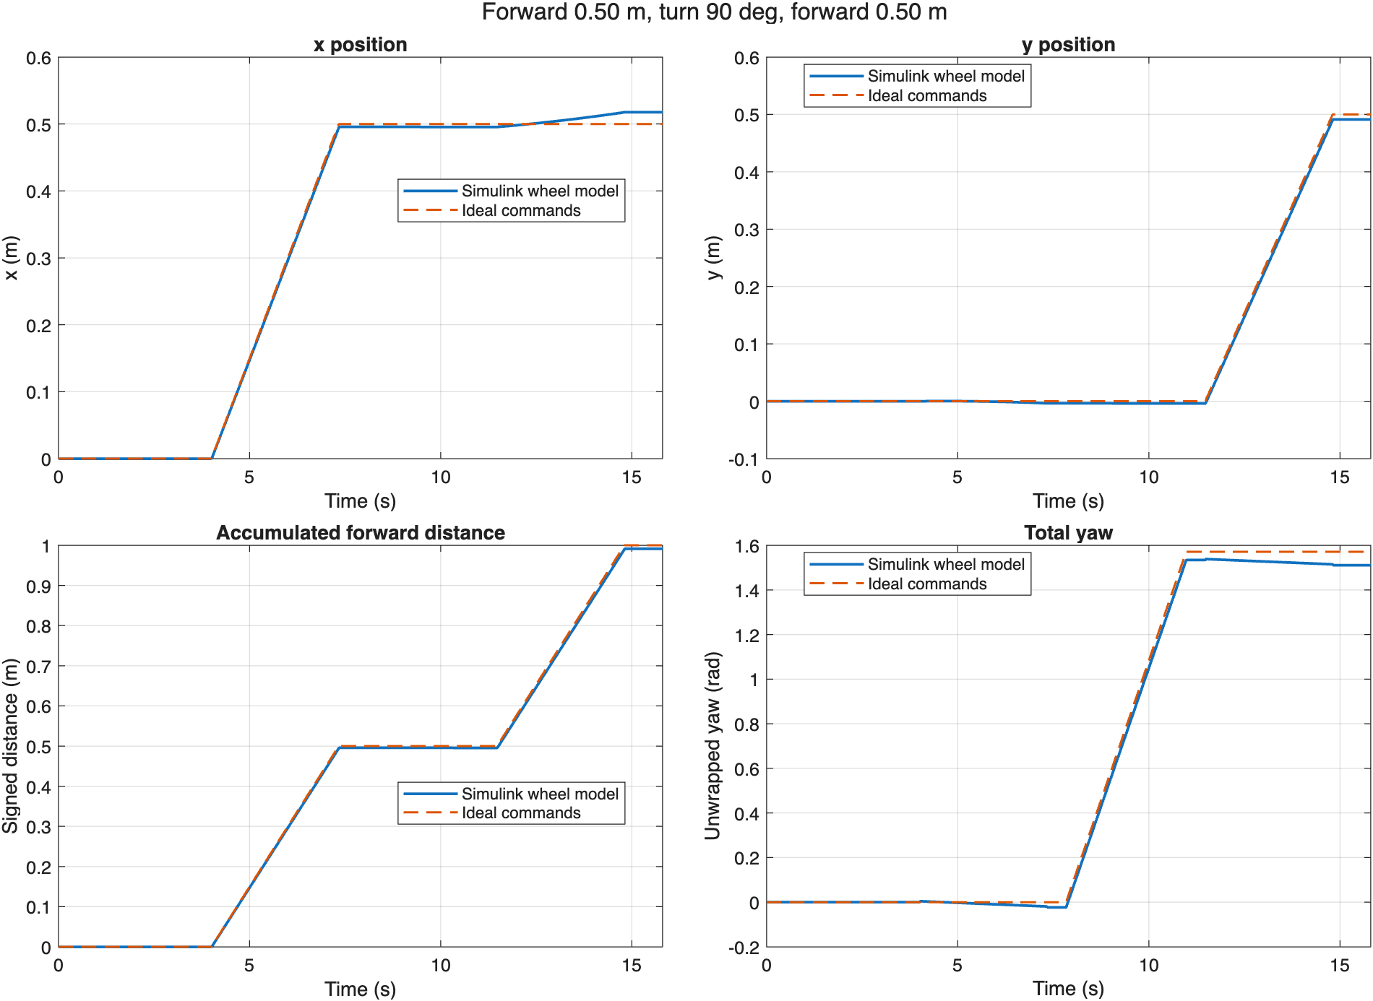
Figure 1. Position, signed forward distance and total yaw over time. Solid blue curves show the simulated wheel response; dashed orange curves show perfect command tracking.

Interpreting the four plots
The simulation uses the existing two-wheel model and tuned proportional speed controllers. All horizontal axes show time in seconds. Position is expressed in a fixed frame: +x points initially forward and +y initially left.
x position (m). It rises during the first straight and should remain approximately constant during the second straight. A small later increase indicates that the robot has not turned through the full commanded angle.
y position (m). It remains near zero during the first straight and rises during the second. Small departures from zero before the turn indicate heading drift.
Signed accumulated distance (m). It integrates actual forward velocity, increasing during both forward segments and remaining approximately flat during the turn and pauses. Reverse motion would subtract from it. It differs from displacement between the start and end positions.
Total yaw (rad). Positive yaw is counterclockwise. The in-place turn should increase it to π/2 rad (90°). Yaw remains unwrapped, without resetting at the end of a turn or at a full revolution.

Final results
At the end of the 15.81-second default simulation:
Quantity | Ideal | Simulated | Difference
x | 0.500 m | 0.518 m | +0.018 m
y | 0.500 m | 0.491 m | −0.009 m
Signed distance | 1.000 m | 0.991 m | −0.009 m
Yaw | 90.00° | 86.54° | −3.46°
Differences are simulated minus ideal. The yaw plot uses radians; its final simulated value is 1.510 rad. Values in the table are rounded.
The simulated robot travels slightly less than commanded and finishes about 3.46° short of the desired heading. The resulting heading error causes x to increase slightly during the second straight. Yaw drift during straight driving reflects unequal actual wheel speeds.

What the results mean
Departures from the ideal curves reflect wheel transients and unequal steady tracking errors in the two proportional controllers. The trajectory uses timed commands without an outer position or heading feedback loop, so accumulated errors are not corrected.
These results are predictions of wheel-based odometry. The model does not include wheel slip or external localization; measured motion on a physical robot may differ.

