Combustion Model for PMMA in Hot Stagnation-point Flow
Includes investigation of extinction limits for the stretch rate and oxygen mass fraction
Phoebe Stierhoff
Case Western Reserve University

Abstract
In this numerical experiment, the ignition of PMMA when subjected to a hot convective stream at 1000K is investigated. Using the methods described in Tien et al. (1978) with some modifications to account for the heat up and pyrolysis of the solid fuel, a reaction profile is developed and propagated to steady state. In particular, the effect of the stretch rate and the initial oxygen mass fraction on ignition time delay, extinction limits, and temperature are computed and discussed. It was found that either lowering the stretch rate or increasing the oxygen percentage significantly accelerated the ignition process, while sufficiently high stretch rates and low oxygen limits produced no reaction at all.
- Methods
1.1 Theory
The first important set of equations are the solid heat up equations (1 and 2) where S is the non-dimensional radiative heat loss parameter, L is the non-dimensional latent heat, h is the non-dimensional convective heat loss parameter, and A is the pre-exponential term for pyrolysis and is defined in equation 4. These determine the temperature of the wall and the burning rate, both of which are very important in the ignition process. The burning rate is related to the mass flow rate of the combustible gas by equation 3. Once the wall temperature becomes high enough, pyrolysis can begin, providing combustable material to the system.
(1)
(2)
(3)
(4)
Different equations are used to describe the heating up and combustion of the gas. Equations 4 through 8 describe the temperature, fuel, oxidizer, and velocity profiles for a gaseous system. 4-6 are dependent on the reaction rate w, defined in equation 9.
(5)
(6)
(7)
(8)
(9)
(10)
The non-dimensional differential time step in the solid and gas equations should be different, however, after encountering some computational difficulties using this method, it was ultimately decided to use the same time step for both sets of equations. This decision will be explained and justified in section 1.4.
1.2 Initial conditions and parameters
Before combustion begins, there is no fuel present in the system, oxygen levels are uniform, and the velocity and temperature of the flow is constant. In non-dimensional terms, this means that U=1, ϴ=1, Y_{o}=YOE, and Y_{f}=0. Even though the velocity is at the wall is 1, an impossible velocity due to the no-slip condition, the computational method quickly adjusts the value of U to reflect the expected boundary layer velocity.

Property values
B | 5.27E+007 s | E_{w} | 16.77 | Pr | 0.7
T₀ | 300 K | E | 15.1 | Sc | 0.7
T_{e} | 1000 K | q* | 2.3 | N_{o} | -1.92
ρ_{e} | 3.40E-005 gm/cm³ | L* | 1.44 | C_{s}/C_{p} | 1.32
μ_{e} | 4.15E-004 g/cm/s | h | 0.001 | C_{p} | 1108.76 J/kg/K
Table 1: lists values of parameters used in calculations. [1][2]
1.3 Numerical method
The solid equations were solved using time-stepping finite difference integration, and the gas heat up equations were solving using the method described in [2], slightly modified (to include the wall temperature and burning rate found from the solid heat-up equations). Both sets of equations were used using the same time step (a method described further in the next section). The python code used for the computations can be found in the supplemental material. Functions “gasheatup” and “solidheatup” calculate the gas and solid equations respectively.
1.4 Time step adjustment
As mentioned previously, there were some difficulties in using the correct time stepping technique for this simulation. The computations took too long to allow for any meaningful iteration through different values of the stretch rate and oxygen percentage, and much of the analysis done in this report would not have been possible if the theoretically correct method was used. However, the process was drastically sped up by using the same non-dimensional time step for both sets of equations. To ensure that these changes wouldn't change the ignition process or steady state solution, a test was run in which the gas time step was 1/a times the solid time step. Both reactions behaved identically, albeit with drastically different times to ignition. The video of both these reactions can be found in the supplemental material (all supplemental material described in the appendix). Because of the similarity between the two reactions, it was decided to use the non dimensional solid time step for both the gas and solid steps in order to obtain a number of meaningful results.

2. Data and Analysis
2.1 Basic ignition
For the first case calculated, the ignition process was found a stretch rate of 30 and an oxygen percentage of 0.21. The wall temperature remains slightly below the flow temperature of 1000 K (the wall temperature remains mostly constant at around 700 K) due to loses from radiation, convection, and latent heat from the released gas. When enough fuel has been released, the reaction begins, slowly and relatively close to the wall.
As time progresses, the rate of reaction begins to increase exponentially, accompanied by a temperature peak. At this point, the flow velocity remains unchanged. Shortly after this peak, the fuel and oxygen present at the point of highest reaction rate is depleted, and the reaction rate splits in two. The reaction peak closer to the wall remains very high until all oxygen has been depleted, at which point it decreases very rapidly. When this peak reaches the wall, it increases the wall temperature, causing more gaseous PMMA to be released, but most of it goes unused due to the lack of oxidizer.
The peak further from the wall splits, and the new peak remains over the intersection of the fuel and oxygen and ultimately becomes the steady state reaction. The peak furthest from the wall continues moving away from the wall as it depletes fuel until it dies out shortly after (slower than the wall reaction rate). Once only the middle peak over the premixed zone remains, the temperature peak becomes narrower and slowly moves away from the wall. Once it has become sufficiently narrow, the velocity begins to spike. Eventually, Steady state is reached (see illustration 1) when T/T_{e} is approximately 3 over an eta of 1.6. The video of this simulation is available in the suplement material.
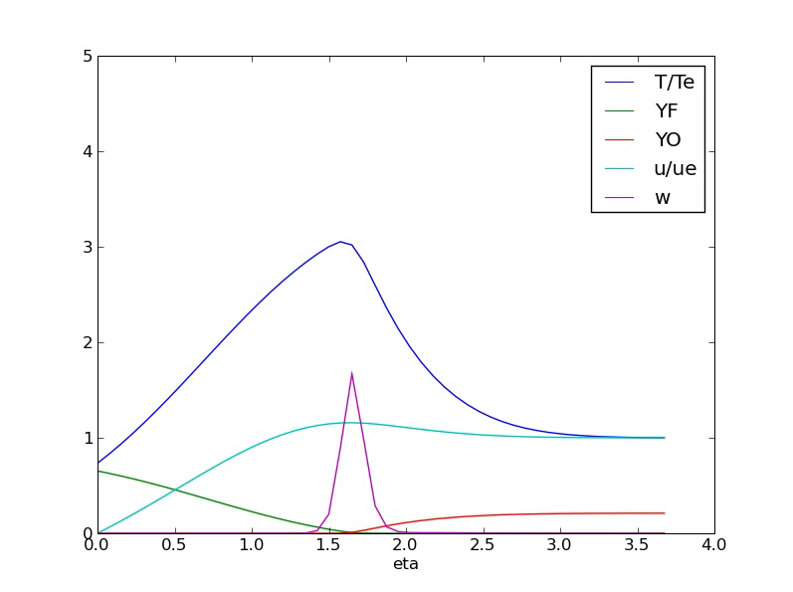Illustration 1: The steady state solution to the base case of a=30 and YOE=.21
2.2 Extinction limits of a and YOE
If the stretch rate (a) is changed, the reaction itself occurs drastically faster. There does not appear to be a lower limit on a, probably because the flow temperature is so high. Conversely, YOE does not appear to have an upper limit and increasing YOE generally makes the ignition hotter, and faster, however, at very low values, ignition cannot occur. At very high stretch rates, ignition is not possible. This point is called blowout, and is possible at any value of YOE, assuming a is high enough.
In illustration 3, the lower limits of YOE were investigated at various stretch rates. Steady combustion is most possible above YOE's of approximately 0.06. The temperature distribution below this point is due to flashes of reaction that don't produce sustainable combustion. A video of one such reaction is available in the supplemental material. The dashed line was drawn in to reference the point at which significant temperature increases occurred (greater than ~0.2), which is important when discussing the locations of these temperature peaks (see illustration 3).
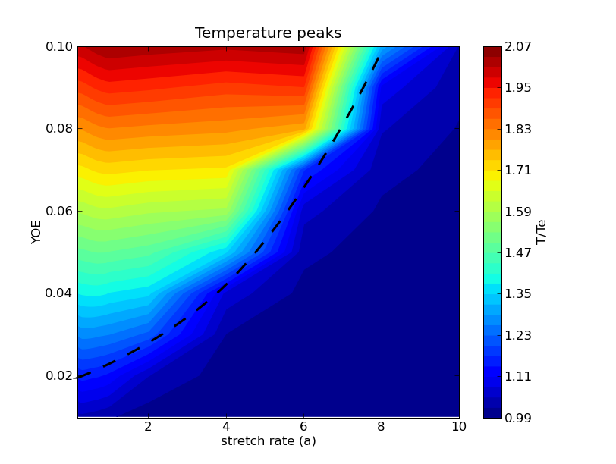Illustration 2: Temperature peak at approximately steady state for different values of a and YOE. Dashed line is a reference line used in illustration 3

There is a a decrease in temperature at low values of a. This is most likely due to radiative loses. In [3], a lower bound of stretch rates were found, however, that experiment was performed with a significantly lower flow temperature. The decrease in temperature may be a reflection of the lower bound found in [3]
In illustration 3, a map of the temperature peaks is provided. The dashed line is identical to the line drawn in figure 1. Where the temperature has peaked higher than 1.2T_{e}, the location of the temperature peak grows closer to the wall as a is increased (despite the initial reaction occurring very close to the solid) and YOE is decreased. Beyond the line, the change of eta is due to the difference between the wall temperature and the flow temperature. The gas near the wall heats up slower for lower YOE and higher stretch rates, and therefore, the “peak” (which will naturally be equal to the flow temperature) is further away from the wall.
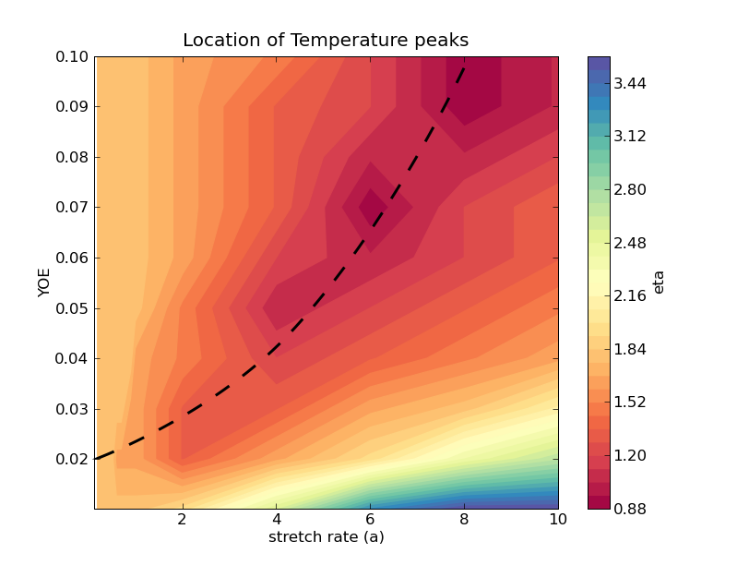Illustration 3: Location of temperature peaks at different values of a and YOE. Dashed line is the reference line defined in illustration 2.
2.3 Time to ignition for a and YOE
The ignition delay is very dependent on the value of YOE and a. At low values of a, the reaction occurs incredibly fast. As a is increased, the time to ignition is increased, in what appears to be a mostly linear trend. See illustration 4.
Changing the oxygen percentage causes an almost exponential change in the ignition delay. At very high oxygen levels, the time to ignition is very small, but very quickly increases as YOE decreases. See illustration 5
Although these trends are very informative, the actual time to ignition cannot be determined by these simulations, due to modification of theory described in section 1.4
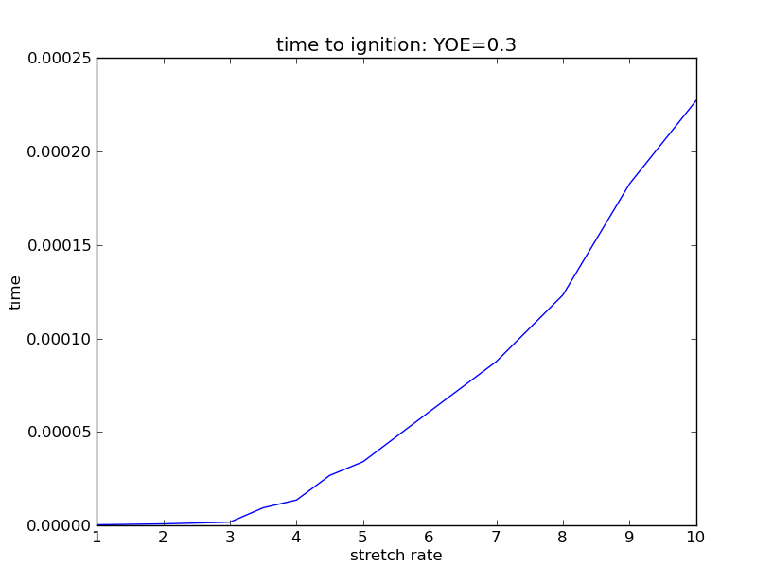Illustration 4: time to reaction at different stretch rates. YOE is a constant 0.3
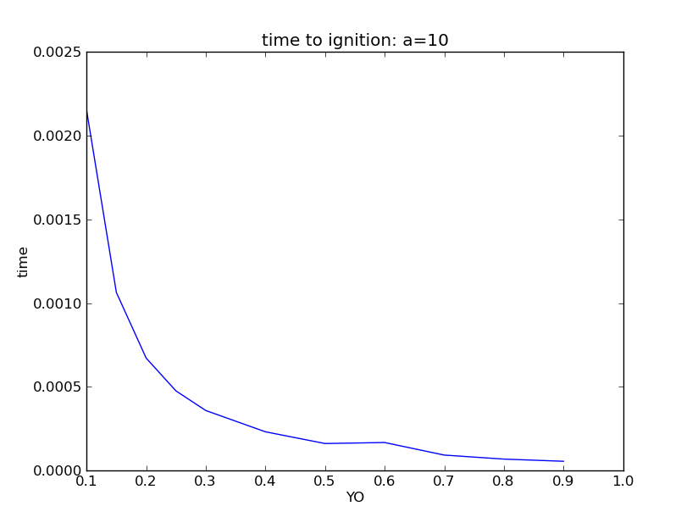Illustration 5: Time to ignition at various oxygen percentages. The stretch rate is a constant 10.
3. Summery
Despite having computational issues with using the theoretically correct non-dimensional time step, ignition profiles were generated by using the same time step for both the gas phase and the solid phase. The steady state solution reached a temperature peak of about 3000K with a stretch rate of 30 and an oxygen mass fraction of 0.21. As the stretch rate increased, the reaction slowed until the blowoff limit was reached and the steady state temperature occurred further from the solid. There did not appear to be a lower limit for the stretch rate. As the oxygen mass fraction increased, the reaction rate sped up almost exponentially and the steady state solution moved closer to the wall.
Appendix: Supplement Material
The contents of the supplemental materials folder is described here:
Case1.avi: Video of combustion of the base case described in section 2.1
Case2.avi: Video of a near-ignition condition described in 2.2
confirm.avi: video of base case with different time steps for gas and solid phase. Video taken at every 50 time steps. See section 1.4
pyOJDF.py: code used to complete the simulation. Can be read in any text editor.
References
- Çengel, Yunus A., Robert H. Turner, and John M. Cimbala. Fundamentals of Thermal- fluid Sciences. Boston: McGraw-Hill, 2008. Print.Used NIST database CD to find certain air property values
- Tien, J., S. Singhal, D. Harrold, and J. Prahl. "Combustion and Extinction in the Stagnation-point Boundary Layer of a Condensed Fuel." Combustion and Flame 33 (1978): 55-68. Print.
- Tien, James S. "Diffusion Flame Extinction at Small Stretch Rates: The Mechanism of Radiative Loss." Combustion and Flame 65 (1986): 31-34. Print.
- Niioka, T. "Gas-phase Ignition of a Solid Fuel in a Hot Stagnation-point Flow." Symposium (International) on Combustion 18.1 (1981): 741-47. Print.
- Han, Bai. The Boundary Layer Combustion Model for Stagnation Point Diffusion Flame. Case Western Reserve University.

The differential equation was made non-dimensional using class supplement notes (Makoto)
Made non-dimensional by method described in reference [5]

