**Name**: Vemburaj Konar **Class**: D16AD **Roll**: 28

Blockchain Lab 4

# Aim: Implement the Blockchain platform Ganache

**Theory:**

Ganache is a personal blockchain development platform that allows developers to create and test Ethereum-based blockchain applications in a controlled and secure environment. It provides a local, in-memory blockchain that can be used for development, testing, and debugging of smart contracts and decentralized applications (DApps) without the need to connect to the live Ethereum network. Ganache oﬀers features such as quick block mining, account management, and a graphical user interface, making it a valuable tool for Ethereum developers to streamline their development and testing processes.

To connect the Ganache environment with Metamask and Remix IDE for performing transactions, follow these steps:

1. Install and Set Up Ganache:

* Download and install Ganache on your system.
* Launch Ganache and create a new workspace or use the default one.

1. Connect Metamask to Ganache:

* Open the Metamask extension in your browser.
* Click on the network selection dropdown (usually showing "Mainnet" or "Ropsten") and choose "Custom RPC."
* Enter the RPC server URL from your Ganache workspace settings into the "New RPC URL" ﬁeld.
* Click "Save" to connect Metamask to your Ganache environment.

1. Import Ganache Accounts into Metamask:

* In Ganache, you have a list of accounts with private keys. You can import these accounts into Metamask for testing purposes.
* In Metamask, go to "Import Account" and provide the private key of an account from Ganache.
* Repeat this process for each account you want to use in Metamask.

1. Compile and Deploy Smart Contracts in Remix:

* Open the Remix IDE in your browser.
* Write or import your smart contract code.
* Compile the smart contract in Remix.

1. Connect Remix to Ganache:

* In Remix, under the "Run" tab, select "Environment" and choose "Web3 Provider."
* Enter the Web3 Provider endpoint from your Ganache workspace settings.

1. Deploy Smart Contracts from Remix

* In Remix, select the contract you want to deploy.
* Click the "Deploy" button.
* Conﬁrm the deployment in Metamask when prompted.

1. Perform Transactions

* Once your smart contract is deployed, you can interact with it through Remix.
* Use Metamask to conﬁrm and sign transactions when executing functions on the smart contract.

These steps will allow you to set up a development environment with Ganache, connect it to Metamask, and use Remix IDE for smart contract development and testing on the Ethereum blockchain.

# Program:

Installed Ganache Successfully

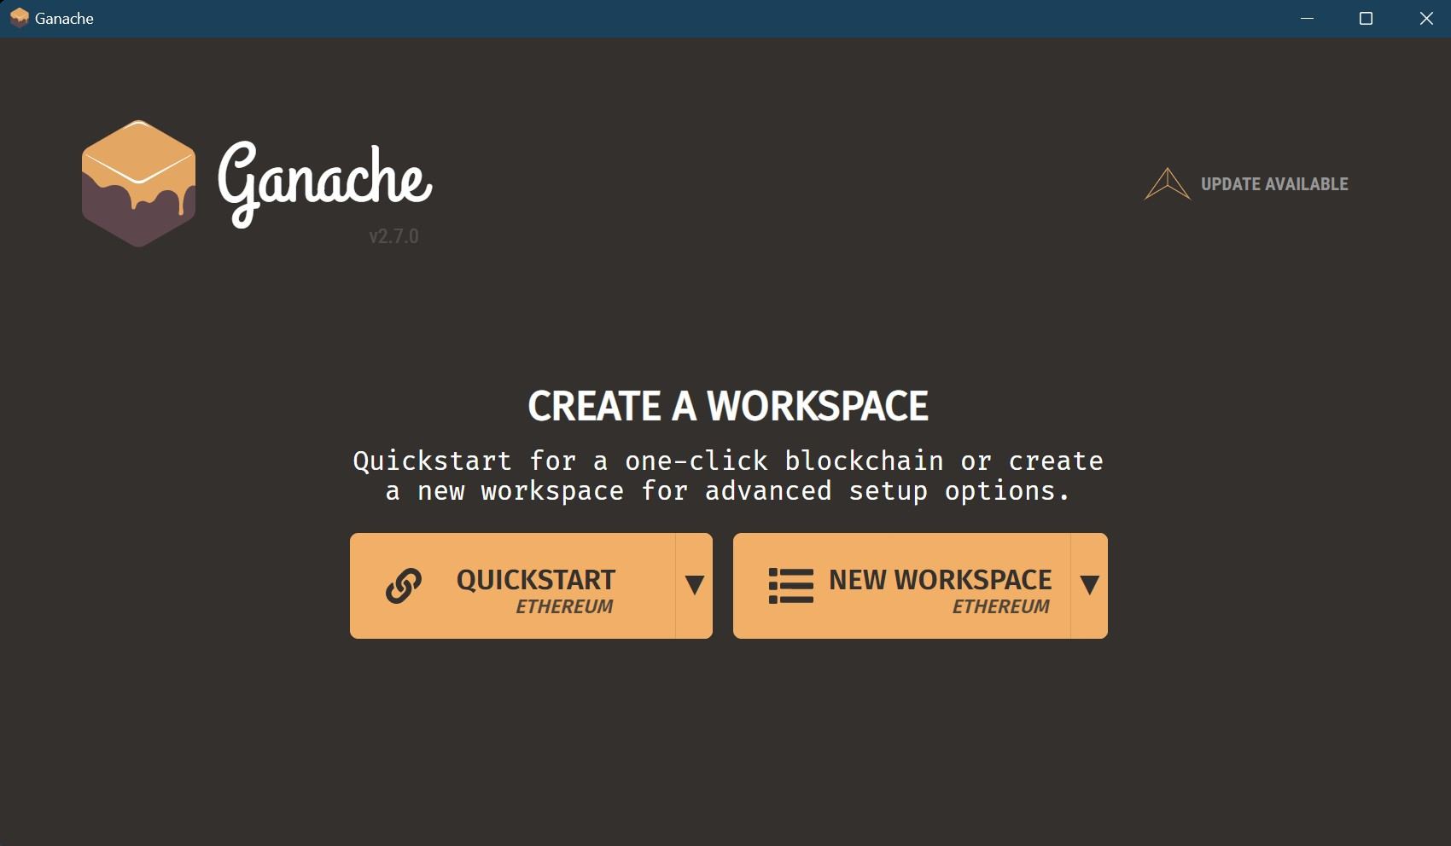

Click on QuickStart

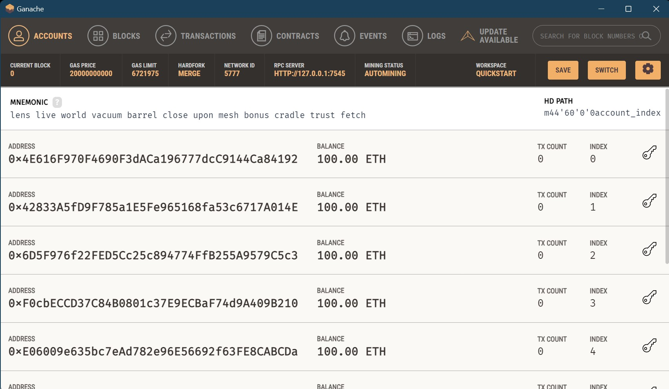

Genesis Block created

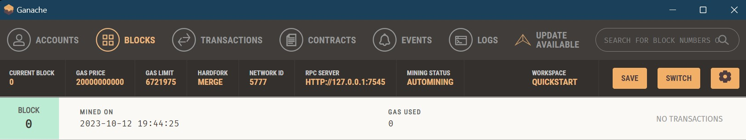

Contents of block 0

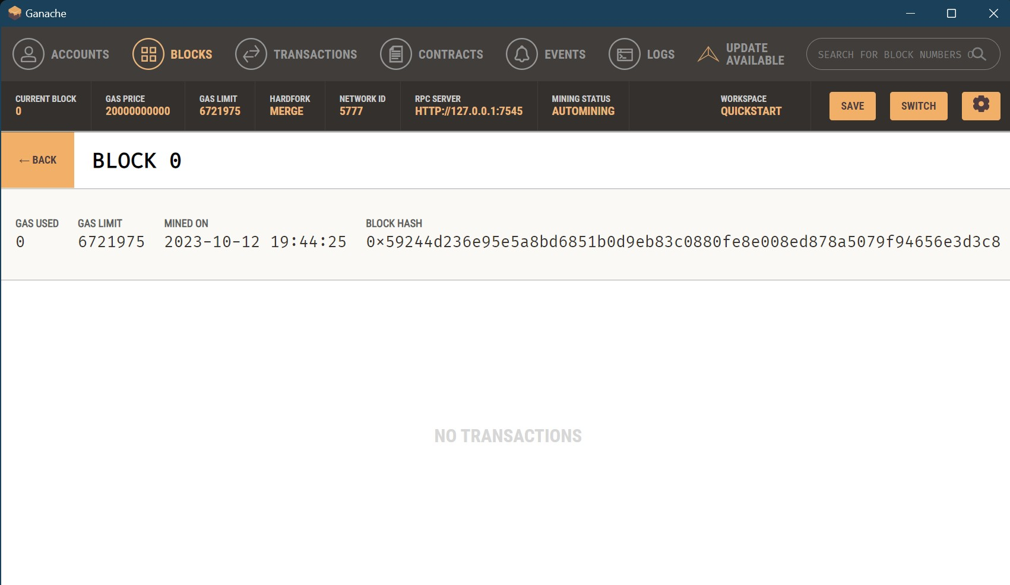

Log

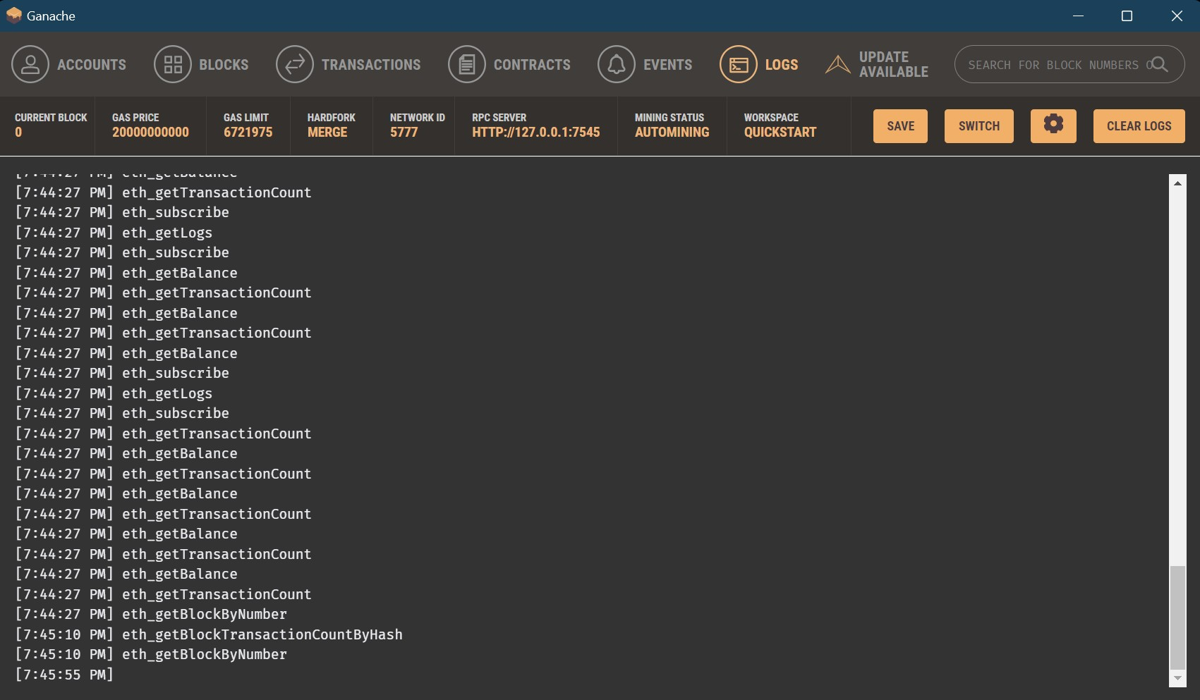

Login to Metamask Wallet

Add Ganache Test Network with the following credentials Network Name : Ganache

New RPC URL : HTTP://127.0.0.1:7545

Chain ID : 1337 Currency Symbol : ETH

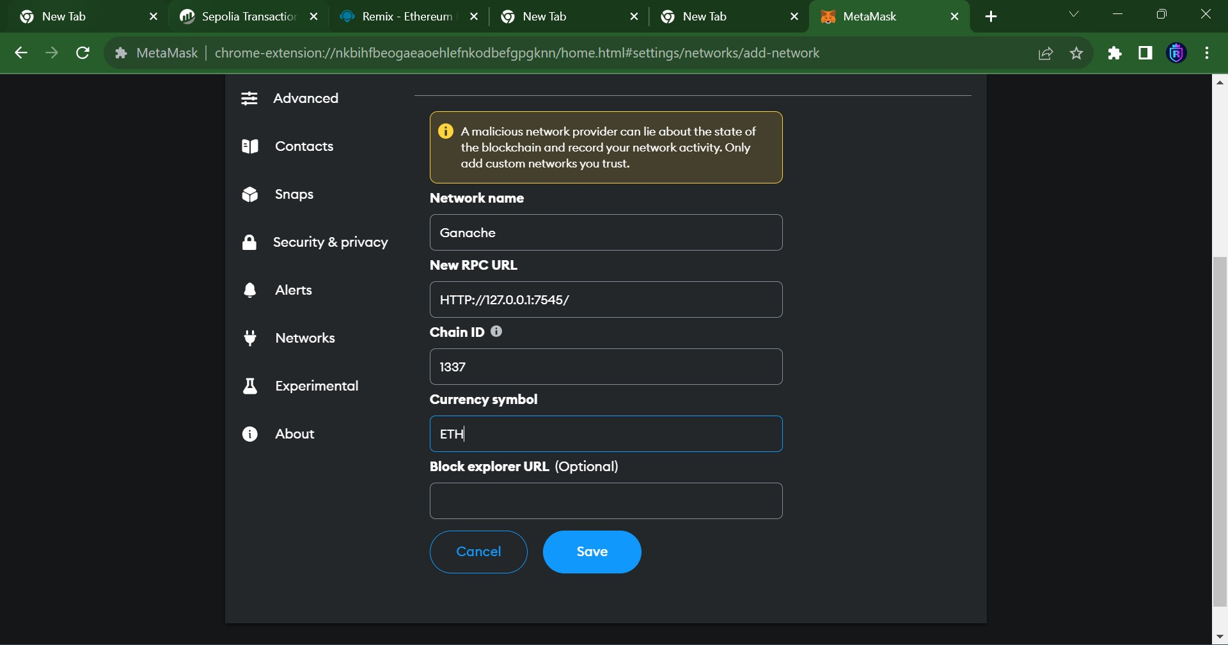

Open the Ganache IDE, clicl on the privatre key for any account. Copy the Private Key

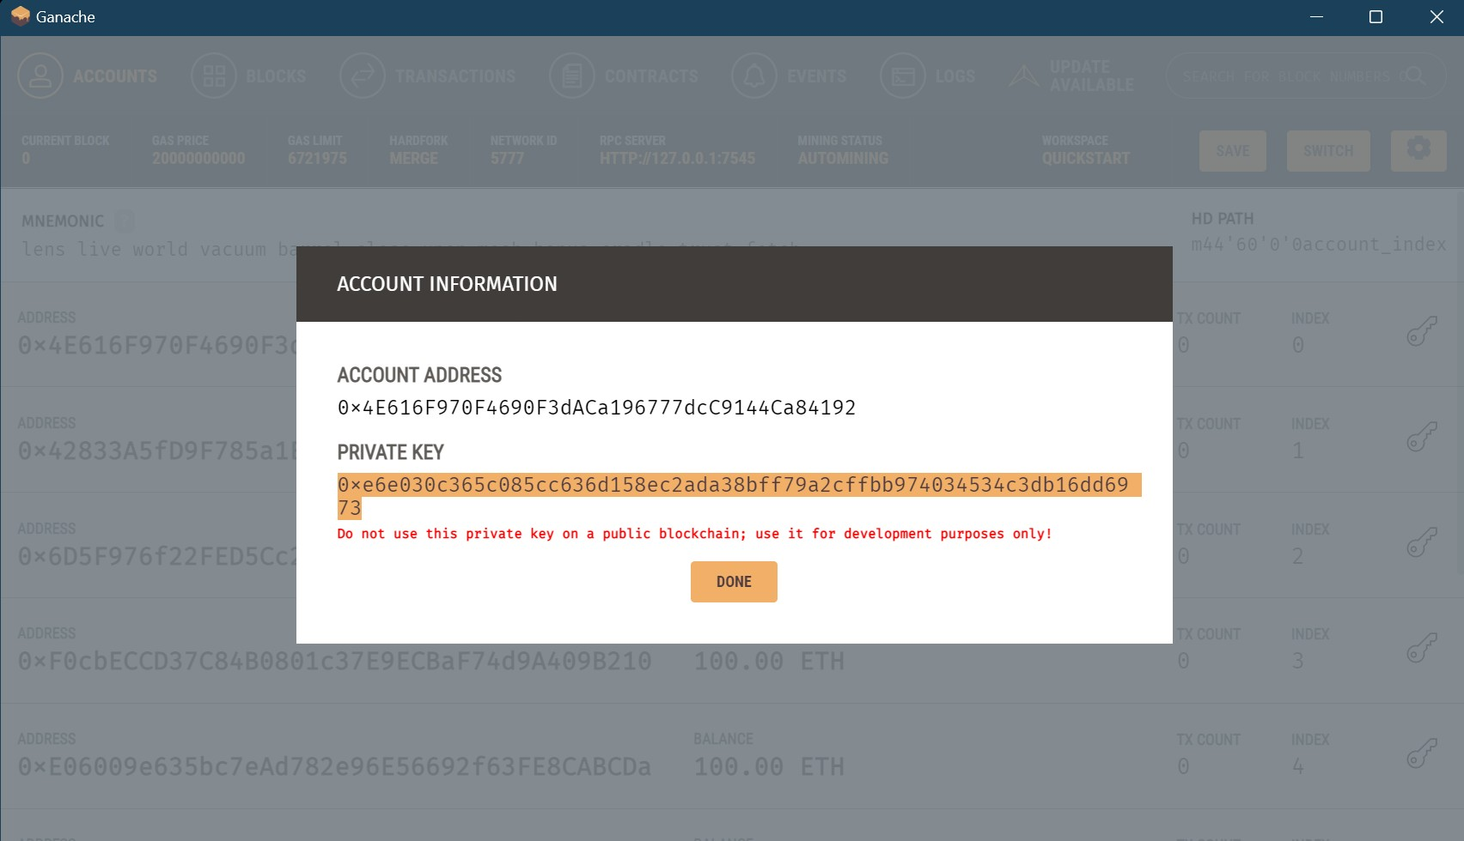

Go to Matamask, select Import Account option.

Paste the Private Key of the Account. Click on Import button

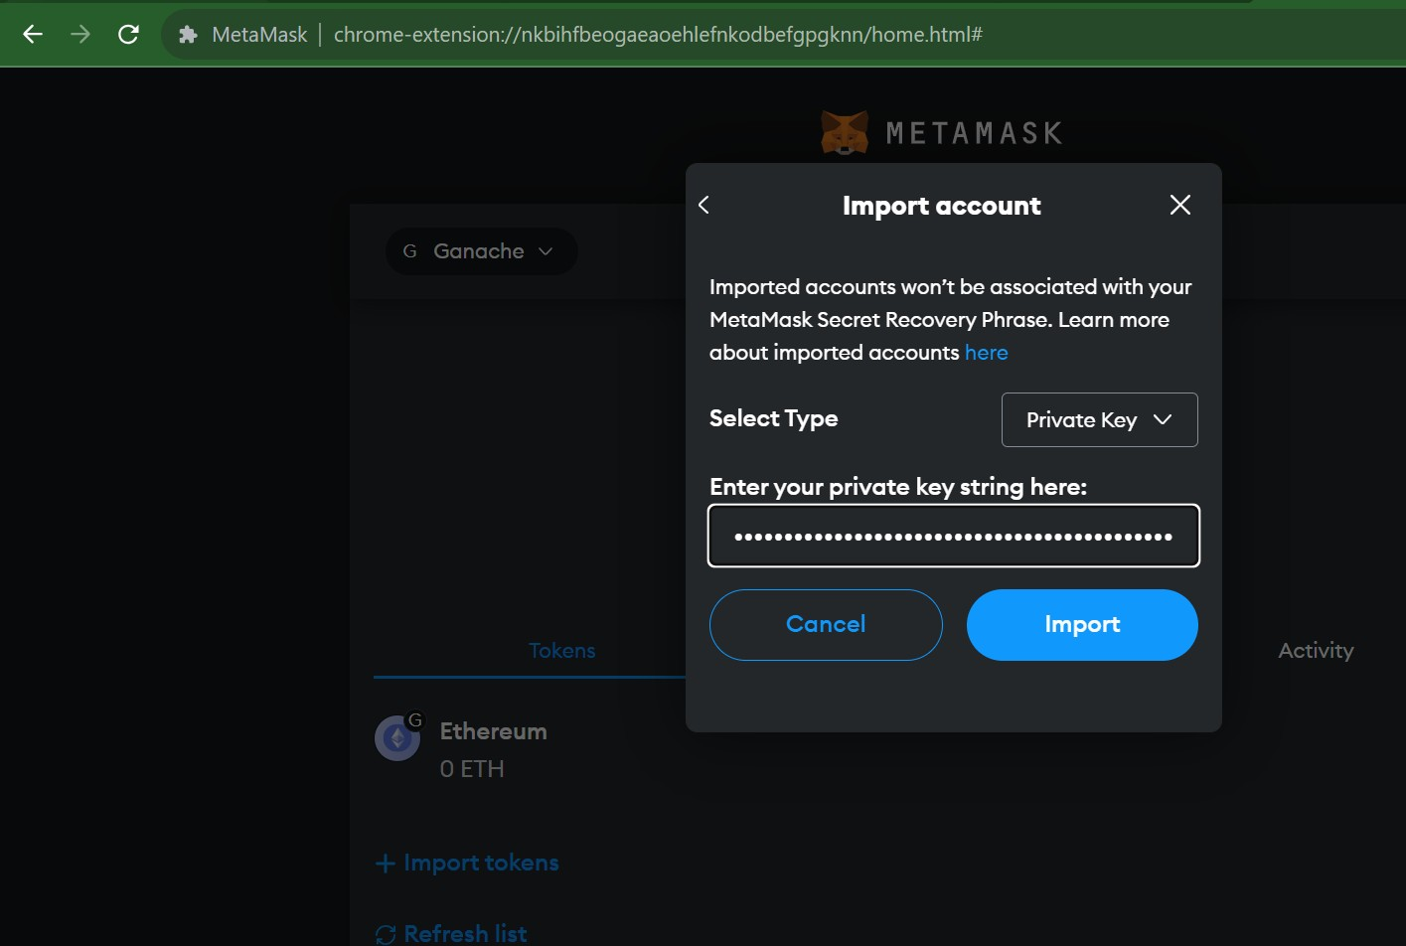

On the Remix IDE, select the Environment : Injected Provider(Metamask) . Follow the steps to establish Connection. Select an Account from the Wallet

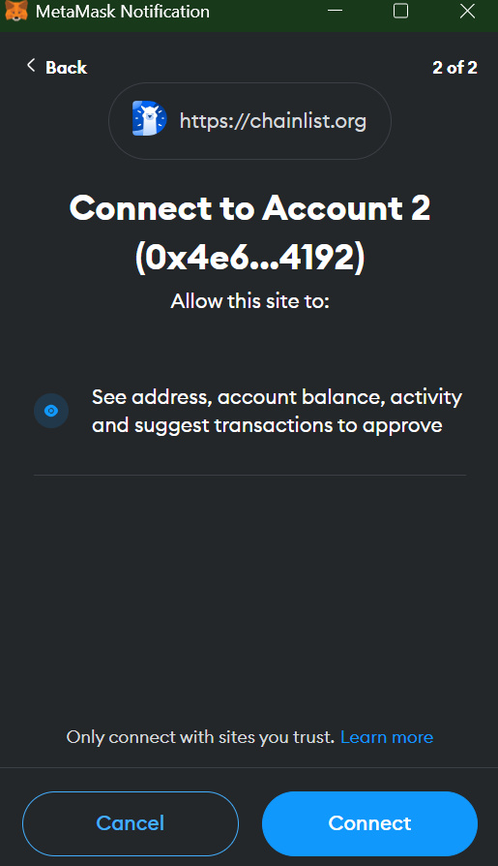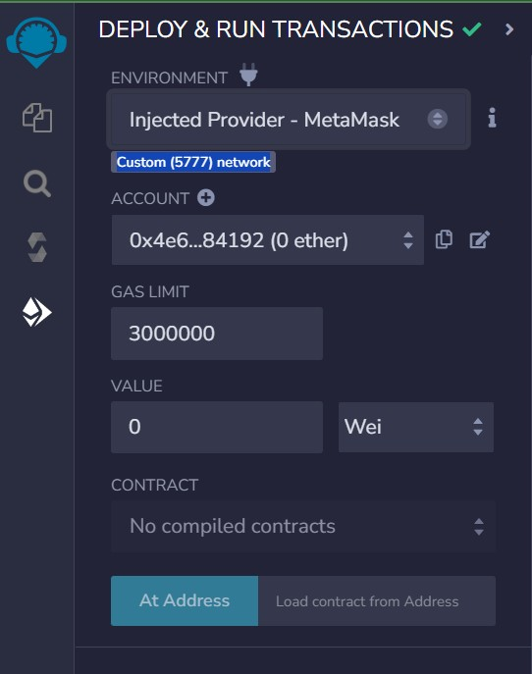

After compiling the Smart Contract in Remix IDE, deploy the Contract

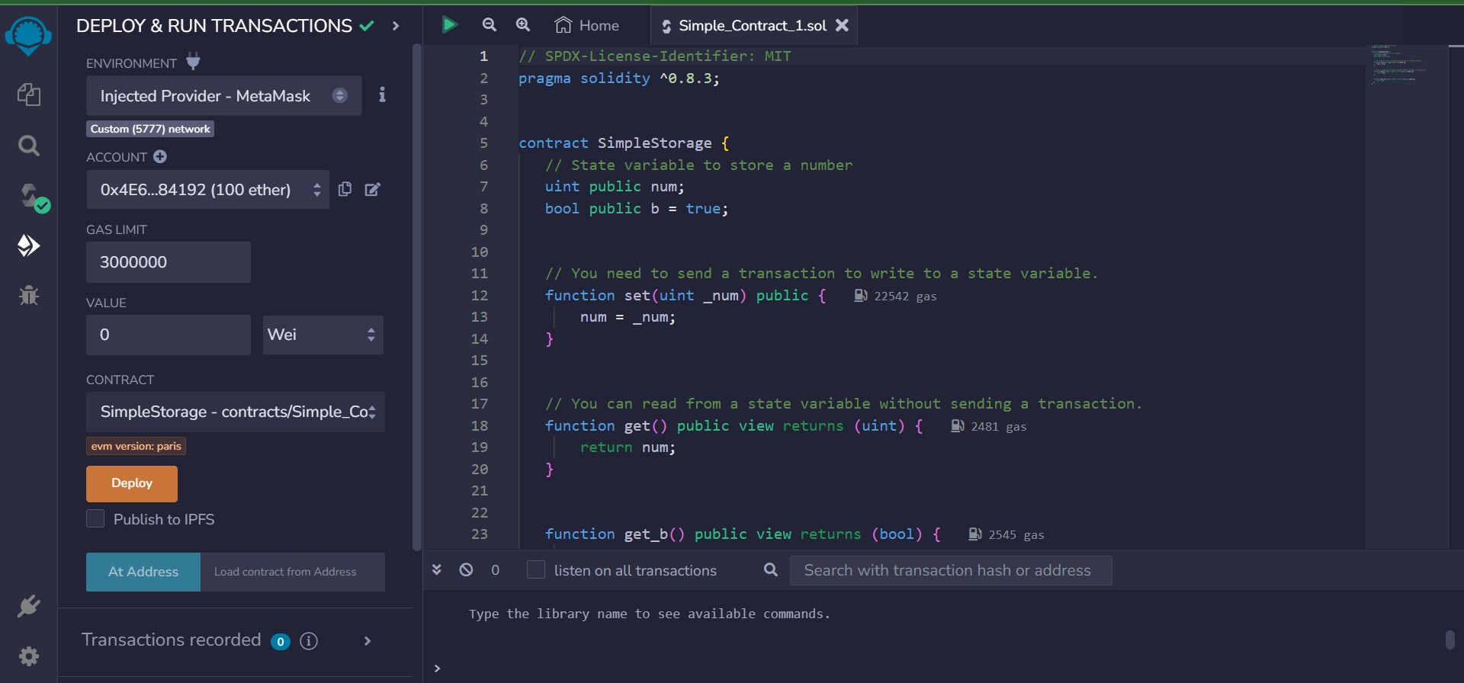

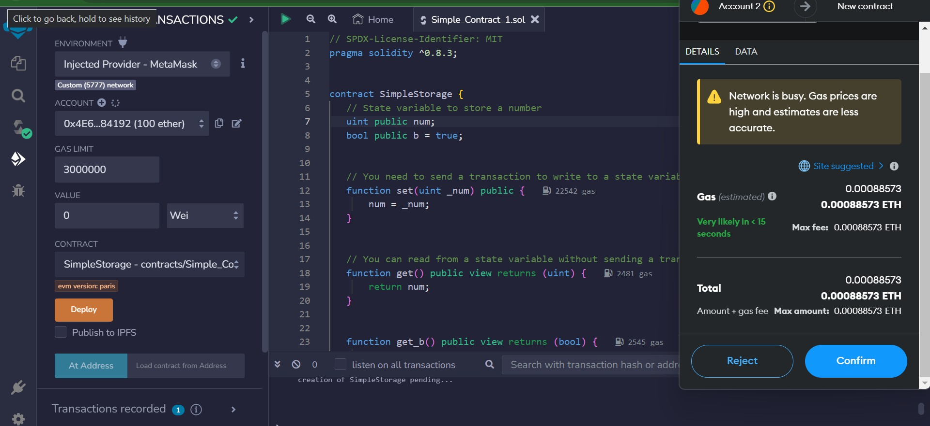

Metamask Account status is updated

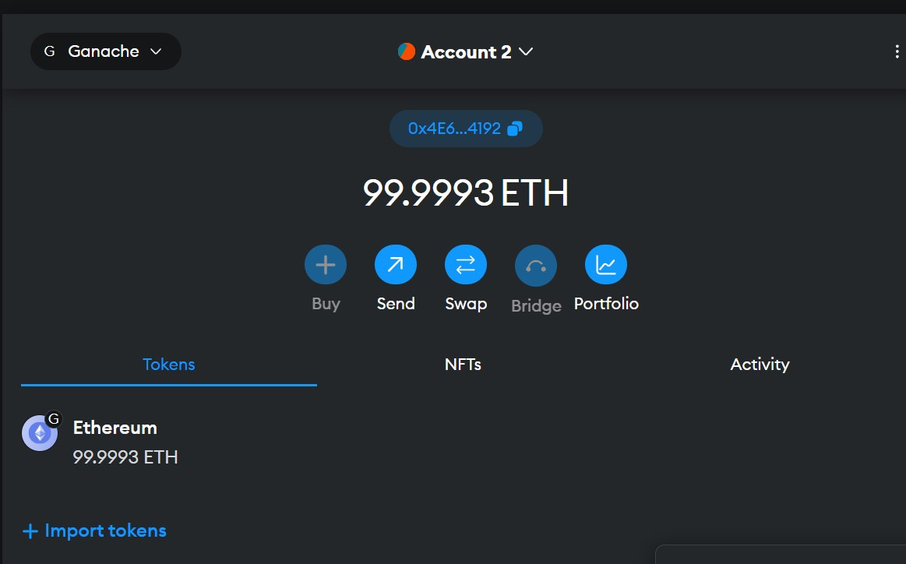

Check the Ganache Environment. We can see that the Transaction Count for the ﬁrst account is 1

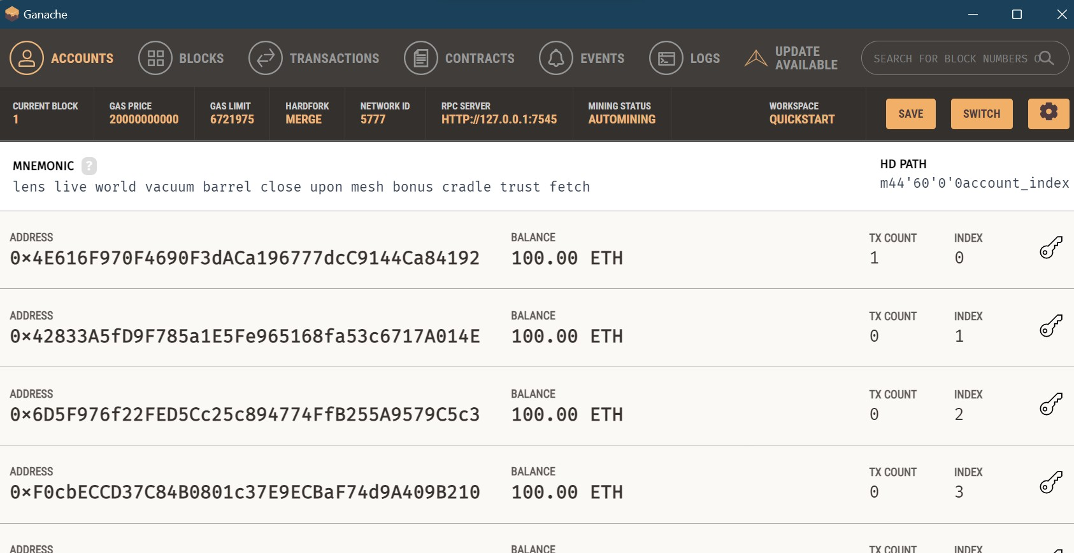

Check the Mined Block

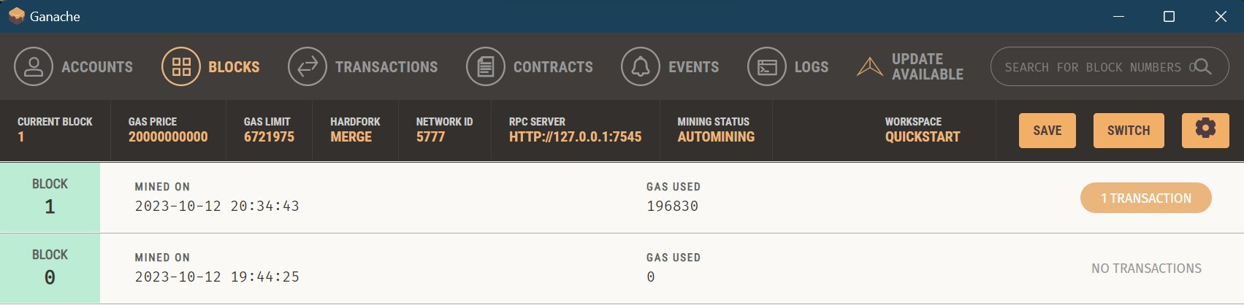

Check the Transaction details in Ganache

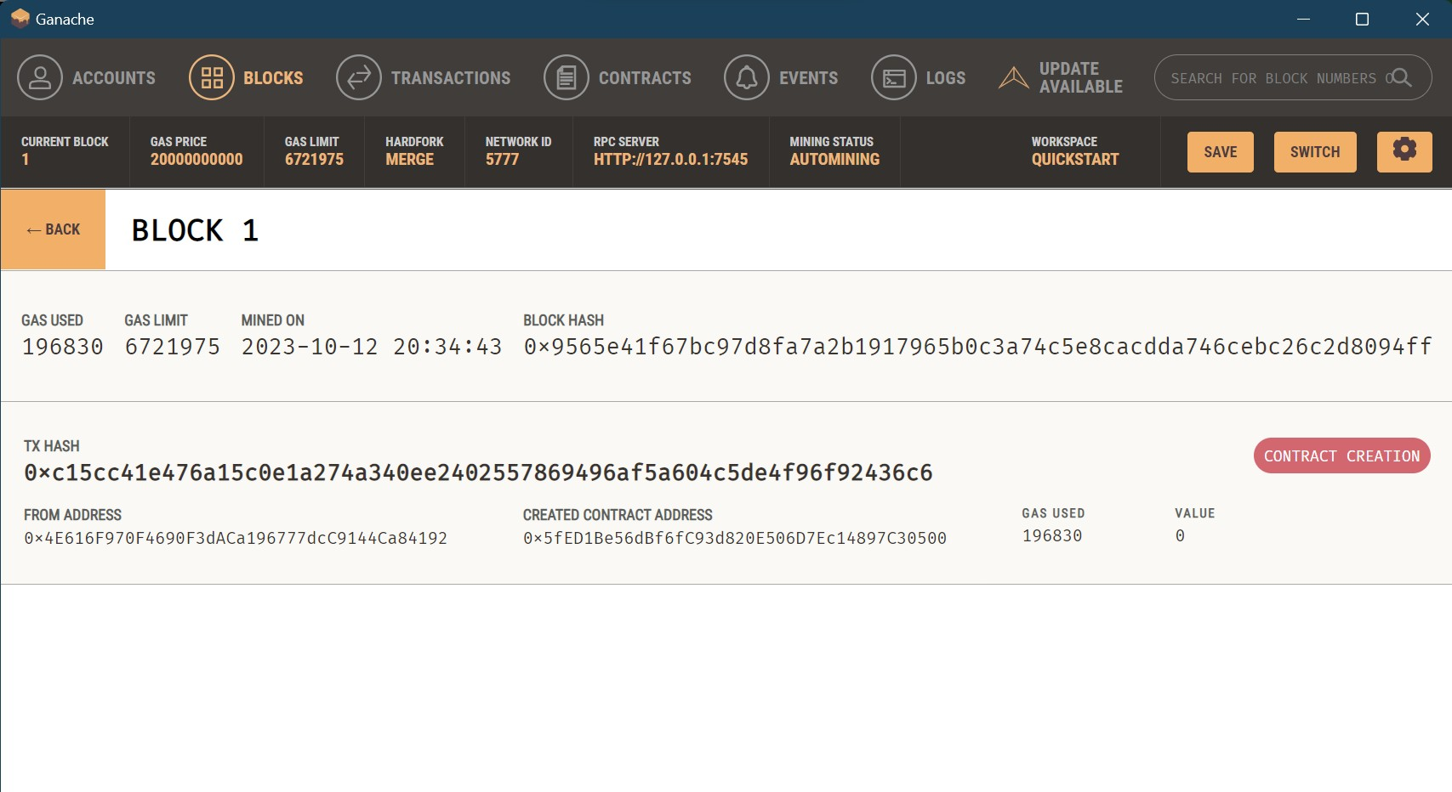

**Conclusion:** our experiment implementing the Blockchain platform Ganache proved to be a valuable exercise in understanding the fundamentals of blockchain technology. We successfully set up a local development environment and gained insights into smart contract deployment and interaction.