**Name**: Vemburaj Konar **Class**: D16AD **Roll**: 28

Blockchain Lab 7

**Aim:** To develop a blockchain-powered web application using Solidity programming language on Remix IDE and embedding Metamask Wallet.

# Theory:

Metamask is a popular cryptocurrency wallet and Ethereum decentralized application (DApp) browser extension. It serves as a bridge between your web browser and the Ethereum blockchain, allowing users to manage Ether and interact with Ethereum-based DApps. Metamask provides a secure way to store and manage digital assets, as well as a convenient means to authenticate and perform transactions on blockchain applications.

A test net is a separate blockchain network that mirrors the functionality of the main Ethereum network but uses test Ether (testnet Ether) that has no real-world value. Test nets are used for development and testing purposes, allowing developers to experiment with smart contracts and DApps without spending real Ether or aﬀecting the main network.

To connect Metamask with Remix IDE for performing transactions, follow these steps:

1. Install and Set Up Metamask:

* Install the Metamask browser extension and set up an account.
* Ensure you have some test Ether (from a testnet) in your Metamask wallet for transactions.

1. Open Remix IDE:

- Open the Remix IDE in your web browser.

1. Connect Remix to Metamask:

* In Remix, under the "Run" tab, select "Environment" and choose "Injected Web3."
* This option connects Remix to the Metamask extension.

1. Select the Network in Metamask:

- In Metamask, make sure you're connected to the appropriate test network (e.g., Ropsten, Rinkeby, or a custom testnet) that matches your Remix setup.

1. Compile and Deploy Smart Contracts:

* Write or import your smart contract code in Remix.
* Compile the smart contract in Remix.

1. Deploy Smart Contracts from Remix:

* In Remix, select the contract you want to deploy.
* Click the "Deploy" button.
* Conﬁrm the deployment in Metamask when prompted.

1. Perform Transactions:

* Once your smart contract is deployed, you can interact with it through Remix.
* Use Metamask to conﬁrm and sign transactions when executing functions on the smart contract.

These steps will allow you to set up a development environment with Metamask and Remix IDE for Ethereum-based smart contract development and testing on a test network.

# Program:

**Step 1 and 2:** Installed the metamask and added eth in metamask using Sepolia Testnet

# Step 3:

In the Remix IDE, select the Environment as Injected Web3.

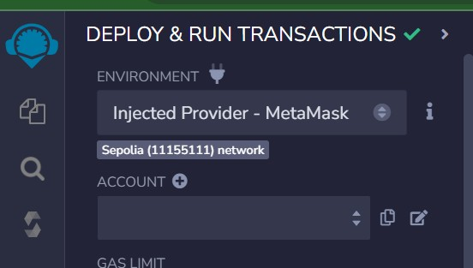

Once the Injected Web3 Provider is selected as Metamask, the following popup appears.

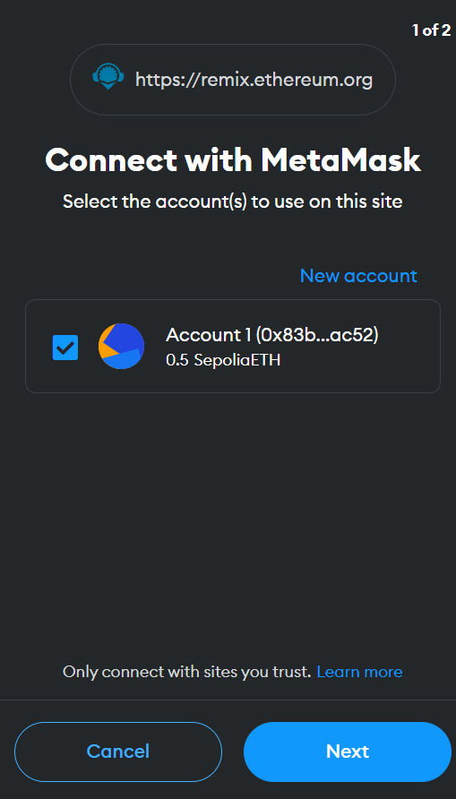

Click on Connect button. Once the Account is linked to Remix IDE, the Metamask Account details appears in the Deployment Environment as follows:

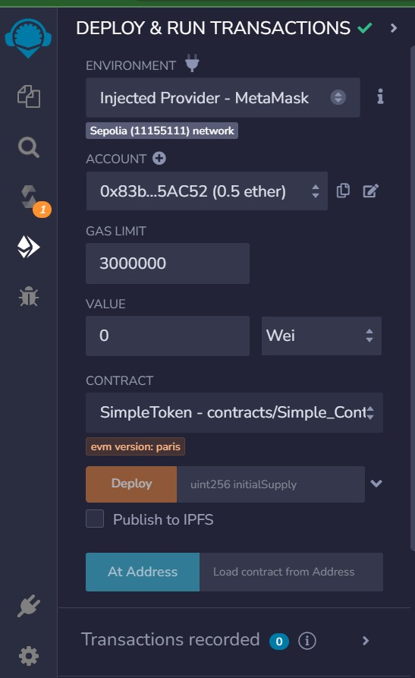

Create a simple smart contract and compiled it using remix ide. Once the Contract is deployed on Remix IDE, the popup appears to conﬁrm the Contract Deployment.

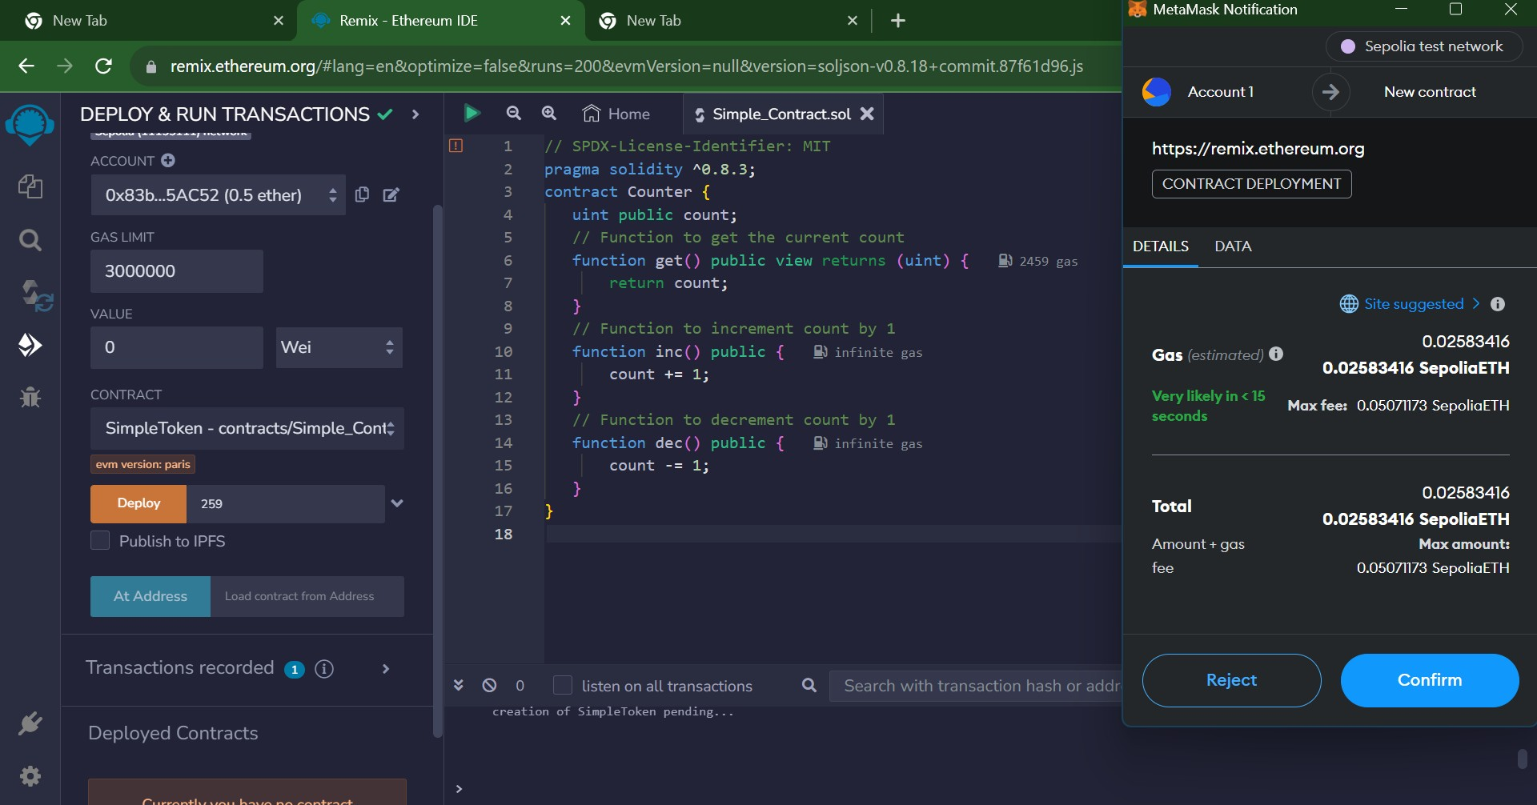

Once the transaction is conﬁrmed the status of the transaction is displayed

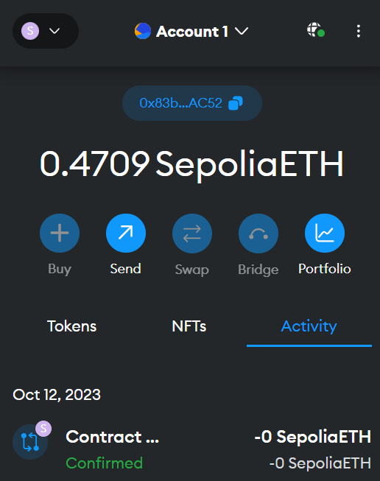

In Remix IDE terminal, the transaction details are displayed

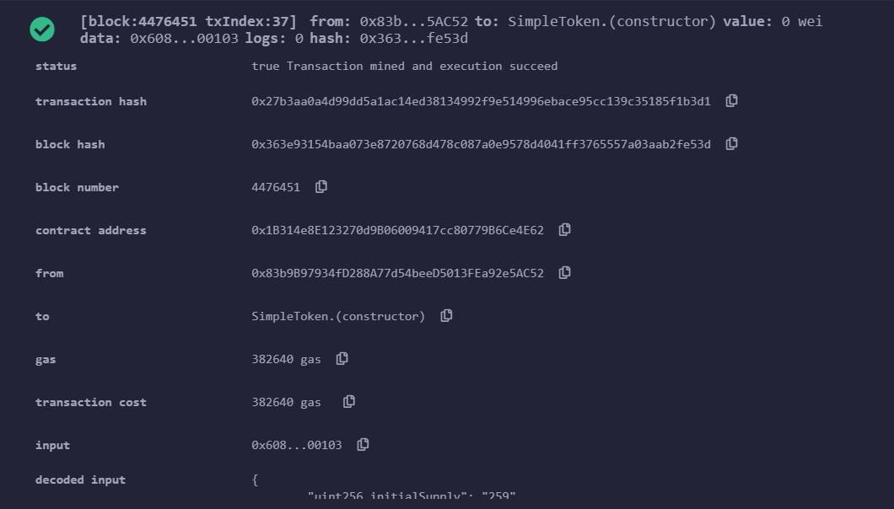

**Conclusion:** Our experiment to develop a blockchain-powered web application using Solidity on Remix IDE and embedding Metamask Wallet was a successful demonstration of decentralized application development. We achieved a seamless integration of smart contracts and Metamask, enabling users to interact with the blockchain directly from the web application. This hands-on experience sets the stage for further exploration and innovation in the exciting realm of blockchain-based web applications.