Tyrese Sheraan Ah-Dong

ST10445009

IMAD5112 Practicum 2025 README document

This file contains screenshots of code used in the recipe app.

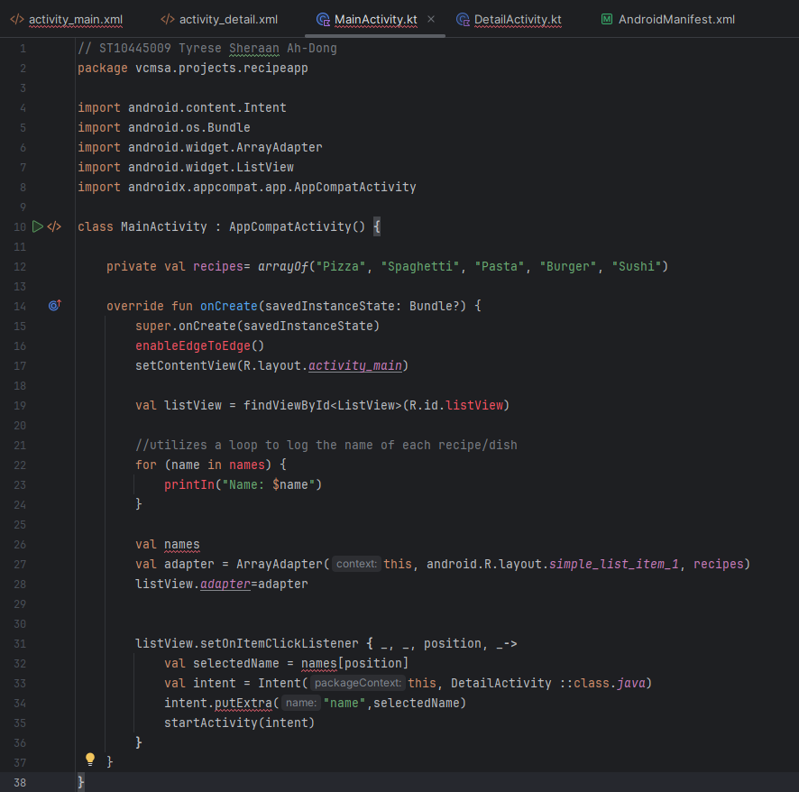

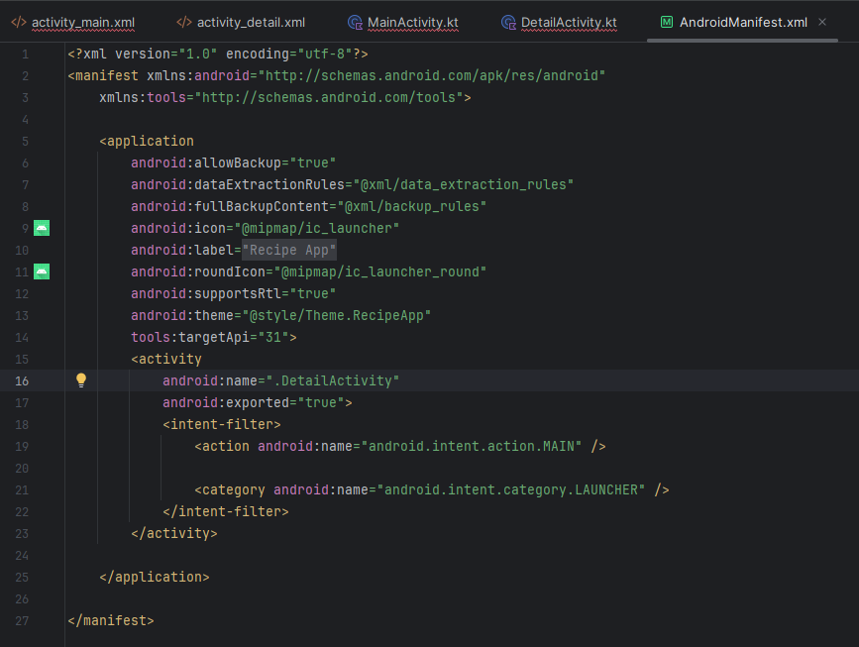

Referencing:

(IIE Varsity College) advtech online IMAD5112 Module Manual,2025. [Accessed 2025/07/28] <https://advtechonline.sharepoint.com/:w:/r/sites/TertiaryStudents/IIE%20Student%20Materials/New%20Student%20Materials%20CAT/IMAD5112/2025/Term%201/IMAD5112_MM.docx?d=wa1ff62f08e1a47bc99bdca07ae24427d&csf=1&web=1&e=D2nwt9>