Date: 15 August, 2026

Student ID:4697566D Tye

Project : My Rent & Investment Estimator

Brief Summary of the Project

The project is developed with AWS Sagemkeer MLFlow application for preprocessing ,visualization and experiment tracking and Sagemaker pipeline for training, evaluation, condition model selection and model registration. The Mlfow application and pipeline provide a managed environment without requiring a team to deploy and maintain a separate Mlflow server.

Machine Learning Lifecycle:

1. Problem Definition:

There are many mortgage calculators for loan repayment but no specific calculator to estimate the potential investment value of the property.

1.1. Objective of Estimator :
The rent estimator is to predict montlhy rental price for non-landed private residential units in Singapore, and translate that into an indicative investment value.

System Architecture of Machine Learning from raw data to a publicly accessable prediction application.

Raw Rental >>SageMaker Pipeline>>Real-Time Endpoint>>Streamlit App>>Public URL

2. Dataset Collection

The data set is a complied historical data of private-residential transactions across Singapore between 2021 and 2025.

URA source between the year 2021-2025

"https://eservice.ura.gov.sg/property-market-information/pmiResidentialRentalSearch"

The raw data are downloaded in batches by year and month date and a python script is run to concatenate the data to 1 raw dataset in csv format. The data size has about 404000 entries spanning from Feb, 2021 to Dec, 2025.

3.Dataset Cleaning and Preprocessing

The following are the processing performed on the raw data set.

a) The raw data are converted to dataframe
b) All lines with incomplete data are dropped
c) Columns names are shorten for better handling and processing.
d) string date are converted to lease date and subsequently to lease year and lease
month
e) Floor area are converted to just 1 size of area in square metres.

4.Exploratory Data Analysis

Visual Analysis performed on clean dataset to see the relationship among variables.

The charts that show linear relationship between variables of interest are given below.

Linear Regression Chart: Floor Area in SM vs Month Rent
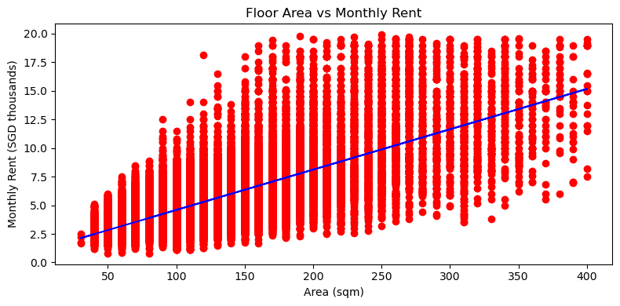

Correlation of Features

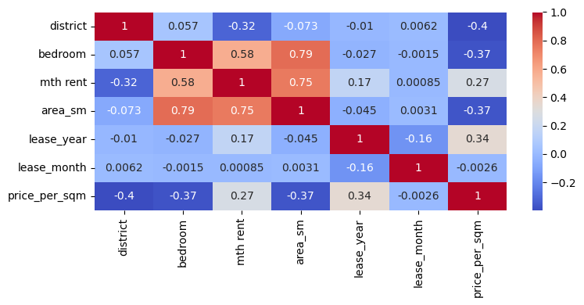

Districts and Median:

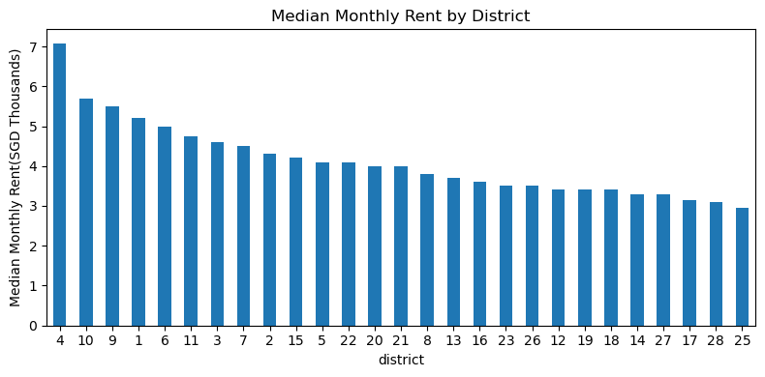

Observation: Median Rent in prime districts such as 4, 9,10,11 are higher than outskirts like
districts 23 to 25.

Observation: Monthly Rent has risen post covid and seem to pick middle of 2023 and flatten in
2024 onward.

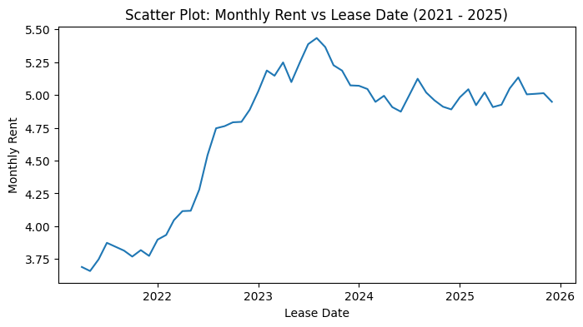
5. Feature Engineering and Selection

Based on the above exploratory data analysis,the features selected for training are
bedroom,area_sm, lease_year, lease_month and districts are transformed to onehotencoder as
districts are just string labels and not numerical value and the predictor value is the monthly
rent.

The dataset are split 80 percent for training and 20 percent for test.

6. Training Models Experiments and Selection.

The visual observation indicates a linear relationship between floor size and monthly rent,and
there are transactions date in lease years and lease months a training model for time series data
is a better fit to the dataset.

A Random Forest Algorithms is selected as the base line model for the following reasons.

a) Reduces Overfitting: Combines multiple decision trees to produce more
stablepredictions.

b) Robust to Outliers: Averaging predictions from many trees reduces
the effect ofextreme values.

c) Works with large datasets which is this case 369000 line of data

From the base line model, further experiment is performed with Random Forest hyperparameter
tuning. There is no significant difference between Random Forest model and Random Forest
with tuned hyperparameter due to the initial high iteration and maximum depth of 6

There are many machine learnings sites which suggest XGBoost Regressor provide better prediction and a third experiment is performed with XGBoostRegressor to check its performance.

Comparison of 3 Models on MAE, RMSE, R2 Score Metrics.

Comparison of Models in MAE RMSE and R2 Score

MAE |  | RMSE | R2
RF Baseline | 0.660725 | 1.052011 | 0.795315
RF Tuned | 0.675882 | 1.053702 | 0.794656
XGBoost | 0.642391 | 1.013268 | 0.810113

The above table shows XGBoost is th model best fit the dataset for prediction, and therefore it is selected as the model for sagemaker pipeline.

6.1 Interpretability and Explainability of features.

Shapley Analysis on Explainability of features importance to the predicted values.

XGBOOST SHAP Analysis
SHAP sample size for analysis : 3000 rows
Number of features: 31 columns

Top 15 features:
area_sm 0.954845
lease_year 0.458160
bedroom 0.254397
dist_9 0.223031
dist_10 0.142093
lease_month 0.097579
dist_1 0.091261
dist_4 0.081552
dist_3 0.070484
dist_19 0.064613
dist_2 0.054999
dist_23 0.051769
dist_18 0.044729
dist_16 0.041811
dist_11 0.034962

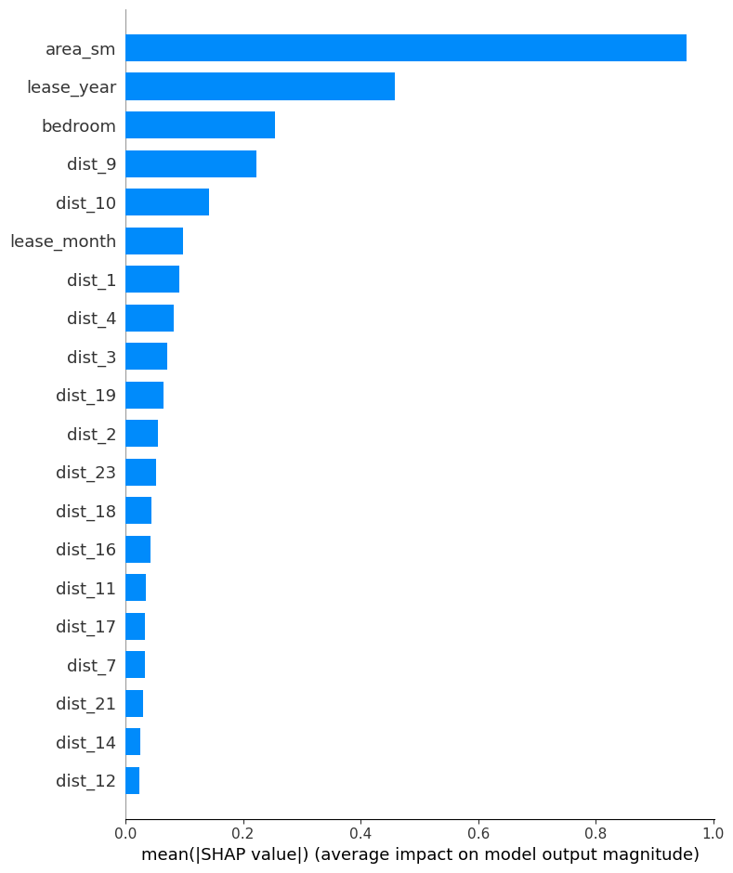
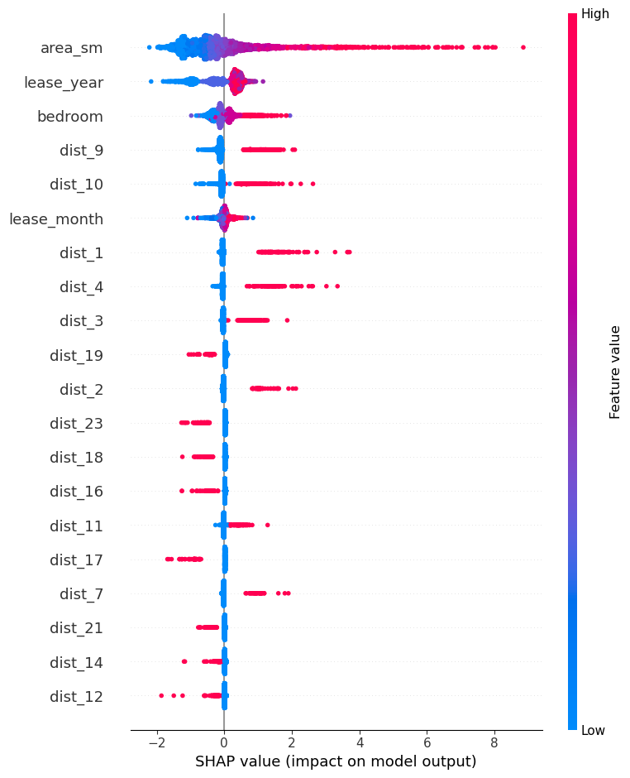
7

Notes and References
From Step 2 to 6 please see attached Jupyter Notebook “4697566D_ITI113_experiment_SageMaker_mlflow_app_arn.ipynb” attached
or download a copy from Github “https://github.com/Tye8103/iti113-team08-repository”

7. Sagemaker Machine Learning Pipeline
The sagemaker ML pipeline can automate sequence of steps used
to build, test, register and deploy a model instead of running data preparation, training and
deployment manually. A pipeline links the individual tasks together into a seamless workflow.

The pipeline is a script to automate the transition from raw data to a production-ready model.
The script feeds the output of one step into the next step, for examples from data preprocessing to
model training, model evalutation, model registration and model deployment.

The pipeline ensures reproducibility to ensure that every model is trained with same code, data
transformation and selection criteria, tracks lineage with logging every run and speed up
re-running of new data with the same automated sequence.

The Pipeline Steps in my attached Jupyter Notebook are

a) Data Preparation: Cleans, transforms, and split raw data to train, validation, and test

b) Model Training with XGBoost Regressor : Feeds the prepared data into an XGBoost Algorithm
to train the model.

c) Evaluation & Validation: Evaluates the trained model against a test dataset to measure accuracy

d) Condition Check; Evalutates if the model meet performance thresholds of > 0.8 on R2 score

e) Deployment / Registration : saves the model to a registry and deploys it to a production endpoint.

Notes and Reference:
Jupyter Notebook “4697566D_ITI113_My_Rental_Pipeline__MLflow_App_Web_R1.ipynb” attached or download a copy from Github
“https://github.com/Tye8103/iti113-team08-repository”

8. Streamlit library
In this project, Streamlit is used to provide the user-facing web application for the rental price
and investment estimation system. Users can enter property information through the Streamlit
interface, and the application sends the input data to the sagemaker inference endpoint.
The predicted rental price is then returned and presented to the user together with the relevant
results and visualizations.
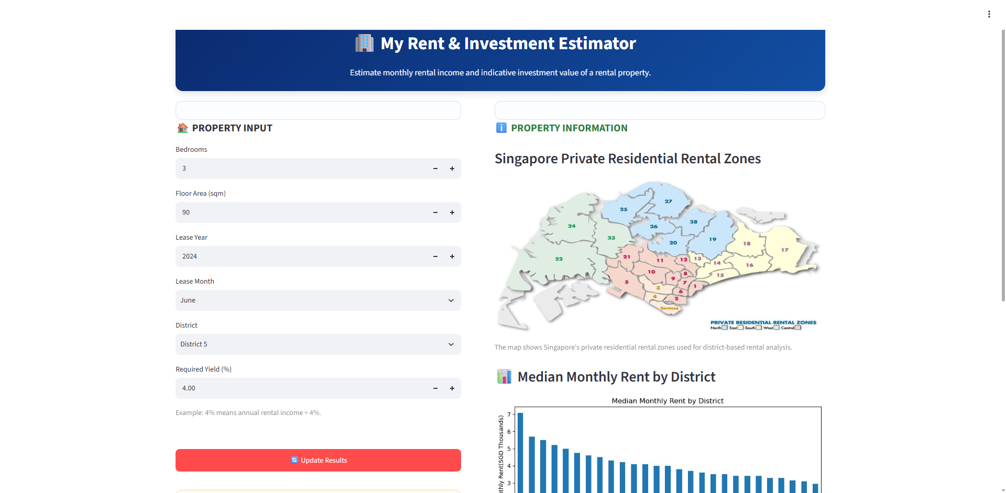

-----------------------End of Report------------------------------

9.ngrok
ngrok is used to provide temporary external access to the Streamlit application during
development and demonstration. It creates a secure public HTTPS tunnel from the locally
running Streamlit application to the internet. This allows the application running inside the
SageMaker Studio/Jupyter environment to be accessed through a web browser without
deploying the Streamlit application to a separate public server.

sample url:Testing URL : https://expansion-blaspheme-reprogram.ngrok-free.dev
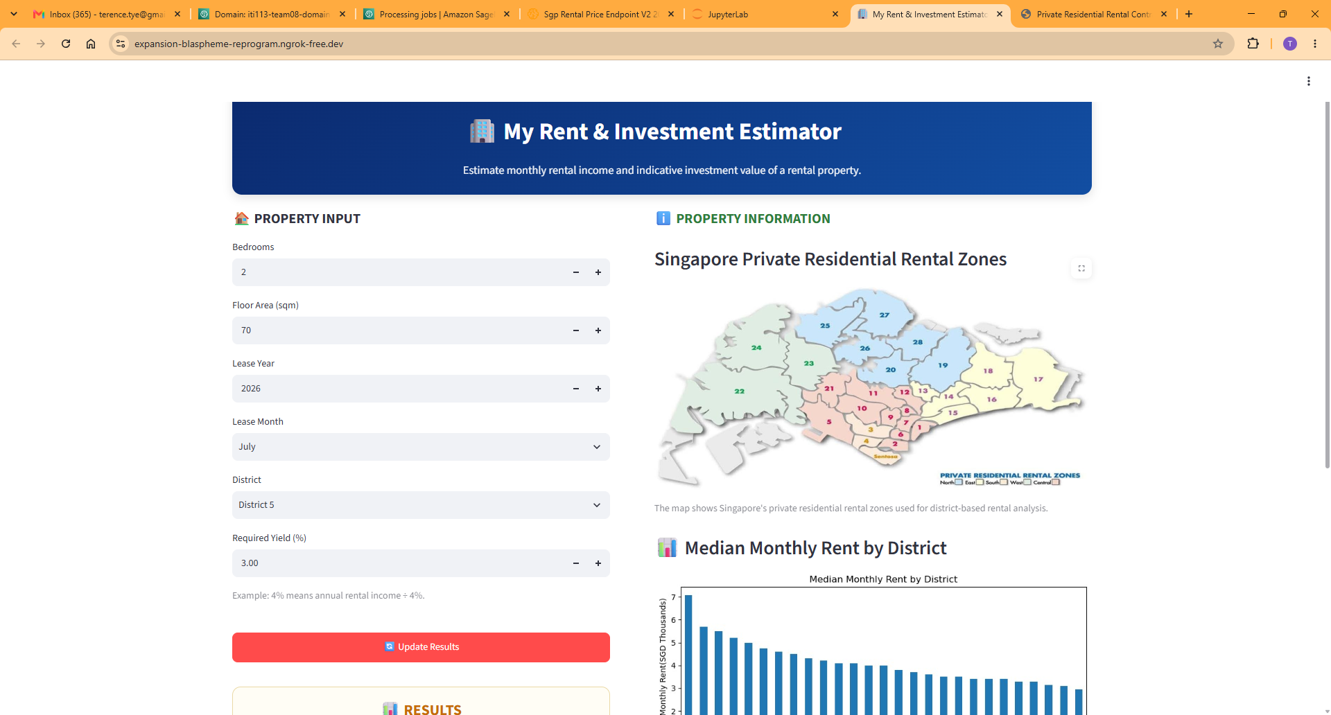

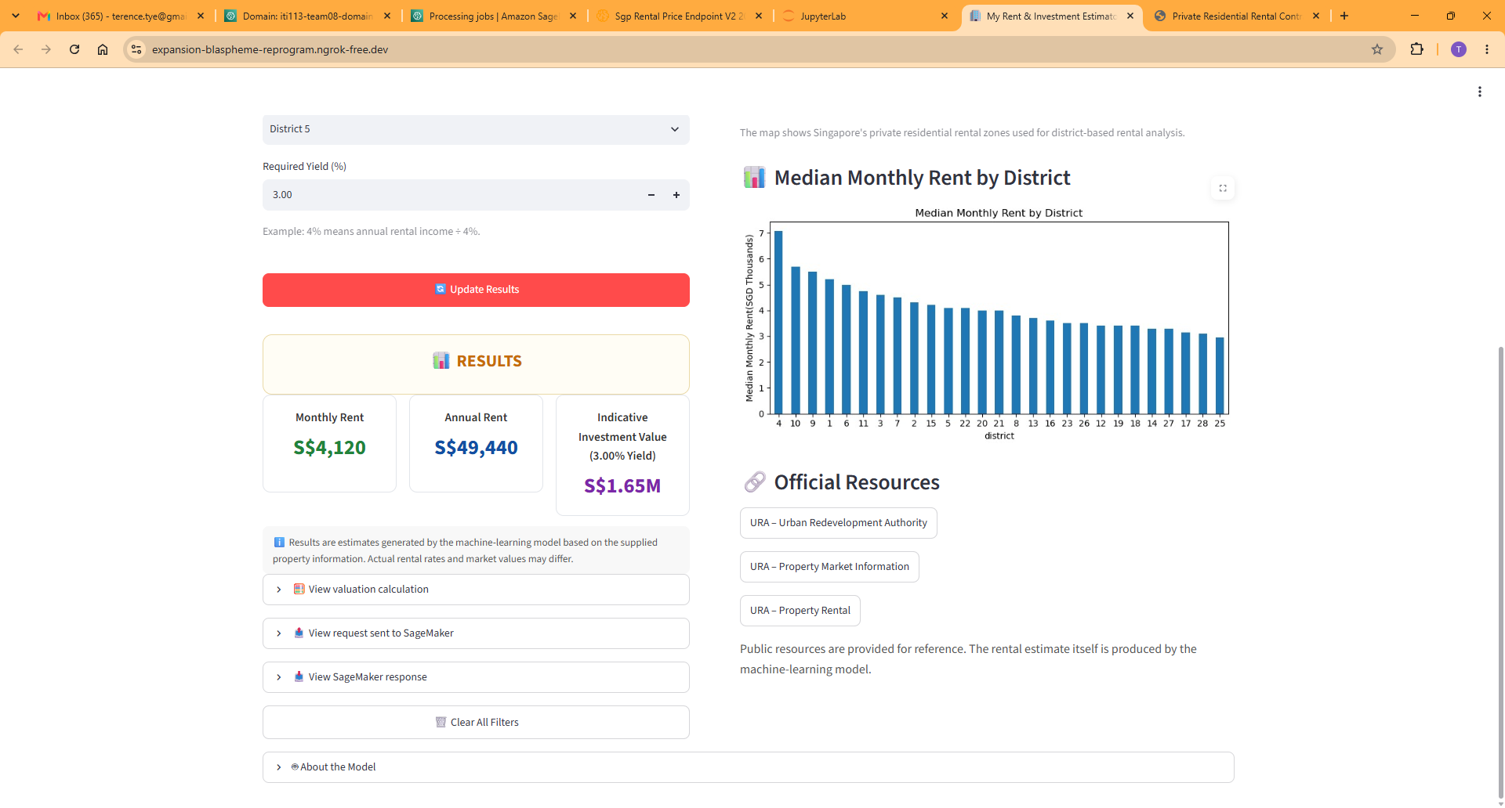

Actual Rent from the URA

“https://eservice.ura.gov.sg/property-market-information/pmiResidentialRentalSearch”

NORMANTON PARK | NORMANTON PARK | 05 | Non-Landed Properties | 2 | 4,200 | 60 to 70 | 600 to 700 | Jul-26

WEST BAY CONDOMINIUM | WEST COAST CRESCENT | 05 | Non-Landed Properties | 2 | 3,700 | 80 to 90 | 800 to 900 | Jul-26

----------------------------- END OF REPORT--------------------------------------------------

