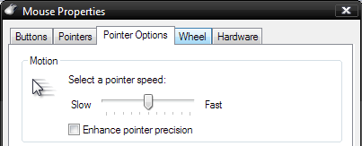

; Buttons I Pointers POiY'ItBFODiiOFIS I Hardware

Motion

m Select a pointer speed:

**Slow L J Fast**

IE] Enhance pointer precision