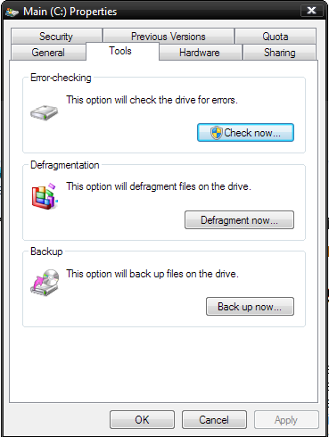

Security | Previous VersiOns I Quota General A Hardware I Sharing Error-checking

This option will check the dn've for errors.

Defragrnerrtation

E1“: This option will defragmerrt files on the drive.

**Defragmerlt now...**

Backup y This option will back up files on the drive.

[ OK Cancel Appty