英文普刊样式说明
内容体例按照以下顺序排列（不保留编号），不排版（我们排版），全文靠左，单栏，所有字体选10号字，Times New Roman字体，单倍行距，不留空行，2页以上。
特别注意英文表达，特别特别注意题目、摘要的英文表达。
全文不能出现任何中文表达，也不能出现中文标点符号，包括图、表和公式。
期刊的论文发表尽量限制在一个版面内。（8000个字符以内，不计空格），超出部分一个额外版面的费用是3000。我们的专业意见是只发陈述性内容，理论概念酌情删减，保证研究观点明确，提出问题解决对策导向性意义明确，减少过多陈述。

论文题目 The title

作者、作者单位和地址、通讯作者邮箱the author's name(s), affiliation(s) with complete addresses
样例：
Jun Lin^{1,2}, Yu Li^{1,*}
¹ Shanghai Advanced Research Institute, Chinese Academy of Sciences (CAS), Shanghai, 201210, China
² University of the CAS, Beijing 100039, China
*E-mail: ***@***.edu.cn

摘要 Abstract
不超过200单词

Keywords
3-5个

正文
各级标题用1. 2.，1.1, 2.1 标注，全大写，例如1. INTRODUCTION。
参考文献在文中标注格式参考下段，不要用上标：
Because of their high theoretical energy capacity and low cost, lithium–air batteries have the potential to replace conventional lithium–ion batteries as the future power source of electric vehicles.[1-7] However, lithium–air batteries still suffer from slow oxygen reduction/evolution reactions (ORR/OER) kinetics,[8] inefficient decomposition of the discharge products,[9] chemical instability of the electrolyte[10] and corrosion of the lithium anode.[11] These current challenges must be addressed before their implementation can be realized.
图在文中说明是用Fig. 2，在图下的说明里用的是Figure 2.。彩色图片网络版本是彩色的，纸质期刊是单色灰度图片。
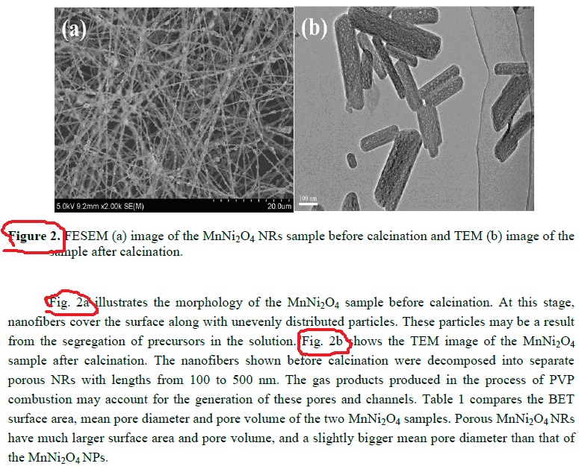
表与图类似在文中说明是用Tab. 2，在表上的说明里用的是Table 2.。表用全实线表。如：
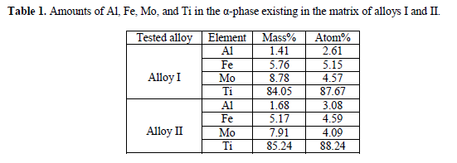
公式用word自带的编辑器编写，且按顺序标号。
项目资助信息以致谢的形式体现，放在正文后参考文献前。

参考文献格式如下：
[1]G. Eason, B. Noble, and I. N. Sneddon, On certain integrals of Lipschitz-Hankel type involving products of Bessel functions, Phil. Trans. Roy. Soc. London, 1955,24(7): 529–551.
论文格式：作者，作者，作者，论文题目，杂志名称，年，卷（期）：页码范围。
[2]J. Clerk Maxwell, A Treatise on Electricity and Magnetism, 3rd ed., Oxford: Clarendon, 1892.
著作格式：作者，作者，书名，版本，出版社，年。
[3]Y. Yorozu, M. Hirano, K. Oka, and Y. Tagawa, Electron spectroscopy studies on magneto-optical media and plastic substrate interface, IEEE Transl. J. Magn. Japan, August 1987: 740–741.
会议论文格式：作者，作者，作者，论文题目，会议名称，地点，时间：页码范围。
以下是样文：
The Research on Transient Thermal Stress of Coal Mine Ventilation Air Methane Oxidation Bed
Jun Lin^{1,2}, Yu Li^{1,*}
¹ Shanghai Advanced Research Institute, Chinese Academy of Sciences (CAS), Shanghai, 201210, China
² University of the CAS, Beijing 100039, China
*E-mail: ***@***.edu.cn
Abstract: Xxxxxx Multi-objective optimisation model to a new developed model, The model is resolved by multi-objective genetic alXxxxxx and pollution-control. xxxxxxxx xxxxx xxxxx xxxxxxxxxxxxxxx xxx xxxxxxx xxxxxx xxxxxx xxxxx xxxxx xxxxxx xx xxxxxx xxxxx xxxxxxxxx xxxx xxxxx xxxx xxxxx xxx xxx xxxxx xxxxxxxxx xxxx xxxxx xxxx xxxxx xxx xxxxxxx. This model xxxxxxxx xxxxx xxxxx xxxxxxxxxxxxxxx xxx xxxxxxx xxxxxx xxxxxx xxxxx xxxxx xxxxxx xx xxxxxx xxxxx xxxxxxxxx xxxx xxxxx xxxx xxxxx xxx xxxxxxx some insight to further study about decision making of operation rules in heavily polluted rivers.
Keywords: Yingshang sluice, xxx xxx, xxx xxx, xxx xxx, xxx xxx.
1. INTRODUCTION
The Huai River is the earliest river, which performs water pollution control in china. In 1995, the State Council issued the ‘Interim Regulations of water pollution prevention on Huai River’. This model xxxxxxxx xxxxx xxxxx xxxxxxxxxxxxxxx xxx xxxxxxx xxxxxx xxxxxx xxxxx xxxxx xxxxxx xx xxxxxx xxxxx xxxxxxxxx xxxx xxxxx xxxx xxxxx xxx xxxxxxx. xxxxxxx.

Because of their high theoretical energy capacity and low cost, lithium–air batteries have the potential to replace conventional lithium–ion batteries as the future power source of electric vehicles.[1-7] However, lithium–air batteries still suffer from slow oxygen reduction/evolution reactions (ORR/OER) kinetics,[8] inefficient decomposition of the discharge products,[9] chemical instability of the electrolyte[10] and corrosion of the lithium anode.[11] These current challenges must be addressed before their implementation can be realized.

2. EXPERIMENTAL

2.1 STUDY AREA

xxxxxxxx xxxxx xxxxx xxxxxxxxxxxxxxx xxx xxxxxxx xxxxxx xxxxxx xxxxx xxxxx xxxxxx xx xxxxxx xxxxx xxxxxxxxx xxxx xxxxx xxxx xxxxx xxx xxxxxxx. xxxxxxxx xxxxx xxxxx xxxxxxxxxxxxxxx xxx xxxxxxx xxxxxx xxxxxx xxxxx xxxxx xxxxxx xx xxxxxx xxxxx xxxxxxxxx xxxx.

2.2 METHOD

xxxxxxxx xxxxx xxxxx xxxxxxxxxxxxxxx xxx xxxxxxx xxxxxx xxxxxx xxxxx xxxxx xxxxxx xx xxxxxx xxxxx xxxxxxxxx xxxx xxxxx xxxx xxxxx xxx xxxxxxx. xxxxxxxx xxxxx xxxxx xxxxxxxxxxxxxxx xxx xxxxxxx xxxxxx xxxxxx xxxxx xxxxx xxxxxx xx xxxxxx xxxxx xxxxxxxxx xxxx Fig. 1.
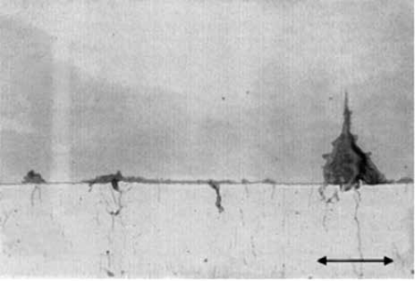
Figure 1. Map of study area and sampling locations
Hydrodynamic governing equation:
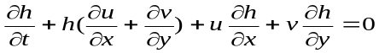 (1)
(2)

xxxxxxxx xxxxx xxxxx xxxxxxxxxxxxxxx xxx xxxxxxx xxxxxx xxxxxx xxxxx xxxxx xxxxxx xx xxxxxx xxxxx xxxxxxxxx xxxx xxxxx xxxx xxxxx xxx xxxxxxx. xxxxxxxx xxxxx xxxxx xxxxxxxxxxxxxxx xxx xxxxxxx xxxxxx xxxxxx xxxxx xxxxx xxxxxx xx xxxxxx xxxxx xxxxxxxxx xxxx Tab. 1.
Table 1. xxxxxxxx xxxxx xxxxx xxxxxxxxxxxxxxx
Period | Fuyang sluice |  | Huai River |  | Remark
Period | flow  （m³/s） | ammonia concentration（mg/l） | flow  （m³/s） | ammonia concentration（mg/l） | the normal water storage capacity ofdays
1 | 2.5 | 0.60 | 192.5 | 0.6 | the normal water storage capacity ofdays
2 | 6.4 | 5.28 | 2.6 | 0.3 | the normal water storage capacity ofdays
3 | 7.6 | 7.5 | 2.8 | 0.9 | the normal water storage capacity ofdays
4 | 5.2 | 5.5 | 10.8 | 0.5 | the normal water storage capacity ofdays

xxxxxxxx xxxxx xxxxx xxxxxxxxxxxxxxx xxx xxxxxxx xxxxxx xxxxxx xxxxx xxxxx xxxxxx xx xxxxxx xxxxx xxxxxxxxx xxxx xxxxx xxxx xxxxx xxx xxxxxxx. xxxxxxxx xxxxx xxxxx xxxxxxxxxxxxxxx xxx xxxxxxx xxxxxx xxxxxx xxxxx xxxxx xxxxxx xx xxxxxx xxxxx xxxxxxxxx xxxx.

3. RESULTS AND DISCUSSION

xxxxxxxx xxxxx xxxxx xxxxxxxxxxxxxxx xxx xxxxxxx xxxxxx xxxxxx xxxxx xxxxx xxxxxx xx xxxxxx xxxxx xxxxxxxxx xxxx xxxxx xxxx xxxxx xxx xxxxxxx. xxxxxxxx xxxxx xxxxx xxxxxxxxxxxxxxx xxx xxxxxxx xxxxxx xxxxxx xxxxx xxxxx xxxxxx xx xxxxxx xxxxx xxxxxxxxx xxxx.

4. CONCLUSIONS

xxxxxxxx xxxxx xxxxx xxxxxxxxxxxxxxx xxx xxxxxxx xxxxxx xxxxxx xxxxx xxxxx xxxxxx xx xxxxxx xxxxx xxxxxxxxx xxxx xxxxx xxxx xxxxx xxx xxxxxxx. xxxxxxxx xxxxx xxxxx xxxxxxxxxxxxxxx xxx xxxxxxx xxxxxx xxxxxx xxxxx xxxxx xxxxxx xx xxxxxx xxxxx xxxxxxxxx xxxx.

5. ACKNOWLEDGMENT

The authors wish to thank A, B, C. This work was supported in part by a grant from XYZ.

REFERENCES
[1]G. Eason, B. Noble, and I. N. Sneddon, On certain integrals of Lipschitz-Hankel type involving products of Bessel functions, Phil. Trans. Roy. Soc. London, 1955,24(7): 529–551.
[2]J. Clerk Maxwell, A Treatise on Electricity and Magnetism, 3rd ed., Oxford: Clarendon, 1892.
[3]Y. Yorozu, M. Hirano, K. Oka, and Y. Tagawa, Electron spectroscopy studies on magneto-optical media and plastic substrate interface, IEEE Transl. J. Magn. Japan, August 1987: 740–741.

