**Team:**

* Arthur & Tygo

**Project name:**

* GTRacing Pro

**The game will contain (mechanics):**

* Reasonably realistic controllable car. 3rd person camera;
  + The car will be controlled by the player;
* Controllers. The game will be controlled via a keyboard or a controller;
  + Keyboard. A or D turning, W driving, S breaking;
  + Controller. Joystick turning, R2 driving, L2 breaking;
* Car choosing. You can choose the car you can play with and they will have different driving characteristics/stats;
  + Car characteristics/stats. Top speed, acceleration and car handling;
  + The player can choose between 3 cars. These cars will have the car characteristics/stats;
  + The player can choose there car when they click on the “Start” button;
  + Out lap after car choosing;
* Main Menu. The main menu will contain the “Start” and “Quit” buttons;
* Timer. The timer will start after the player finished an out lap;
  + Time stops after you hit the finish line again;
* High-score. The lowest lap time will be the highest score, this will be tracked;
* Crashing. The player can crash against the wall, this will reset the car back to the track;
* Pause Menu. A pause menu used to quit and reset the game.

**The player will (dynamics):**

* Try to improve their laptime;
* Try to cut corners in the track;
* Crash or hit the barrier;
* Choose the best car for them and there racing style;
* Try and minimize the time of the out lap;
* Use their preferred controller, will it be keyboard or controller;
* Try to get the most out of a car;
* Try to exploit the timer or the track;

**The goal of the game will be (aesthetics):**

* Challenge, you will want improve your time and driving skill throughout playing the game.
* Submission, it will be easy to pick up and hard to master because the concept is quite simple.

**What will the game look like (visuals):**

* Afbeelding met auto, dak

  Automatisch gegenereerde beschrijvingAfbeelding met berg, lucht, buiten, weg

  Automatisch gegenereerde beschrijvingAfbeelding met weg, auto

  Automatisch gegenereerde beschrijvingThe game will look semi realistic and will be inspired by other racing sims. We will make it look like this by using third party models and assets;
* 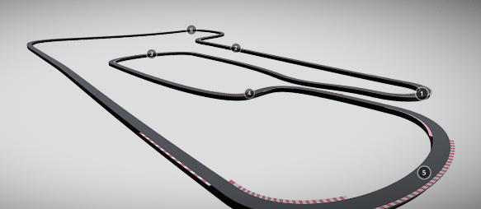Afbeelding met weg, geel, auto, autoracen

  Automatisch gegenereerde beschrijvingAfbeelding met tekst, lucht, buiten, weg

  Automatisch gegenereerde beschrijvingAfbeelding met gras, buiten, hoogland, aarde

  Automatisch gegenereerde beschrijving

**MoSCoW prioritization**

Crashing;

Car stats.

Pause menu;

Main menu;

Car choosing;

High-score.

Car controller;

Timer;

Car input.

M

S

C

W