PROJECT

PLAN.

Team: GTRacing Pro

Arthur Stam.

Tygo Boons.

Contents

Chapter 1

Project description...................................................................................................................3

Chapter 2

Game-Design............................................................................................................................4

Chapter 3

Asset list………………………………….............................................................................................7

Chapter 4

Technical Design......................................................................................................................8

Chapter 5

Planning...................................................................................................................................11

Chapter 6

Expected obstacles & difficulties..........................................................................................14

Chapter 7

Feedback…………………………………..........................................................................................15

Chapter 8

Changelog…………………………………........................................................................................16

**Chapter 1: Project description.**

Team name:

* Team GTRacing

Collaborators:

* Arthur Stam
* Tygo Boons

Project description:

* GTRacing Pro is a simple racing game that will mainly be about setting fast lap times in a car around a track. The game will be made in the span of 4 weeks. The game will feature a realistic visual and will be fully created using Unreal Engine. The goal of the game will be to set faster laps and improve your high score.

**Chapter 2: Game-Design.**

**The game will contain (mechanics):**

* Reasonably realistic controllable car. 3rd person camera;
  + The car will be controlled by the player;
* Controllers. The game will be controlled via a keyboard or a controller;
  + Keyboard. A or D turning, W driving, S breaking;
  + Controller. Joystick turning, R2 driving, L2 breaking;
* Car choosing. You can choose the car you can play with and they will have different driving characteristics/stats;
  + Car characteristics/stats. Top speed, acceleration and car handling;
  + The player can choose between 3 cars. These cars will have the car characteristics/stats;
  + The player can choose their car when they click on the “Start” button;
  + Out lap after car choosing;
* Main Menu. The main menu will contain the “Start” and “Quit” buttons;
* Timer. The timer will start after the player finished an out lap;
  + Time stops after you cross the finish line again;
* High-score. The lowest lap time will be the highest score, this will be tracked;
* Crashing. The player can crash against the wall, the player needs to go back on the track them self. There are no penalties for crashing;
* Pause Menu. A pause menu with the options to quit and reset the game.

**The player will (dynamics):**

* Try to improve their laptime;
* Try to cut corners in the track;
* Crash or hit the barrier;
* Choose the best car for them and their racing style;
* Try and minimize the time of the out lap;
* Use their preferred controller, will it be keyboard or controller;
* Try to exploit the timer or the track;

**The goal of the game will be (aesthetics):**

* Challenge, you will want improve your time and driving skill throughout playing the game.
* Submission, it will be easy to pick up and hard to master because the concept is quite simple.

**What will the game look like (visuals):**

* Afbeelding met auto, dak

  Automatisch gegenereerde beschrijvingAfbeelding met berg, lucht, buiten, weg

  Automatisch gegenereerde beschrijvingAfbeelding met weg, auto

  Automatisch gegenereerde beschrijvingThe game will look semi realistic and will be inspired by other racing sims. We will make it look like this by using third party models and assets;
* 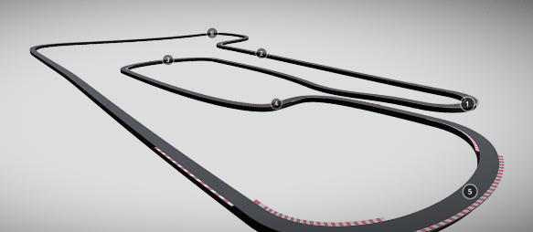Afbeelding met weg, geel, auto, autoracen

  Automatisch gegenereerde beschrijvingAfbeelding met tekst, lucht, buiten, weg

  Automatisch gegenereerde beschrijvingAfbeelding met gras, buiten, hoogland, aarde

  Automatisch gegenereerde beschrijving

**MoSCoW prioritization**

M

S

C

W

Car controller;

Timer;

Pause menu;

Main menu;

Car choosing/multiple cars;

High-score.

Crashing;

Car stats;

Switching from 3rd to 1ste person;

Car Handeling.

**Google froms:**

<https://forms.gle/NEqTgZcPsp23vizf7>

**Chapter 3: Asset list**

Assets:

* 3 3D car models;
  + Car1: <https://sketchfab.com/3d-models/mclaren-mp4-12c-a53f76d67c3a4184896a47a1af9e07d1>
  + Car2: <https://sketchfab.com/3d-models/camaro-ls-dctm-e9c677d1c6a3454ebb4746a160129386>
  + Car3: <https://sketchfab.com/3d-models/mclaren-600lt-f576442d6839419ea157837df84ddfee>
* A 3D racetrack model;
  + [~~https://sketchfab.com/3d-models/race-track-c-001-33km-ae5378bd1cde4f13830eec4bf71eb3bd~~](https://sketchfab.com/3d-models/race-track-c-001-33km-ae5378bd1cde4f13830eec4bf71eb3bd)
  + UPDATE: Landscape and track will be built using Unreal Engines spline landscape road builder and based off of Spa Frachonchips
* 3D trees for landscape
  + <https://sketchfab.com/3d-models/game-ready-oak-tree-model-8ba0e67f477c4cc49ca97af0d68081ea>
* Material textures for landscape;
  + <https://www.istockphoto.com/nl/fotos/grass-texture-seamless>
* 3D background for car choosing;
  + <https://sketchfab.com/3d-models/garage-de7a8dd4309e461cbc99be85f928b480>
* 2D textures for switching between cars button;
  + By: Tygo Boons
* 2D GTRacing Logo
  + By: Tygo Boons
* Car sound
  + <https://www.youtube.com/watch?v=9osfA1l-ya8>
* 4 Different soundtracks
  + We Are The Union - A Better Home: <https://www.youtube.com/watch?v=FxJ4sp7nMQY>
  + Initial D - Déjà vu: <https://www.youtube.com/watch?v=dv13gl0a-FA>
  + Vanettica: - Confidential Liar: <https://www.youtube.com/watch?v=wgEmsIJgYdc>
  + Bean5 – ReadyGo: By Tygo Boons
* 2D images for the menu buttons;
  + By: Tygo Boons
* Apex trail
  + By: Tygo Boons
* Barriers
  + By: Tygo Boons
* Font
  + LightSider: <https://www.fontsc.com/font/tag/racing>
* Building
  + <https://www.cgtrader.com/free-3d-models/exterior/house/condor--2>

**Chapter 4: Technical Design.**

Tools:

* Unreal engine 4 v4.27.2
* Visual studio 2022
* Unreal Blueprints
  + C++ classes will define to base structure of a Blueprint class. Blueprint classes are based on C++ classes;
  + Blueprints are the visual coding language of Unreal engine;
  + Blueprints will be used together with C++;
  + HUD Elements will be created using Blueprints.
* Github / Git
  + Source control

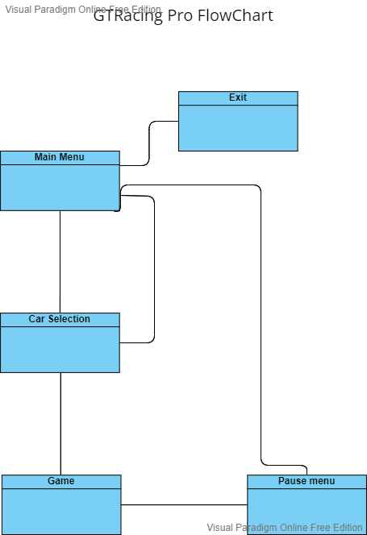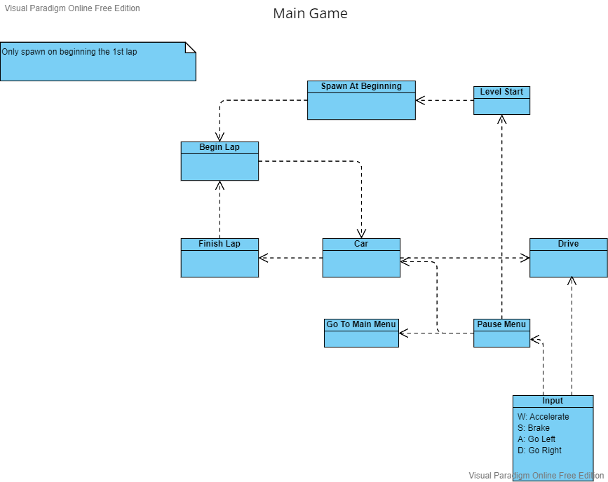

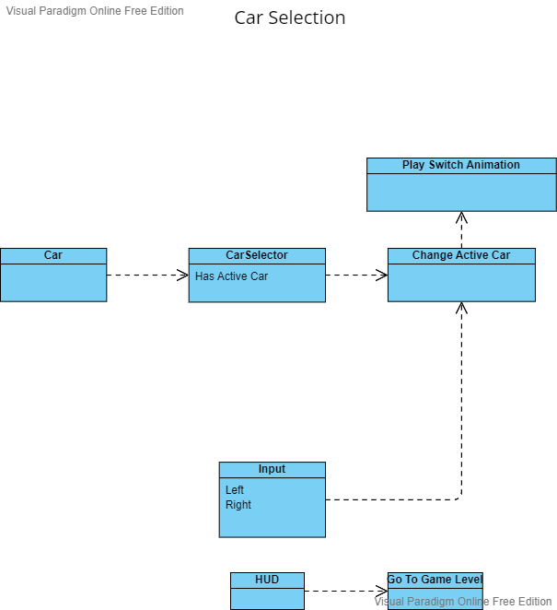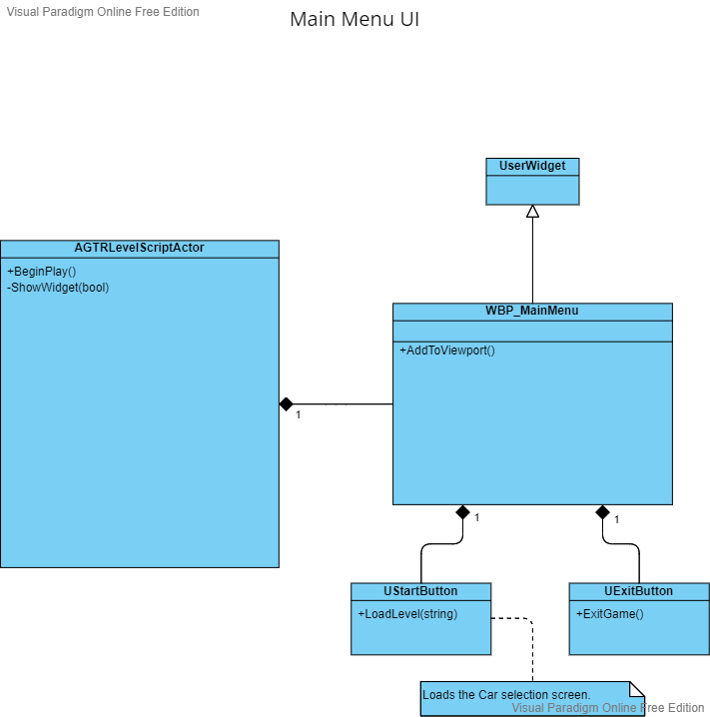

**Chapter 5: Planning.**

Sprint 1 (Week 5):

* Fully finished Game-design document; (Arthur)
* Fully finished Technical-design document; (Tygo)
* Start of project plan; (Arthur & Tygo)
* Beginning a Trello featuring these documents. (Arthur)

Week 5: We’re going to make the project plan and the start of a Trello board. We’re going to focus on Game-design and Technical-design for the project plan.

Sprint 2 (Week 6):

* Trello will be done; (Arthur)
* Finished PoC, with every Must from the MoSCoW table; (Arthur & Tygo)
* Making the car controller/movement system; Car can move and turn and player can use keyboard and controller; (Tygo)
* Making the timer system; (Tygo)
* Making google forms for feedback; (Arthur)
* Finished gathering third party assets and stating their sources (Tygo)
* First feedback phase and updating Project plan. (Arthur & Tygo)

Week 6: We’re going to make and finish the PoC, this part will mostly be done by Tygo. Arthur is going to finish the Trello, help with the PoC and making a google forms for feedback.

Sprint 3 (Week 7):

* Process feedback and add more content from the should from the MoSCoW table; (~~Arthur~~ & Tygo)
* Update google forms; (~~Arthur~~) NOT FINISHED
* First prototype done and another feedback phase; (~~Arthur~~ & Tygo) NO LEVEL DESIGN
* Updating Project plan. (~~Arthur~~ & Tygo)

Week 7: We’re going to make the first prototype, this prototype will have the feedback into it and all the content from the should from the MoSCoW table. Arthur is also going to update the google form. We’re also going to have another feedback phase and updating the project plan.

Sprint 4 (Week 8):

* Add final touches and Process feedback; (Arthur & Tygo)
* Present game. (Arthur & Tygo)
* Finish Level Design(Tygo) (Was not finished by Arthur)

Week 8: We’re going process the feedback from the week 7 feedback phase and add more content from the could from the MoSCoW table. If there is enough time than were going to do another feedback phase and process that. This will also be the week where we’re going to present our game.

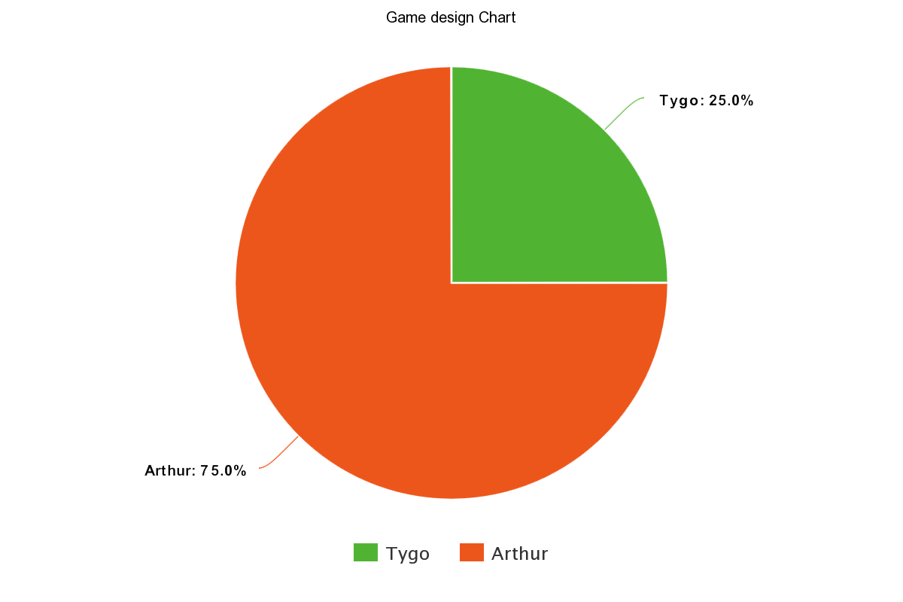Game-Design:

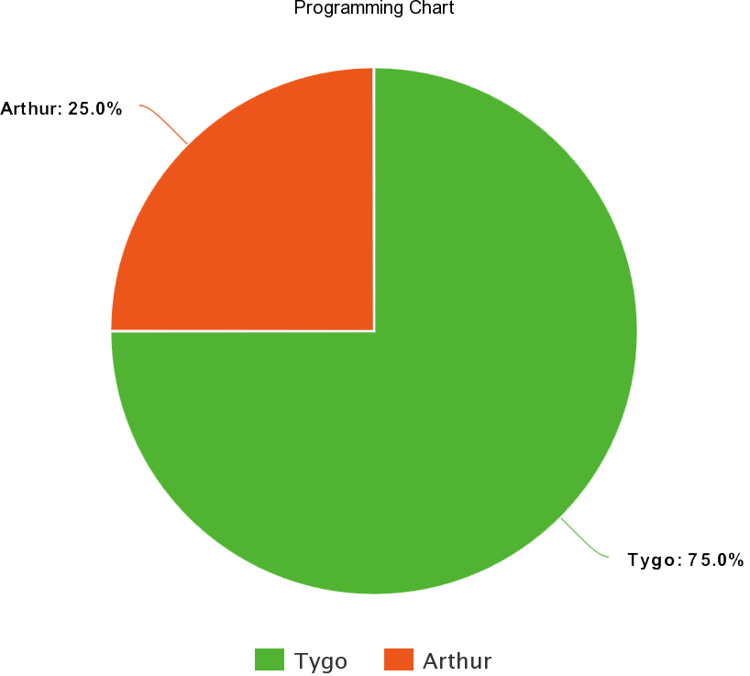Programming:

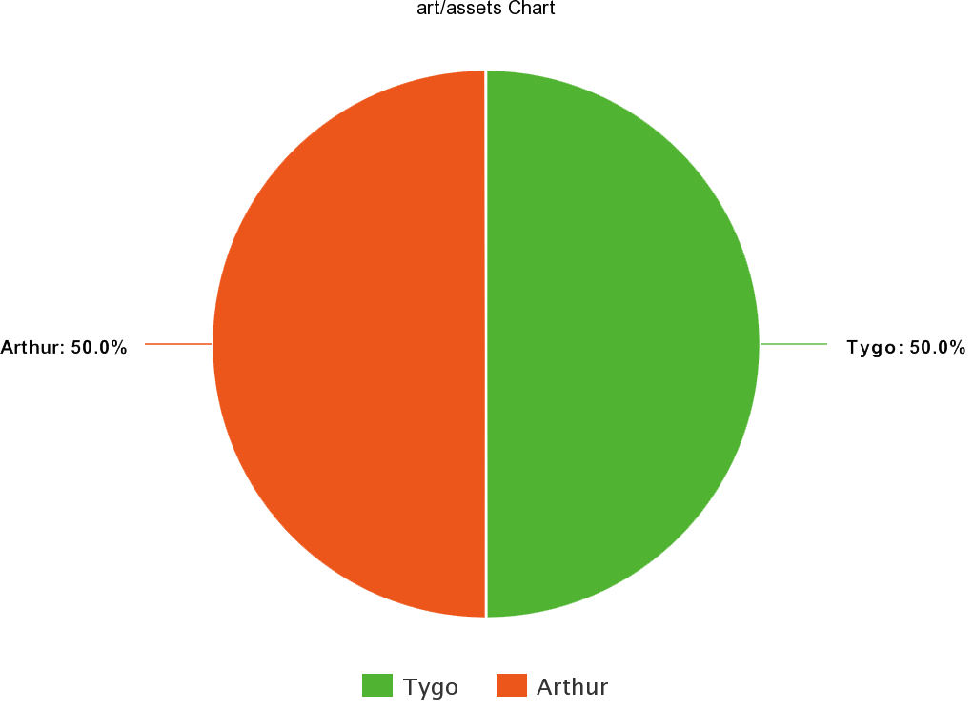Art/Assets:

**Chapter 6: Expected obstacles & difficulties.**

* Making the map. It’s a challenge making a map that works well with a track.
* It is possible we encounter a system we don’t recognize in Unreal engine which will take a bit to figure out.
* Time management.
* Github desktop problems.

**Chapter 7: Feedback.**

POC 1:

* Driving Sim Amateur:
  + The car feels erratic, especially in the high-speed corners.
  + No indication of how fast you are going, for example add objects on the side of the track as a reference and a speedometer .
  + There is no good indication of braking zones.
  + Camera feels stiff, it does not move.
  + The environment does not fit, the game is very unforgiving. Add something like a barrier.
  + Game feels fast but the car controls erratic.

POC 2:

* Game artist klas GA..
  + The car felt great.
  + There was no Timer visible.
  + The camera position was also good.
  + Favorite moment or interaction was the car selection.

**Chapter 8: Changelog.**

POC 1:

* Added car controller
* Added track and car models
* Added light scneery
* Added Timer to time lap time

Prototype 1:

* Added Main Menu
* Improved Car controller
* Added Garage scene
* Added Car Selection
* Added Logo
* Added new track (With Spa francorchamps layout)