Desk 3D Scene Proposal
Tyrone Hamilton
Southern New Hampshire University
September 21, 2026
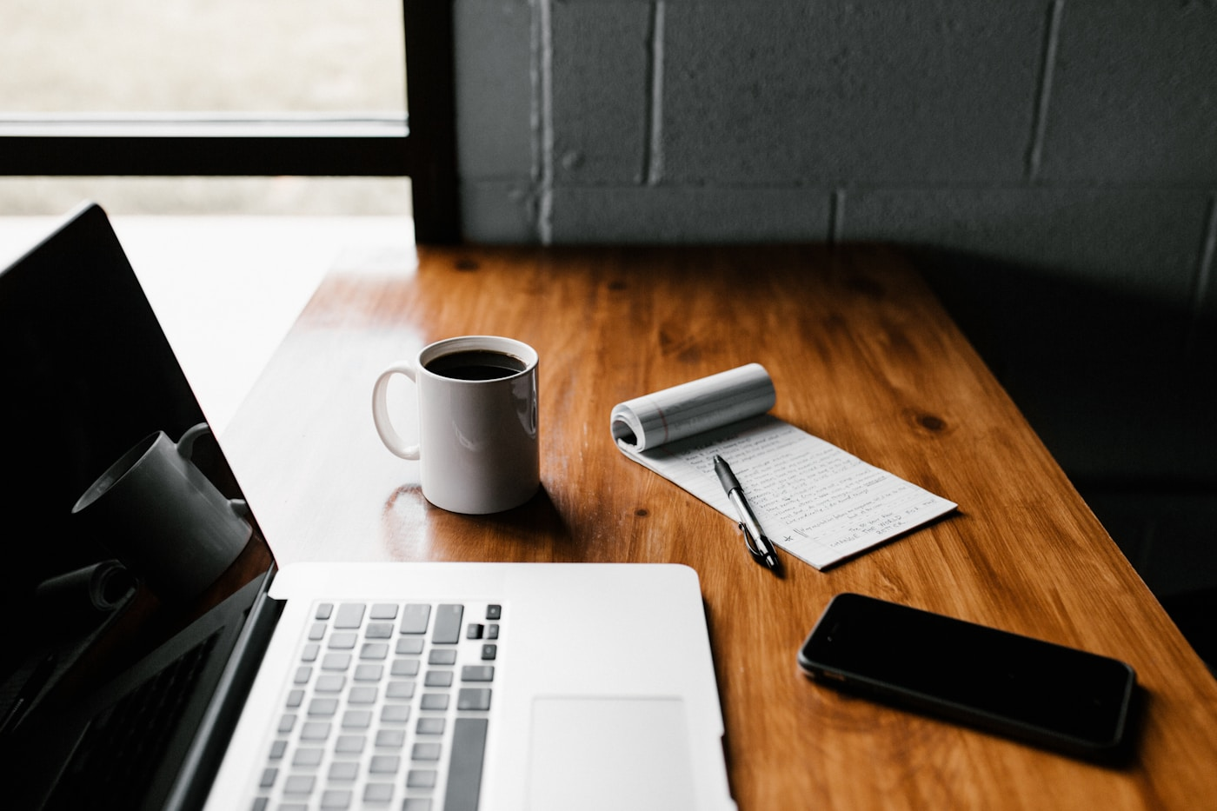
Figure 1. Desk workspace selected for the 3D project (Unsplash, n.d.).
For my final project, I selected a desk scene containing a laptop, coffee mug, notepad, pen, and smartphone. The wooden tabletop clearly separates the objects and gives me more than four items to recreate. The scene also includes a useful mix of flat, rectangular, round, and curved forms, which should make the finished model interesting without making it too difficult to build.

Objects Selected for Replication
The main objects I will replicate are the desk, laptop, coffee mug, notepad, pen, and smartphone. These items are good choices because each object has a recognizable shape and a clear location in the image. The laptop will be the largest focal object, while the smaller items will add detail and make the workspace feel natural. Their simple arrangement will also leave enough time for textures, lighting, and camera movement.

Basic 3D Shapes
I will use a plane as the tabletop that grounds every object and apply a wood texture to it. The laptop will combine thin boxes for its base, keyboard area, and screen. The smartphone and notepad will also use flattened boxes. I will construct the coffee mug from a cylinder for the cup and a torus for the handle, making it an object built from multiple shapes. The pen will use a narrow cylinder with a small cone at its tip, and the rolled top of the notepad can use another cylinder. The scene therefore uses a plane, boxes, cylinders, a torus, and a cone.

Project Scope
The project is achievable because the objects can be made by scaling and combining basic meshes. I will create the desk and larger objects first, then position the mug, notepad, pen, and phone. Small details such as individual keyboard keys can be simplified into a keyboard texture if they take too much time. After the models are placed, I will add wood, metal, glass, paper, and plastic textures, followed by lighting and camera controls.

Reference
Unsplash. (n.d.). Desk workspace with laptop, coffee mug, notepad, pen, and phone [Photograph]. https://images.unsplash.com/photo-1499750310107-5fef28a66643

