COSC 3P01

For my project I choose to do a chat room with the ability of having as many clients as you can have. As well as you can have many servers running as long as they are on different ports. I was not sure how to be able to handle having multiple servers on the same port but I am sure it would have been threaded but much more complex then what I have done. The chat room is able to send files to everyone in the chat room. This was the only way I could figure out how to send the file, I tried many other things but this was the only way I could get some results.
The first thing that I created was the chatMsg class, which is named poorly but it was late at night. I choose to do it this way because it is much easier to send string objects back and forth then having to deal with another way. Java does really well with objects so incorporating this I feel made it a lot simpler to program and handle all the messages. It was made serializable to make it easier to be transmitted across the network connection. There are a few different types of messages that can be sent by the client, message, logout, send file, and receive file. These are made integers so it can be used in case statements to handle the actions of each type of message. Everything that is being sent between the client and server is a chatMsg.
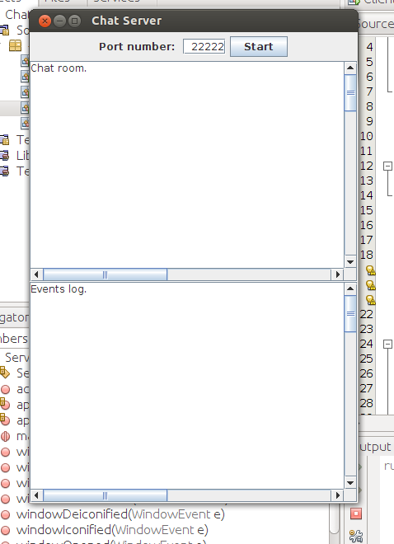
The server has a very nice and plain graphical user interface, the GUI was something I added to make it a bit more complex. It prompts for the server port so that you are able to have many different chat rooms open. The default is set to 22222, which was asked for in the assignment outline. From the image you can see at the top that you select a port and hit start and it will open a chat room. The GUI also allows for an event log to see who is connecting and disconnecting. The server has a class that handles all the server functions and another for the GUI. Being able to seperate this made it much easier to work with, as the GUI was more on the difficult side to figure out. Within the server class it creates the thread that allows for multiple clients in one room. I am using output and input streams to handle the data, this was just easier to deal with the objects. The run method will go forever until logout is typed by the client. When a client is connected to the server the event log will give a time and the port that is being used so the person running the server can tell that the people that want to connect.
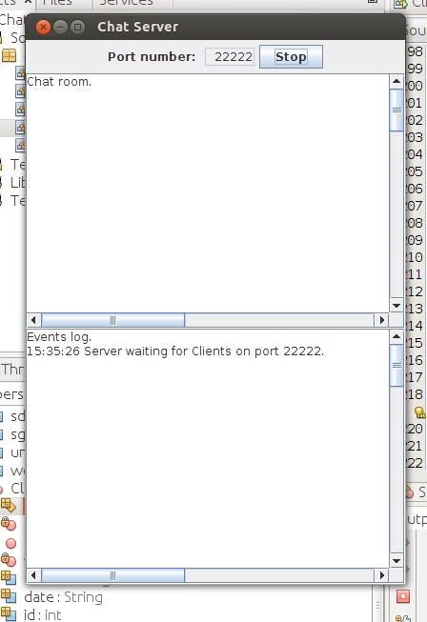

To execute the server you just type java ServerGUI in command prompt or like I have been using netbeans just launching the server in there.
The Client class has graphical user interface as well, this was implemented to help the client use the program easier and so its not just a command line program. The client has a few buttons to make using the interface more streamlined it has a login button to log in to the server. It has a few boxes of interest the server address to plug in an ip address if you are using them from different computers. It also has the port box which lets you change the port number so you can run multiple clients on different servers. It also allows for you to change the username it has the default set to anonymous but can be changed to whatever someone wants. The server will then broadcast the chosen username for the chatroom to see. When all the information that you need or want is entered you just click login and it will connect you to the server of the chosen port.
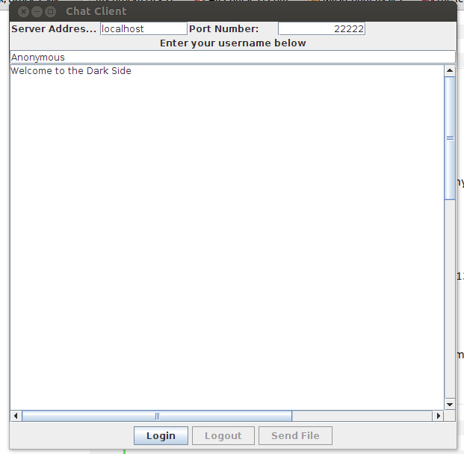
As you can see everything is simple and clean for client to use effectively. It then creates threads to listen to the server and will send everything as a string or when sending a file it will send a file. Once you login to the server the logout and send file buttons are activated and the user are able to use them.
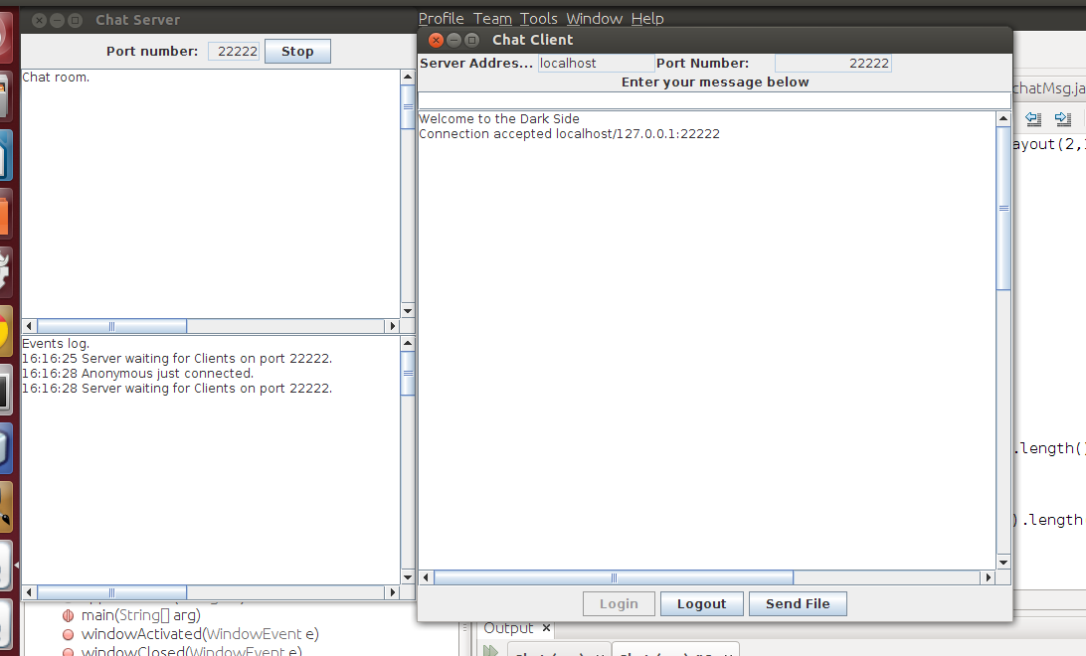
Once connected you can see the server log showing that the client has connected and that on the client window the buttons are activated and the login one is deactivated. The connection was accepted and the client GUI lets the person knows. You can see the the chat box where the user can enter text, the text is then converted to an object and passed to the server and spit back out as string.
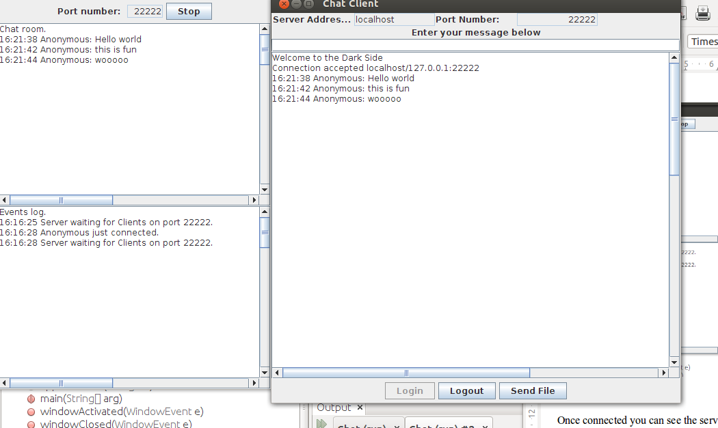
The text is passed between the server and then back to the client! The send file is also taken care of in the clientgui and the client classes. When the user clicks send file a prompt is issued and the user can name a file within the directory that the code is placed. The file is then saved where the code is running as well.
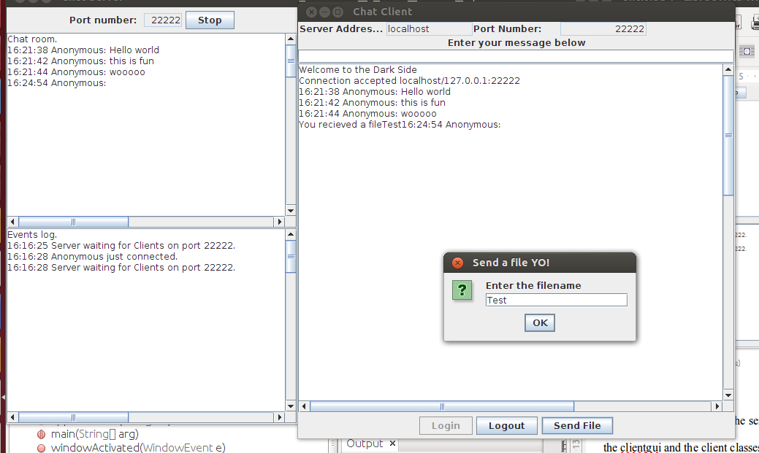

As you can see the prompt box allows you to type the file name in and then is sent to all users in the chat room. In my testing I added a 2 to make sure it was sending a new file when I was using the same computer.
In conclusion this assignment was a lot of fun to program and to try and figure out. I learned a lot about sockets and threading as well as getting more in depth with swing class and AWT to implement many features that I have not used a lot of in java. I have learned a great deal abou tthe behind the scenes of what actually goes into communicating.

