**Iteration 2 Use Cases**

Use Case 1: As a user, I want to log in the system

|  |  |
| --- | --- |
| **User Input** | **System Response** |
| Step 1: User starts application | Step 2: System Displays login screen |
| Step 3: User inserts password and clicks submit | Step 4: System verifies password and logs user in |

Use Case 2: As a user, I want to change my login password

|  |  |
| --- | --- |
| **User Input** | **System Response** |
| Step 1: User selects settings tab from the main screen. For manager, the button is in exact same location on the screen | Step 2: System displays settings screen |
| Step 3: User selects “Change Password” | Step 4: System goes to the change password screen |
| Step 5: User inserts current password, new password, and new password again for confirmation. User then clicks confirm | Step 6: System updates the password and gives a confirmation |

Use case 3: As a user, I want to change my display/profile photo

|  |  |
| --- | --- |
| **User Input** | **System Response** |
| Step 1: User selects settings tab from the main screen | Step 2: System displays settings screen |
| Step 3: User selects “Change Profile Picture” | Step 4: System prompts user to select a new photo from a generic list |
| Step 5: User selects new photo and clicks “Confirm” | Step 6: System updates the user’s profile picture |

Use Case 4: As a cashier, I want to check out an order

|  |  |
| --- | --- |
| **User Input** | **System Response** |
| Step 1: A user that is a cashier is by default placed on the checkout screen | Step 2: System displays checkout screen |
| Step 3: Cashier adds items into the order, adding in weights as necessary | Step 4: System displays those items on the checkout screen |
| Step 5: Cashier finishes adding all items and then clicks Pay | Step 6: System asks which type of payment will be used |
| Step 7: Cashier selects the Cash option | Step 8: System asks cashier to input how much cash was given by the customer |
| Step 9: Cashier inputs the amount of cash given, then presses “Confirm” | Step 10: System asks whether the customer would like a receipt or not |
| Step 11: Cashier selects “Yes” | Step 12: System asks what format the receipt should be printed in |
| Step 13: Cashier Selects one of the options | Step 14: System returns to homepage and stores a receipt as a file of the chosen option |

Example receipts for Use Case 4:

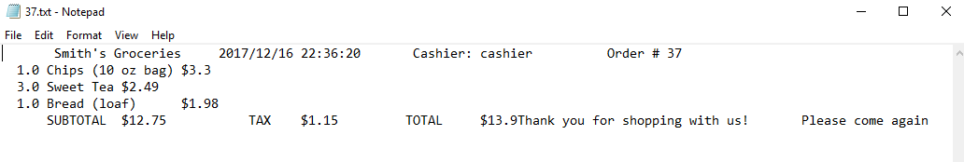

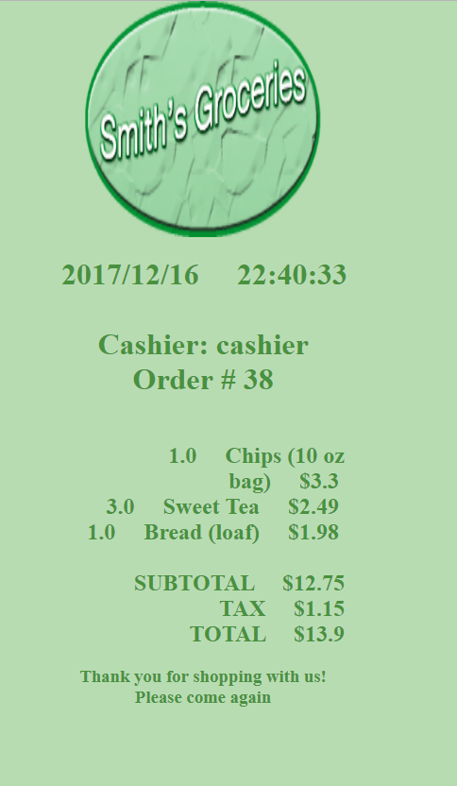

Use Case 5: As a manager, I want to add a new product into the system

|  |  |
| --- | --- |
| **User Input** | **System Response** |
| Step 1: User who is a manager selects “Add Item” | Step 2: System displays add item screen |
| Step 3: Manager enters in product details, then clicks Confirm | Step 4: System adds new product to the system, then confirms the product has been added |

Use Case 6: As a manager, I want to update a current product in the system’s database

|  |  |
| --- | --- |
| **User Input** | **System Response** |
| Step 1: User who is a manager selects “Edit Item” | Step 2: System asks for product ID |
| Step 3: User enters product ID, then clicks Load | Step 4: System displays all current information on the product |
| Step 5: Manager enters in updated product details, then clicks Confirm | Step 6: System changes product information in the system, then confirms the database update |

Use Case 7: As a manager, I want to create a new user, assign role, generate a default password for a new user

|  |  |
| --- | --- |
| **User Input** | **System Response** |
| Step 1: User who is a manager selects “Add User” | Step 2: System displays add user screen |
| Step 3: Manager enters in the new user’s name, then selects their job position, either cashier or manager. Then manager clicks Confirm | Step 4: System adds new user to the system, and also shows the default password generated for the new user |

Use Case 8: As a manager, I want to view and sort the business report: e.g., what products are sold, how many units, how much revenue

|  |  |
| --- | --- |
| **User Input** | **System Response** |
| Step 1: User who is a manager selects “View Business Reports” | Step 2: System displays add business report screen |
| Step 3: Manager inputs the date for the report desired | Step 4: System displays the Business Report for that date |
| Step 5: Manager clicks on the “Name” column | Step 6: System sorts the table in descending alphabetical order |
| Step 7: Manager clicks again on the “Name” column | Step 8: System sorts the table in ascending alphabetical order |
| Step 9: Manager changes the date to 11/13/2017 | Step 10: System automatically brings up the business report for that date |
| Step 11: Manager selects “Back” to return to the main screen | Step 12: System displays the home screen |