CSE 212 – Programming with Data Structures
W01 Prove – Response Document

Name: | Tyler Burke
Date: | 01/12/2026
Teacher: | Brother Godderidge

It is a violation of BYU-Idaho Honor Code to post or share this document with others or to post it online. Storage into a personal and private repository (e.g. private GitHub repository, unshared Google Drive folder) is acceptable.

Question 1: For the rotate right problem, provide a description of how you solved the problem.
The first things that I did was use simple math to calculate the number of spots that will be moved when the code is tested on. The next line then uses a method I called rightSlice to cut the pieces of the array that we want to have moved. The next line removes the pieces that are going to be moved, and the line after that then puts those pieces at the front of the array, thus moving the end to the beginning of the array.

Question 2: For the rotate right problem, draw a picture of how you solved the problem.
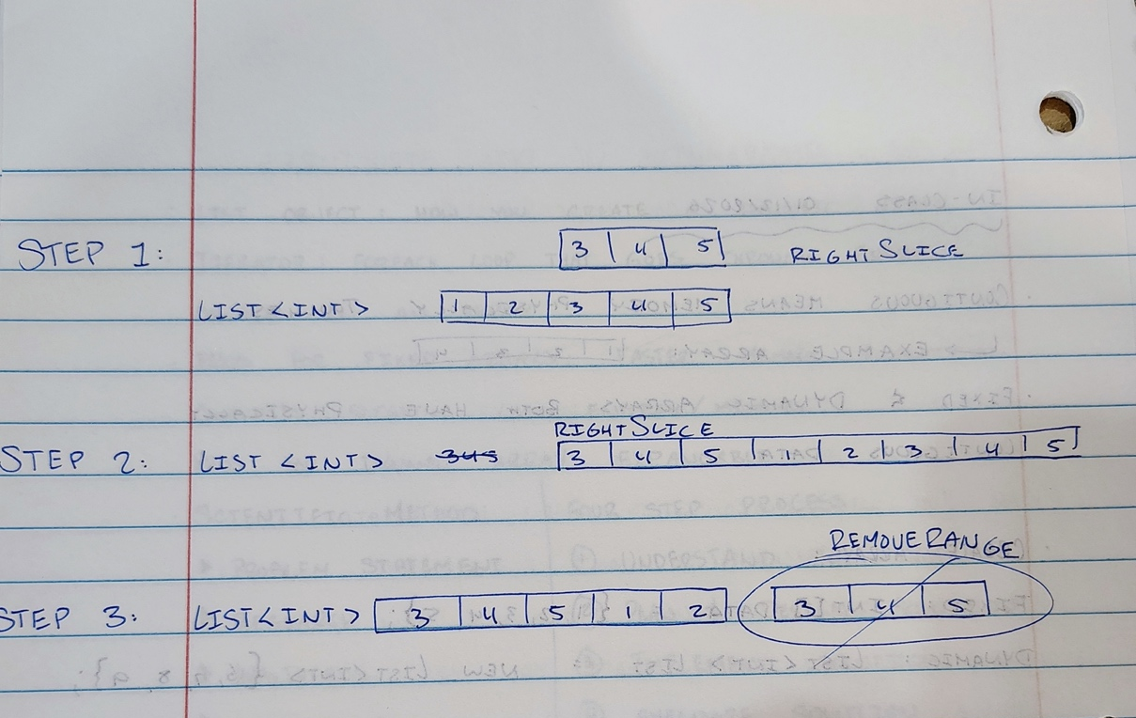
Remember: You need to commit all the changes to the prove-01-<username> repository along with this document. Then submit a link to the repository in I-Learn.

