A1_Report  
Tyler Janvrin

Matrix Algebra

1.

By row 1:  
2x = 8  
x = 4

By row 2:  
2y=6  
y=3

2.

a+b = 5, ab = 6  
Therefore a=2, b=3

3.

Determinant:

Multiply each cofactor Aij = (–1)i+j Mij, where M is the minor of aij, by a row or column of the matrix.

[2 -3 -2]

[1 -1 -1]

[0 2 1]

= -1

Inverse:

[1 -1 1]

[-1 2 0]

[2 -4 1]

4.

A + 3X = I3  
3X = I3 – A  
X = 1/3 (I3 – A)

X = 1/3 * [-3 3 -6]  
[-3 18 6]  
[3 -12 18]

X = [-1 1 -2]  
[-1 6 2]  
[1 -4 6]

4.

A^2 = [9 8 8] [8 9 8] [8 8 9]

4A = [4 8 8] [8 4 8] [8 8 4]

5I = [5 0 0] [0 5 0] [0 0 5]

Obviously, then, A^2 – 4A – 5I = 0  
Just look at at!

Finding A^-1

A^2 – 4A – 5I = 0  
A^2 – 4A = 5I  
A(A-4I) = 5I  
A * 1/5(A-4I) = I

Therefore, 1/5(A-4I) = A-1 = [-3/5 2/5 2/5][2/5 -3/5 2/5][2/5 2/5 -3/5]

6.

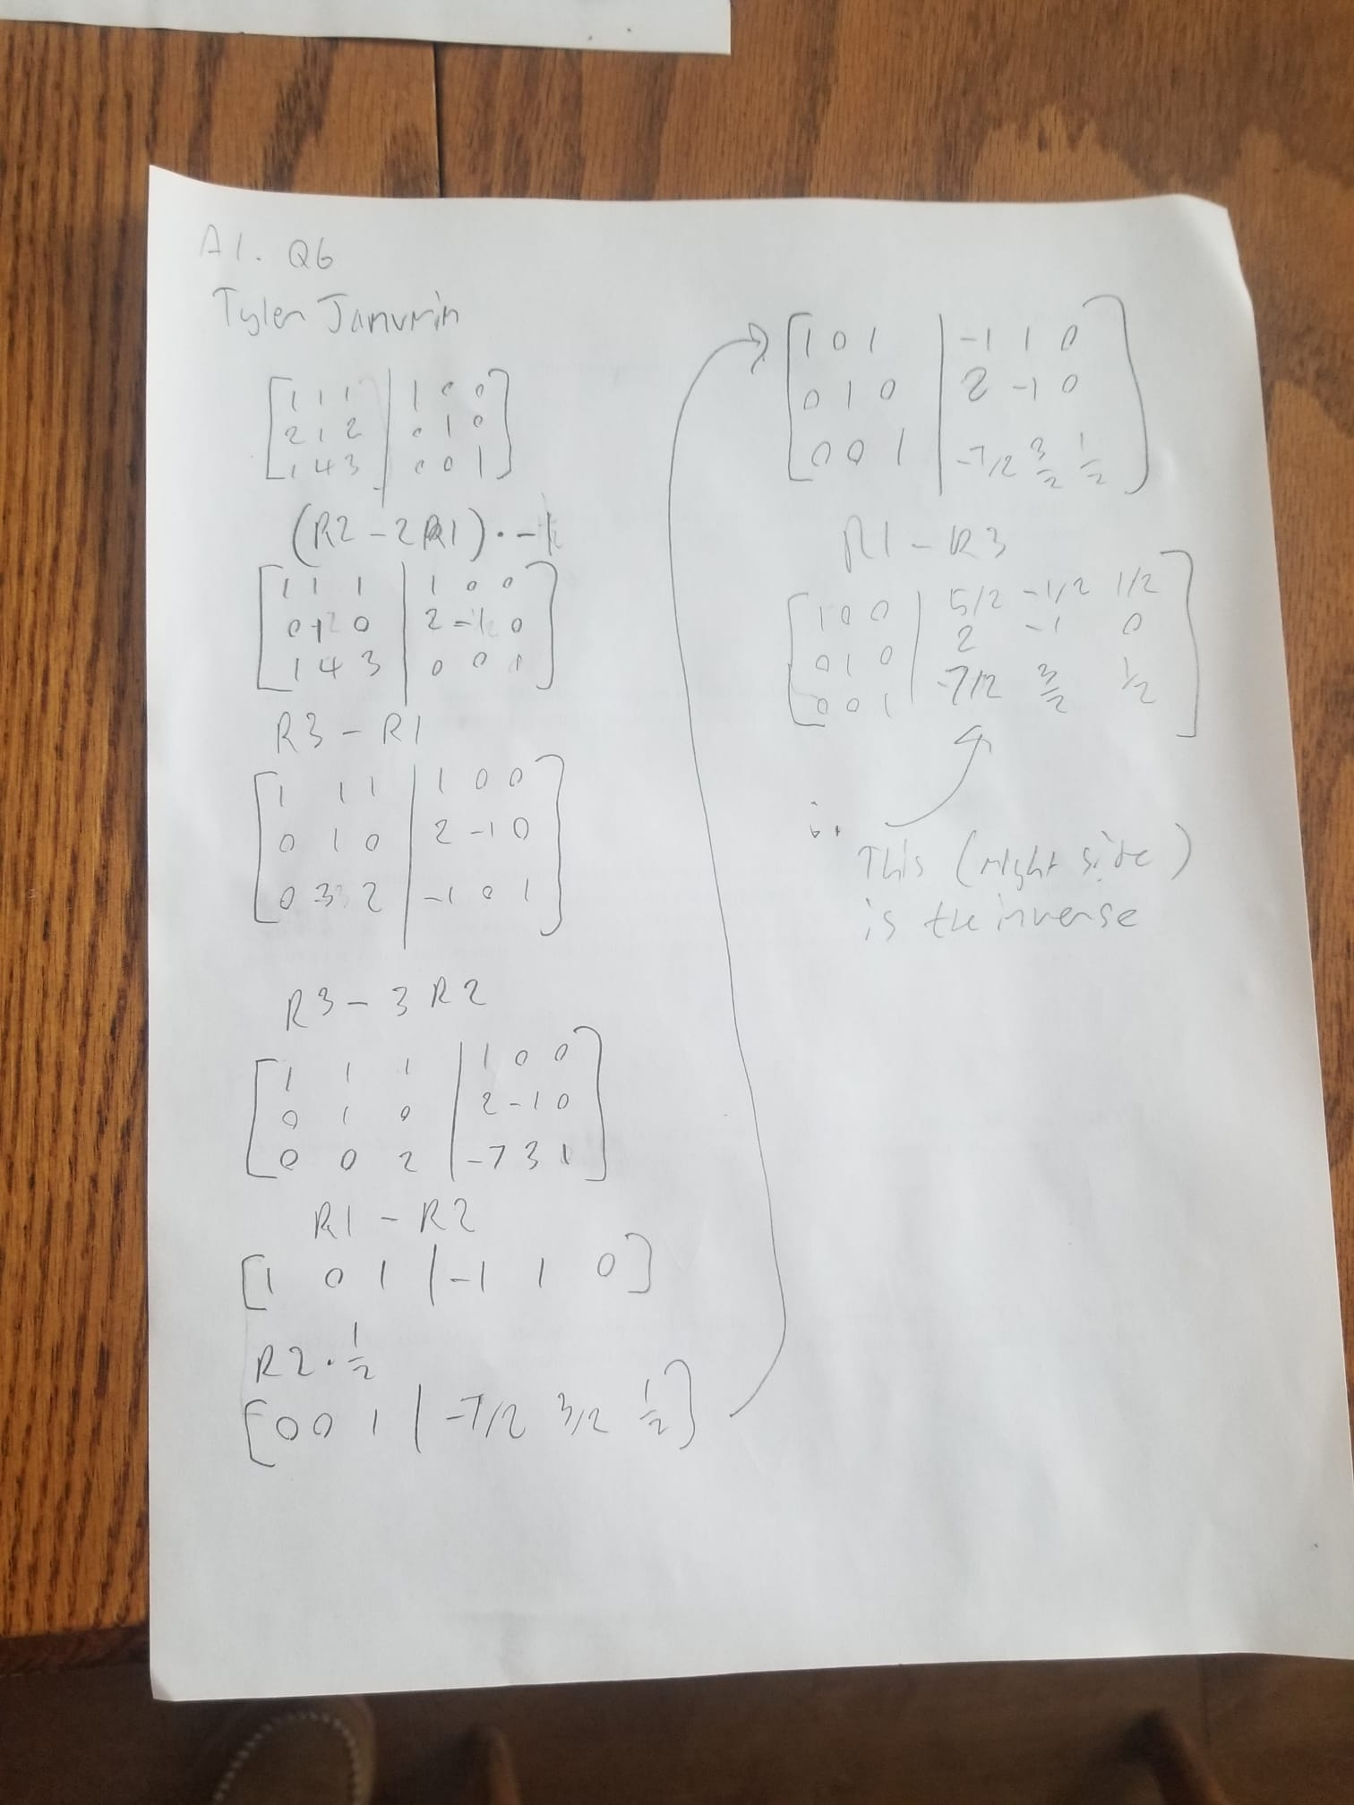

Since A^-1 = [5/2 -1/2 1/2] [2 -1 0] [7/2 3/2 ½], and since we have

Ax = b  
A^-1Ax = A^-1b  
x = A^-1b

Therefore, a quick matrix multiplication gives:  
x = [1] [-1] [1]