Lab 02 Report

Tyler Janvrin

Student Number 1154436

-

Q1

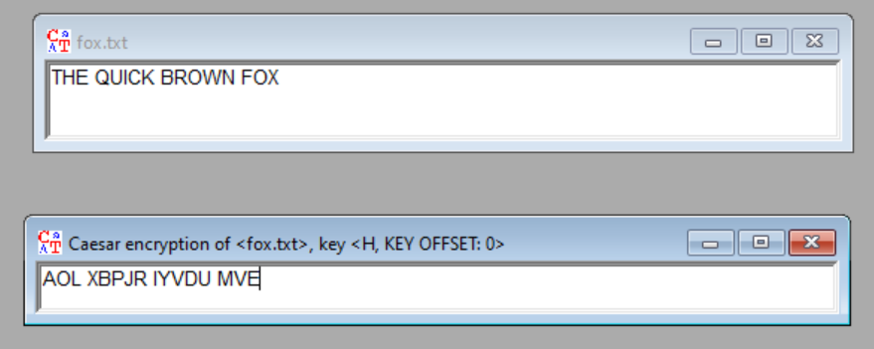

Encrypting “THE QUICK BROWN FOX” with the Caeser Cipher key H in Cryptool 1 gives the string “AOL XBPJR IYVDU MVE”.

Q2

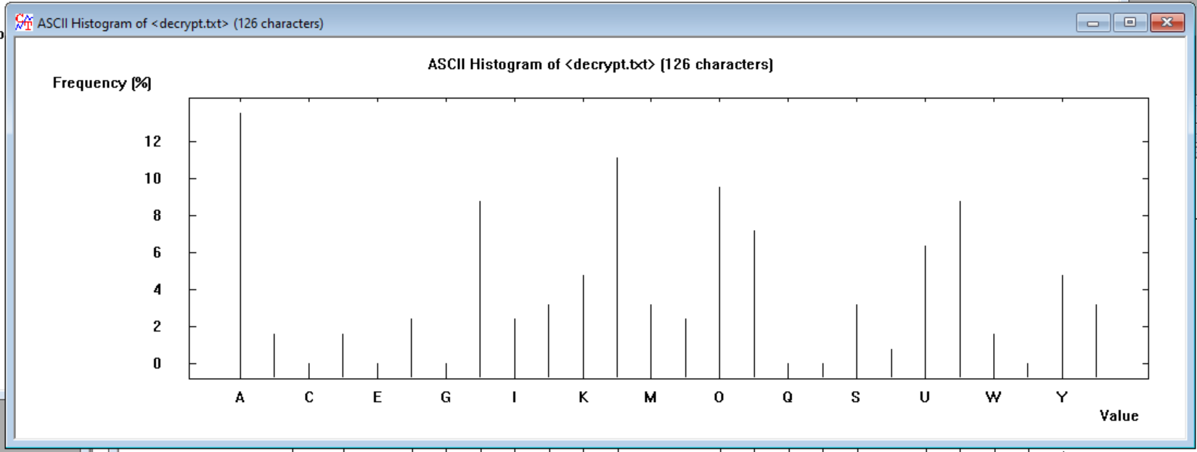

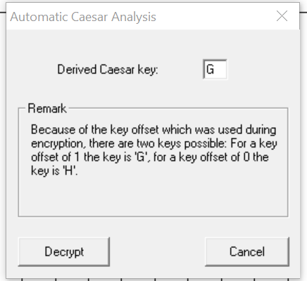

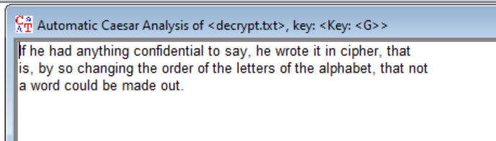

The output was “If he had anything confidential to say, he wrote it in cipher, that

is, by so changing the order of the letters of the alphabet, that not

a word could be made out.”

Q3

Partner name:

Partner encoding: MXG FHW MAKXX

Partner message: TEN MOD THREE

My encoding: Jehedje

My message: Toronto



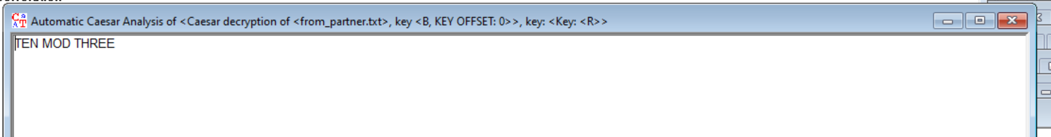

I used the same method to decrypt this that I used in Q2.