**Pets Eating Timing System (P.E.T.S.) Team Lead and Database Developer Fall 2018**

* **Primary Function:** This system permits the user to monitor and feed their pets remotely.
* **Team Lead:** Managed project closure activities which included completing the user manual, presentation of the prototype with its functionalities to various persons of interest.
* **Technologies used:** Raspberry Pi Micro, Computer, Python, MySQL database.

**Project Summary:** There was a pain where animal owners were unable to feed monitor and ensure the safety of our pet.

My team (PrymaTec) and I have decided to tackle that issue. Through extensive research and validation testing we developed a revolutionary pet feeding system and monitoring device which enables the owner to remotely care for the pets regardless of their location once there is internet connectivity between the device and the owner who will be interfacing with it remotely. The System also boost a fail-safe functionality which allows it to operate autonomously even without network connectivity based on some predetermined condition which will be triggered at certain events such as time and it’s built in motion sensing capabilities. The project was entered in the nationals for the Scientific Research Council (SRC) where team PrymaTec came in second place.

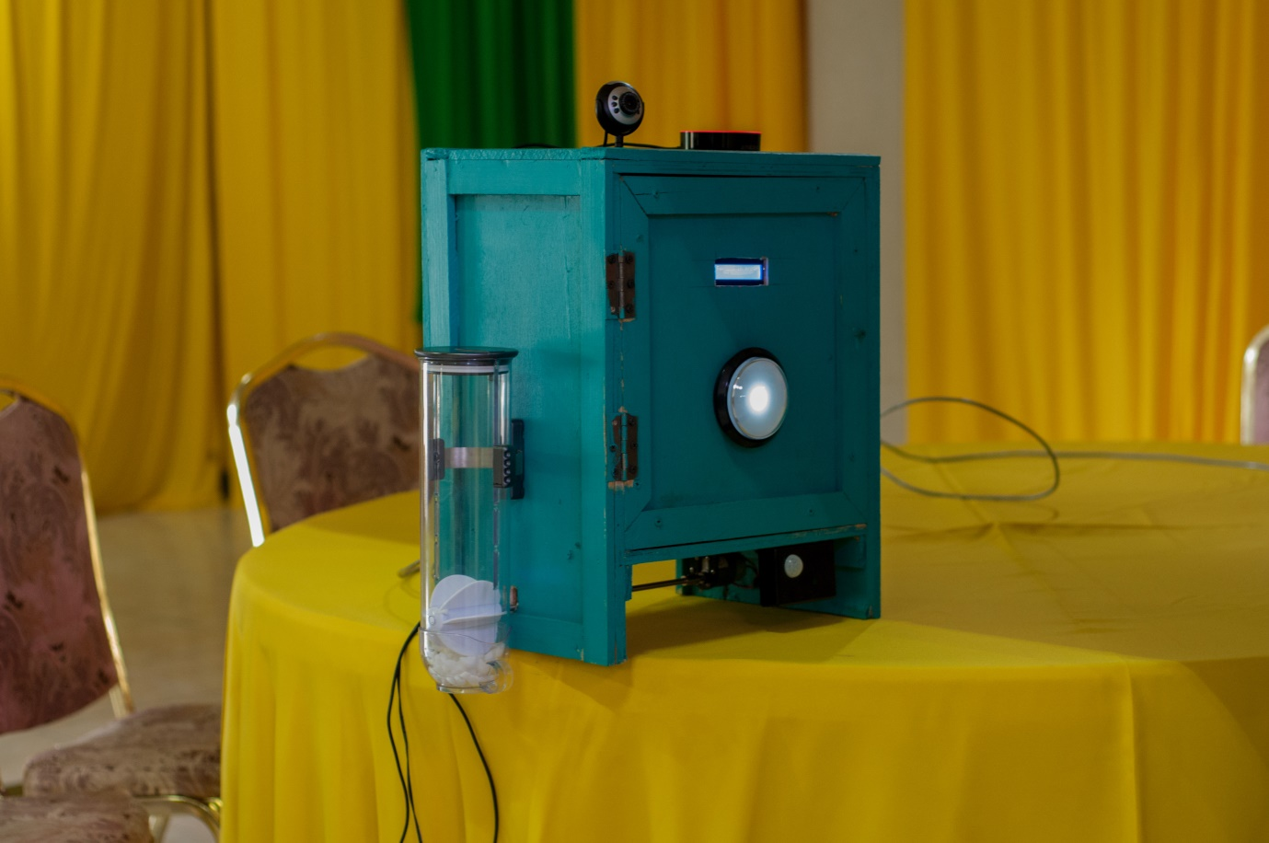

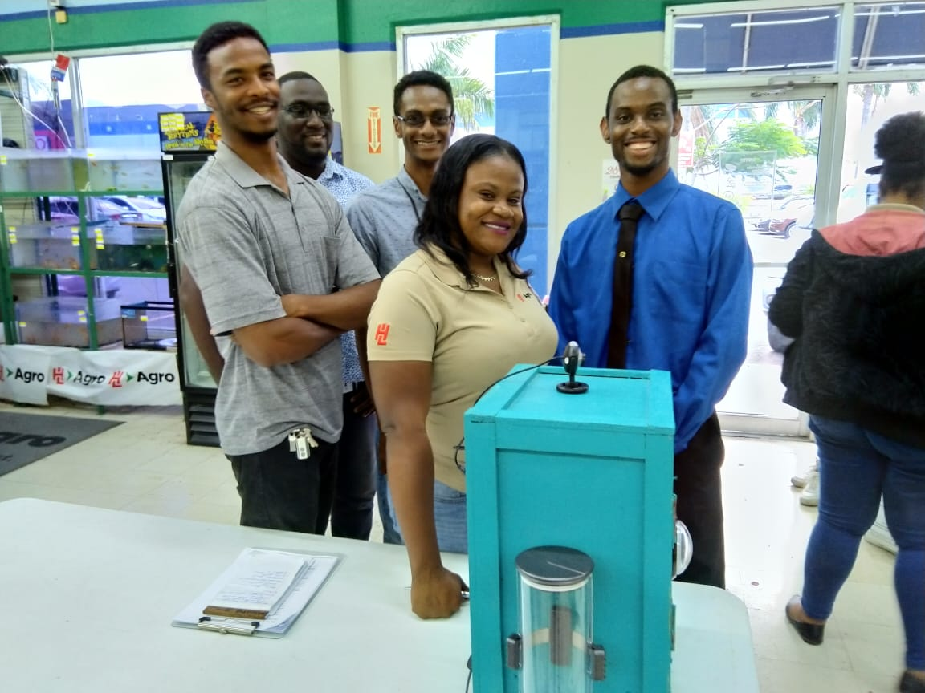

**Computer Hardware Analyser Defender (C.H.A.D.)** Fall 2017

A security system both hardware and software enabled, that enables the user to secure their network smart devices from any external invasions such as botnet attacks

* **Team Lead:** Delegated specific tasks to various skilled individuals on the team and provided oversight of overall project.
* **Technologies used:** Visual Studio C#, MySQL database.

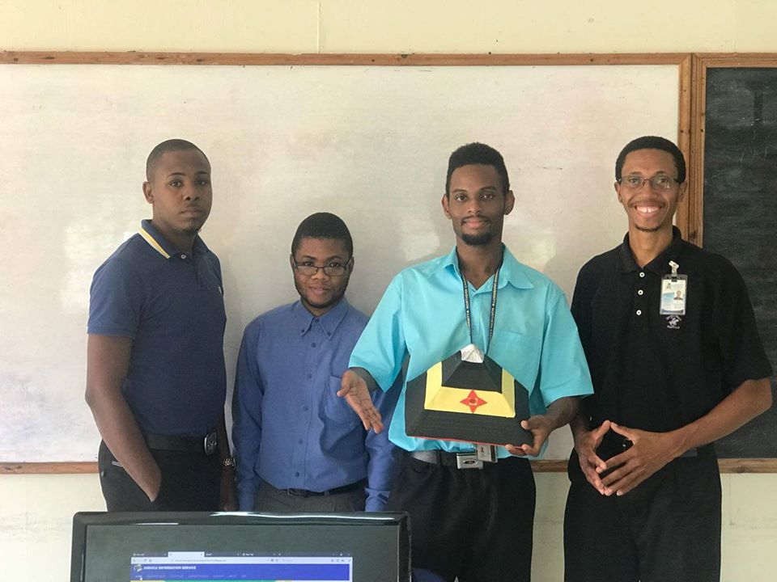

**Project Summary:** The purpose of the CHAD (Computer Home Analyser Defender) is the implementation of a home automated security system in which the user can communicate/interface on various aspects such as oral, visual or tactile to produce the desired operation. Another purpose of CHAD (Computer Home Analyser Defender) is to implement a product which is also user friendly and act as a barrier against certain security threats protecting the other household smart devices from cyber-attacks such as hacking and botnets with the added feature of alerting users via notifications of any abnormal activity. It is an all in one security system which boasts all the latest cyber defence mechanisms that will ensure safety of the owner and his/her property.

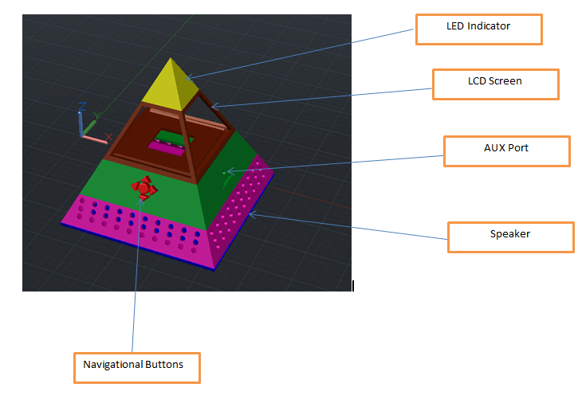

\

**Autipik, Autism Communication Software** Fall 2017

This is a system that allows caregivers of individuals with autism to communicate more effectively with them by using audio-visual aids.

**Team Lead:** Managed the overall software testing for every functional aspect of the program.

**Technologies used:** Visual Studio C#, MySQL database.

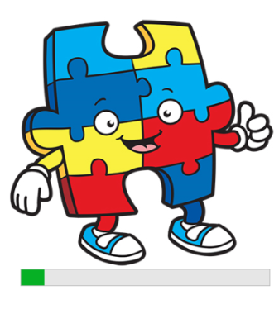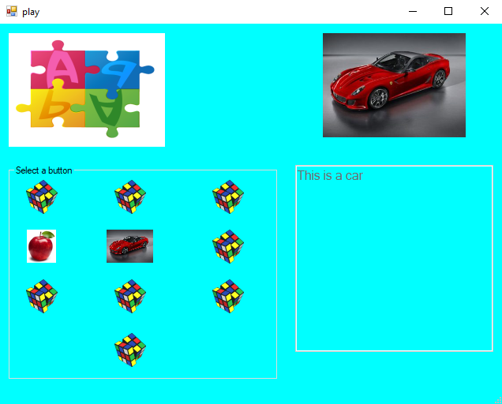

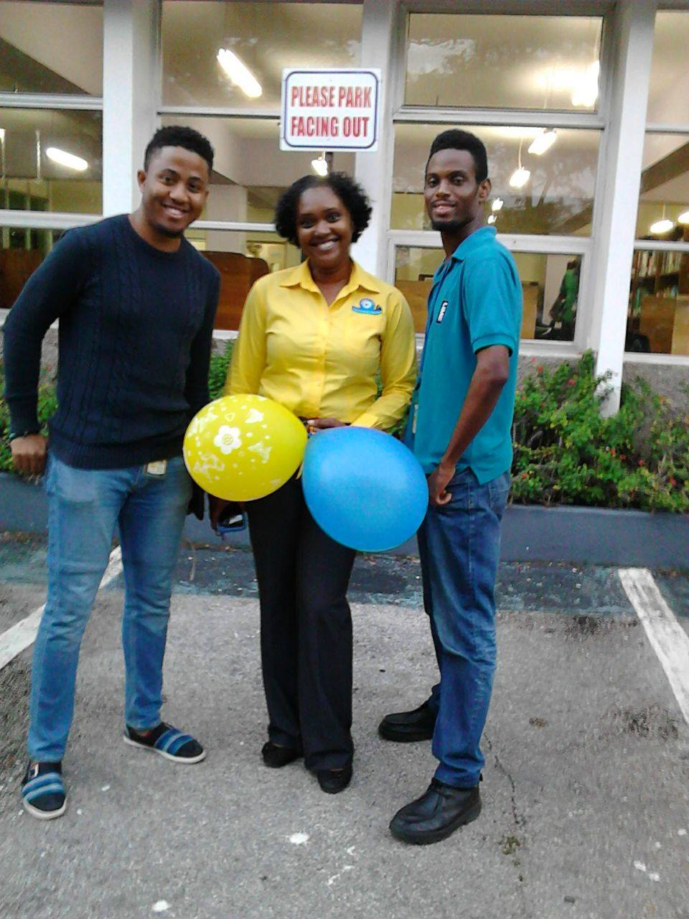

**Health Jam** Spring 2019

We developed a website enabling fitness company owners to be able to showcase their goods and services at an affordable cost.

**Team Lead:** Managed the overall software testing for every functional aspect of the program.

**Technologies used:** PHP, CSS, JavaScript, MySQL database.

“HealthJam” is an ecommerce platform which allows business of various sizes of showcasing their products and services from across Jamaica, and making them available to existing and potential market segments across the nation. Driven by a strong service philosophy, assert that a healthy lifestyle can be adopted by everyone who is desirous, at affordable costs. We further believe that fitness and health providers should be presented with a suitably sophisticated platform from which they can showcase their products and services to the public at large, especially to the health and fitness market.

