**Name:** Best Info for Crypto

**Domain:** Bestinfoforcrypto.com

**Logo:**

**Site Purpose:**

This site will deliver information regarding the current price, market value, and basic information about multiple cryptocurrencies. The goal of this site is to help investors, miners, owners, and others to find the information they need about the status of the cryptocurrencies that interests them or that they own or have invested in. Those who visit the site will likely be looking for information and current statistics of several different cryptocurrencies. They will be looking for information that will help make investing, mining, purchasing or other financial decisions. This site will need to be able to quickly recover that information and display it in an accessible way.

**Target Audience:**

Persona 1: Stevie

My Dude ^^^

This man is basically a prophet. Stevie bought Bitcoin in early 2010 when it was just a fraction of a penny. Later that year, the price jumped to $0.08 and his buddies all cashed out. Stevie, using his prophetic vision, decided to HODL (hold on for dear life). When the price reached an all-time high of $68,000 a few weeks ago, he decided to sell some of his coin. Above is a picture of him I snagged last week after he cashed out. While Stevie has already ‘made it’, he is still keeping tabs on the market regularly and will use this site to find news, exchange rates, and new cryptocurrency to invest in.

Persona 2: Kyle

This guy ^^^

Kyle chose to put the money he would have spent on his girlfriend’s engagement ring in the new cryptocurrency SQUID (based on the popular tv show Squid Game) several weeks ago. Unfortunately for him, his girl left him and so did his money since SQUID was essentially a scam because you couldn’t sell it after buying in and the creators pulled out. RIP Kyle. Hope he makes better decisions in the future

SQUID is real, it happened:

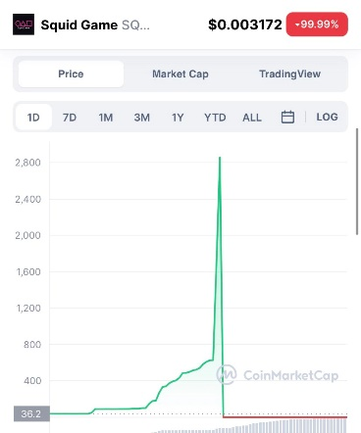

Persona 3: “oh hi mark”



Meta…

Mark is the founder of a large company that is looking towards the future of technology and is beginning to bring in the metaverse. Mark believes that cryptocurrency will be the main currency in this digital world. As a result of this belief, he is trying to get his company to implement this currency into their current and future products. To learn about the currency, exchange rates, and other information, Mark will have members of his company visit this site to find the information they need to help them implement cryptocurrency into their products. **The real reason Mark is interested in Crypto is because he hopes it will make him even more money than he already has.**

**Site Map**

**Colors**

**Typography**

Paragraph/Link text:

Google Font, Ubuntu Light 300

https://fonts.google.com/specimen/Ubuntu?query=ubuntu

Heading text:

Google Font, Readex Pro Regular 400

<https://fonts.google.com/specimen/Readex+Pro#standard-styles>

**Home Wireframe**

Large

Medium/Small

