PitPulse AI
Software Architecture Specification
F1 Race Strategy & Telemetry Analytics Platform
CS 4800 Semester Project
Architecture based on the project Business Plan and High-Level Requirements

1. Purpose and Scope
This document defines the high-level software architecture for PitPulse AI, an F1 race strategy and telemetry analytics platform. The architecture supports historical Formula 1 race selection, telemetry and lap comparison, tire/stint analysis, pit strategy analysis, basic strategy simulation, undercut/overcut comparison, recommendations, and dashboard interaction.
The design is intentionally limited to the current 12-week MVP. The requirements specification explicitly places live race data, full safety-car simulation, weather prediction, advanced traffic modeling, full finishing-position prediction, chatbot features, multi-series support, and user-account/social features outside the MVP.

1.1 Source Documents
- Business_Plan_PitPulse_AI.pptx - product concept, users, technology direction, value proposition, and sprint roadmap.
- Software_Requirements_Specification.docx - functional requirements FR-01 through FR-13 and non-functional requirements NFR-01 through NFR-12.
Scope decision: the Requirements Specification is treated as authoritative for MVP scope. Although the earlier business-plan technology slide mentions authentication, the current requirements explicitly exclude user accounts/social features, so authentication is not part of the MVP architecture.

2. Architecture Drivers
- Historical-data workflow: users select a season, event, session, driver, and lap before analysis.
- Data-intensive visualization: the UI must support lap-time, telemetry, tire, stint, and strategy views.
- Repeatable analytics: strategy calculations must be deterministic for identical inputs.
- Fast interaction: cached sessions and filter changes should respond quickly after initial loading.
- Graceful degradation: missing telemetry or invalid selections must produce readable messages instead of crashes.
- Separation of concerns: UI, API/data access, and analytics/strategy logic must be independently modifiable.
- Testability: core calculation functions must be isolated enough for automated tests.

3. Actors and External Systems

3.1 Primary Actor
End User: a racing analyst, student, content creator, sim racer, motorsport fan, educator, or member of a small racing organization. These user types share the same MVP workflow, so they are represented by one primary actor at the architecture level.

3.2 External Systems and Data Sources
External System / Source | Purpose | Interaction
FastF1 / Historical F1 data source | Primary historical timing, lap, stint, tire, pit-stop, and telemetry data source. | Accessed through a dedicated data adapter. Returned data is normalized and cached before analytics use.
Public F1 dataset files | Fallback or seeded historical data for testing, demos, and cases where the primary source is unavailable. | Imported through a separate dataset adapter so the rest of the system does not depend on file format details.
Browser download / local export target | Receives user-requested charts or analysis outputs. | The presentation layer initiates client-side or API-assisted export of already-computed results.
No separate administrator actor is included in the MVP because the current Business Plan and Requirements Specification do not define administrator-facing use cases.
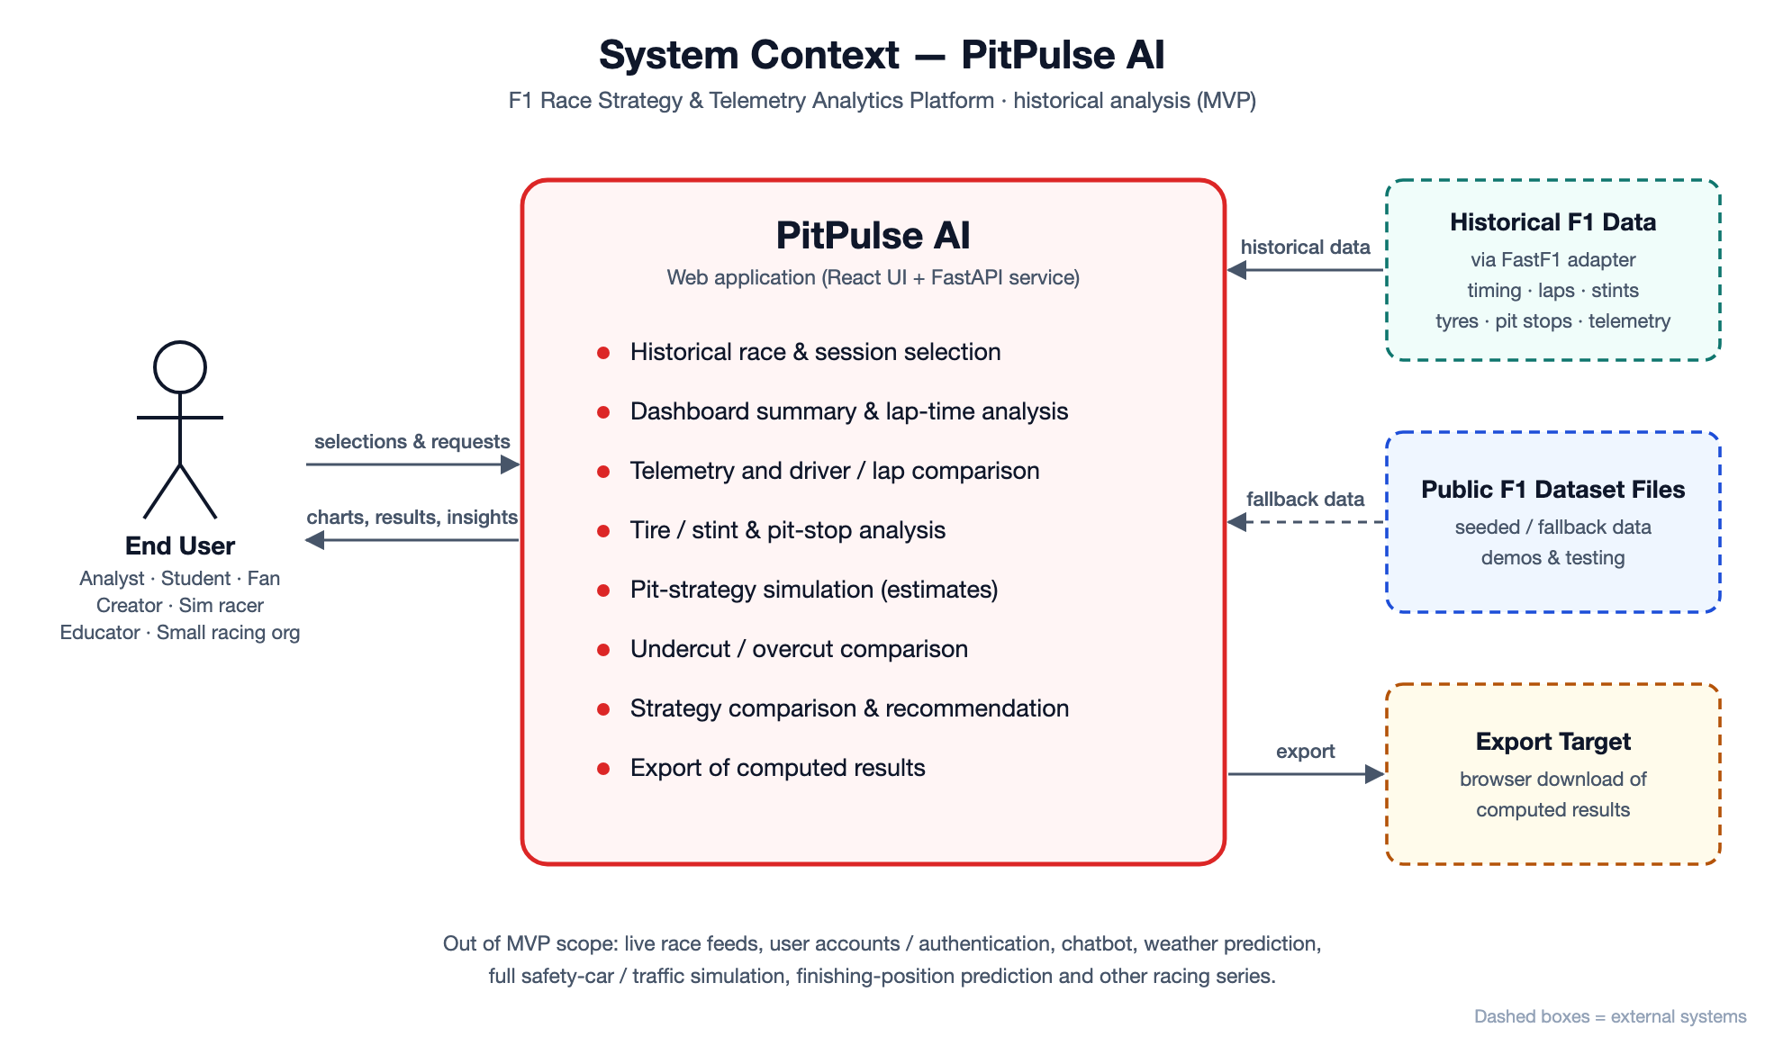
Figure 1. System context and external interactions.

4. Architectural Style and Rationale
PitPulse AI uses a layered web architecture. A React presentation layer communicates with a FastAPI application layer. Analytics and strategy calculations are isolated from data-access code, while a data-access/cache layer shields the rest of the application from FastF1 and public dataset formats. PostgreSQL may persist cached derived data and analysis metadata.
- Presentation layer: owns navigation, filters, charts, tables, strategy controls, and user-facing error messages.
- Application/API layer: validates requests, coordinates workflows, and returns stable response models to the UI.
- Analytics & strategy layer: performs lap comparison, tire/stint analysis, pit-loss calculations, undercut/overcut comparisons, and basic recommendations.
- Data access & cache layer: retrieves, normalizes, caches, and validates historical session data.
- Persistence layer: stores cached/derived data where useful; it is not a user-account database in the MVP.
- External adapters: isolate FastF1 and public dataset specifics so source changes do not force UI or analytics changes.
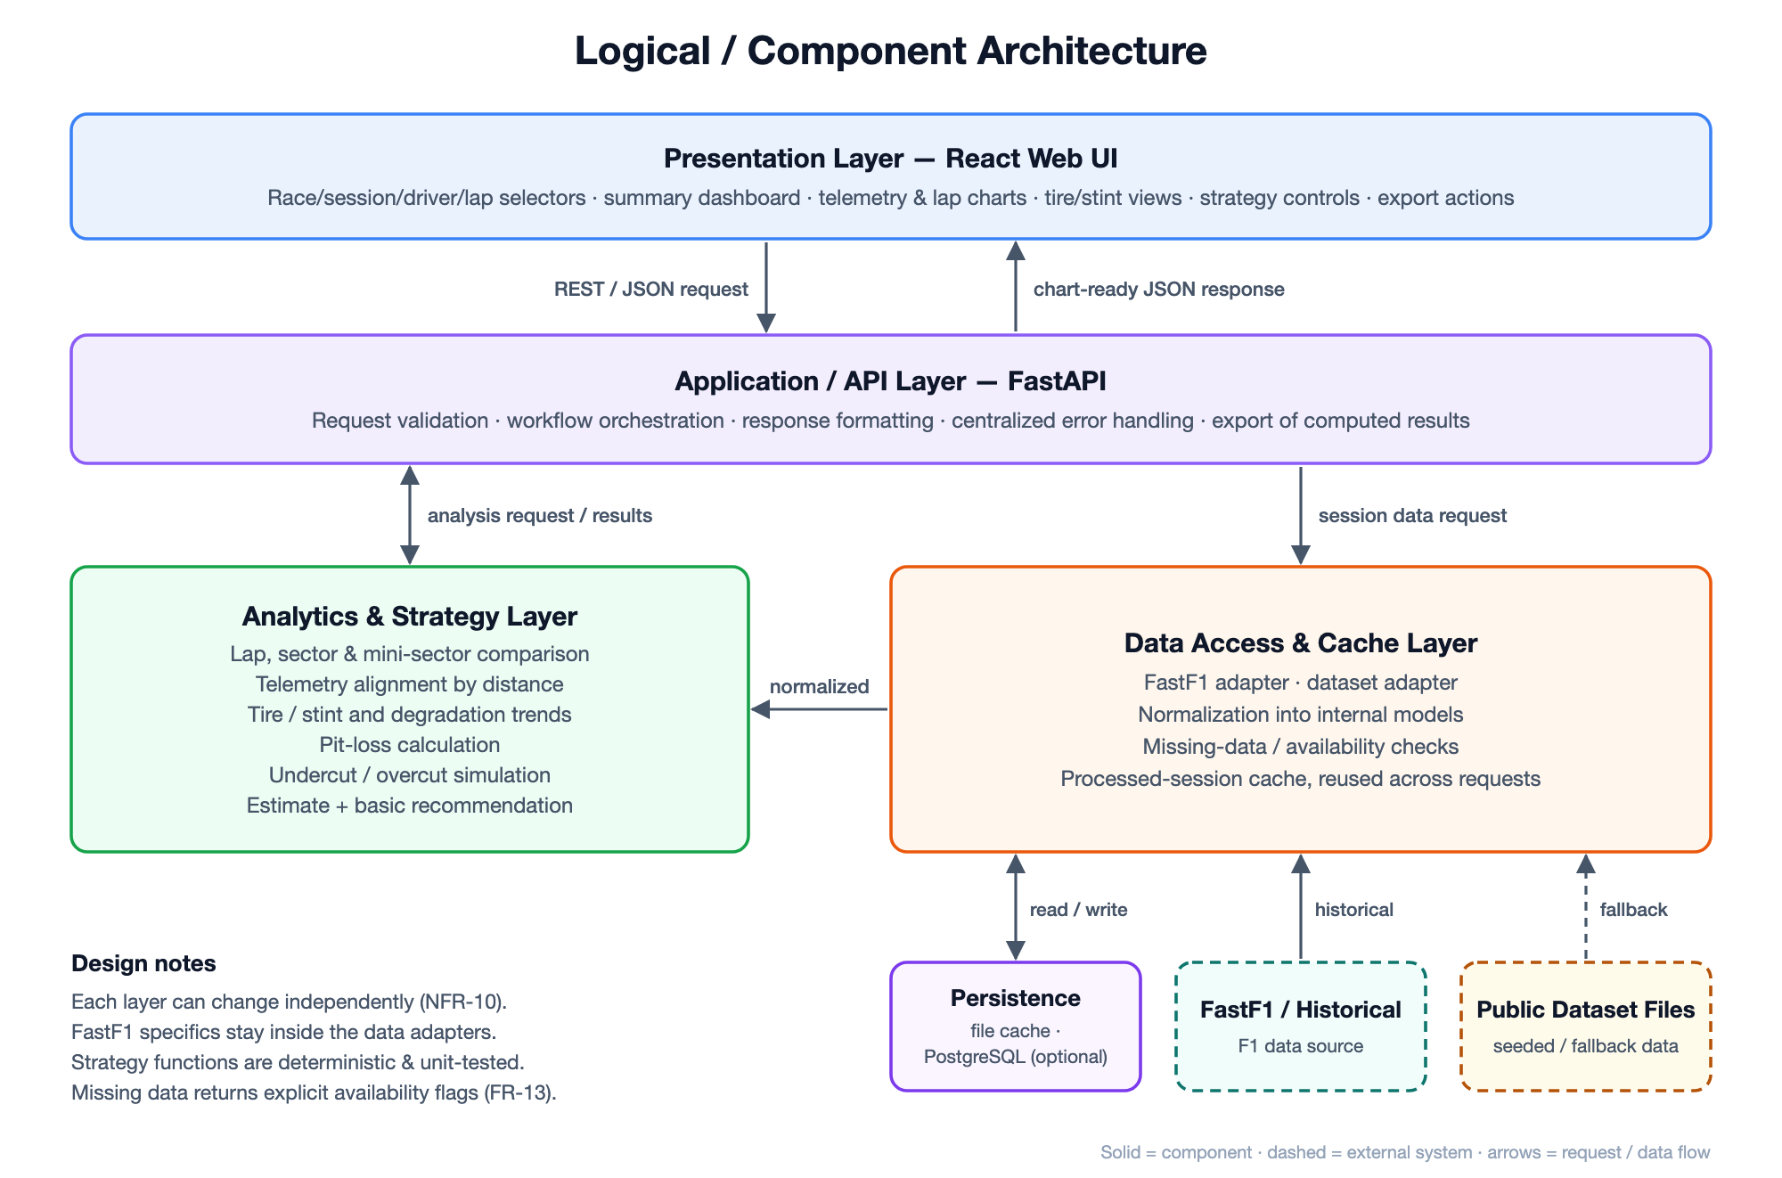
Figure 2. Layered component architecture.

5. Component Responsibilities
Component | Responsibility | Requirement Mapping
React Web UI | Race/session/driver/lap selectors; summary dashboard; telemetry charts; lap overlays; tire/stint views; strategy controls; recommendations; export actions. | FR-01, FR-03 to FR-12
FastAPI Application Service | Input validation, workflow orchestration, response formatting, error handling, and interface between UI and analytics/data layers. | FR-01 to FR-13
Telemetry Analysis Module | Lap-time comparison, telemetry alignment by distance, speed/throttle/brake/RPM/gear visualization data, sector/minisector comparisons. | FR-04 to FR-06
Tire & Stint Analysis Module | Compound, stint length, lap progression, degradation trends, and pit timing summaries. | FR-07, FR-08
Strategy Simulation Module | Alternative pit timing/compound scenarios, pit-loss calculations, actual-vs-simulated comparison, undercut/overcut estimation, basic recommendation output. | FR-09 to FR-11
Historical Data Adapter | Retrieves FastF1/historical source data and maps source-specific structures into internal models. | FR-02, FR-13
Dataset Adapter | Loads seeded/public F1 data for fallback, demonstrations, and testing. | FR-02, FR-13
Cache / Persistence | Reuses session data, stores normalized/derived data where useful, and reduces repeated source loading. | NFR-01, NFR-02, NFR-12
Export Service | Packages already-computed charts/results for download without changing analysis state. | Business Plan feature: Export & Reporting

6. Primary Data and Control Flow
- The user selects a historical season, event, session, driver(s), and optionally laps/stints.
- The React UI sends the selection to the FastAPI application service.
- The application service checks the session cache. If the requested data is not available, the data adapter retrieves it from the historical F1 source or seeded dataset.
- The data-access layer normalizes timing, lap, stint, tire, pit-stop, and telemetry records into internal structures and records missing-data conditions.
- The analytics modules calculate comparison series, stint/tire metrics, and strategy inputs.
- For what-if strategy requests, the strategy module applies pit timing/compound assumptions, calculates the scenario result, and compares it with the historical baseline.
- The API returns chart-ready and summary data to the React UI.
- The UI updates charts/tables without leaving the main workflow. If data is missing, it displays a clear unavailable-data message.
- If the user chooses export, the current visible analysis is packaged for download.

7. High-Level Data Model
The architecture does not require a final database schema at this stage, but the following logical entities support the specified workflows:
- Season / Event / Session - identifies the historical race context.
- Driver - selected participant and identifying metadata.
- Lap - lap number, lap time, sector times, status, and references to telemetry.
- TelemetrySample - distance, speed, throttle, brake, RPM, gear, and related sampled values.
- Stint - driver, start/end laps, tire compound, tire age, and stint metrics.
- PitStop - lap, timing, duration/loss estimate, and surrounding stint context.
- StrategyScenario - selected driver/session, proposed pit timing, tire compound assumptions, and scenario parameters.
- StrategyResult - estimated race-time delta, comparison with actual strategy, and recommendation/summary.
- CachedSession - normalized historical session data plus cache metadata.

8. Deployment View
For the class project, the architecture can be deployed as a standard three-part web application:
- Client: modern desktop browser running the React application.
- Application server: FastAPI service hosting request validation, workflow orchestration, analytics/strategy calls, and export functions.
- Data services: PostgreSQL plus a local/server-side cache for processed historical sessions.
- External data access: FastF1/historical data retrieval and optional import of public dataset files.
The deployment remains intentionally simple for the semester project. Containerization can be used for repeatable local/demo deployment, but the Requirements Specification does not require a specific cloud provider.

9. Non-Functional Architecture Decisions
Requirement(s) | Architecture Element | How Addressed
NFR-01, NFR-02, NFR-12 | Cache + preprocessed chart-ready responses | Reuse previously loaded sessions and avoid recomputing unchanged selections.
NFR-03 Reliability | Validation boundaries + centralized error handling | Invalid selections and unavailable source data are converted to controlled errors, not crashes.
NFR-04 Data Accuracy | Normalized internal models + source-value verification | Displayed values originate from traceable source records or documented calculations.
NFR-05 Calculation Consistency | Deterministic strategy functions | Identical scenario inputs are processed by stateless, repeatable calculation functions.
NFR-06 Usability | Single analysis workflow | Race selection, comparison, stint inspection, and simulation remain accessible from the main dashboard flow.
NFR-07, NFR-08 Compatibility / Responsive Layout | Browser-based responsive React UI | Core controls and charts are designed for current desktop browsers and 1024-1920 px widths.
NFR-09 Error Handling | Missing-data contract between API and UI | API returns explicit availability/error states; UI renders user-readable messages.
NFR-10 Maintainability | Layered modules and adapters | UI, API, analytics/strategy, and data access are separated.
NFR-11 Testability | Pure calculation modules + adapter mocks | Telemetry, tire/stint, and strategy functions can be unit-tested independently of the UI and external source.

10. Functional Requirement Traceability
Requirement(s) | Architecture Element | How Addressed
FR-01 to FR-03 | React UI + FastAPI + Historical Data Adapter | Selection, retrieval, and dashboard summary flow.
FR-04 to FR-06 | Telemetry Analysis Module | Lap times, telemetry visualization, and driver/lap overlay comparison.
FR-07 to FR-08 | Tire & Stint Analysis Module | Compound/stint trends and pit-stop strategy analysis.
FR-09 to FR-11 | Strategy Simulation Module | Alternative strategies, undercut/overcut comparison, and recommendation output.
FR-12 | React UI + Application Service | Filter and selection changes without leaving the analysis workflow.
FR-13 | Data Adapter + Application Service + UI | Missing data detection and readable user-facing status/error messages.

11. Assumptions, Risks, and Deferred Features

11.1 Assumptions
- Historical F1 data required for the selected demo sessions is available through FastF1 or seeded/public datasets.
- The strategy simulator is a basic analytical model, not a complete race simulator.
- The MVP is optimized for desktop/laptop use rather than mobile-first interaction.

11.2 Architecture Risks
- Historical telemetry may be incomplete for some sessions. Mitigation: adapter-level availability checks and seeded fallback data.
- Telemetry datasets can be large. Mitigation: session caching, preprocessing, and returning only chart-ready subsets.
- Strategy results can be misinterpreted as exact predictions. Mitigation: label outputs as estimates/comparisons and document assumptions used by the simulator.

11.3 Deferred / Out of Scope
- Live race telemetry and real-time streaming.
- Full safety-car and advanced traffic simulation.
- Weather prediction as a separate predictive model.
- Full finishing-position prediction.
- Chatbot functionality.
- Support for F2, Formula E, IndyCar, or other series.
- User accounts, social features, and collaboration workspaces.

12. Architecture Summary
The proposed architecture is a layered, modular web system built around a React frontend, FastAPI application layer, isolated analytics/strategy modules, and a historical-data adapter/cache layer. This design directly supports the project requirement that presentation, analytics/strategy, and data access remain independently modifiable while still providing one integrated user workflow from historical race selection through telemetry analysis and strategy simulation.

