AFLW Testing Battery

Bilateral Countermovement Jump
Equipment: ForceDecks/Hawkins Dynamics

Purpose
Lower-limb power and asymmetry during jumping and landing.
Why? Forceful athletes are exposed to greater tissue loading. CMJ is a quick & easy general test of force production that correlates strongly with other athletic tasks.

Setup
- One foot on each force plate
- Feet self-selected width apart
- Hands on hips

Protocol
- Stand still for ≥1 s before movement
- Perform a quick countermovement to a self-selected depth
- Immediately transition into a maximal vertical jump
- Keep hands on hips throughout
- Land with one foot on each plate
- Stabilise quickly after landing
- Reset position with a couple of seconds rest
- Repeat for 3 trials in one recording

Key Variables
- Jump height (cm)
- Peak force (N)
- Asymmetry (%)

Cues
- “Quick down, quick up”
- “Jump as high as possible”

Single-Leg Triple Vertical Hop
Equipment: HumanTrak

Purpose
Trunk and knee control during single-leg jump-landings
Why? Trunk lateral position is a main contributor to knee/ankle torque, and therefore, ligament loading. Knee valgus increases ACL loading. Task designed to be forceful, challenge single-leg control, continuous motion with rebound, and take attention away from movement.

Setup
- Stand on one leg
- Opposite leg off the ground
- Hands on hips

Protocol
- Perform 3 consecutive maximal vertical jumps on the same leg
- Minimise ground contact time between hops
- Stick and stabilise after the final landing
- Reset position with a couple of seconds rest
- Complete 3 trials per leg

Key Variables
- Trunk lateral flexion (°)
- Trunk flexion (°)
- Knee flexion (°)
- Dynamic knee valgus (2D medial knee displacement) (°)
- Hop height (cm)
- Contact time (ms)

Cues
- “Jump as high as possible”
- “Head through the roof on every jump”
- “Quick ground contact”

Isometric Hip Adduction and Abduction Strength
Equipment: ForceFrame

Purpose
Assess maximal strength of the hip adductor and abductor muscle groups
Why? Hip muscle strength important for controlling pelvis position and femur alignment that contributes to knee/ankle ligament injury. Hip adductor muscle strains common in hip/groin pain.

Setup
- Lying supine (on back)
- Legs straight (hip and knee 0 degrees)
- Arms by sides
- Align pads with ankle malleolli

Protocol
- Gradually build force
- Hold peak effort for ~3–5 s or until force plateus
- Alternate between inwards (adduction) and outwards (abduction)
- Complete 3 trials per side for each direction

Key Variables
- Peak force (N)
- Adduction asymmetry (%)
- Abduction asymmetry (%)

Cues
- “Squeeze or push as hard as possible”
- “GO! GO! GO!”

Eccentric Knee Flexor Strength
Equipment: NordBord

Purpose
Assess maximal strength of the knee flexor muscle group during a Nordic hamstring exercise.
Why? Hamstring strains commonly occur during eccentric contractions. The Nordic hamstring exercise is an easy way to tests supra-maximal strength (i.e., force above 1RM due to eccentric only phase).

Setup
- Kneel on padded surface
- Hooks superior to ankle malleoli
- Hooks should be as vertical as possible
- Body upright, hips extended,
- Hands ready at chest for ground contact

Protocol
- Slowly lean forward from the knees
- Maintain straight line from shoulders to knees
- Lower chest to the ground under control
- Catch body with hands when unable to hold position
- Reset position and rest a few seconds
- Repeat 3 times

Key Variables
- Peak force (N)
- Asymmetry (%)

Cues
- “Chest up, hips forward”
- “HOLD! HOLD! HOLD!”

Isometric Knee Extension Strength
Equipment: DynaMo

Purpose
Assess maximal strength of the knee extensor muscle group
Why? Knee extensor strength underpins acceleration, deceleration, and landing performance.

Setup
- Seated position with knee just passed edge
- Knee flexed to 70°
- Feet off the ground
- Holding onto sides of seat
- Optional: strap around hips.
- Dynamometer strap around ankle
- Strap secured underneath/behind seat
- Strap approximately 90° to lower leg

Protocol
- Gradually build force over ~1–2 s
- Hold peak contraction for ~3–5 s
- Pull down into seat to stop hips rising
- Complete 3 trials per side (in a row for convinence)

Key Variables
- Peak force (N)
- Asymmetry (%)

Cues
- “Kicking out and build slowly”
- “KICK! KICK! KICK!”

Isometric Seated Calf Strength
Equipment: ForceFrame

Purpose
Assess maximal strength of the plantarflexor muscle group
Why? Seated with bent knee biases soleus, which is commonly strained.

Setup
- Seated with knee under the pad
- Knee positioned over toes
- Heel flat on the ground
- Adjust height to stop plantarflexion
- Holding onto the ForceFrame

Protocol
- Push down through forefoot
- Gradually build to maximal effort
- Hold for ~3–5 s
- Complete 3 trials per side

Key Variables
- Peak force (N)
- Asymmetry (%)

Cues
- “Push through forefoot”
- “PUSH! PUSH! PUSH!”

Ankle Dorsiflexion Range of Motion
Equipment: DynaMo

Purpose
Ankle dorsiflexion range of motion in lunging position (knee-to-wall)
Why? Dorsiflexion enables greater movement options and prevents componsentation by proximal joints.

Setup
- DyanMo strapped to side of leg
- Shoe off
- Lunge position
- Test side foot placed flat on ground
- Heel in contact with the floor
- Opposite knee supporting weight

Protocol
- Lunge knee forward over toes
- Keep heel flat on ground at all times
- Move until maximal dorsiflexion is reached
- Record angle of tibia relative to vertical
- Repeat for 2–3 trials per side

Key Variables
- Peak angle (deg)
- Asymmetry (%)

Cues
- “Drive knee forward”
- “Push heel down”

Isometric Neck Strength
Equipment: DyanMo

Purpose
Assess maximal strength and rate of force development of the neck muscle groups in flexion, extension, and lateral flexion (left and right)
Why? Neck muscle force production may improve head-neck control during collisions

Setup
- Athlete seated or standing
- Neutral head and trunk position
- Device or resistance applied in test direction

Protocol
- Test flexion, extension, left lateral flexion, and right lateral flexion
- For maximal strength trials, gradually build force over ~1–2 s and hold maximal contraction for ~3–5 s
- For rate of force development trials, contract as fast and hard as possible from rest and hold briefly for ~1–2 s
- Maintain posture and alignment
- Complete 2–3 trials per direction

Key Variables
- Peak force (N)
- Rate of force development (N/s)
- Directional asymmetry

Cues
- “Push hard and fast”

3D Body Scan
Equipment: HumanTrak

Purpose
Full body anthropometric measurements
Why? Limb lengths is a key determinant of joint torques, and therefore, ligament loading and muscle force required to produce movement.

Setup
- Stand front on to the camera
- Standing up straight
- Arms slightly away from body (A pose)

Protocol
- Stand still
- Complete single capture

Key Variables
- Height
- Segment lengths
- Body dimensions

Cues
- “Stand tall & relaxed”
- “Arms out to the side”

Reactive change of direction
Equipment: OpenCap + SmartSpeed

Purpose
Movement analysis during reactive running change of direction (sidestep))
Why? Reactive sidestep testing captures cutting mechanics in a more sport-specific setting. Change of direction commonly associated with knee/ankle ligament injuruies.

Setup
- 4 x gates
- Gate 1 to 2 times the 5m accleration
- Gate 2 triggers either a left or right cut
- Direction is random
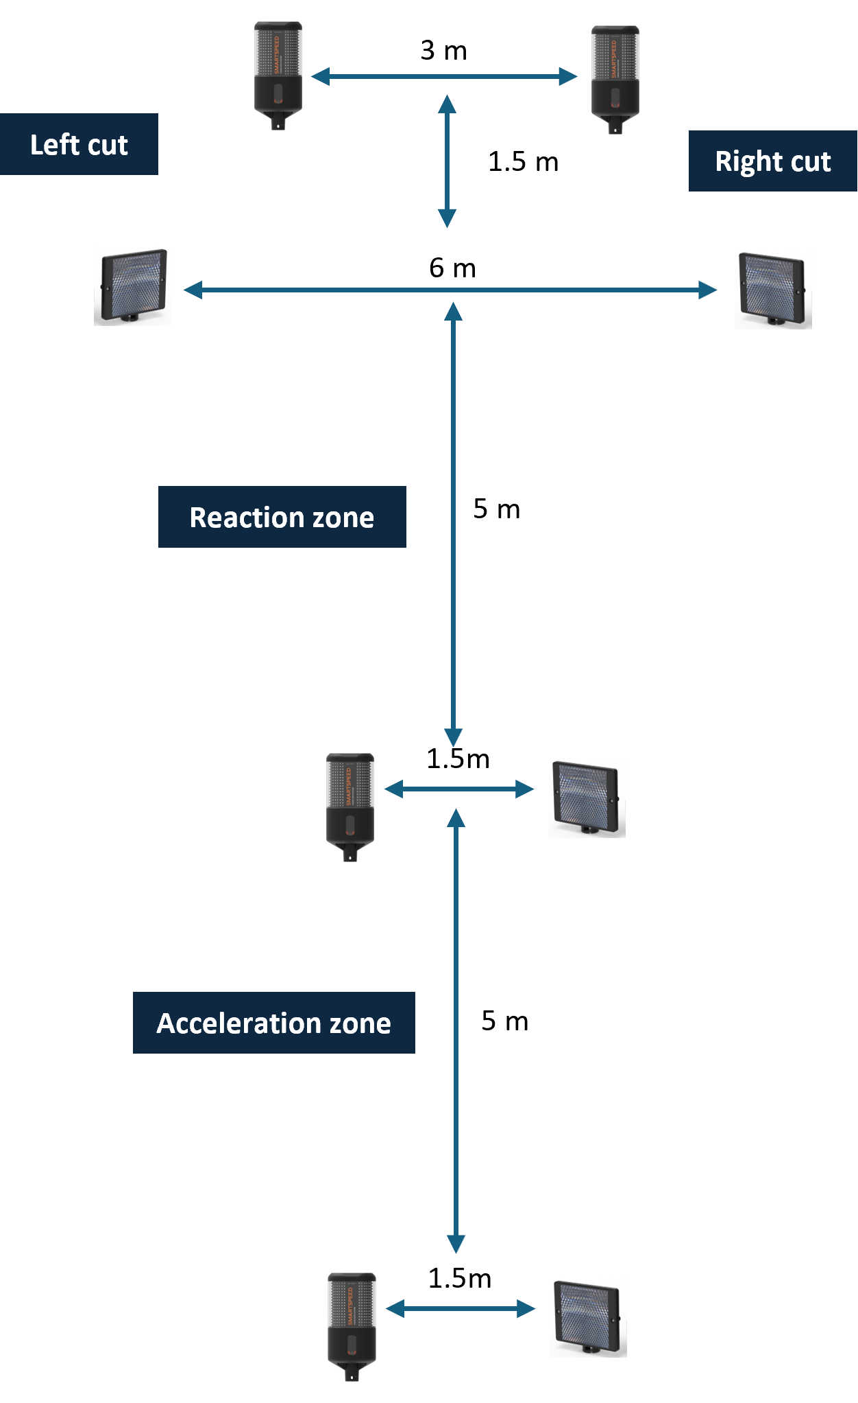
Unanticipated sidestep setup diagram

Protocol
- Start behind gate 1
- Acclerate through the first 5m as fast as possible
- Respond to light on gate and change direction to the left or right
- Acclerate through the left/right gate as a fast as possible
- Complete as many trials as need to get 3 in each direction

Key Variables
- 5m time (s)
- Change of direction time (s)
- Knee flexion (°)
- Knee valgus (°)
- Trunk lateral flexion (°)

Cues
- “Run through the gates as fast as possible”
- “Don’t try guess”

