**Prerequisites:**

-Please make sure to open OneDrive and Outlook on your new machine to get logged into them

-Please save this folder in your OneDrive – MMO folder so it is easy to access between the devices

**How to make a .pst file in Outlook**

Step 1: Open Outlook

Step 2: Click File

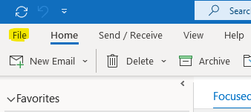

Step 3: Click Open & Export

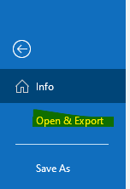

Step 4: Click Import/Export

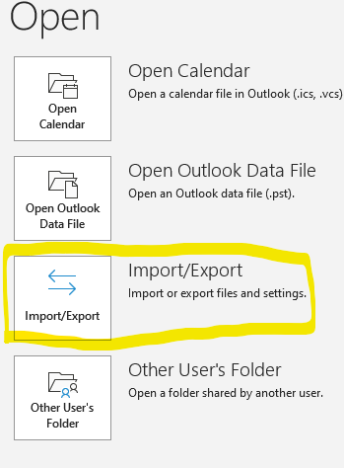

Step 5: Click Export to a file and click Next

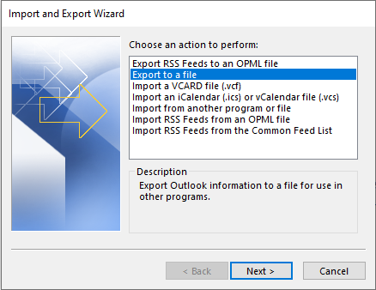

Step 6: Click Outlook Data File (.pst) and click Next

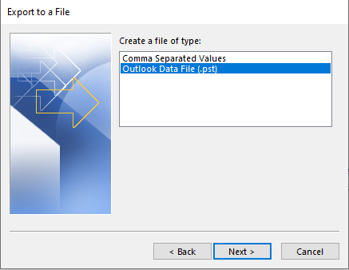

Step 7: Click your Medical Mutual Email Address and Click Next

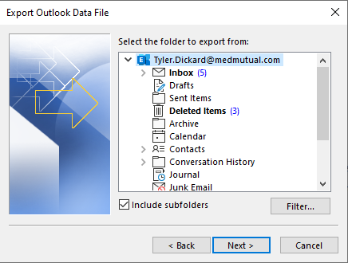

Step 8: Click Finish

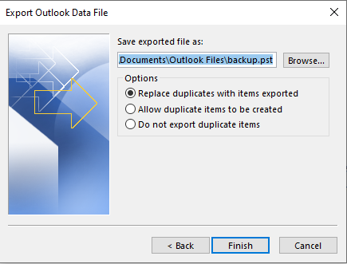

Step 9: Click OK, you can set a password if you’d like

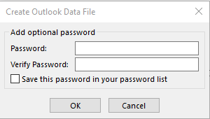

Step 10: Once finished, close out of outlook



Step 11: You’re done! 😊

**Running the script**

Step 1: Locate the executable named copyScript.exe on Old Machine

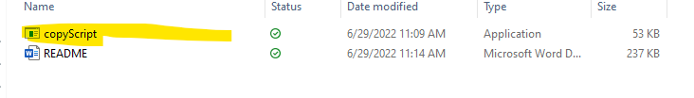

Step 2: Double click the copyScript.exe file to open it, and click OK until you see this menu

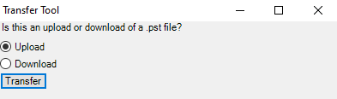

Step 3: Since this is the upload from the old machine to the new machine, just click transfer



Step 4: Wait until this screen closes

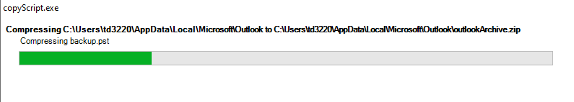

Step 5: Open OneDrive on your new deice, wait until you see this file appear in your OneDrive



Step 6: Run the script on your new computer again click OK until you see this menu



Step 7: Click the download button, and then hit transfer

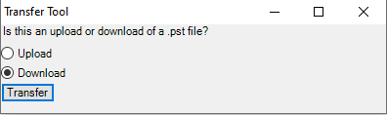

Step 8: Once the menu closes you are done with the file transfer!

**How to import from a .pst file using Outlook**

Step 1: Open Outlook on your new machine

Step 2: Click on File



Step 3: Click on Open & Export



Step 4: Click on Import/Export



Step 5: Click on Import from another program or file and click next

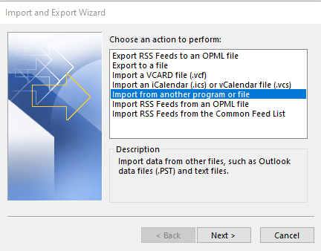

Step 6: Click on Outlook Data File (.pst)

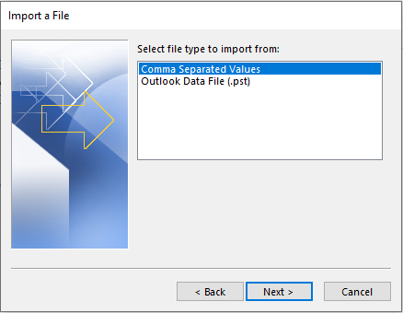

Step 7: Fill in the {UserName} with your username and then copy this directory to the File to import text box.

C:\Users\{UserName(i.e.jd1234)}\AppData\Local\Microsoft\Outlook\backup.pst

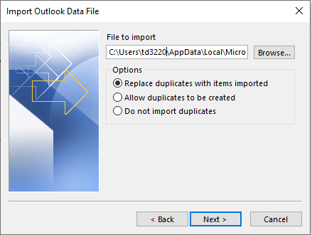

Step 8: Select Do not import duplicates and click next

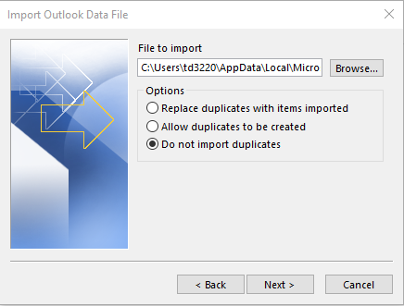

Step 9: Click finish, and then you have successfully transferred your outlook data from one machine to another!

