Tyler Doherty

Dr. Sarkar

Computer Science

07 December 2023

Hangman

The project is called Hangman, created by Tyler Doherty for the Computer Science Class. The goal was to Implement a console-based Hangman game in Python, engaging users in guessing a randomly selected word within limited attempts. I had to Utilize a function to randomly select a word from a predefined list, Develop a function to display the guessed word, replacing unguessed letters with underscores, and Incorporate modular design principles for code readability and maintainability. The outcomes were successfully creating an interactive Hangman game where users guess letters, preventing duplicate guesses, tracking correct/incorrect attempts, and ultimately achieving a win or loss condition. This project was made for when you are bored and want to play a game, it gives you something fun to do to cure your boredom. I used my computer, python, class notebooks, and the internet. Some of the algorithms implemented were ​​random word selections, displaying the guessed word, handling user input, preventing duplicate guesses, and winning or losing conditions! The detailed architecture of my project used Word Selection and Initialization, Displaying the Guessed Word, and Winning or Losing Conditions. Some challenges and solutions to them were not knowing how to do certain parts of the code because I am still a beginner with coding, but I used our class notebooks and the internet to help teach myself the stuff I didn’t know. I also had trouble with over complicating my code, and I solved this by just reading through it and discovering parts that I could very easily simplify. I achieved a successful hangman game that randomly selects 1 of 5 words and lets you guess the letters, telling you if you're right or wrong. Screenshots below.

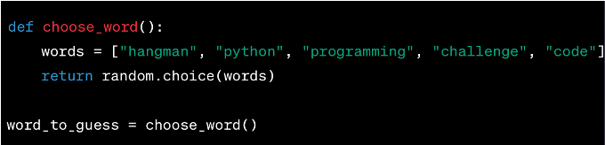

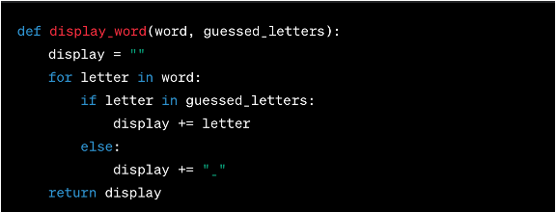

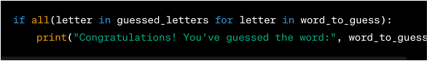

I think the outcomes are significant as it successfully completes its goal and makes an enjoyable game for you to play. I learned many lessons, specifically as said before how to make random word selection and how to make limited guess attempts. I definitely could have made a better user interface and more words for people to guess when playing. Overall keep code simple, anything is possible just do some research to learn how to do it, work on the interface, put more words to guess, and make the design look prettier.

Sources

"W3Schools. "random.choice() Method." W3Schools, n.d.,<https://www.w3schools.com/python/ref_random_choice.asp>.

"Username of the person who asked the question." "How to write a script that only allows a limited number of attempts to input something?" Stack Overflow,<https://stackoverflow.com/questions/70948469/how-to-write-a-script-that-only-allows-a-limited-number-of-attempts-to-input-som>.

And some class Notebooks.