**EXACT SOLUTION**

**ADAMS BASHFORD 2 RESULTS**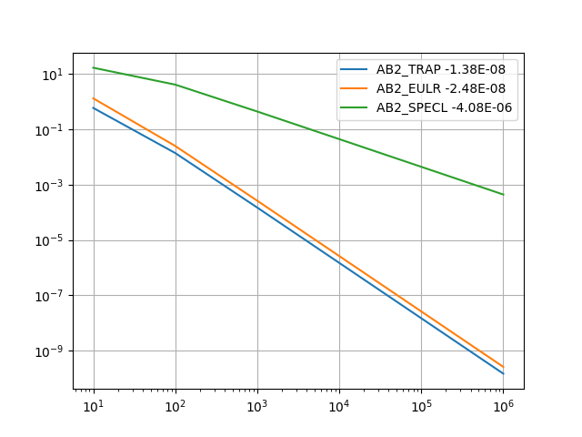

Above are the results for AB2 with initial guess methods Trapezoidal, Euler, and Special Euler (with N subdivisions between 0 and for increased accuracy of prediction for .) Shown with the legend are the slopes of the various lines, representative of the order of these methods. The plot is a log-log plot. With log(N) on x axis and log(Err) on y axis. I would have imagined the special method to produce fastest convergence, perhaps my results are erroneous

**ADAMS MOLTON 3 RESULTS**

I ran AM3 method for , using Forward Euler to obtain .

**PUT PLOT HERE**

This produced some odd results, because the slope of Error vs N seemed to be increasing with N. I decided to run AM3 method for a finer distribution of N-s, as follows

Such an example of this set is as follows

This quickly became computationally expensive, so I stopped at . The produced results are below.

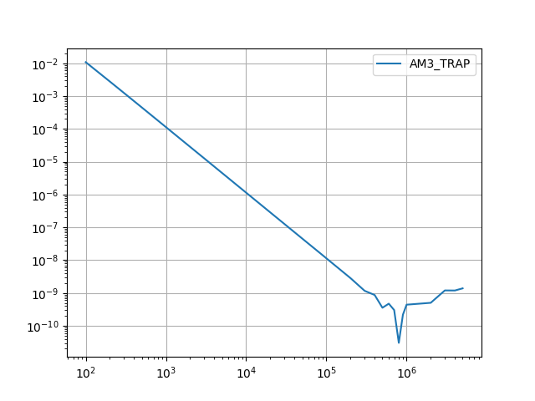

This perplexed me. Although this method uses more information to iteratively guess the next point, and is of higher order, it appears to become unstable with larger and larger values of N. Had I had more computational resources I would have generated an even finer plot as to show the instability in finer detail.

This agrees with what we discussed in class, that higher order methods although they initially have fast convergence will eventually become unstable.