**TYLER GABB**

**HOMEWORK 3**

**Q1:**

The arithmetic involving the validity of the formula is in the attached file [Analysis.pdf](Q1_Formula_6_Verification.pdf).

Below is the plot requested

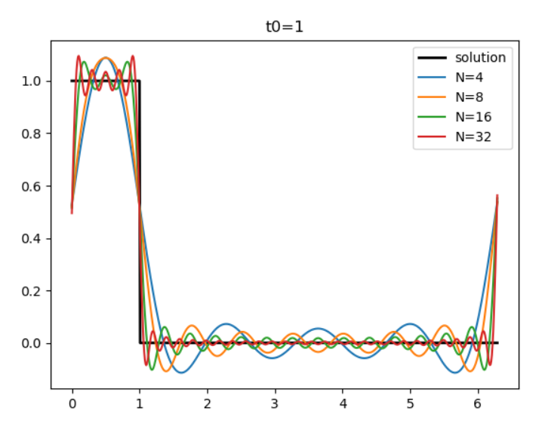

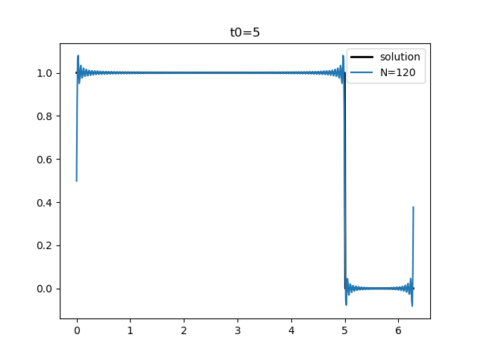 I notice that the solutions are periodic over the interval $2π$. End points are tied to $x\left(n2π\right)=x\left(\left(n+1\right)2π\right) =0.5$ for some n in the non-negative integers, no matter how many terms were summed to find the solution.

As you can see there is still a bit of overshoot even for N = 120, and it appears that no matter where the discontinuity is, the endpoints of the function are always tied to $x=0.5$.

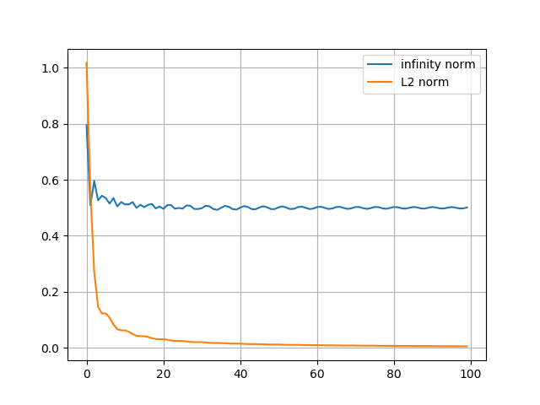**Q2:**

To the right is a plot overlaying the infinity norm and L2 norms.

The infinity norm saturates to a value of 0.5 as $N→ ∞$ which makes sense because the maximum of the error will always be 0.5 because of the behavior at the bounds of the interval.

It makes sense that the $L2$ norm would decrease to zero as $N→∞$ because it is like the area between the solution and approximated solution in the interval $[0,2π]$. As can be seen in the plots from Q1, more terms in the summation lead to a tighter approximation for the solution, which means less area between them.

I really wanted to carry these out analytically, however, I chose the easy route because I did not know where to start. I used Simpson’s rule for a given $N$ to approximate the integral for ${\left\|x\right\|}_{2}$, and just enumerated $\left|x\left(t\right)-x_{N}\left(t\right)\right|$ for some partition of $\left[0,2π\right]$ and found the maximum value programmatically for ${\left\|x\right\|}_{∞}$

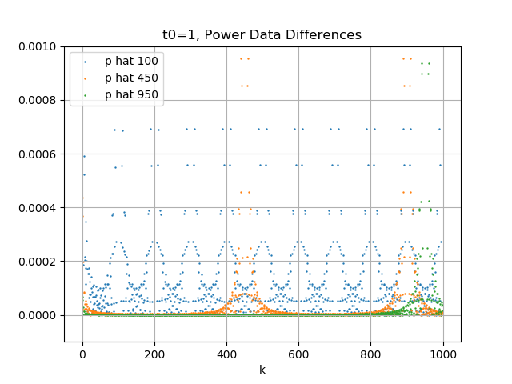**Q3:**

The above plot is a plot of $\left|\tilde{p}- \hat{p}\right|$ as a function of $k$. $\hat{p}$ was found for $N$ values 100, 450 and 900. For higher values of $N$ the plot points stayed closer to zero for longer. For smaller values of $N$, the periodicity property can be clearly seen. Smaller values of $N$ also cause the plot points to stay further away from the solution for longer.