**BE vs FE**

**FORWARD**

Before I begin I need to setup what desired is required to make F.E. converge.

Let , then our

We learned in class that in order for F.E. to converge , where

Therefore

I began iteratively solving for the solution to the heat equation with F.E. for , comparing it with a surface obtained with . I set the solution values to when they deviated too far out of an appropriate view window.

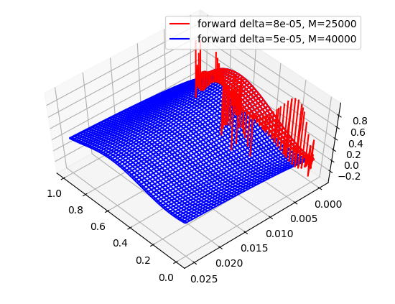

You can see that for , the solution is O.K. up until and then it quickly diverges. I increased to , and observed some similar results.

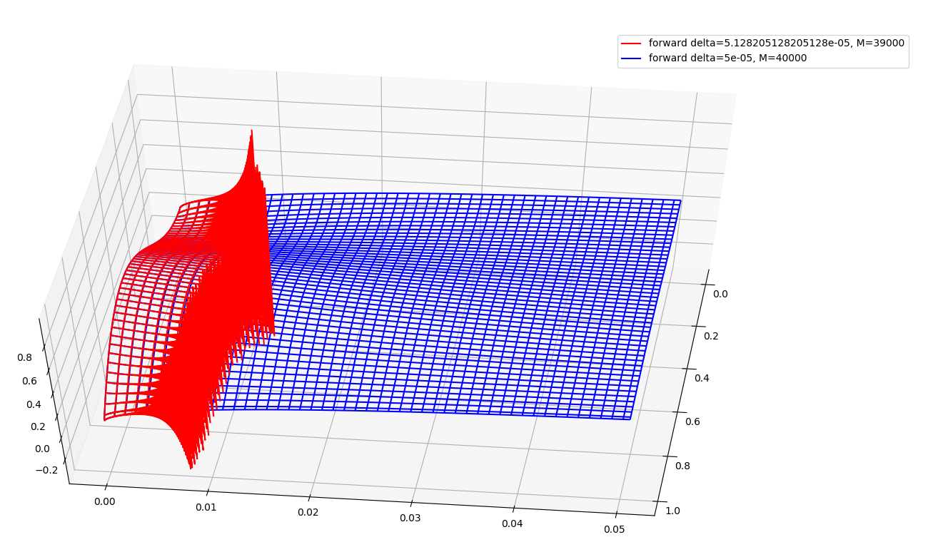

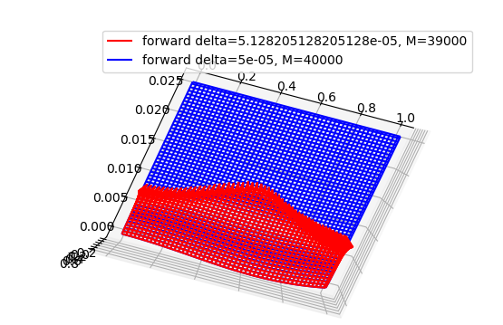

Even here, so close to the solution only makes it a little bit farther in time before becoming unstable. I increased and to perform an eyeball norm for F.E.

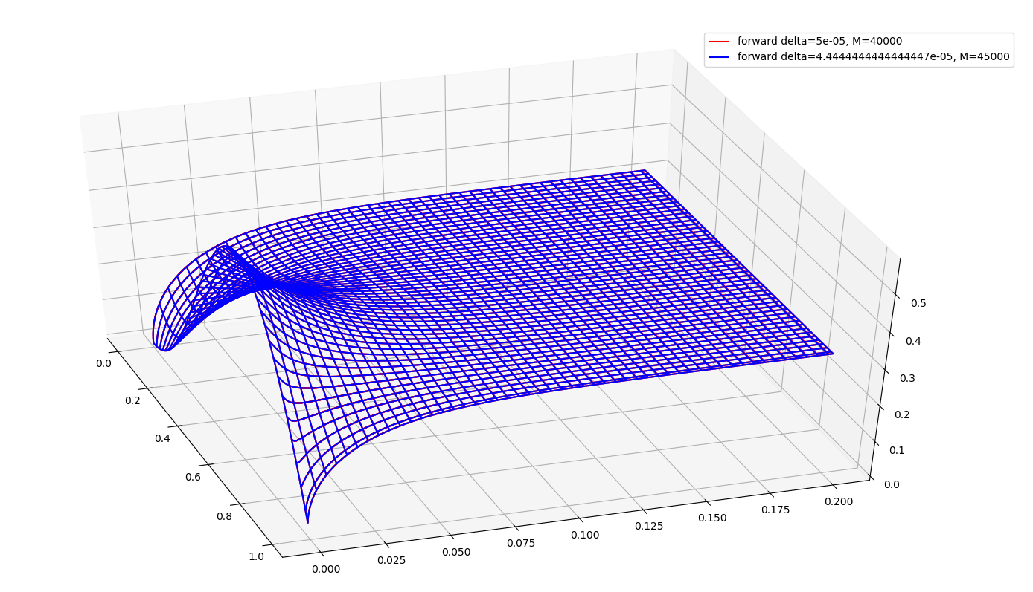

I noticed no visible difference. It looks like our rule that is true.

**BACKWARD**

Here it is convenient that B.E. tends to have a less expensive iteration count to converge. I started small beginning with and the eyeball norm indicated that I should go further.

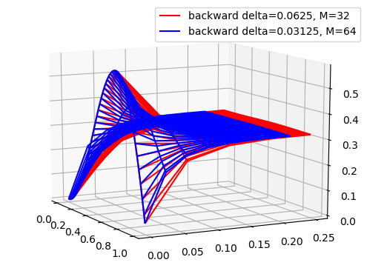

I increased each by a power of two.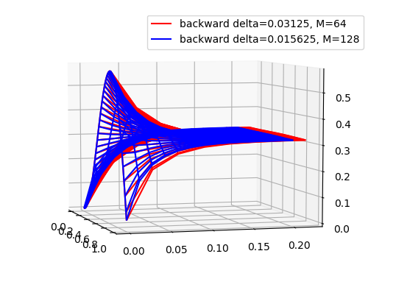

And again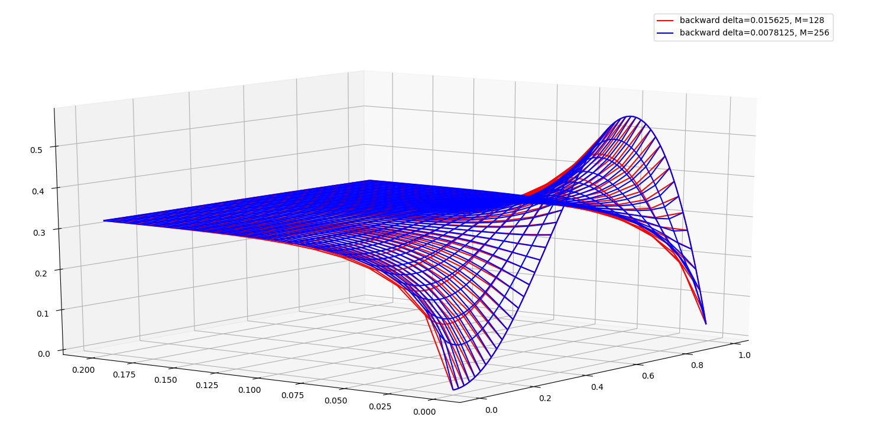

It appeared at this point that I was approaching truth. I continued.

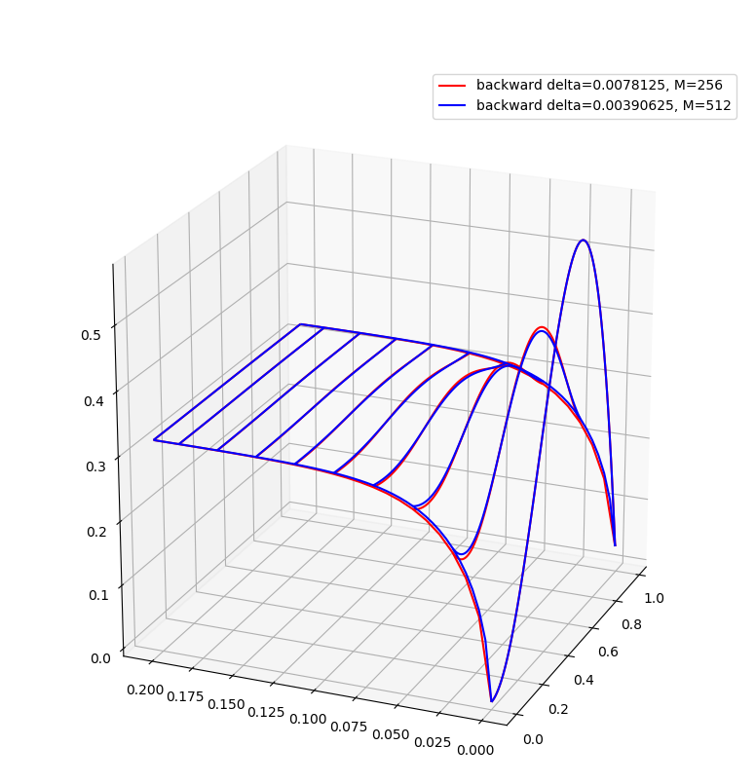

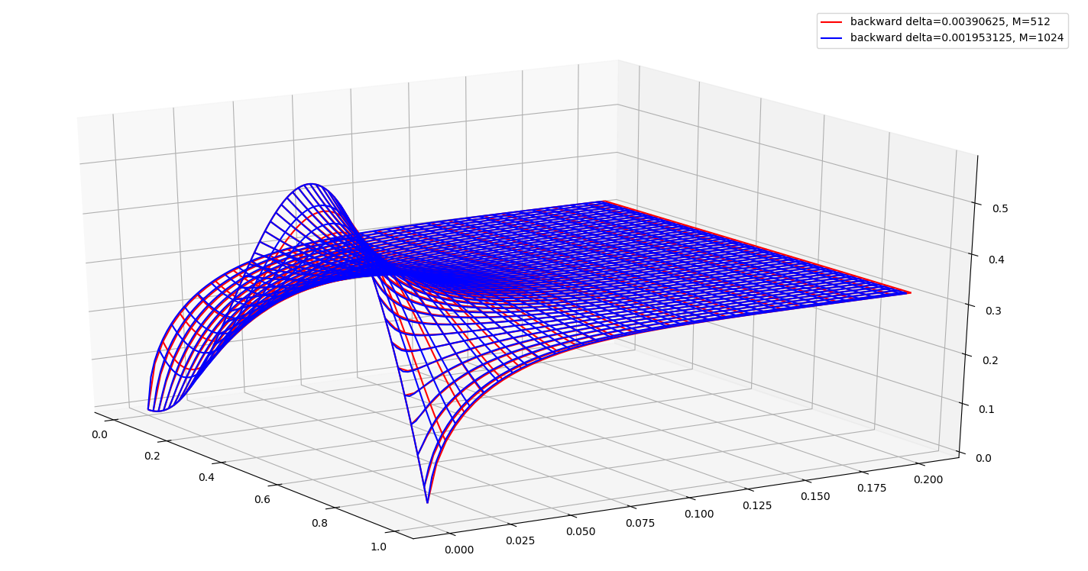

At this point I considered to be close to the true solution. 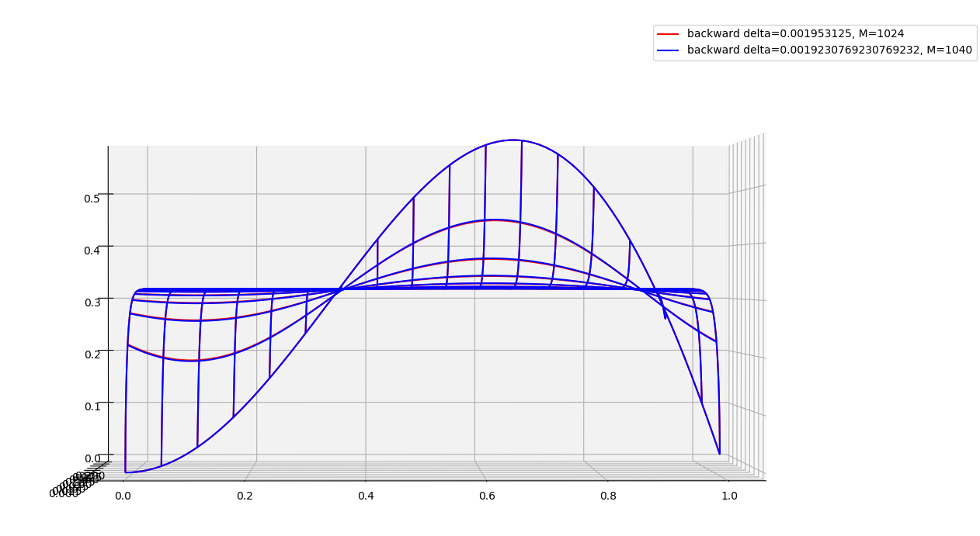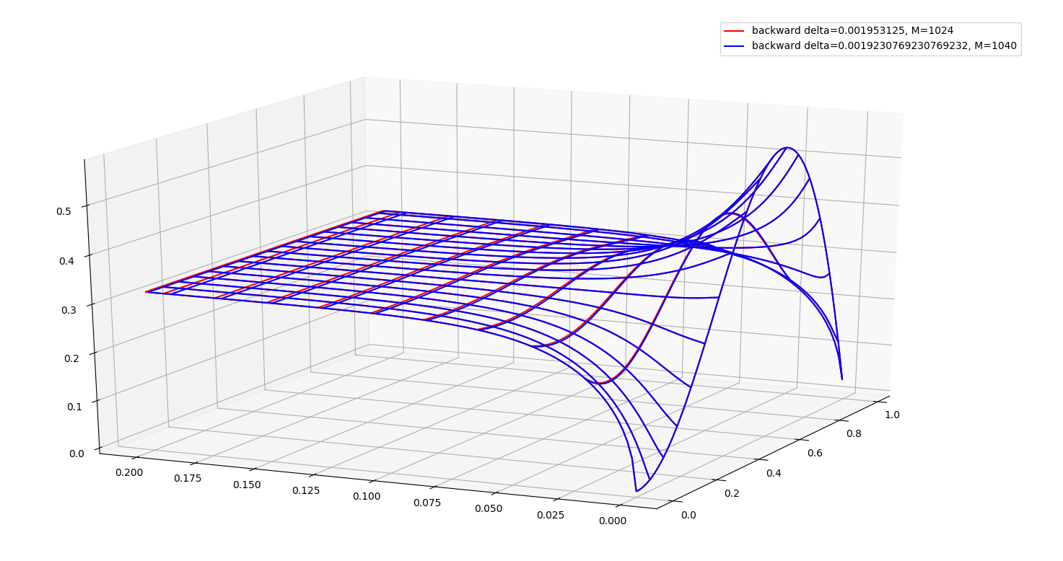

Here, the eyeball norm was sufficient enough for claiming is a viable condition for convergence of B.E.

B.E. took considerably less computation time than F.E. but I find it hard to believe that this comes without a cost. Taking into consideration that these solutions are purely numerical, I hypothesize that the solution obtained from B.E. is farther from *true* truth, and perhaps violates some fundamental law of physics, perhaps more-so than F.E.

**SYMMETRIC VS. NON-SYMMETRIC, BACKWARD EULER**

Given the results found in the previous experiment, I took the solution from to be the true solution for the following convergence criteria. For , I found the volume under each curve using symmetric and non-symmetric matrices and compared those values to the volume under what I considered to be truth.

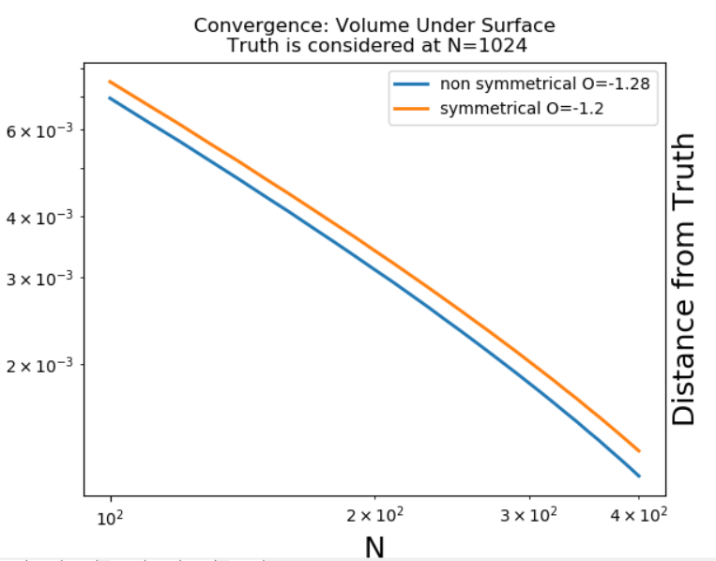

These two methods appear to have nearly the same convergence order, but one is closer to truth than the other with each iteration. It would have been useful to have known about M.C. methods here because the volume calculation was incredibly expensive.

The symmetric matrix was much quicker for use in obtaining a solution, however I again think that there is a cost. When considering that these solutions model real world phenomena, it is feasible that the methods which are less expensive or faster likely ignore some fundamental rules of physics/thermodynamics.