# F# Programming Assignment [50 pts] Due Date: Saturday, April 18, 2015 by End of Day

1. [50 pts] Implement a **recursive** function that computes the **determinant** of an N by N matrix of **integers**, represented as a **2D array**. Your method should support any size matrix. Submit the implementation file (Hw4.fs) of the provided interface.

**Notes and Hints**

* Implement the provided interface (IHw4.fs) by including it in your F# project (see below).
* Use the method of expanding “by minors” as shown in on Wolfram MathWorld (<http://mathworld.wolfram.com/Determinant.html> ). *You will basically have to implement formula (8) on this site.*
* You may define an F# Console app project that contains the provided interface, your implementation file (Hw4.fs) and the Program file, also provided for your convenience and as an example of how you are expected to call your interface method.

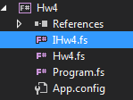

* For help on multidimensional arrays see the MSDN site:  
   <https://msdn.microsoft.com/en-us/library/dd233214.aspx> ).
* You should submit only the **Hw4.fs** file which will contain the implementation of the interface. A snippet of **Hw4.fs** is shown below:

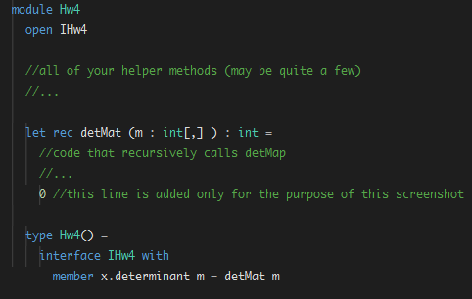

* A sample output based on the provided Program.fs content, is shown below.

Given the input 2x2 matrix:

let matrixOfInt = array2D [| [| 1; 2|]; [| 3; 4 |] |]

, the program produces the following output:

