**Read Me for Rock-Paper-Scissors Game**

* It is a simple Rock-Pape-Scissors game that we play. I assume you know the rules.
* If you are not familiar with the rules, you can visit this link for details: <http://www.wikihow.com/Play-Rock,-Paper,-Scissors>

**In-order to compile the app, follow these steps:**

1. Drag and drop the *rockPaperScissors.c* file in the present working directory inside Kali Linux.
2. Assuming you copy it into the root folder, check if the file has been successfully copied. (Use ls command to list the files)

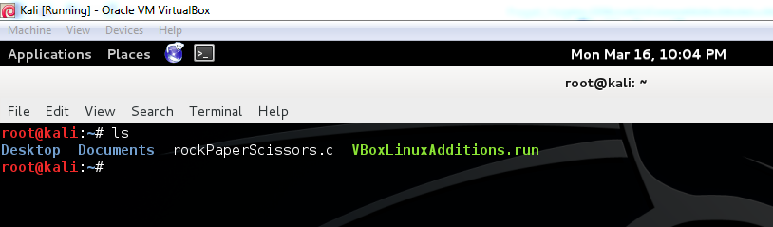

1. Disable ASLR

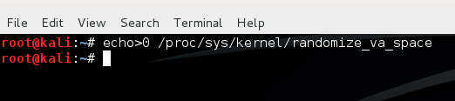

1. Compile the program by using the following command:

gcc -g -fno-stack-protector -mpreferred-stack-boundary=2 -o rockPaperScissors rockPaperScissors.c

**In-order to run the program, follow these steps:**

1. Run the program by using the following command:

./rockPaperScissors

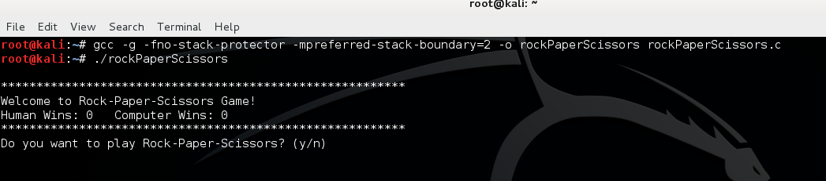

1. 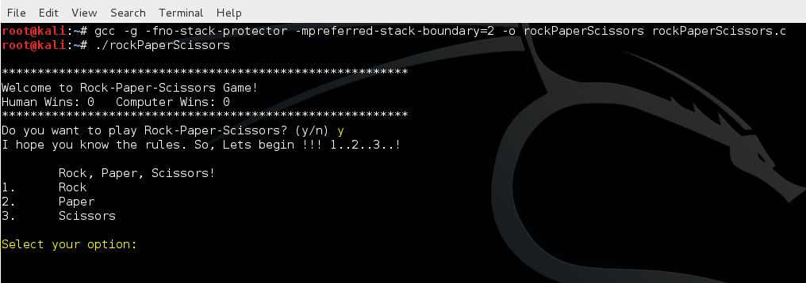It will display the welcome message. Press y to play the game, n to exit.
2. Select your option: either 1, 2 or 3.

Assuming you select 1:

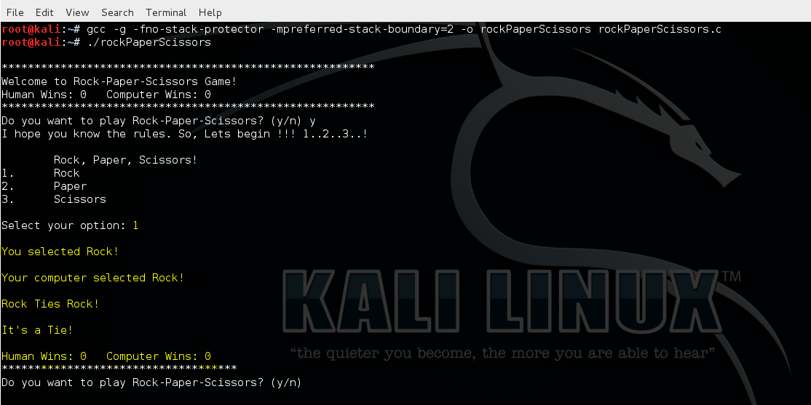The computer might randomly select its option and the result would be displayed. If you win, the score would be updated under *Human Wins.* If you lose, the score would be updated under *Computer Wins.*

1. 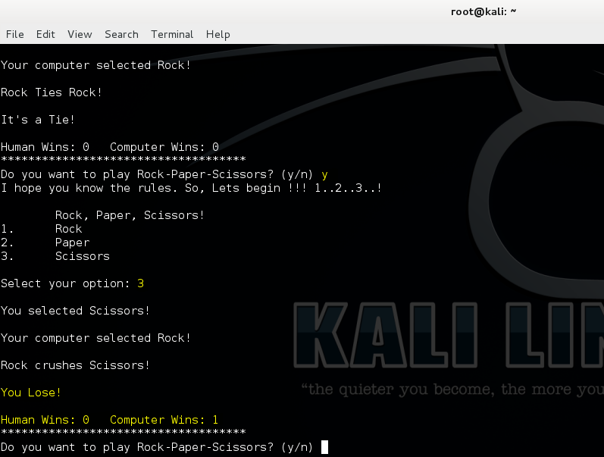You might chose to play again by entering y.

The goal of a successful exploit is to **always win the game!**

**Enjoy Playing!**