CSE 5349/7349

Network Security

Homework No.5
Due on: Apr. 22

- Consider the following IP network segment with two end nodes and 3 routers. The corresponding IP addresses are shown the in the figure below.
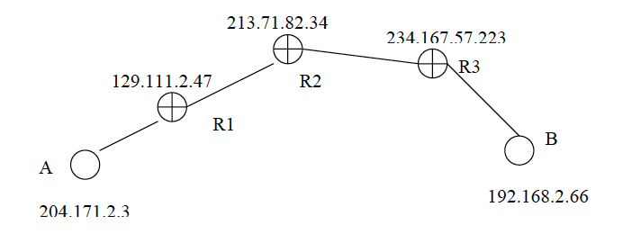

Given:

- The MTU between R1 and R3 = 1024 bytes
- MTU between A and R1 = 2048 bytes

Consider IP packets of size 1280 bytes sent from A to B. Now consider IPSec applied to the connection from A-B. Show header formats of the packets (fragments where applicable) highlighting the address fields for the following two scenarios.
  - Tunnel mode ESP between R1 and R3
  - Tunnel mode ESP between R2 and R3, Tunnel AH between R1 and B and transport AH between A and B
- Consider a 16-bit sliding replay window for IPSec. Let the current vector representing the received packets is 0011,1111,0111,1110 and the sequence number of the packet in the first slot is N. Describe the actions if the packets with the following sequence numbers arrive in the given order:
    - N+4
    - N+2
    - N+8
    - N+19
    - N+2
- Compare the advantages and disadvantages of SSL VPNs and IPSec VPNs.
- Set up two unsecured web connections. Show the packets after:
  - Using SSL protection on one of the connections
  - Tear down SSL and use IPSec to a server available to you.

