AWS 2

Tyler Chung

Purpose: In this lab I learned how to create an Amazon S3 Bucket to store and access resources. An Amazon S3 allows for hosting of static website without a webserver. A bucket is a simple storage service on AWS. I also learned how to enable the bucket for public access, add a policy to the bucket and access resources on the bucket through a website.

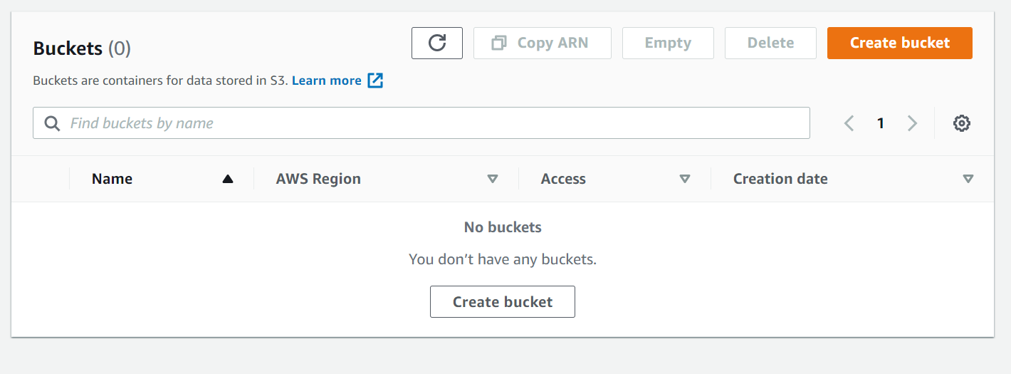

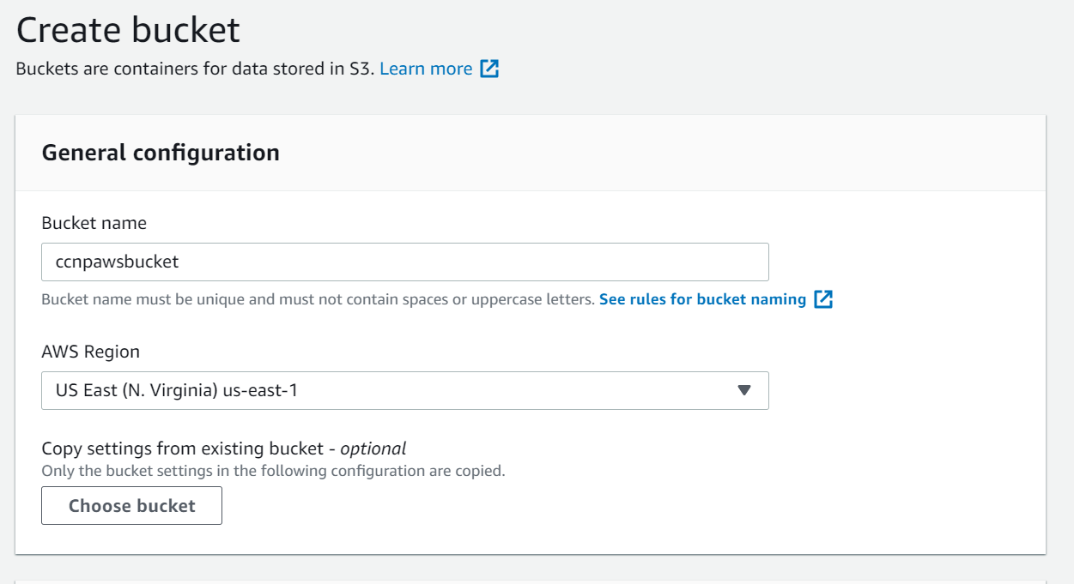

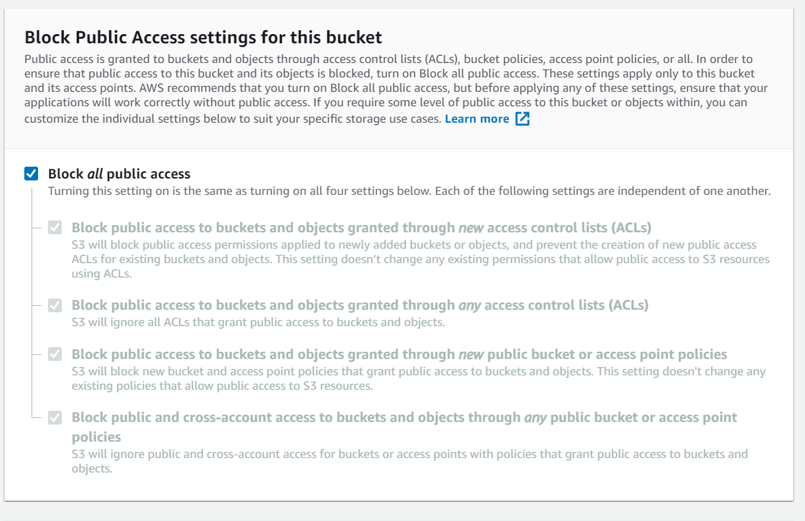

First, I created an Amazon S3 Bucket with public access blocked to store files in.

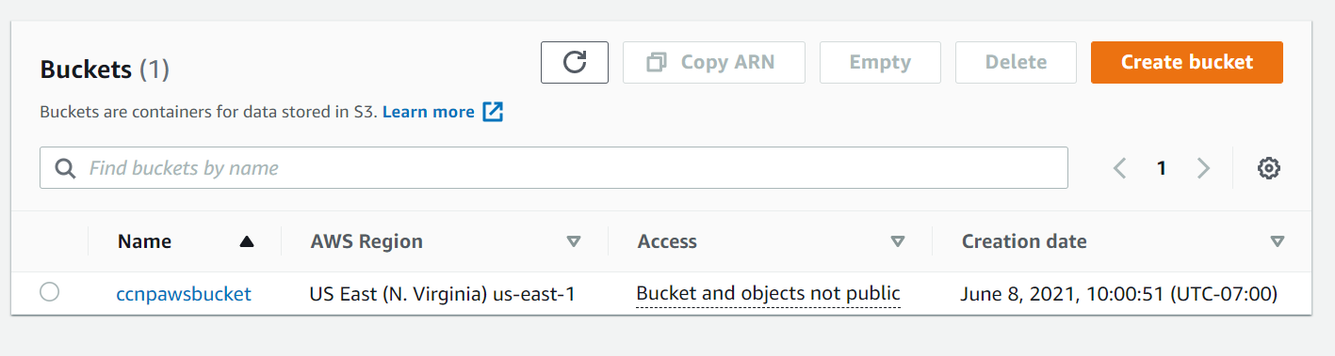

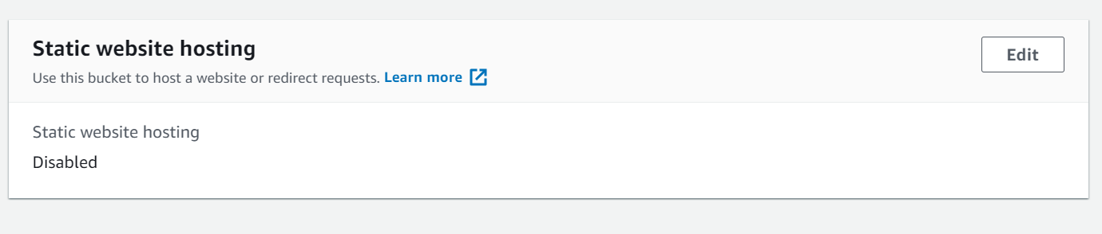

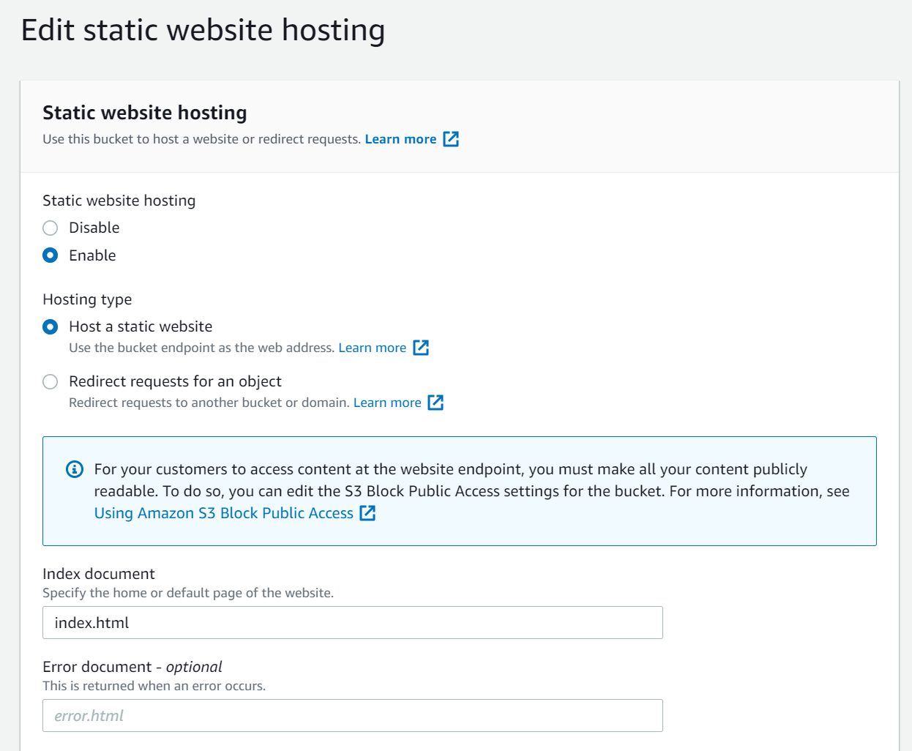

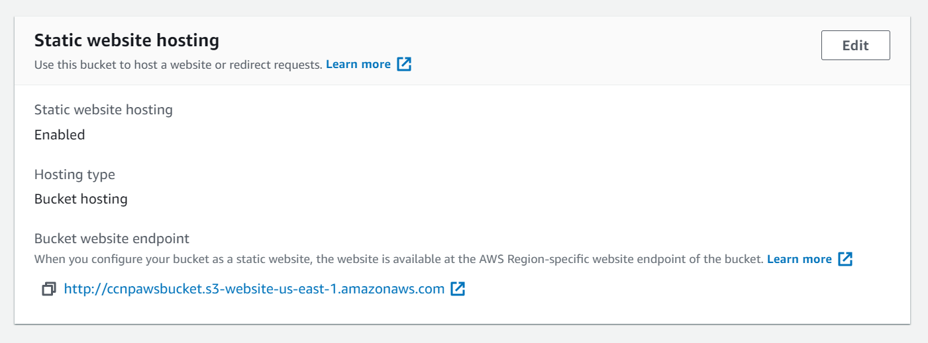

Next, I enabled static web hosting on the Bucket previously created which allows me to host a webpage from the bucket.

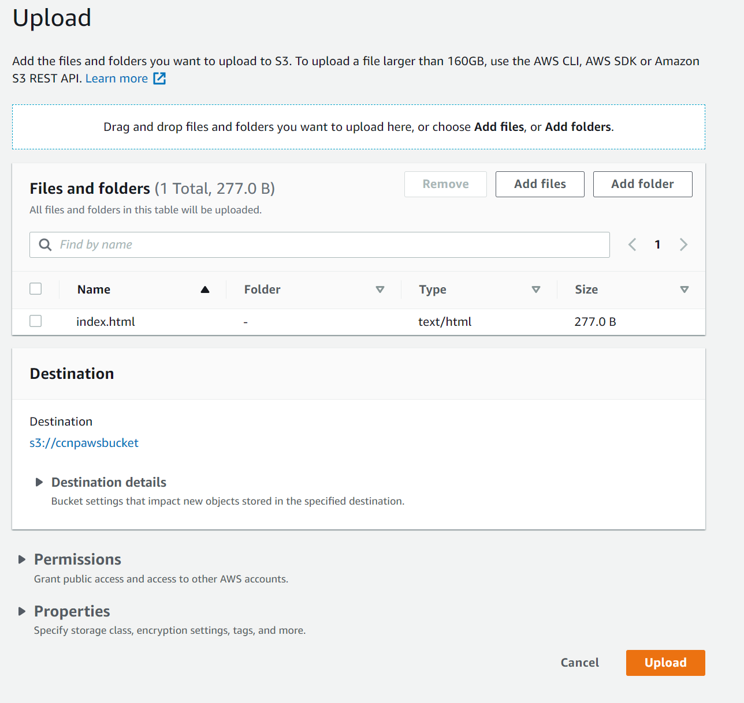

I uploaded a website file called ”index.html” which adds a new object called “index.html” to be used as a website.

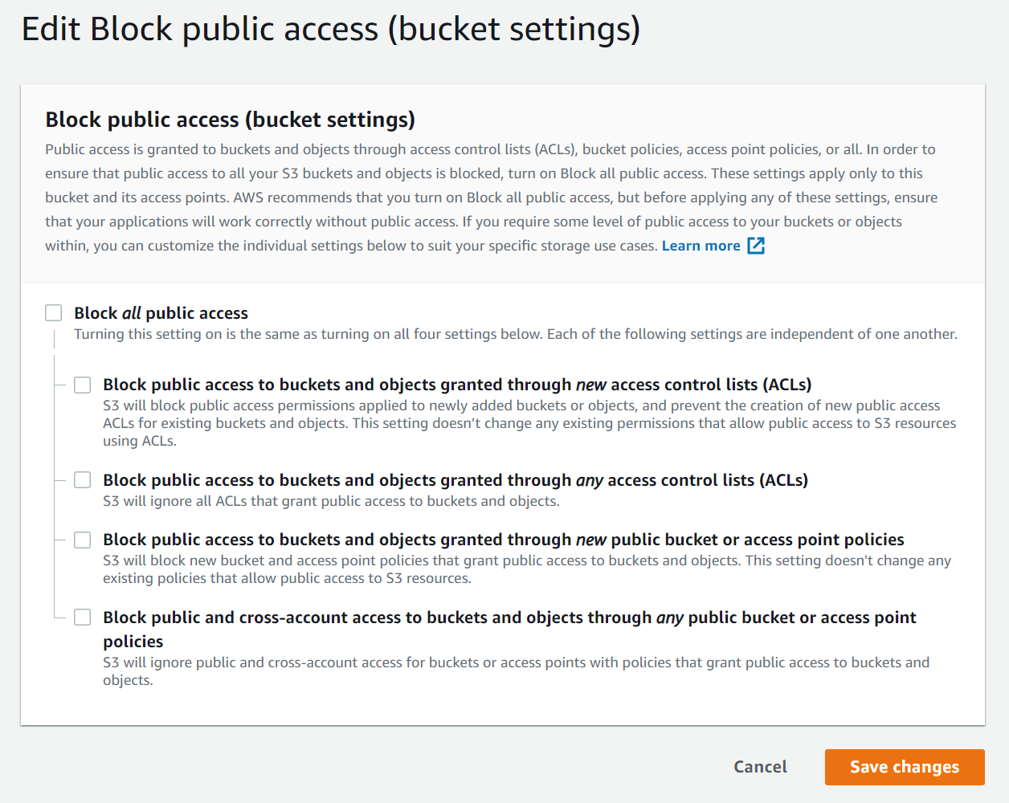

I then allowed public access to the bucket which allows users on the internet to access my bucket.

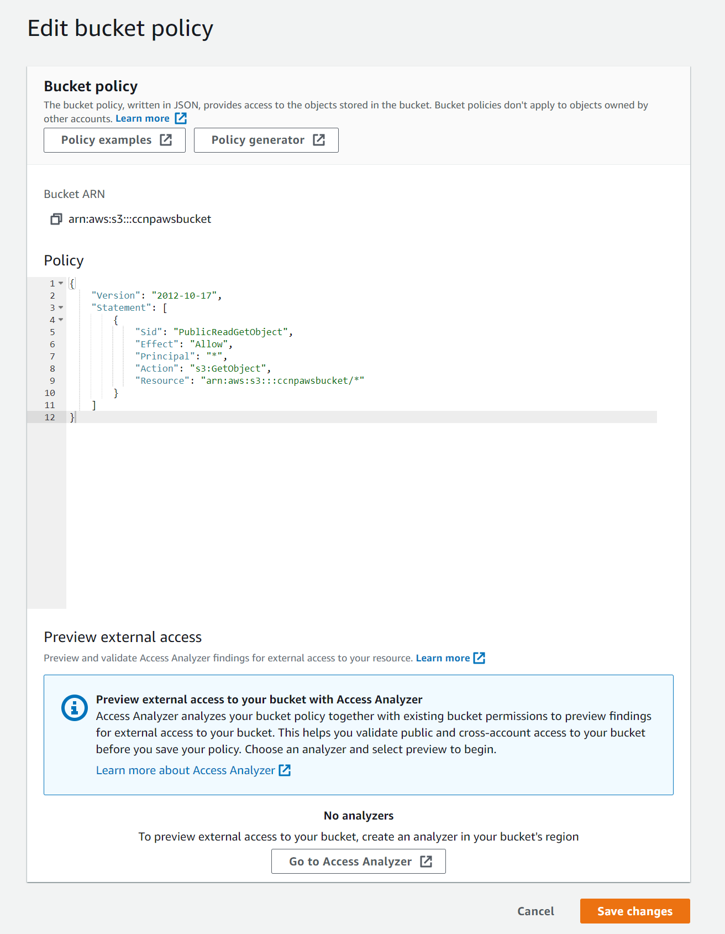

I then added a bucket policy which allows the user to access the objects within the bucket.



The website worked at url “[ccnpawsbucket.s3-website-us-east-1.amazonaws.com)](http://ccnpawsbucket.s3-website-us-east-1.amazonaws.com/)”. It displayed the index.html page.