AWS 3

Tyler Chung

Purpose: In this lab I learned how to start an EC2 instance. I set up the EC2 instance to run a specific operating system, instance type, added user data, and configure security. This EC2 instance acts as a webserver to store and transfer public information. We configured our EC2 instance as a Linux machine with an Apache HTTP server to be publicly accessible.



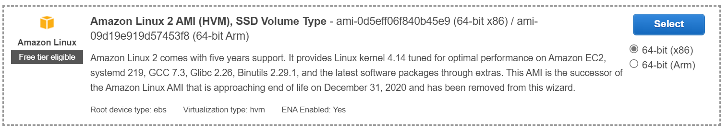

First I created an EC2 instance running the operating system, Amazon Linux 2.





I then choose the instance type of t2.micro instance.



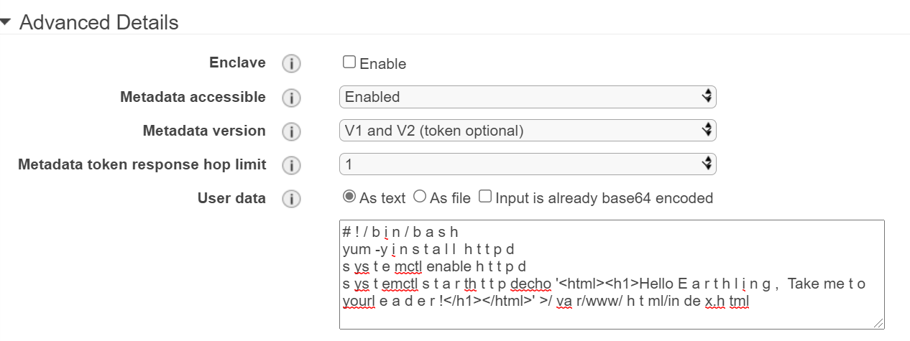

I added user data which installs, enables and starts an Apache HTTP server and then creates an index.html page.



There was no extra storage needed.

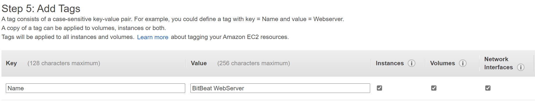

I then created a tag with the Key as “name” and the value as “BitBeat WebServer”.

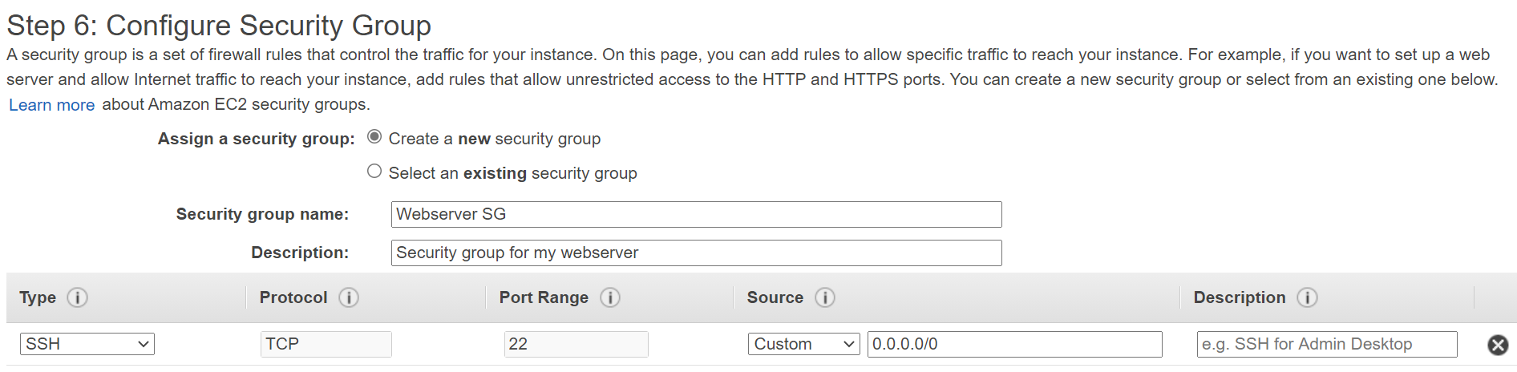

I then created a security group which allows for inbound http in both IPv4 and IPv6. The security group was named “Webserver SG”.

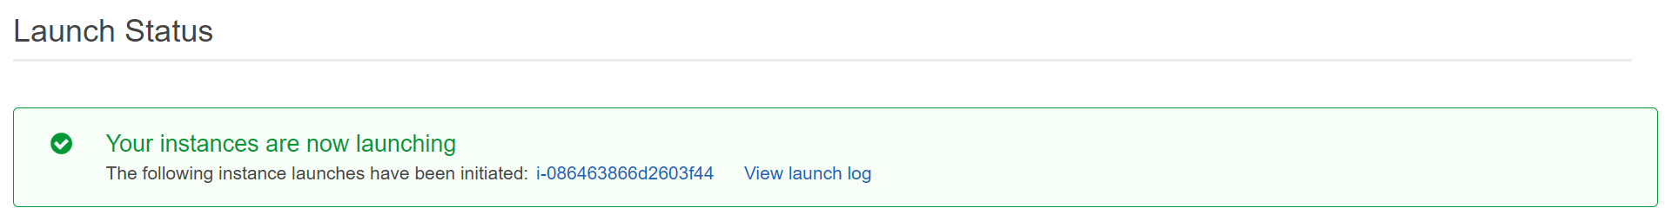

After launching, the instance came up.

Problems:

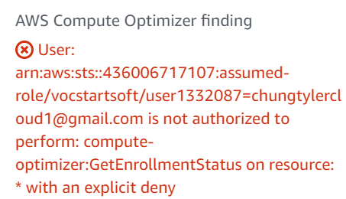

There was an error message that occurred which stated that the account was not authorized to perform a task which was not resolved.