AWS 4

Tyler Chung

Purpose: I learned how to use the VPC wizard to create a VPC. I also learned how to create and set an Elastic IP on a VPC and EC2 instance. I also created a public and private subnet. The VPC wizard allowed me to quickly create a VPC with subnets and if the VPC is create using the wizard, the wizard automatically adds routes to the routing table.

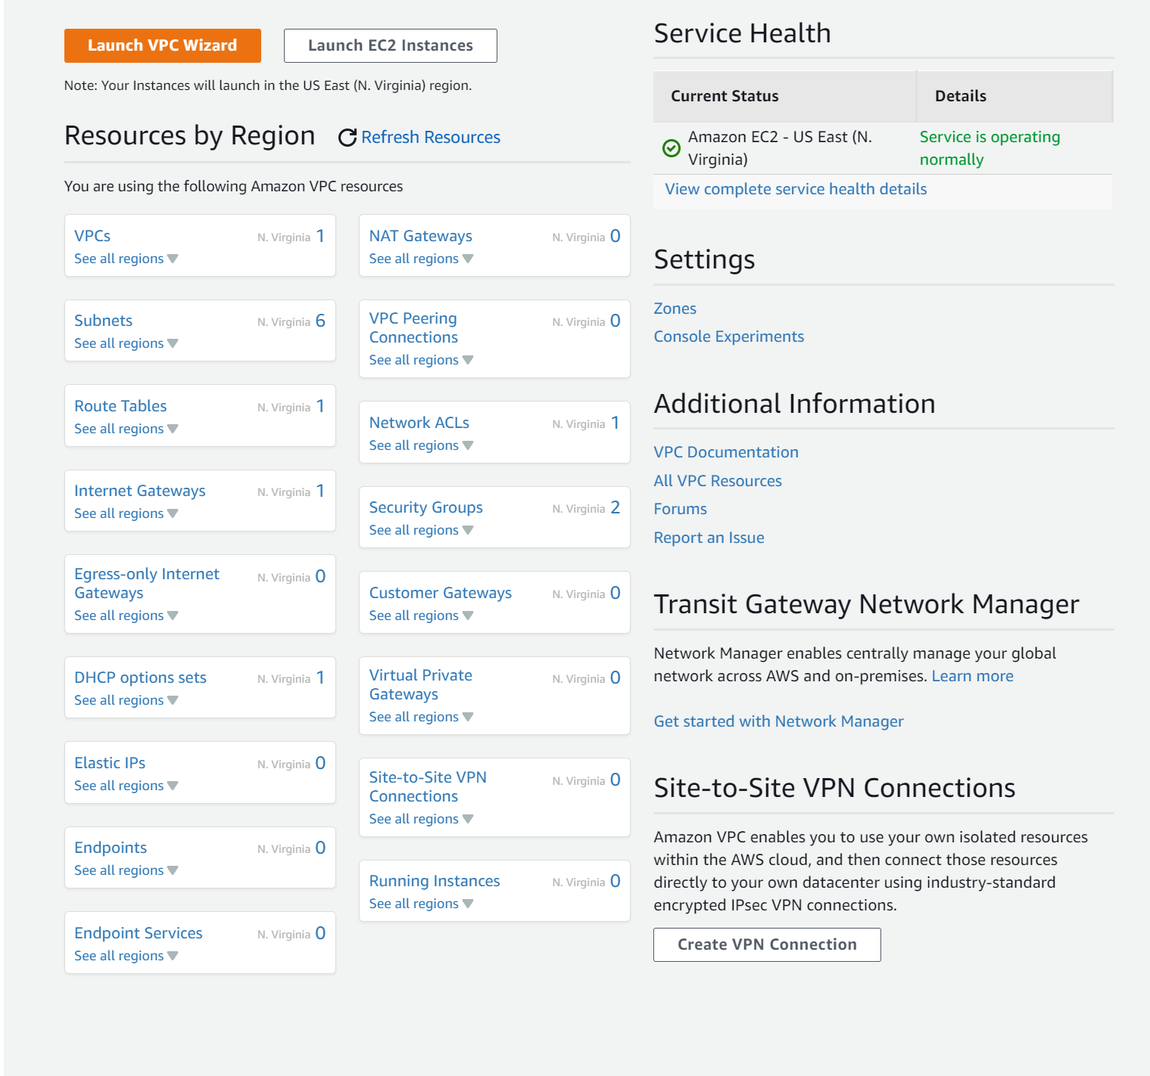

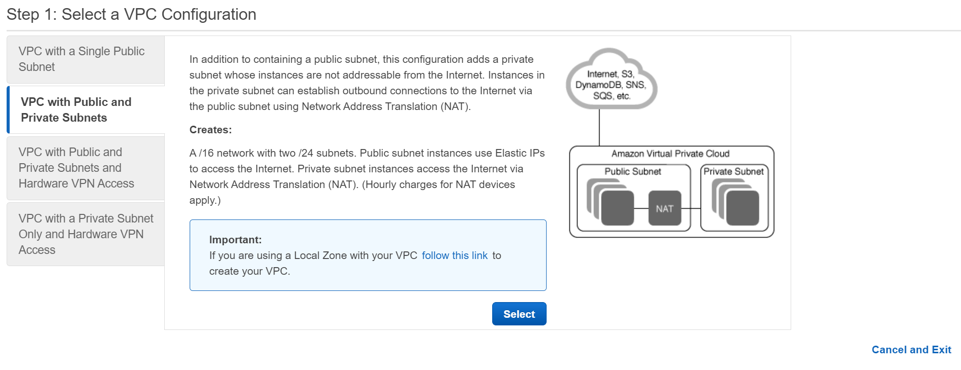

First I entered the VPC Wizard and selected VPC with Public and Private subnets.

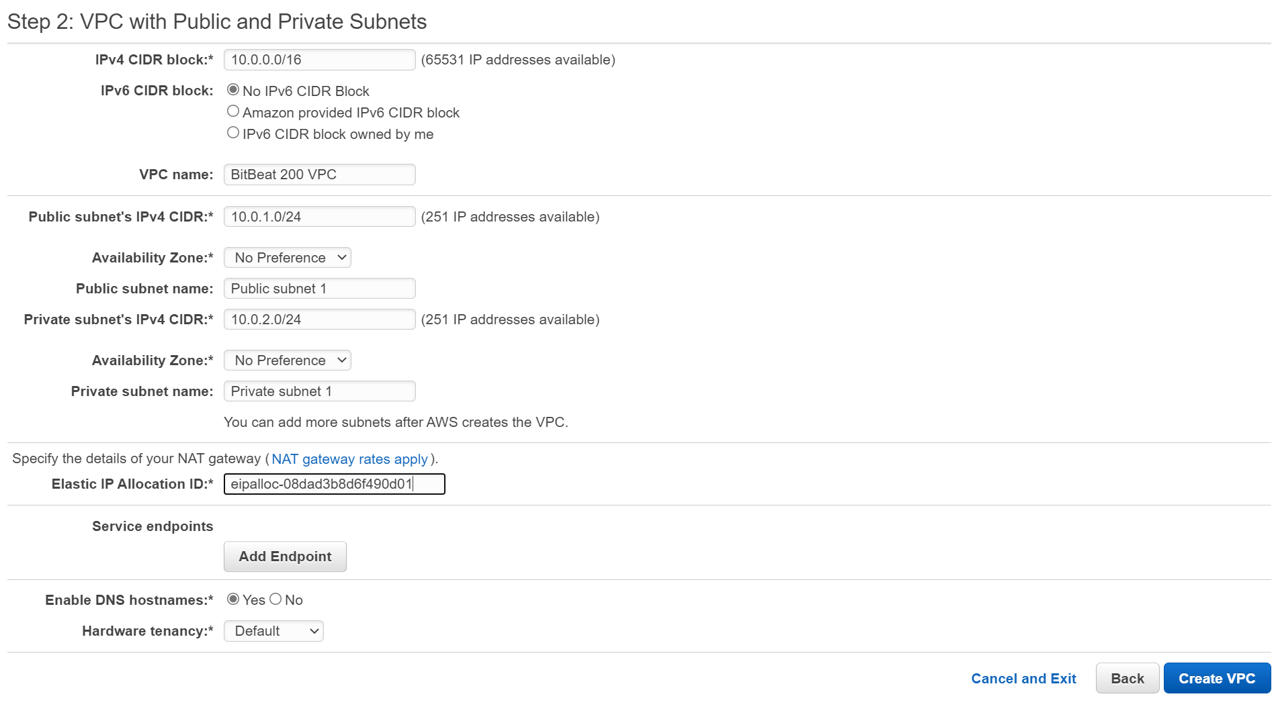

Next I added address pools for the subnets and allocated an elastic IP I created.

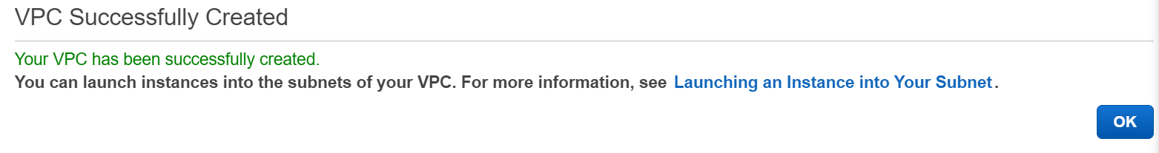

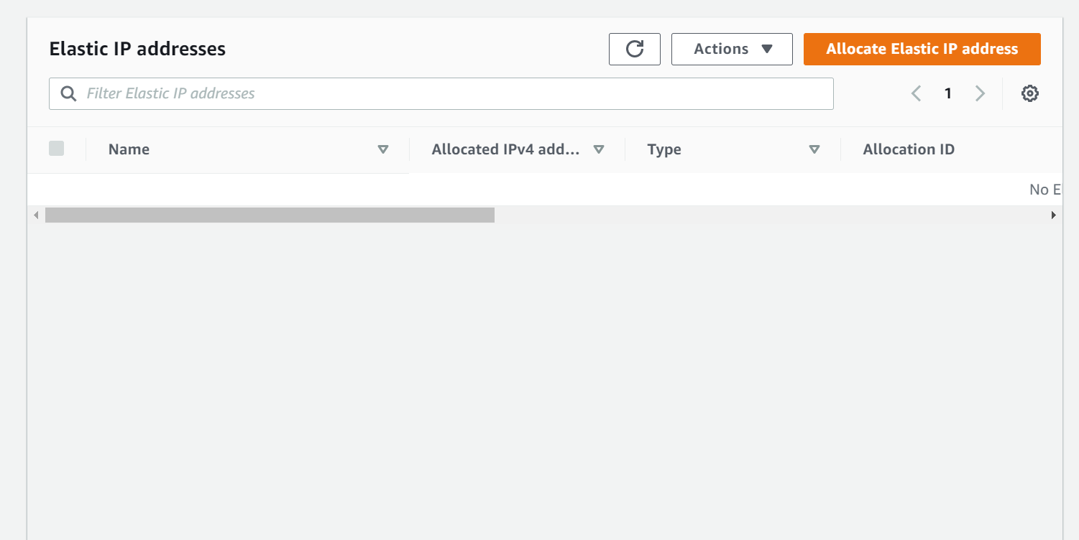

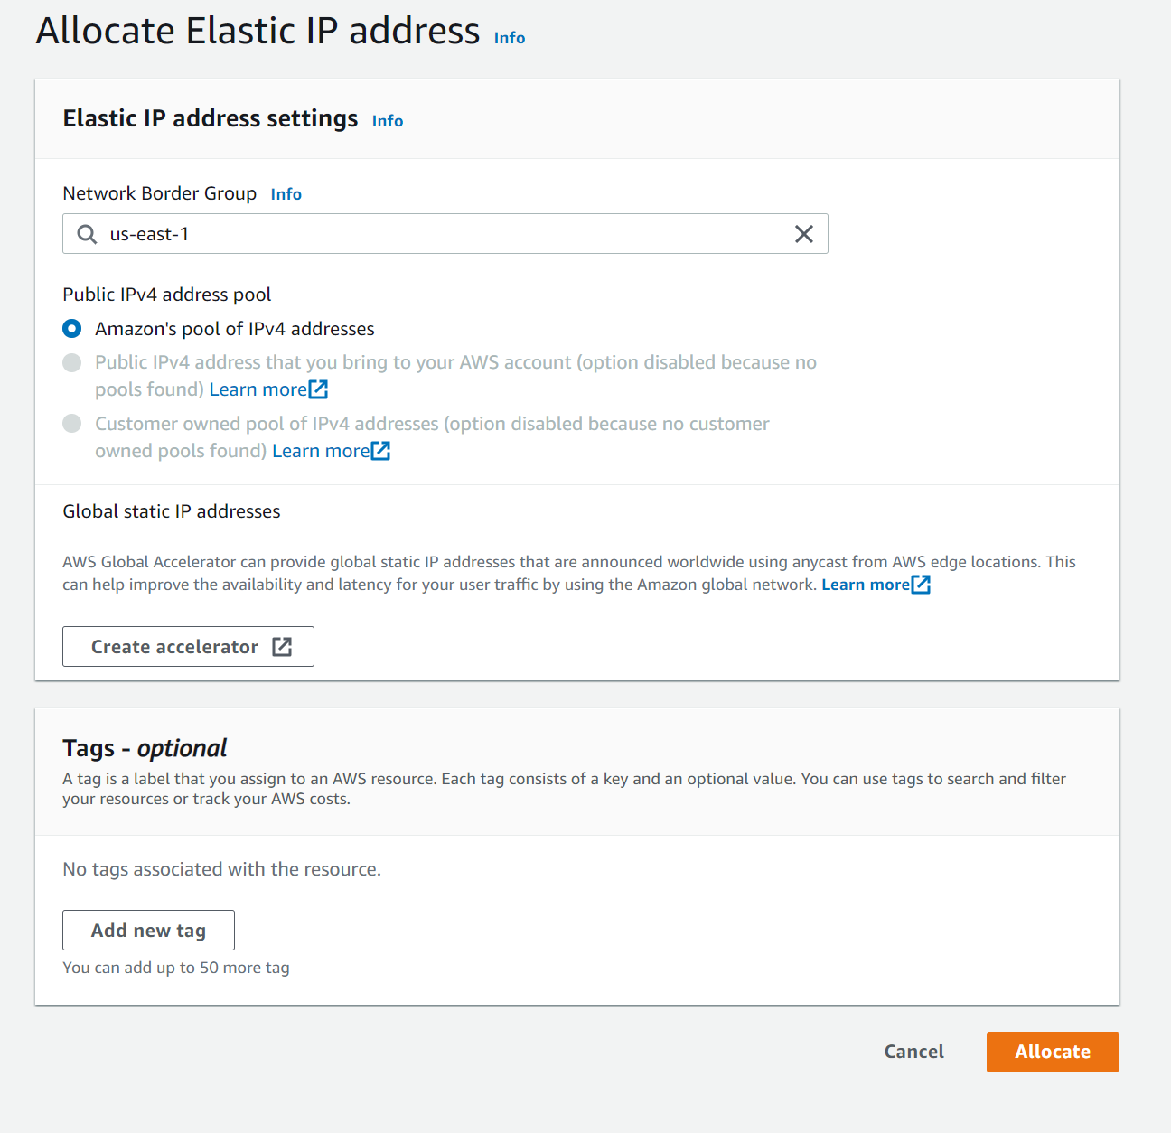

I allocated an elastic IP address to attach to my VPC.

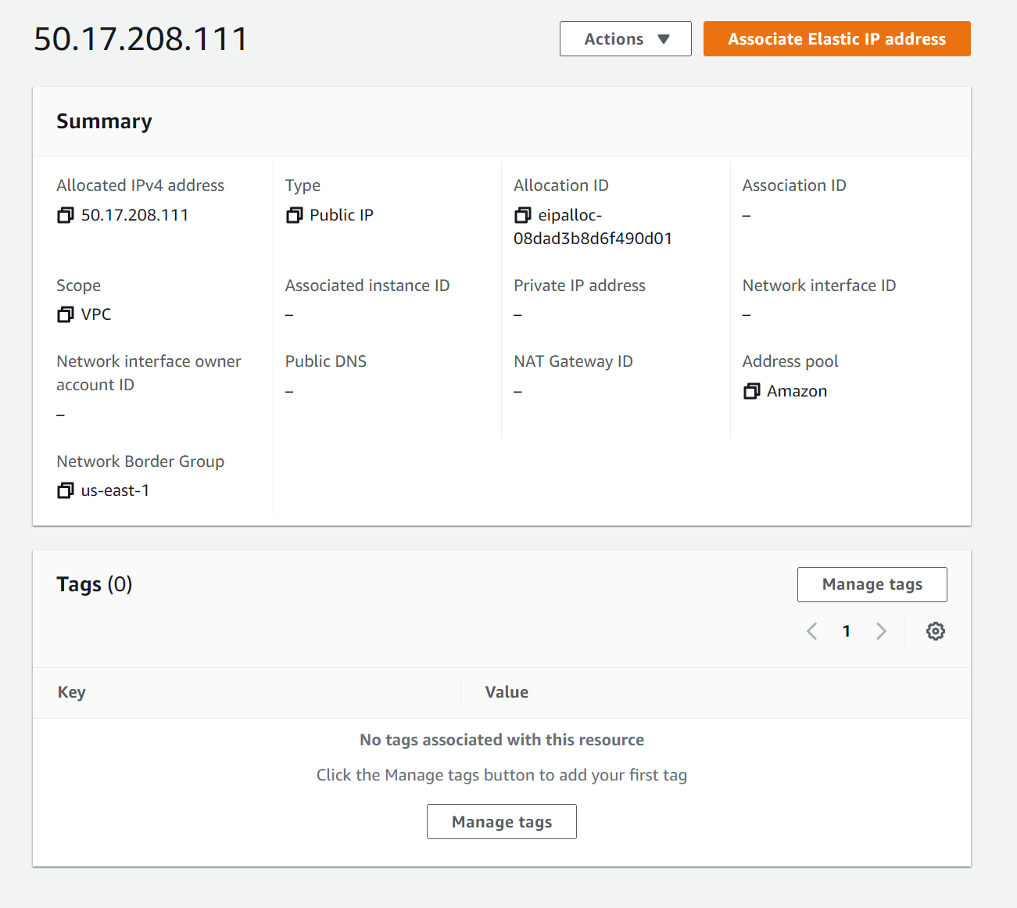

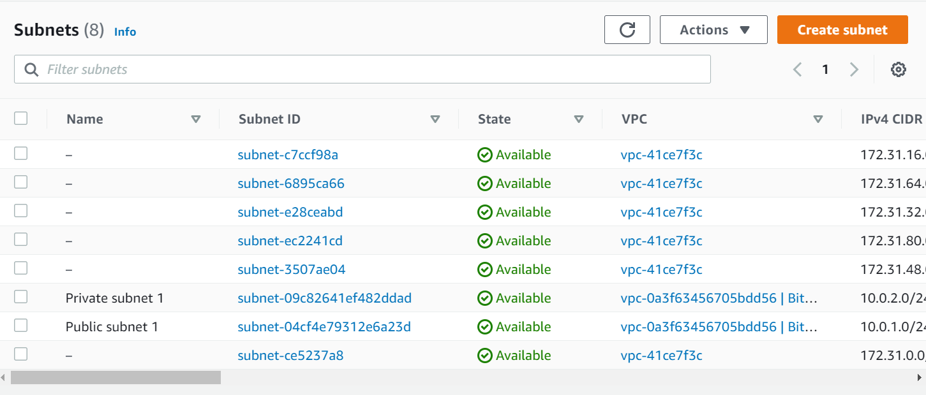

Using the VPC wizard created a public and private subnet.

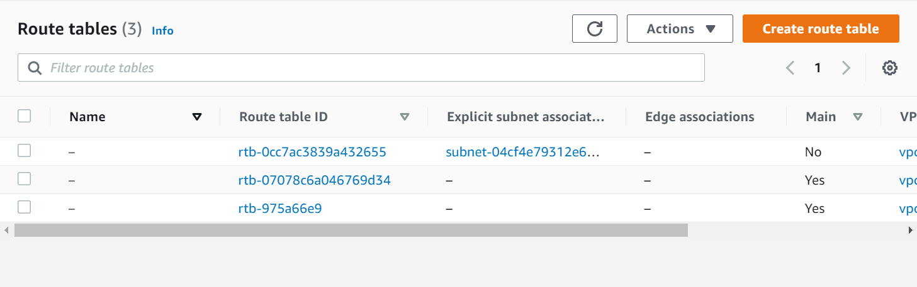

Using the VPC wizard created a route table for the public subnet.

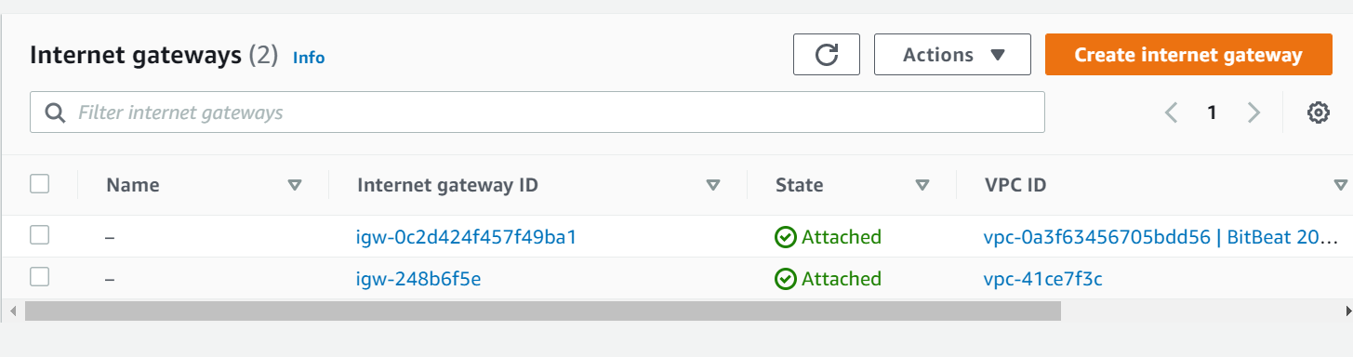

Using the VPC wizard created an internet gateway for the VPC.

Conclusion: In this lesson I learned how to allocate an elastic IP and attach it to a VPC. I then learned how to configure a VPC using the VPC wizard. The VPC wizard allowed me to create the VPC, Subnets, Route table and Internet gateway through only one menu. All in all, I created a VPC, with public and private subnets, allocated with an elastic IP.