AWS 5

Tyler Chung

Purpose: In this Lab I created a bucket and added resource to the bucket. Then I learned how to enable the bucket and the resources on the bucket for public access. The lab continued to teach me about Amazon CloudFront however, due to account permission error I was unable to complete this portion of the lab.

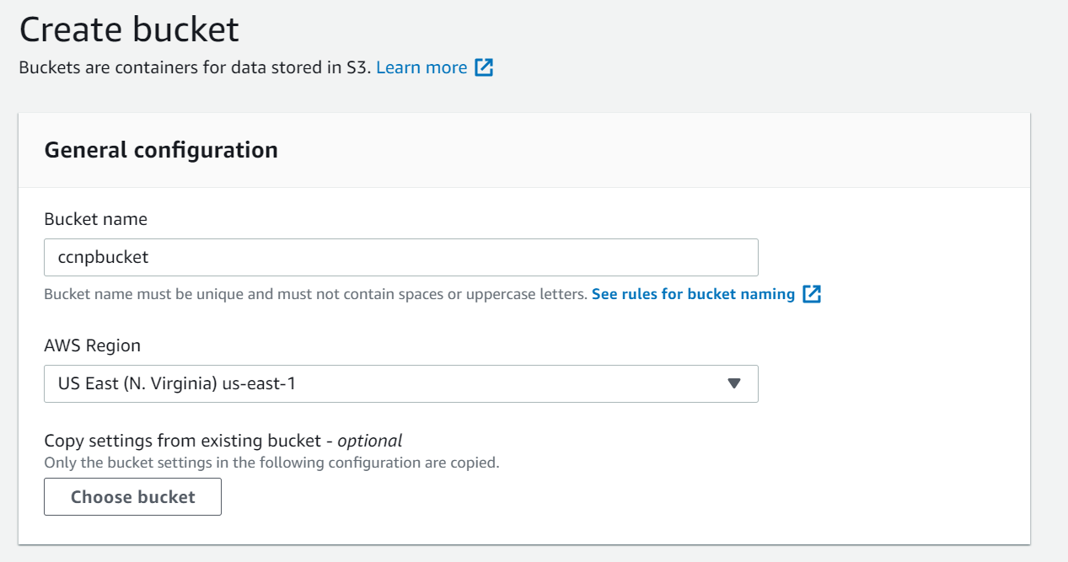

First, I created an S3 bucket called “ccnpbucket”.

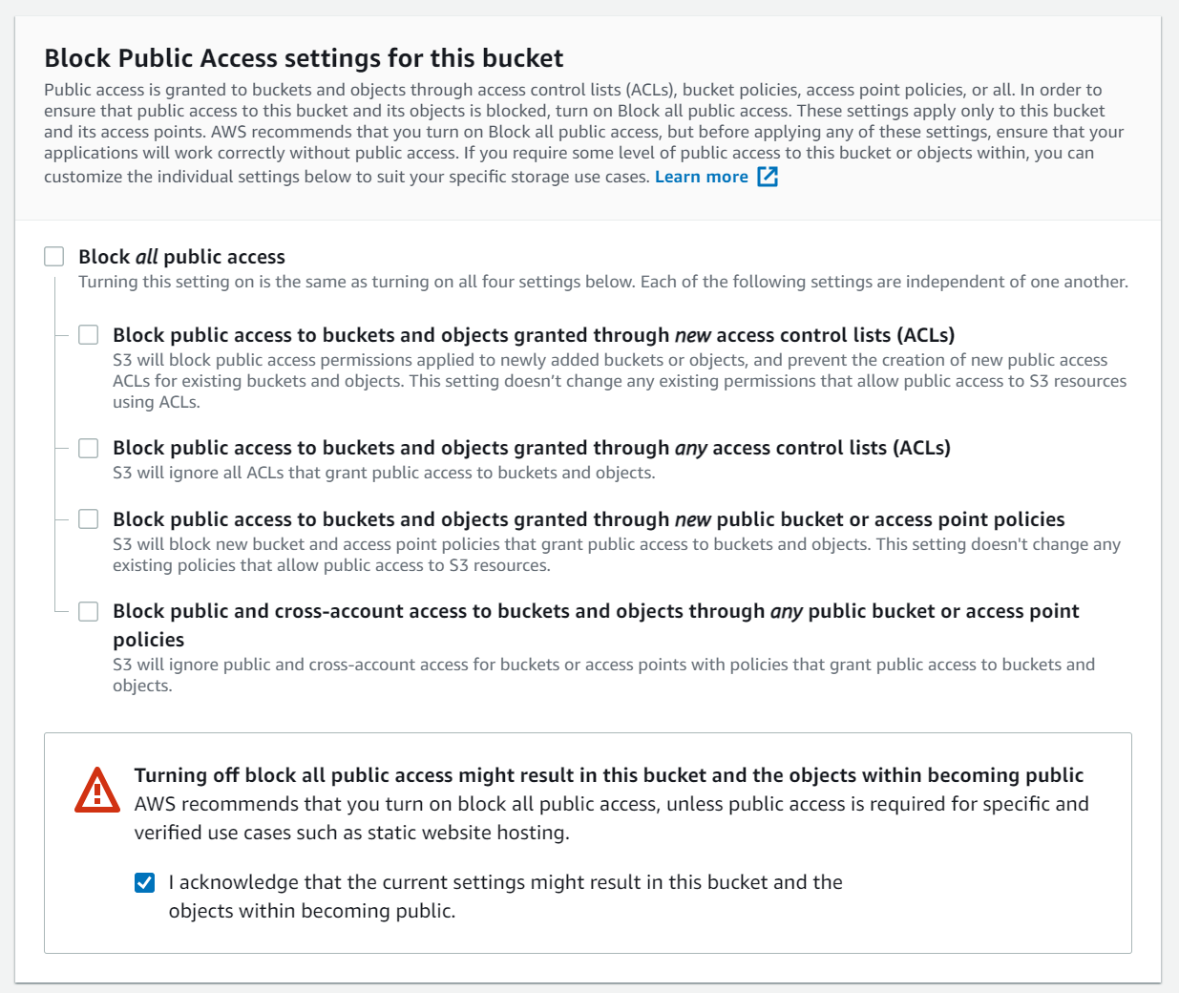

When setting up the bucket I allowed public access to the bucket.

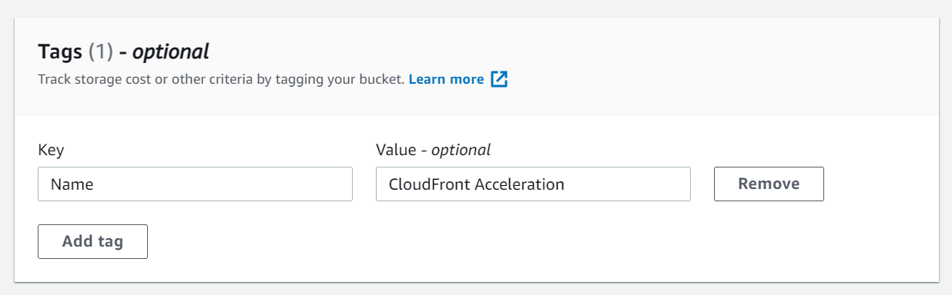

Then, I created a tag with the key: “Name” and Value “CloudFront Acceleration”

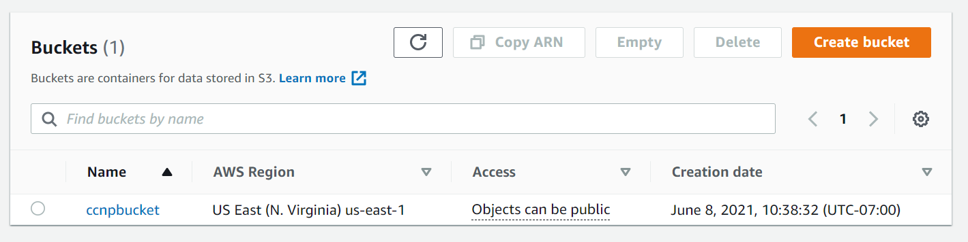

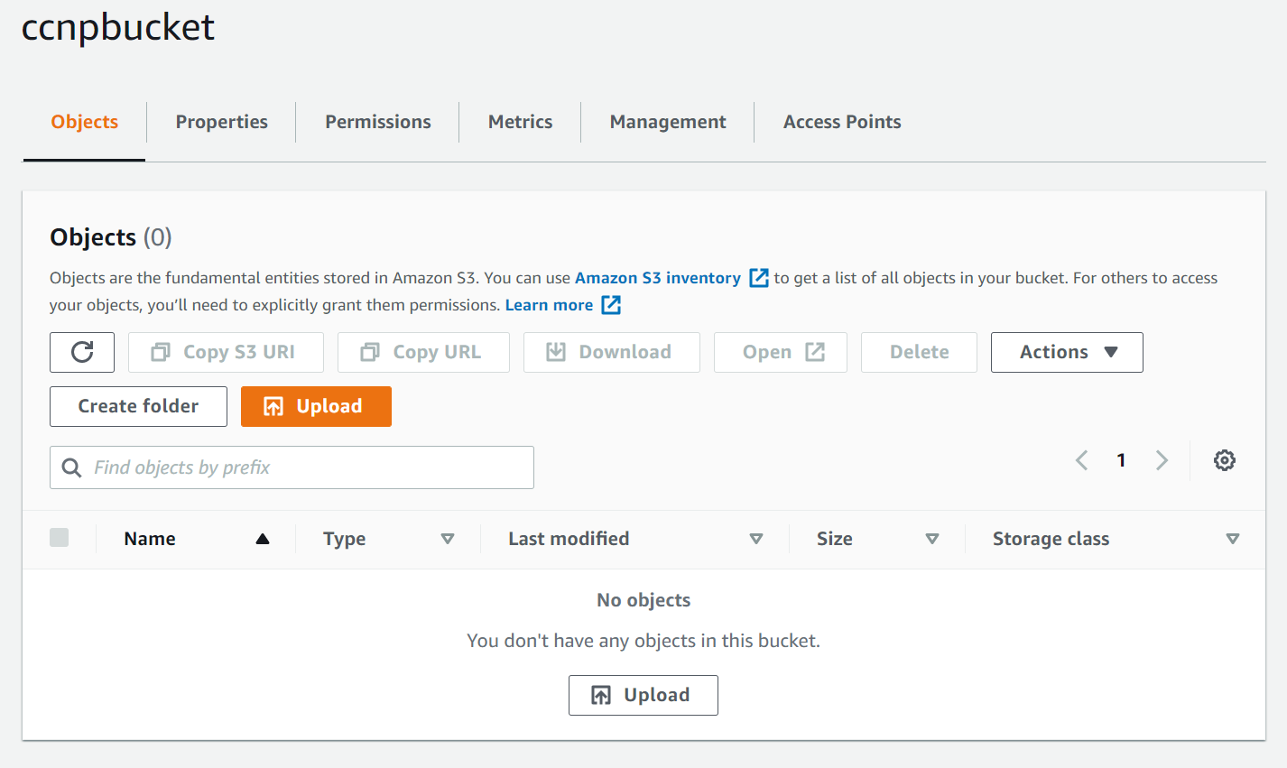

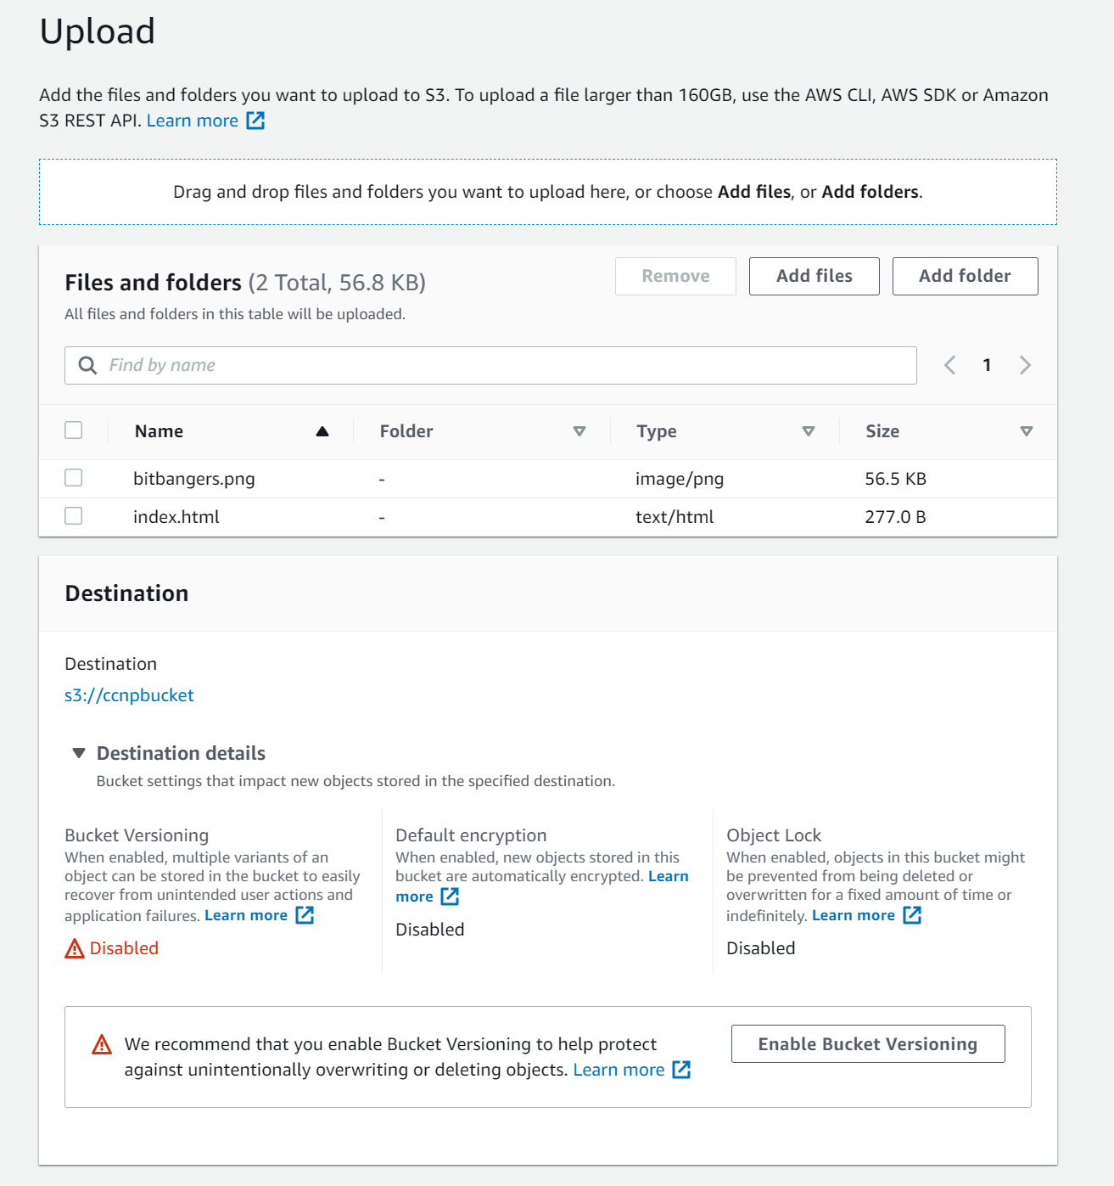

Next, I uploaded resources to the bucket.

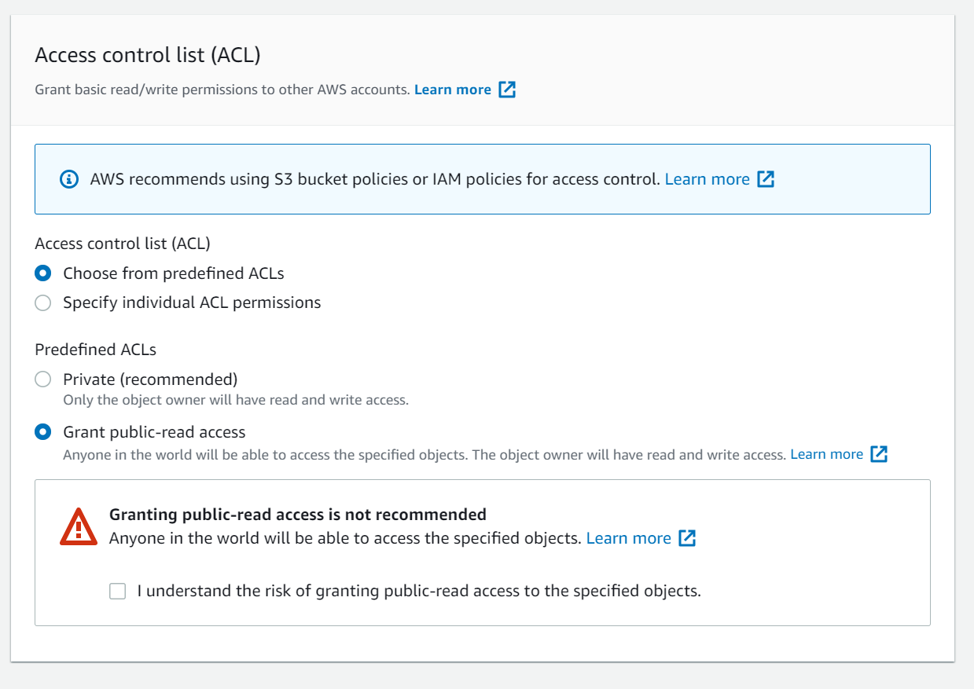

I enabled the resources in the bucket for public access.

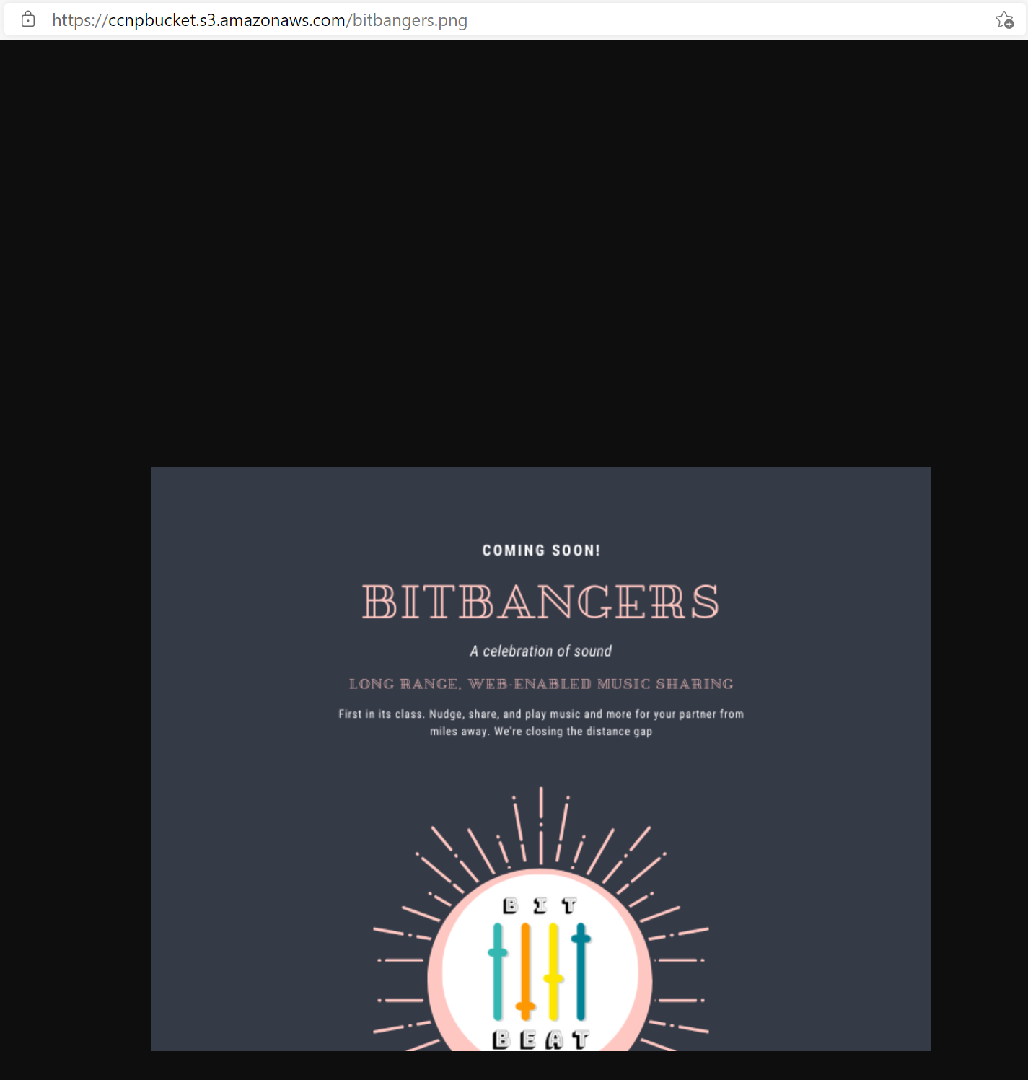

I could successfully access the resources on the bucket.

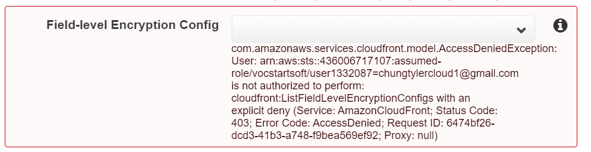

Problems: When trying to configure the CloudFront web distribution error messages appeared, saying “AccessDenied” referencing the account we use for AWS. This means that the accounts we use for AWS do not have permission to access these features making it impossible to complete the lab. Due to this error, I was unable to complete the CloudFront portion of the lab. I encountered no problems in the previous sections of the lab.