AWS 6

Tyler Chung

Purpose: I refreshed on how to create a VPC with Public and Private subnets, Public and Private route tables, and an internet gateway. I then created a EC2 instance which was linked to the components previously mentioned. I then used the EC2 instance to attempt to access a website which did not work due to account error.

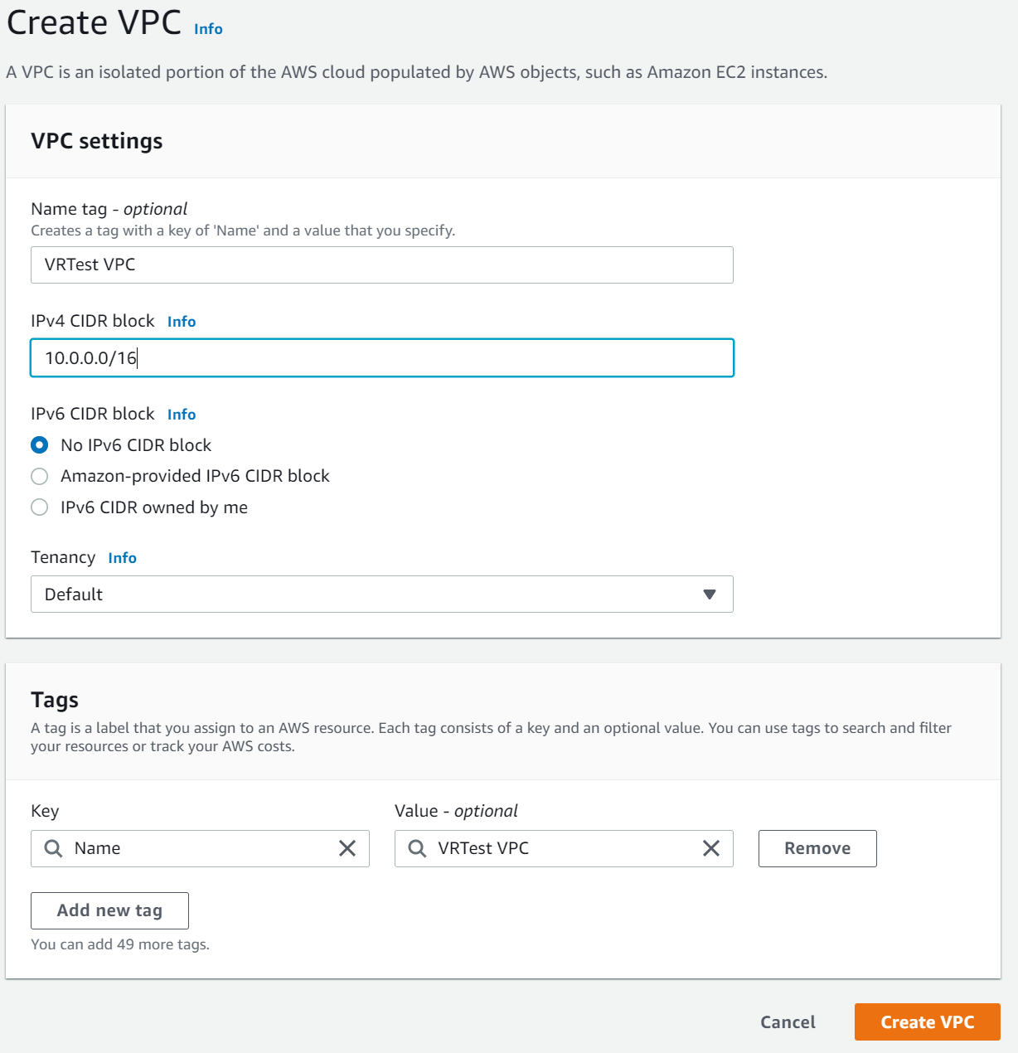

First I created a VPC and named it “VRTest VPC” with the address block 10.0.0.0/16

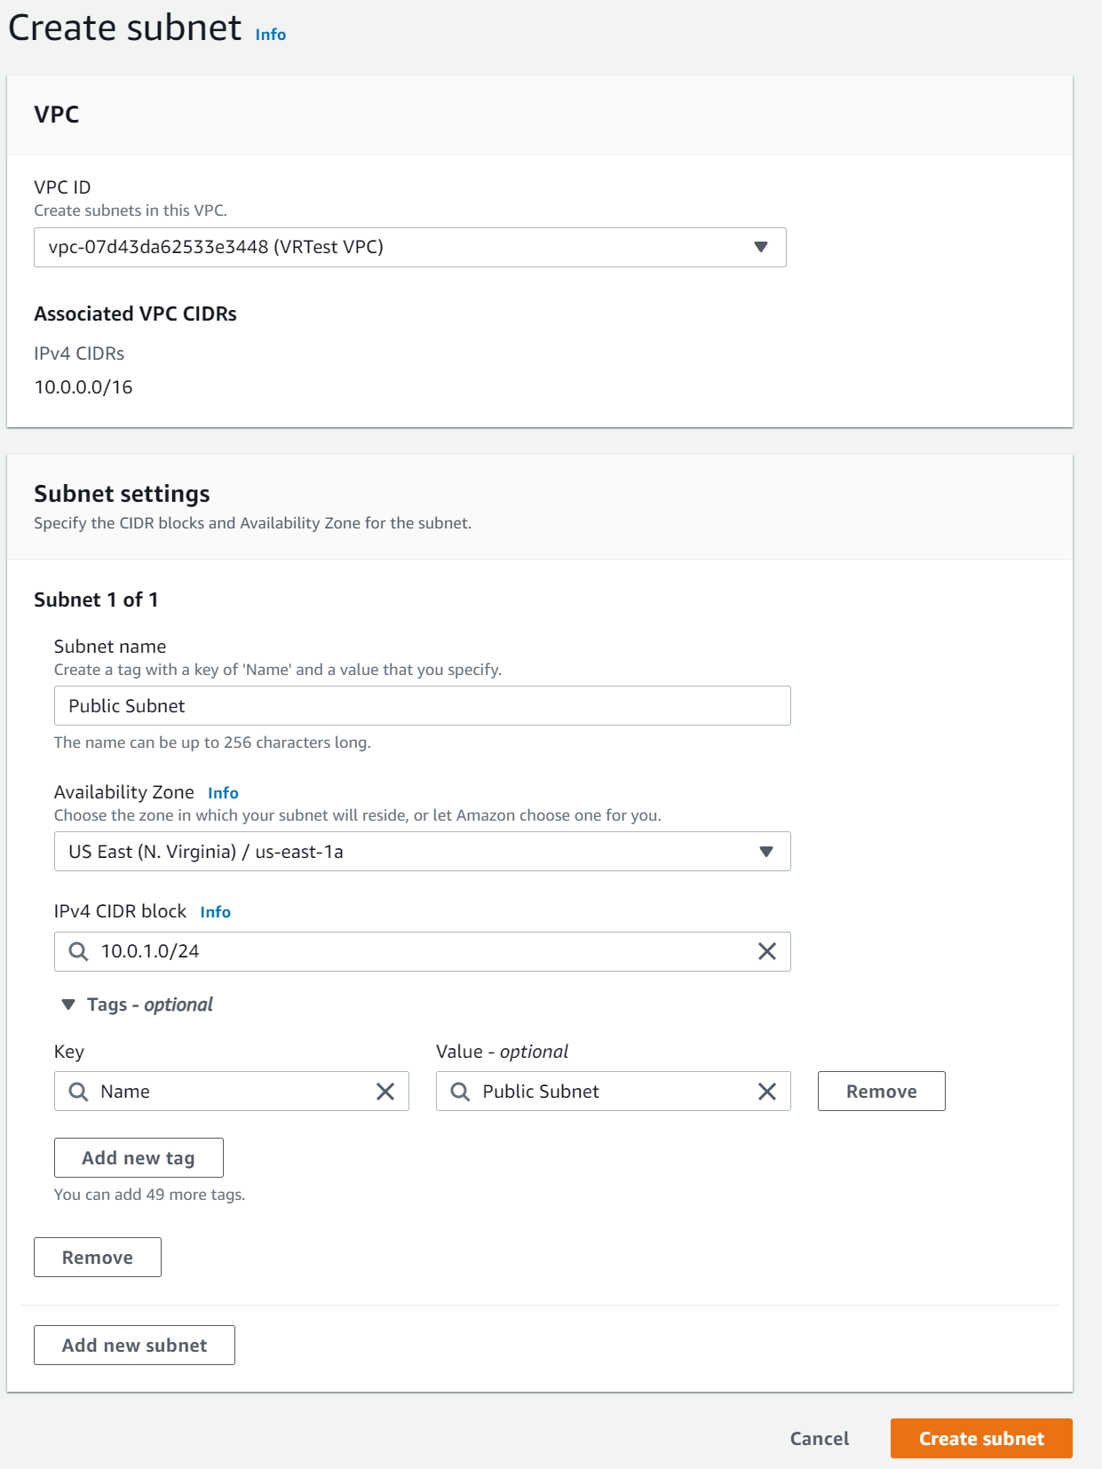

I created a Public subnet with the IP block 10.0.1.0/24.

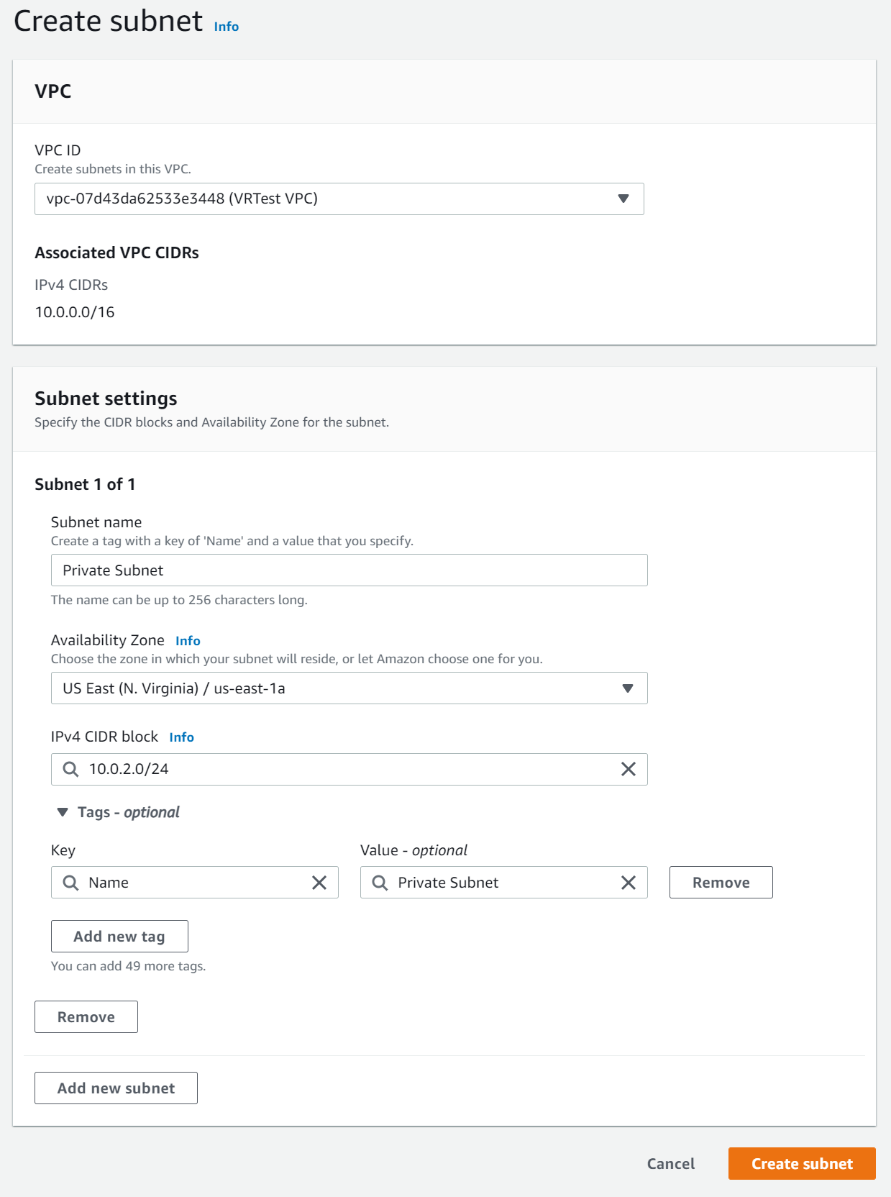

I created a private subnet with the IPv4 block 10.0.2.0/24.

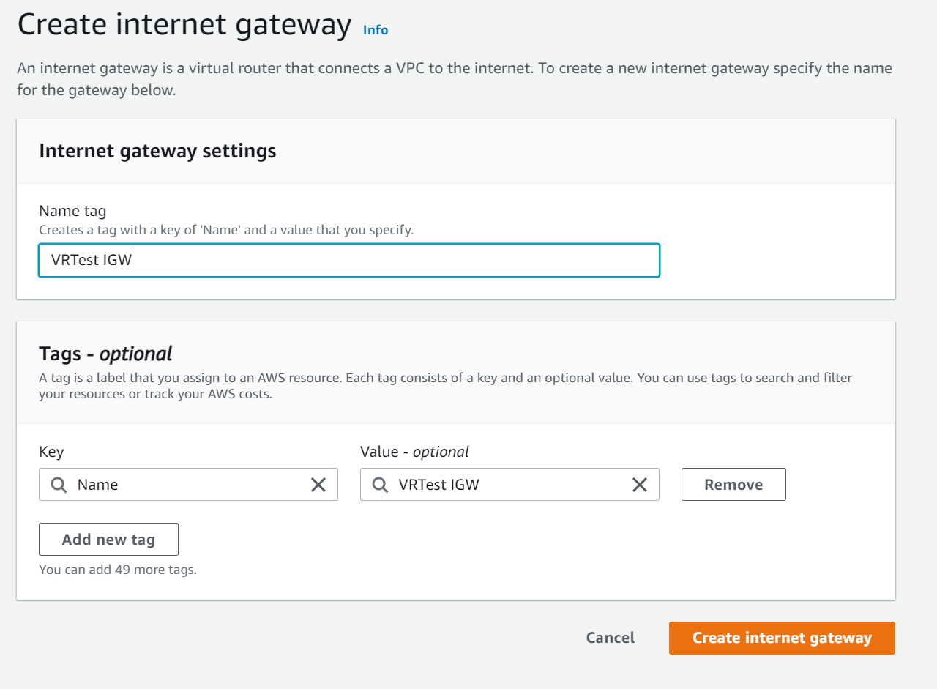

I then created an Internet Gateway with the name “VRTest IGW”

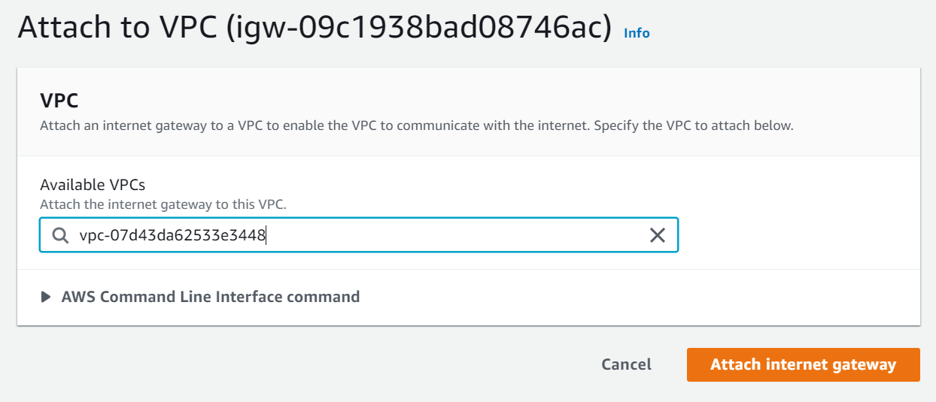

I attached the internet gateway to the VPC previously created.

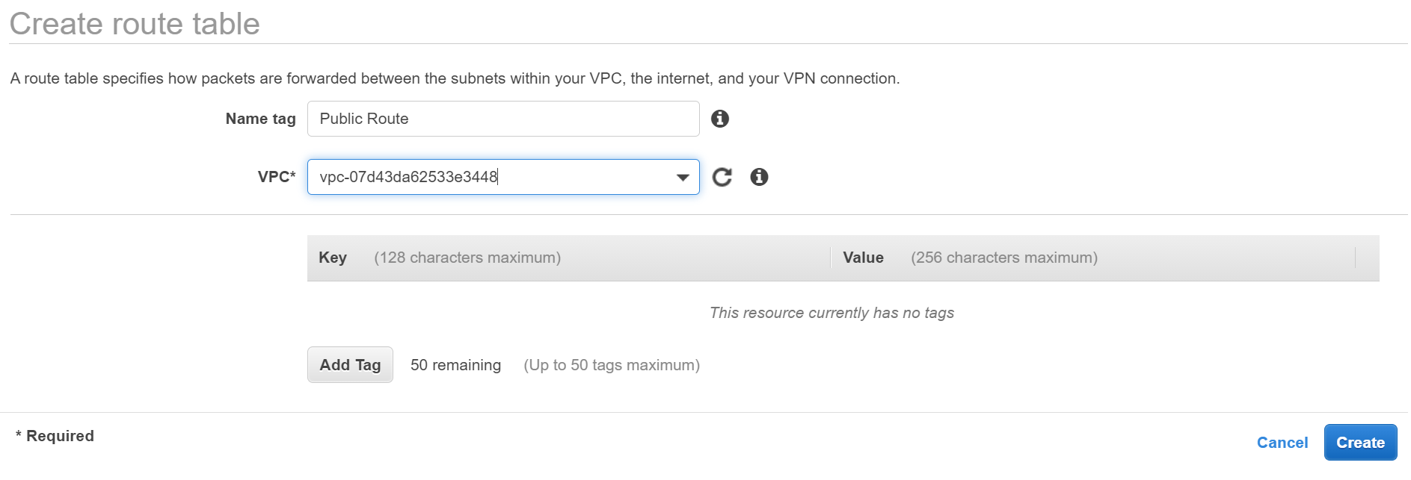

I then created a Public route table.

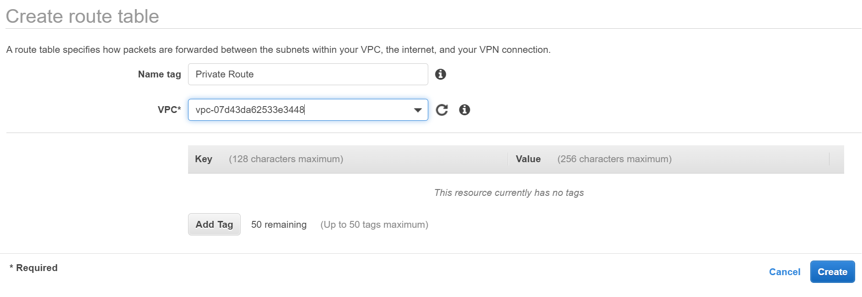

I also created a private route table.

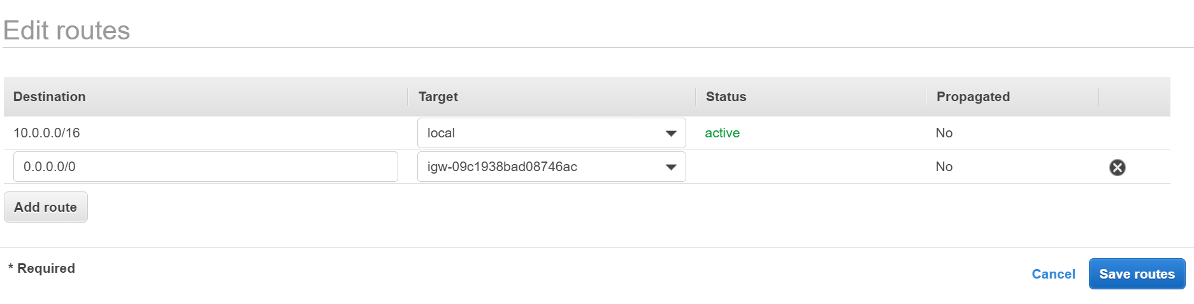

I added a default route to the internet gateway in the public routing table.

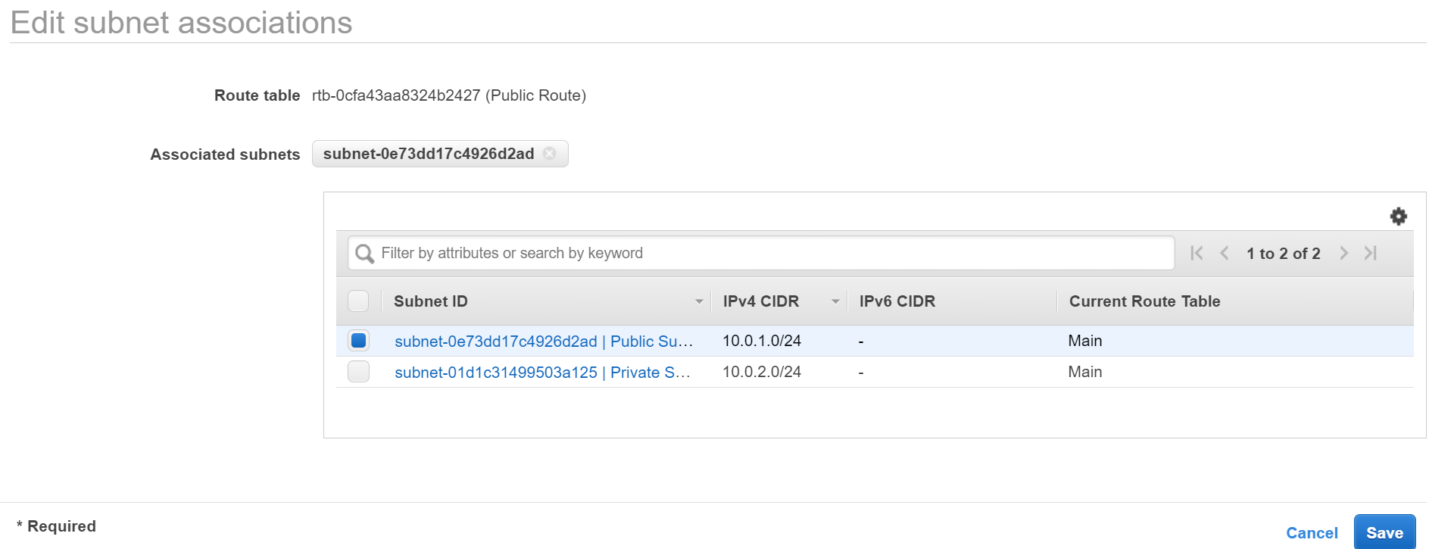

I linked the Public routing table to the public subnet.

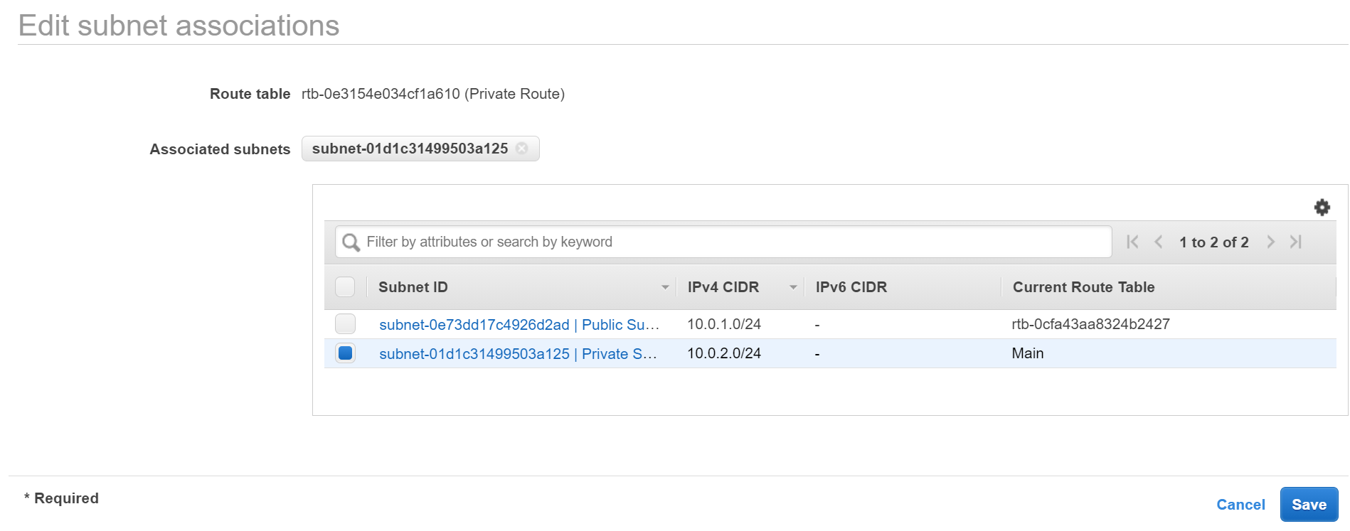

I repeated the above process for the private route table.



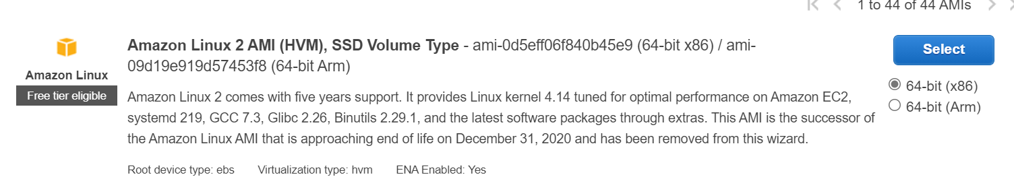

I choose the Amazon Linux 2 AMI machine image.

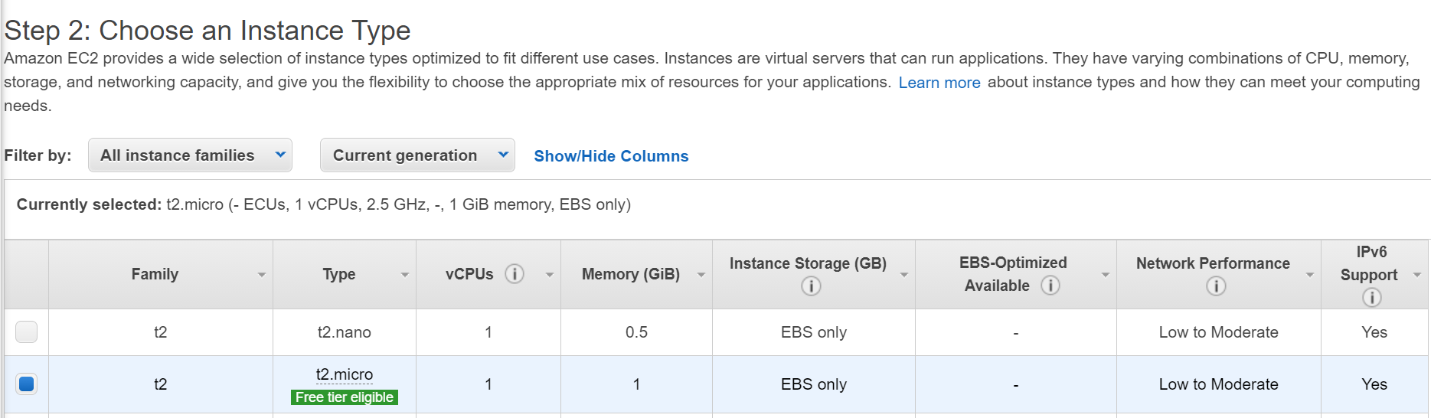

I choose t2.micro instance type.

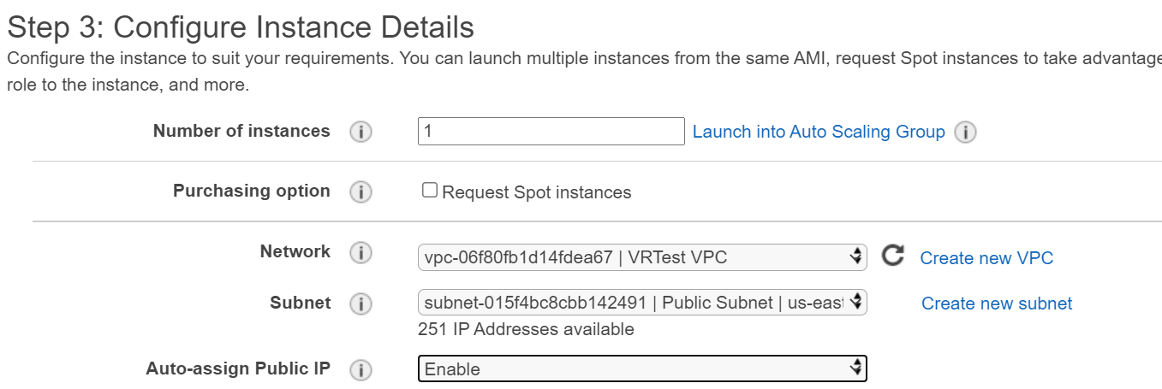

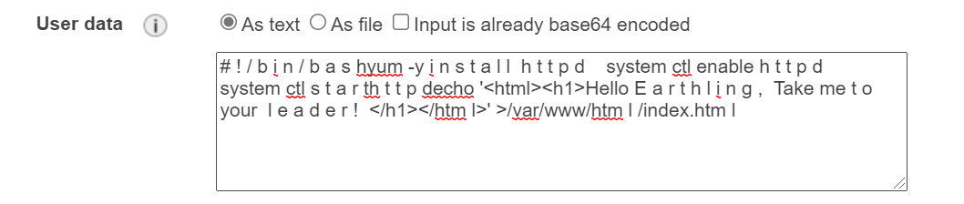

Next, I connected the EC2 instance to the VPC and subnets previously created and added the same user data added in AWS lab 3.

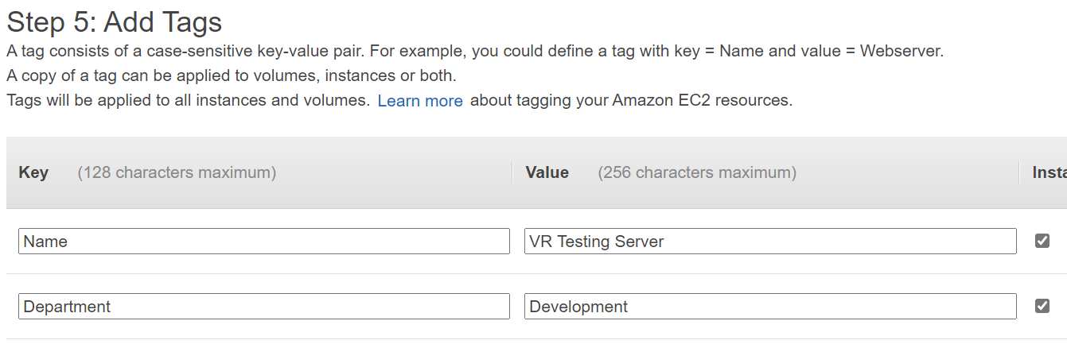

Then, I added two tags, one with the key: “Name” and value: “VR Testing Server” and the other with the key: “Department” and value: “Development”

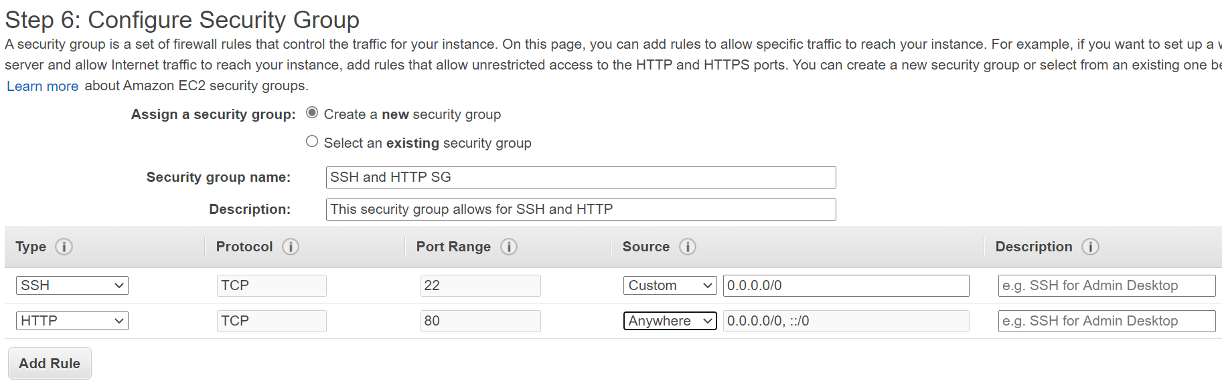

Next, I set up a security group named “SSH and HTTP SG” which I enabled all HTTP traffic to pass through.

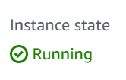

My EC2 instance successfully started running.

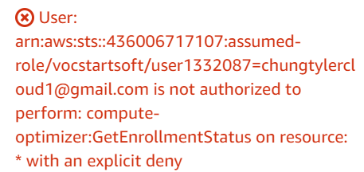

Problems: Could not view the website due to this error message. I believe this error message is stating that my AWS account does not have access to these features.